Revised biomass density estimates of Antarctic krill in Bransfield Strait during the 2023/24 austral summer from a new glider-based wideband echosounder; forthcoming biomass estimates from the 2024/25 glider deployment and mooring and glider deployment plans for 2025/26

Anthony M Cossio¹ and Christian S Reiss (Retired)
¹NOAA Fisheries
Ecosystem Science Division
Southwest Fisheries Science Center
La Jolla, CA

Abstract
The U. S. Antarctic Marine Living Resources (U. S. AMLR) program deployed two Teledyne Webb Research Slocum G3 gliders, each equipped with a suite of oceanographic sensors and newly designed Nortek Signature100 single beam wide-band compact echosounder (70 kHz to 120 kHz). We previously reported these krill densities to CCAMLR (EMM2024/53), but noted a large discrepancy between the two gliders, and attributed the differences to calibration errors. Here we present corrected biomass densities after a more rigorous calibration procedure. At 120kHz, differences in biomass density estimates within the BS survey area between gliders ranged from 2.9 to 3.3 g m⁻², suggesting that the revised calibration procedure corrected previously reported differences. Revised biomass densities at 120 kHz from both the ALL energy and SWARMS method differed by about 5 to 8 g m^{-2,} at 120 kHz. Biomass density using the ALL energy ranged from 38.22 g m⁻² (SD 85.64 g m⁻²) to 41.67 g m⁻² (SD 130.78 g m⁻²), for AMLR03 and AMLR04, while biomass density using the SWARMS method ranged from 33.91 g m⁻² (SD 78.77 g m⁻²) to 35.01 g m⁻² (SD 99.72 g m⁻²), for AMLR03 and AMLR04, respectively. Gridding the glider data into 0.2 by 0.1 degree cells and estimating the mean biomass density for the entire deployment area, provided estimates that were similar to the survey area method. At 120 kHz, biomass density ranged from 35.67 to 37.4 g m-2 for the ALL energy method while application of the SWARMS method produced biomass density estimates ranging from 32.81 to 33.82 g m-2 for AMLR04 and AMLR03 respectively. Our reanalysis reaffirms the utility of autonomous gliders for conducting acoustic surveys for krill biomass estimation, and argues that estimates from these platforms should comprise an import6ant source of data used to assess krill populations in some areas of the Southern Ocean.

Further, to continue developing our glider-based timeseries of krill biomass density estimates within Bransfield Strait, U.S. AMLR will process the acoustic data from the 2024/25 glider deployment in Bransfield Strait. Additionally, the U. S. AMLR Program has plans to deploy two gliders within Bransfield Strait in the upcoming field season (2025/26) equipped with active acoustic systems and a shadowgraph plankton camera system in early summer. Finally, attached to this document is a preliminary acoustic mooring deployment plan for an 18 month deployment of up to 12 NORTEK Signature100 moorings.

Introduction
CCAMLR requires estimates of krill biomass at appropriate time and space scales to develop a revised krill management plan that can allocate krill catch within and among subareas. Annual biomass estimates have historically been made from research vessel based acoustic trawl surveys. Owing to the cost of these surveys, many national programs have reduced the frequency or eliminated surveys. At the same time, krill catch has increased,. Thus, there is a realization that a revised krill management strategy will need to expand the types of surveys that can be included to generate estimates of krill biomass. Considerable effort has been expanded to use fishing vessels to provide acoustic estimates on fishing grounds, in addition to their use in fishery independent surveys.

The US Antarctic Marine Living Resources (US AMLR) program has historically provided Antarctic krill acoustic biomass estimates since 1991 (Hewitt et al. 2003: Reiss et al. 2008). Initially, the US AMLR program used ships to collect acoustic data during the austral summer until 2012, when the program did five consecutive winter acoustic estimates (2012 – 2016) (Reiss. et al. 2017). In 2018, US AMLR started using autonomous underwater gliders equipped with active acoustics (Reiss et al. 2021) and have been performing annual glider deployments to continue to provide summer krill biomass estimates.
Here we report on krill estimates or the 2023/24 austral summer in Bransfield Strait from two autonomous gliders. We demonstrate the use of a new single beam wide-band echosounder (Nortek Signature100 compact echosounder), and compare the biomass density estimated by each glider to better understand the utility of these tools. Finally, we propose a new method to estimate kill biomass by gridding the glider data over a fixed grid to remove the effects of oversampling, and then use a bootstrap estimate to calculate the mean and estimate the variability of the survey estimates.

Methods
The US AMLR program deployed two Teledyne Webb Research Slocum G3 gliders (AMLR03 and AMLR04) south of Smith Island, in the Bransfield Strait on November 28, 2023 by the RVIB Laurence M. Gould (Figure 1). The general survey design is to replicate, as best as possible, the cross basin transects historically surveyed during our previous ship surveys (Reiss et al. 2008), and recent autonomous surveys. In addition to the cross basin transects, the survey path is also aimed to increase sampling in areas where the fishery operates (on the south side of the Bransfield Strait), and of penguin foraging areas near King George Island. Additionally, as part of other oceanographic investigations, a repeat survey was conducted near the mouth of Gerlache Strait in SW Bransfield Strait. After completing the survey, the gliders were retrieved on January 27, 2024 south of Hoeseason Island by the RVIB Laurence M. Gould. Both gliders dove to 950m depth or 35m off of the bottom.
The two gliders were equipped with a Sea-Bird Glider Payload CTD, an Aanderaa oxygen optode model 4831, a Wetlabs Ecopuck (FLBBC) that measured fluorescence, colored dissolved organic matter, and optical backscatter. Additionally, in contrast to gliders used in previous deployments (Reiss et al. 2021), the gliders were equipped with a new compact wide-band single beam echosounder that was housed in a wet bay forward of the buoyancy pump (Nortek Signature 100 compact echosounder). The gliders were programmed to dive at 26 degrees so that the acoustic transducers were directed normal to the sea surface while sampling. The echosounders are single beam wideband echosounders with an operational range between 70 kHz and 120 kHz, similar to the echosounders in the Nortek Signature 100 ADCP (Cutter, et al, 2022). We sampled at 1/6 Hz, transmitting one wideband pulse followed by two narrowband pulses. The wideband pulse with frequencies of 74, 82, 91, 99, and 108 kHz was first transmitted with a 1 second delay between frequencies. This is followed by a narrowband pulse transmitted at 70 kHz with a 1-ms duration followed by a 120 kHz pulse with a 1-ms duration. The echosounders have a range of 200m but there was an artifact in the 70 kHz data at 97m so the analysis range was limited to 96m at both frequencies on both gliders.

Unlike ships, gliders collect acoustic data during discrete, oblique dives through the water column. Ships will sample along transects and over a fixed depth range relative to the water surface. The glider acoustics sample similar to an oblique net tow, were the range of the echosounder (effective 96m in this survey) is an angled slice through the water column. Each of these discrete, oblique dives are called profiles. The horizontal distance traveled by the glider during each dive-climb cycle and the interval between dives was dependent on dive depth, with increased horizontal sampling resolution when dives were shallower, thus more frequent.

Instrument Re-calibration
All echosounders were calibrated at the Southwest Fisheries Science Center test tank using the standard sphere technique (Foote et al. 1981; Demer et al. 2015; Reiss et al. 2021). The echosounders were originally calibrated by hanging a 25.4 (units?) tungsten-carbide sphere under the echosounder attached at either side of the wet bay, at a location that we calculated would center the sphere under the center of the transducer beam when the glider was commanded to a 26 degree angle. At the time, no live viewing of the data was possible, and the echosounder sampled at 1/6 Hz. The sphere was fixed at a depth of 4.5m below the transducer at the time, and the calibration was based on the assumption that the sphere was centered on the transducer. Data were recorded until approximately 200 pings were recorded, and the highest 10% of the pings were used to calculate the calibration coefficient.

For the recalibration, we attached the tungsten carbide sphere to three electronic downriggers on monofilament line such that the sphere could be centered 4.5m below the transducer face when the glider is at the surface but is angled at 26 degrees. In contrast to our first calibration, we used live viewing of the data to make sure the sphere was on axis and we recorded the data at ½ Hz until about 200 pings are collected. The highest ten percent of the pings are then averaged to calculate the calibration coefficient. In both cases we used the in situ salinity and water temperature data from the CTD aboard the glider to adjust the sound speed in calculations. Gains are the adjusted in Echoview software to apply the calibration.
We recalibrated each echosounder twice during the same day (AMLR03 on November 5, 2024 and AMLR04 on January 16, 2025). Each of the calibrations was within one decibel of the other providing confidence that the calibration was done correctly. The new calibration coefficients applied to the two echosounders were noticeably different from to the original calibration results . The original calibration resulted in a 0.5 dB difference between the two 70 kHz echosounder channels and a 1.83 dB difference between the 120 kHz echosounder channels. After recalibration with the new method, the difference in the 70 kHz coefficients declined to 0.3 dB, and to 0.79 dB for the 120 kHz channels.
Processing
The acoustic data were analyzed using Echoview software (15.0) and processed in two ways. First, we only processed dives, as this is when the echosounder is perpendicular to the water surface as the glider samples. Basic processing of the data included removing the first ten meters of a dive to account for any bubbles adhering to the transducer face, bubbles in the water column. We also removed the first three meters of data below the transducer face to account for ringdown, and after identifying the bottom echo we removed the bottom by stepping back three meters from the bottom echo. Background noise removal was applied, followed by impulse noise removal, when necessary, to clean the data (DeRobertis and Higginbottom 2007). This process was done for both the 70 and 120 kHz data. Decibel differencing was not used to delineate krill like in previous studies (Reiss et al. 2021), instead we applied two methods to examine these data. First we integrated all the echo energy (ALL), without krill delineation, to provide a ceiling for the biomass density estimates because the energy can also include other scatterers that are not krill. Cleaned data were then integrated in 5m by 5m bins and exported as area backscattering coefficient (ABC, m²m⁻²) from 10m from the surface until the bottom of the dive. The second method, we used the Shoal Analysis and Patch Estimation System (SHAPES, Cotezee, 2000) or ‘schools’ detection algorithm for krill school identification. School detection settings were based on Guihen et al. (2104) and are found in Table 1. School detection was run on a 3x3 dilation filter for the 120 kHz and the detection regions were applied to each narrow band frequency (70 kHz and 120 kHz) using a -75 dB threshold. A mask was then placed over the data that was not classified as a school and was considered empty water. The detected schools data was also integrated in 5m by 5m bins and exported as ABC.

Once the data were exported from Echoview, analysis was continued in Matlab for both the ALL echo energy output and SWARMS output. The code used to process the acoustics generally integrates the 5m x 5m bins to the surface of each discrete glider dive (profile) and matches it with the oceanographic data. Conversion factors to convert ABC into density (g m⁻²) were generated using the Stochastic distorted-wave Born approximation (SDWBA) target strength model. Krill length frequency data (see below) were used in to create the conversion factors following SG-ASAM (2010).
Calculation of biomass density
The processing of ABC to density requires a few steps. The ABC values of 5m x 5m bins for each dive profile is first integrated from 250m to the surface. The integrated ABCs are then multiplied by the conversion factor from the krill length frequencies in order to get a density (g m⁻²) for each glider dive profile. We calculated a simple mean density and standard deviation across all the dive profiles following Reiss et al. (2021).
A second method of calculating the mean density was investigated as well. The area of Bransfield Strait was divided into 0.2° by 0.1° grid cells (Figure 1). This grid cell size approximates the Rossby radius of deformation (10 km) at 64 degrees south). The Rossby radius provides an index of the spatial scales for the size of mesoscale eddies that can form, a useful spatial scale for physically driven phenomena. Glider profiles were gridded into the grid cells and the mean ABC of those grids were calculated. The means of the grid cells were bootstrapped 1000 times to get the mean density and confidence intervals. Areal biomass was calculated using the mean density times the area of the Bransfield Strait survey.
Krill length frequency
Because there were no concomitant net surveys in the region from which to generate a length frequency distribution, we used krill obtained from diets of penguins (Reid and Brierley 2001; Miller and Trivelpiece 2007). Length frequency data of Antarctic krill were collected from breeding gentoo penguins at Llano Point, King George Island, Antarctica, during January 2024. Penguins often spill small boluses of krill on the ground while feeding chicks. These fresh boluses were collected opportunistically from throughout the colony and immediately sorted to identify intact, whole individuals. The length of all whole individuals was measured from the anterior side of the eye to the tip of the telson.

Results and Discussion
General findings
Both gliders covered about the same number of dives in the surveyed area of Bransfield Strait, with just a couple of differences. AMLR03 completed 561 total dives that generated 321 profiles in the survey area, while AMLR04 completed 563 total dives generating 323 profiles in the survey area. AMLR03 also sampled an additional loop off King George Island that was not sampled by AMLR04 (Figure 1). Profiles of mean ABC backscatter showed that most krill were in the upper 250m of the water column (Figure 2; only showing upper 500m of water column), consistent with previous studies. Most of the Bransfield Strait is than 1000m deep (except for a small area of the deep basins), so we have little concern that we are missing a large fraction of krill at depth. In fact, no significant aggregations were observed below about 500m. Thus we feel confident that our estimates of biomass density are unbiased with respect to missing krill in the water column.
The surface mapped biomass density of each glider showed several areas with higher biomass densities, but in general the spatial distribution of biomass density was similar between gliders. (Figure 3A and Figure 3B). Peaks in biomass density varied in location between gliders, and this is not unexpected given the overall small size and the random spatial distribution of krill aggregations. In fact with the recalibrated data, the histograms of log10 ABC showed that the patterns of biomass density distribution were very similar between the two gliders (Figure 4A), as might be expected given that one glider was following the other over the whole survey. Empirical cumulative distribution plots (Figure 4B) also demonstrated that the shapes of the distributions were also similar, with the only differences being slightly more schools observed in the ranged of log10 -7.5 to -6. Whether further data processing would result in even better results may be useful to examine in the future. However, the overall pattern indicates that each glider was seeing the same overall pattern of krill.
Biomass density
At 120kHz, differences in biomass density estimates within the BS survey area between gliders ranged from 2.9 to 3.3 g m⁻², suggesting that the revised calibration procedure corrected previously reported differences. Revised biomass densities at 120 kHz from both the ALL energy and SWARMS method differed by about 5 to 8 g m^{-2,} at 120 kHz (Table 3). Biomass density using the ALL energy ranged from 38.22 g m⁻² (SD 85.64 g m⁻²) to 41.67 g m⁻² (SD 130.78 g m⁻²), for AMLR03 and AMLR04, while biomass density using the SWARMS method ranged from 33.91 g m⁻² (SD 78.77 g m⁻²) to 35.01 g m⁻² (SD 99.72 g m⁻²), for AMLR03 and AMLR04, respectively. Data at 70 kHz showed similar patterns, with differences in biomass density between 70 kHz and 120 kHz, ranging around 8 to 10 gm m⁻² for either the ALL echo energy or SWARMS analysis (Table 3 and Table 4).
Spatial gridding and bootstrapping
The current method employed when using gliders to calculate the biomass density, and estimate the total biomass of the survey area, does not consider the relative over-sampling that can occur as the gliders move though areas with large tidal movements or areas of considerable shear. In these situations, the glider does not make headway relative to the movements of the water itself and these areas then get oversampled relative to the goal of getting a representative sample of biomass density along prescribed transects. Thus, we have not presented error estimates for the biomass densities in the past (Reiss et al., 2021). To address this issue, we employed a two-fold strategy to minimize the effects of this oversampling. We developed a grid (Figure 1) across the entirety of the peninsula region that is fine enough (0.2° by 0.1°) to represent horizontal distances of about 10km in longitude and latitude. This spatial dimension is approximately the Rossby radius of deformation, which dictates the length scale of the eddies formed at these latitudes. We then allocated the glider dives to these cells and averaged all data within a grid cell. This reduced the number of data points to 106 (AMLR03) and 101 (AMLR04) in the gridded data set. After generating this gridded data set, we accounted for any grid-to-grid autocorrelation by bootstrapping to 1000 estimates of the mean biomass density, and then calculating a grand mean of those 1000 estimates. We used a bootstrapping method to calculate 95% confidence limits around each of the means. Estimates of bootstrapped mean biomass density of each glider was similar to that using the full data set differing by only 2 to 3 gm m⁻² (Table 5). For example, using the full echo energy data set the mean biomass of krill at 120 kHz the biomass density was within 3 percent of the gridded means for both AMLR03 and AMLR04.

Discussion
We have previously demonstrated that underwater gliders are capable of producing defensible estimates of the biomass of Antarctic krill in Antarctic waters (Reiss et al. 2021). We have also shown using simulation that the sawtooth pattern of glider movement through the water column is robust, and provides similar estimates to ships (Kinzey et al. 2022). Here we have shown, that after recalibration, that the statistical properties between two gliders flying the same survey pattern is also robust, and this should provide managers with confidence that data from multi-glider deployments can be easily combined. Finally, we have also demonstrated the use of a new compact single beam wide-band echosounder (Nortek Signature 100 compact echosounder) derived from a similar instrument used on moorings by the U.S. AMLR Program (Cutter et al. 2022).
Krill SWARMs Parameters
Guihen et al. (2014) examined the parameters used in the SWARMS algorithm as it relates to using this technique with gliders that sample the water column differently than ships. We initially used the parameters defined in Guihen et al. (2014). However, we found that the minimum school length they used provided too many schools with very low acoustic signatures that were not visually identifiable in the echograms. So we used a minimum school length of 6 meters. We are still testing the optimal parameters for use with the long ping interval (1/6 Hz) like those of the NORTEK units.

Conclusions
This is the fifth deployment of echosounder equipped gliders during austral summer around the Antarctic Peninsula, and further demonstrates that these tools are important to continuing acoustic time series that were started in the 1980s using ship based surveys.
We have provided a number of different approaches for estimating krill biomass density, and importantly, the means don’t vary greatly among the alternative approaches. We continue to explore different approaches to the calculation of biomass density and have proposed a modification of the geospatial structuring of sampling, and demonstrated that with even fewer samples in the region (gridded into spatial cells), the biomass density is still within about 3 to 4 g m⁻² of the other approaches, well within the survey variability.
Overall, the estimate of krill biomass density within the historically surveyed area of the Bransfield Strait was between 32 and 35 g m⁻² during austral summer 2023/24.

References
Coetzee J (2000). Use of a shoal analysis and patch estimation system (SHAPES) to characterise sardine schools. Aquatic Living Resources, 13(1), 1-10.
Cutter Jr, GR, Reiss, CS, Nylund, S, and Watters, GM (2022). Antarctic krill biomass and flux measured using wideband echosounders and acoustic Doppler current profilers on submerged moorings. Frontiers in Marine Science, 9, 784469.
De Robertis, A, and Higginbottom, I. (2007). A post-processing technique to estimate the signal-to- noise ratio and remove echosounder background noise. ICES Journal of Marine Science, 64(6), 1282- 1291.
Demer, DA, Berger, L, Bernasconi, M, Bethke, E, Boswell, K, Chu, D,and Williamson, N (2015). Calibration of acoustic instruments. ICES Cooperative Research Reports (CRR), 215.
Demer, D. A., & Hewitt, R. P. (1995). Bias in acoustic biomass estimates of Euphausia superba due to diel vertical migration. Deep Sea Research Part I: Oceanographic Research Papers, 42(4), 455-475.
Foote K.G., Knudsen H.P., Vestnes G., Brede R. and Nielsen R.L. (1981). Improved calibration of hydroacoustic equipment with copper spheres. ICES CM1981/B:20, 18 pp
Guihen, D, Fielding, S. Murphy, E J, Heywood, KJ, and Griffiths, G. (2014). An assessment of the use of ocean gliders to undertake acoustic measurements of zooplankton: the distribution and density of Antarctic krill (Euphausia superba) in the Weddell Sea. Limnology and Oceanography:
Methods, 12(6), 373-389. https://doi.org/10.4319/lom.2014.12.373
Hewitt, RP, Demer DA, and Emerey, JH. (2003). An 8-year cycle in krill biomass density inferred from acoustics surveys conducted in the vicinity of South Shetland Islands during the austral summers of 1991-1992 through 2001-2002. Aquatic Living Resources. Vol 16, Issue 3. Pp. 205-213. https://doi.org/10.1016/S0990-7440(03)00019-6
Kinzey D, Cossio AM, Reiss CS and Watters GM (2022). Acoustic sampling of Antarctic krill with simulated underwater buoyancy gliders: Does the sawtooth dive pattern work? Front. Mar.
Sci. 9:1064181. doi: 10.3389/fmars.2022.1064181
Miller, AK, and Trivelpiece, WZ. (2007). Cycles of Euphausia superba recruitment evident in the diet of Pygoscelid penguins and net trawls in the South Shetland Islands, Antarctica. Polar Biology, 30, 1615-1623.
Reid, K, and Brierley, A S. (2001). The use of predator-derived krill length-frequency distributions to calculate krill target strength. CCAMLR Science, 8, 155-163.
Reiss, CS, Cossio, AM, Loeb, V, and Demer, DA. (2008). Variations in the biomass of Antarctic krill (Euphausia superba) around the South Shetland Islands, 1996–2006. ICES Journal of Marine Science, 65(4), 497-508.
Reiss CS, Cossio A, Santora JA, Dietrich KS and others (2017). Overwinter habitat selection by Antarctic krill under varying sea-ice conditions: implications for top predators and fishery management. Mar Ecol Prog Ser 568:1-16. https://doi.org/10.3354/meps12099
Reiss CS, Cossio AM, Walsh J, Cutter GR and Watters GM (2021). Glider-Based Estimates of Meso-Zooplankton Biomass Density: A Fisheries Case Study on Antarctic Krill (Euphausia superba) Around the Northern Antarctic Peninsula. Front. Mar. Sci. 8:604043. doi: 10.3389/fmars.2021.604043
SC-CAMLR (2010). Report of the fifth meeting of the Subgroup on Acoustic Survey and Analysis Methods. SC-CCAMLR-XXIX/6.

Tesler, W. D. (1989) Bias and precision in acoustic biomass estimation. Proceedings of the Institute of Acoustics, 11(3), 202-211.
WG-ASAM (2024) Report of the Working Group on Acoustic Survey and Analysis Methods (WG- ASAM-2024).
Tables
Table 1. School detection settings used to estimate the density of krill schools during the 2023/24 austral summer glider deployments using a -75 dB threshold.

Minimum total school height (meters) | 2
Minimum candidate length (meters) | 1.5
Minimum candidate height (meters) | 2
Maximum vertical linking distance (meters) | 2
Maximum horizontal linking distance  (meters) | 3
Minimum total school length (meters) | 7.5

Table 2. Krill length frequencies from Gentoo penguins on King George Island.

Length  (mm) | Frequency |  | Length  (mm) | Frequency
20 | 0.000 |  | 41 | 0.073
21 | 0.000 |  | 42 | 0.063
22 | 0.002 |  | 43 | 0.037
23 | 0.000 |  | 44 | 0.044
24 | 0.000 |  | 45 | 0.077
25 | 0.000 |  | 46 | 0.042
26 | 0.000 |  | 47 | 0.066
27 | 0.005 |  | 48 | 0.044
28 | 0.002 |  | 49 | 0.028
29 | 0.007 |  | 50 | 0.044
30 | 0.009 |  | 51 | 0.028
31 | 0.009 |  | 52 | 0.028
32 | 0.005 |  | 53 | 0.005
33 | 0.023 |  | 54 | 0.005
34 | 0.035 |  | 55 | 0.009
35 | 0.063 |  | 56 | 0.005
36 | 0.044 |  | 57 | 0.002
37 | 0.033 |  | 58 | 0.000
38 | 0.049 |  | 59 | 0.000
39 | 0.047 |  | 60 | 0.000
40 | 0.063

Table 3. Antarctic krill density and biomass estimates, standard deviations and the number of profiles in the survey area.

Glider | 70 kHz  density (g/m2) | 70 kHz STD | 70 kHz biomass  (tons) | 120 kHz  density (g/m2) | 120 kHz STD | 120 kHz biomass  (tons) | Survey profiles  (N)
AMLR03 | 48.37 | 106.77 | 4.3533e+05 | 38.22 | 85.64 | 3.4398e+05 | 321
AMLR04 | 43.33 | 117.38 | 3.8993e+05 | 41.67 | 130.78 | 3.7505e+05 | 323

Table 4. Antarctic krill density estimates and standard deviation of school analysis in the survey area.

Glider | 70 kHz  density (g/m2) | 70 kHz STD | 70 kHz biomass  (tons) | 120 kHz  density (g/m2) | 120 kHz STD | 120 kHz biomass  (tons) | Number of schools
AMLR03 | 41.89 | 99.28 | 3.7704e+05 | 33.91 | 78.77 | 3.0515e+05 | 635
AMLR04 | 37.62 | 103.22 | 3.3855e+05 | 35.01 | 99.72 | 3.1508e+05 | 515

Table 5. Table of bootstrapped densities with lower and upper confidence intervals and the number of binned data samples for the entire area using 0.2° by 0.1° grid cells.

Glider | 70 kHz density | Lower CI | Upper CI | 120 kHz density | Lower CI | Upper CI | Number of samples
AMLR03 | 47.17 | 37.47 | 60.64 | 37.41 | 30.14 | 48.62 | 106
AMLR04 | 37.86 | 28.29 | 51.91 | 35.67 | 27.15 | 51.70 | 101
Schools
AMLR03 | 41.28 | 31.91 | 55.75 | 33.82 | 26.09 | 44.41 | NA
AMLR04 | 34.13 | 25.05 | 49.10 | 32.81 | 23.94 | 46.00 | NA

Figure 1. Map of the paths of the two slocum gliders (AMLR03 and AMLR04) deployed in the Bransfield Strait during the austral summer 2023/24. Overlain on the map is the 0.2° by 0.1° grid (~10km by 10km) used to allocate dives into grid cells for bootstrapping the biomass density.

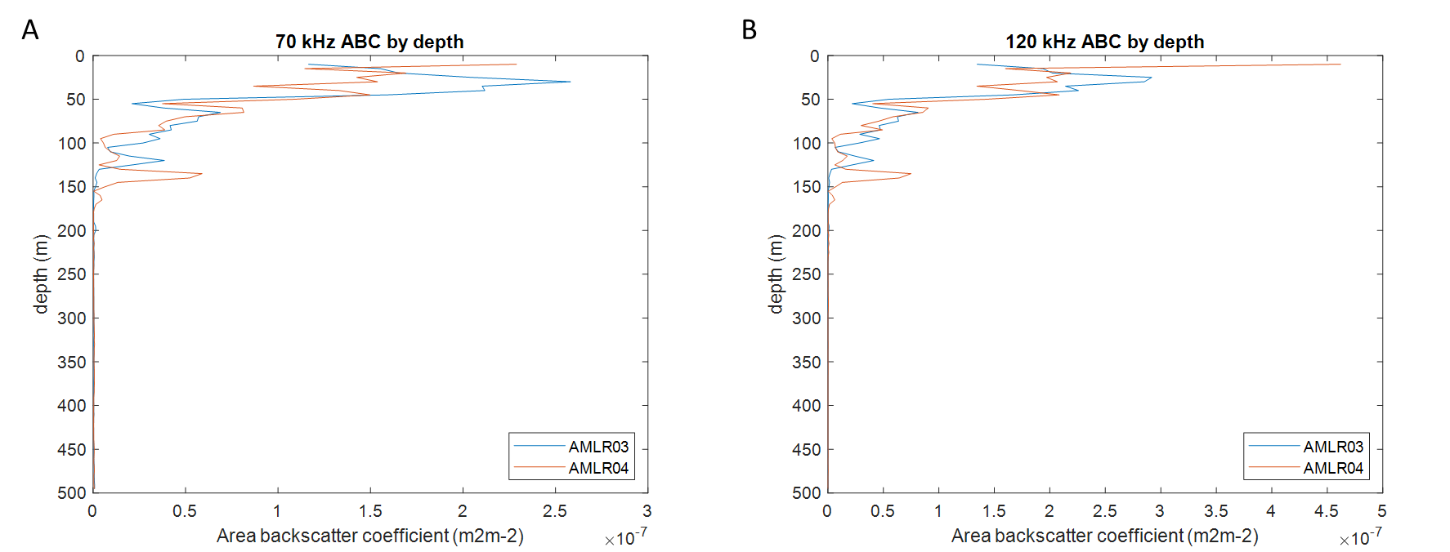

Figure 2. Depth distribution of averaged ABC for AMLR03 (blue) and AMLR04 (orange) using the 70 kHz (A) and 120 kHz (B).

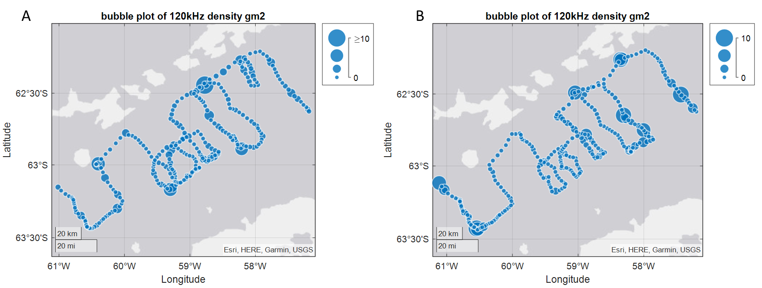

Figure 3. Maps of spatial distribution of krill densities of the 120 kHz for AMLR03 (A) and AMLR04 (B).
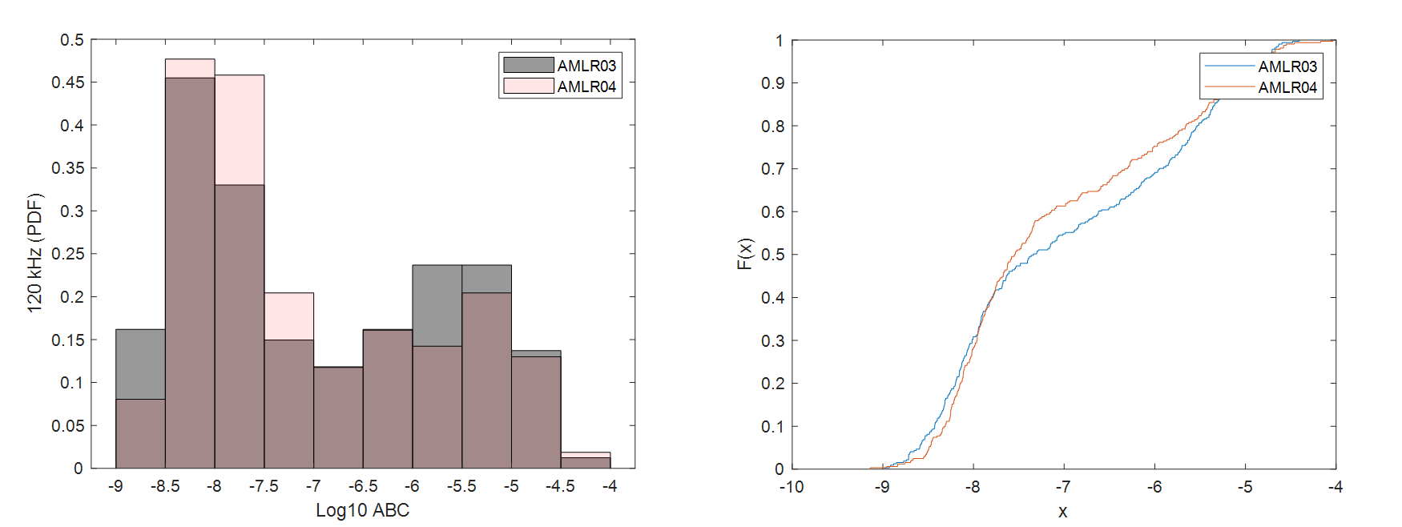
Figure 4. Empirical comparisons of acoustic estimates of biomass density from two gliders during the 2023/24 austral summer (A) Histograms of 120kHz log10 ABC for each profile; (B) Empirical cumulative distribution of biomass for both AMLR03 (blue) and AMLR04 (orange).

2025/26 NOAA U. S. AMLR PROGRAM MOORING DEPLOYMENTS

The U. S. AMLR Program is proposing to deploy up to 12 subsurface moorings in Bransfield Strait, South Shetland Islands, Antarctica in late 2025 and early 2026 (Figure 1). The purpose of these mooring deployments is to collect data on the seasonal transport of krill-like scatterers, the availability of krill in the vicinity of predator foraging areas, and the movement of krill in an important krill fishing area. Secondary U. S. AMLR goals include increasing understanding of the transport and mixing of waters between the southern part of the west Antarctic Peninsula and the northern Antarctic Peninsula. We intend to deploy these moorings for approximately 18 months depending on the exact deployment dates, and the likely recovery dates in austral autumn (March – April) of 2027. These data are critical for continuing time series of krill movement necessary to better test the krill stock hypothesis, and to develop more appropriate harvest strategies for Antarctic krill.

The deployment of the mooring array may happen in three distinct events through partnerships with the U. S. National Science Foundation, and hopefully with the support of other CCAMLR members, or the krill fishery itself. Currently, deployments are loosely scheduled for two cruises. We will deploy on National Science Foundation (NSF) cruise NBP 25-10 (PI: Alison Murray; Desert Research Institute) in early November (Figure 1, Red). We hope to have NSF deploy moorings as part of their Palmer LTER cruise NBP 26-01 (Figure 1, yellow). We are hoping that additional deployments can be made by CCAMLR Members or the fishery during the austral summer (Figure 1, black).

Mooring Specifications:

All acoustic moorings will be bottom anchored with a 350kg train wheel, double acoustic releases, an upward facing Nortek Signature 100 (ADCP/Echosounder), and 2 CTDs ()see Figure 2). CTDs are attached to the underside of the mooring buoy, and approximately 2m above the acoustic releases. Xenon flashers and iridium beacons are attached to the top of the mooring buoy. In all mooring locations except CS4 (Table 1), the top of the mooring will be located between 300 and 350 m from the surface. In general, settings on the instruments will ensure that more than 18 months of data can be collected in the event that recovery is delayed.

For each deployment, the U. S. AMLR Program will provide sufficient spare parts (shackles, line, batteries, etc.) to ensure that small changes in the location of moorings can be accommodated. Additionally, an acoustic transponder will be provided, along with codes for ensuring that instruments can be contacted after deployment. In general, final assembly of these moorings takes two persons approximately 15 minutes, and deployments take about 30 minutes depending on the sea state and deployment method.

Deployment videos are located at (https://drive.google.com/drive/folders/1A8NoZ2Ck0xdM-9ZJwpOTYlZuJYb84AO_?usp=drive_link)

Schedule:

All equipment and supplies will be sent to Punta Arenas as part of the usual U. S. AMLR Program annual deployment. Two AMLR technicians will arrive in late October 2025 to pre-assemble and program most of each mooring. One NOAA contract scientist will join the November deployment to deploy five moorings. Partners will finalize assembly and deploy remaining moorings during individual cruises.

Figure (1) Map of proposed 2025-26 austral summer sub-surface mooring deployment by the U. S. AMLR Program. November deployment by U. S. AMLR Program (red), January deployment by U. S. NSF collaborators (yellow), and proposed but uncommitted deployment of moorings within the Bransfield Strait krill fishing area
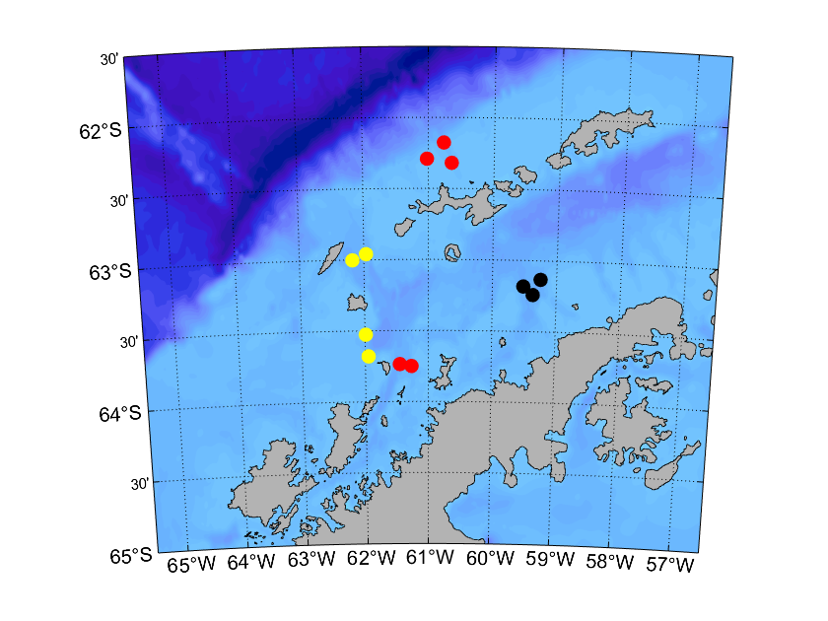
Figure (2) Typical U.S. AMLR Program mooring configurations showing mooring configuration of instruments, and assembly details. The total amount of line, may need to be modified prior to deployment. Most deployments take less than 30 minutes (videos available).
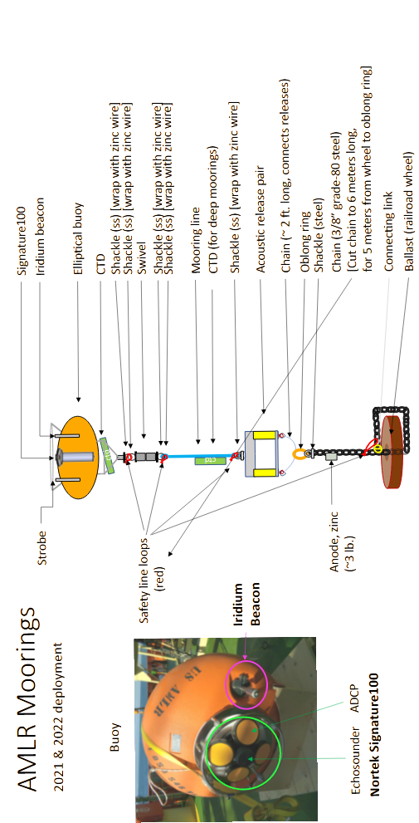
Table (1) Deployment locations for U. S. AMLR Program proposed moorings array for the 2025/26 austral summer season.

