



Commission for the Conservation of Antarctic Marine Living Resources Commission pour la conservation de la faune et la flore marines de l’Antarctique Комиссия по cохранению морских живых pесурсов Антарктики
Comisión para la Conservación de los Recursos Vivos Marinos Antárticos

WG-EMM-2024/53
16 June 2024 Original: English

Biomass density estimates of Antarctic krill in Bransfield Strait during the 2023/24 austral summer from a new glider-based wideband echosounder
WG-EMM

Cossio, A.M. and C.S. Reiss


This paper is presented for consideration by CCAMLR and may contain unpublished data, analyses, and/or conclusions subject to change. Data in this paper shall not be cited or used for purposes other than the work of the CAMLR Commission, Scientific Committee or their subsidiary bodies without the permission of the originators and/or owners of the data.

Biomass density estimates of Antarctic krill in Bransfield Strait during the 2023/24 austral summer from a new glider-based wideband echosounder

Anthony M Cossio and Christian S Reiss NOAA Fisheries
Ecosystem Science Division Southwest Fisheries Science Center LA Jolla, CA

Abstract
The US Antarctic Marine Living Resources (US AMLR) program deployed two Teledyne Webb Research Slocum G3 gliders, each equipped with a suite of oceanographic sensors and newly designed Nortek Signature100 single beam wide-band compact echosounder (70 kHz to 120 kHz). We used these gliders to estimate biomass densities (g m⁻²) of Antarctic krill (Euphausia superba) in the Bransfield Strait during the austral summer of 2023-24. Both gliders were deployed on November 28, 2023 and recovered 61 days later on January 27, 2024. Krill biomass density estimates were calculated from both gliders using two methods, using all echo energy and the other, using schools to delineate krill. Krill length frequencies from the diets of Gentoo penguins at King George Island were used to construct conversion factors. Densities from both methods ranged from 67.61 g m⁻² (SD 181.9 g m⁻² ) to 151.29 g m⁻² (SD 337.26 g m⁻² ). Examination of the number of schools identified between the two gliders suggests a bad calibration on one of the gliders, emphasizing the impact and importance of correct calibrations. We developed a new method to minimize oversampling due to the nature of gliders by creating a grid and bootstrapping the data in the grid.
Density estimates were comparable to the other two methods with a low estimate of 75.54 g m⁻² 95% CI [51.7, 108.64 g m⁻² ] and a high of 161.95 g m⁻² 95% CI [125.08, 213.29 g m⁻² ]. Gliders
remain an important tool to continue to provide acoustic biomass estimates of Antarctic krill.

Introduction
CCAMLR requires estimates of krill biomass at appropriate time and space scales in order to develop a revised krill management plan that can allocate krill catch within and among subareas. Annual biomass estimates have historically been made from research vessel based acoustic trawl surveys. Owing to the cost of these surveys, many national programs have reduced the frequency or eliminated surveys. At the same time, krill catch has increased, and in some areas annually reach interim catch limits. Thus, there is a realization that a revised krill management strategy will need to expand the types of surveys that can be included to generate estimates of krill biomass. Considerable effort has been expanded to use fishing vessels to provide acoustic estimates on fishing grounds, in addition to their use in fishery independent surveys.

The US Antarctic Marine Living Resources (US AMLR) program has historically provided Antarctic krill acoustic biomass estimates since 1991 (Hewitt et al. 2003: Reiss et al. 2008). Initially, the US AMLR program used ships to collect acoustic data during the austral summer until 2012, when the program did five consecutive winter acoustic estimates (2012 – 2016) (Reiss. et al. 2017). In 2018, US AMLR started using autonomous underwater gliders equipped with active acoustics (Reiss et al. 2021) and have been performing annual glider deployments to continue to provide summer krill biomass estimates.
Here we report on krill estimates or the 2023/24 austral summer in Bransfield Strait from two deployed autonomous gliders. We demonstrate the use of a new single beam wide-band echosounder (Nortek Signature100 compact echosounder), and compare the biomass density estimated by each glider to better understand the utility of these tools. Finally, we propose a new method to estimate kill biomass by gridding the glider data over a fixed grid to remove the effects of oversampling, and then use a bootstrap estimate to calculate the mean and estimate the variability of the survey estimates.

Methods
The US AMLR program deployed two Teledyne Webb Research Slocum G3 gliders (AMLR03 and AMLR04) south of Smith Island, in the Bransfield Strait on November 28, 2023 by the RVIB Laurence M. Gould (Figure 1). The general survey design is to replicate, as best as possible, the cross basin transects historically surveyed during our previous ship surveys (Reiss et al. 2008), and recent autonomous surveys. In addition to the cross basin transects, the survey path is also aimed to increase sampling in areas where the fishery operates (on the south side of the Bransfield Strait), and of penguin foraging areas near King George Island. Additionally, as part of other oceanographic investigations, a repeat survey was conducted near the mouth of Gerlache Strait in SW Bransfield Strait. After completing the survey, the gliders were retrieved on January 27, 2024 south of Hoeseason Island by the RVIB Laurence M. Gould. Both gliders dove to 950m depth or 35m off of the bottom.
The two gliders were equipped with a Sea-Bird Glider Payload CTD, an Aanderaa oxygen optode model 4831, a Wetlabs Ecopuck (FLBBC) that measure fluorescence, colored dissolved organic matter, and optical backscatter. Additionally, in contrast to gliders used in previous deployments, the gliders were equipped with a new compact wide-band single beam echosounder in a wetbay forward of the buoyancy pump (Nortek Signature 100 compact echosounder). The gliders were programmed to dive at 26 degrees so that the acoustic transducers were directed normal to the sea surface while sampling. The echosounders are single beam wideband echosounders with an operational range between 70 kHz and 120 kHz, similar to the echosounders in the Nortek Signature 100 ADCP (Cutter, et al, 2022). We sampled at 1/6 Hz, transmitting one wideband pulse followed by two narrowband pulses. The wideband pulse with frequencies of 74, 82, 91, 99, and 108 kHz was first transmitted with a 1 second delay between frequencies. This is followed by a narrowband pulse transmitted at 70 kHz with a 1-ms duration followed by a 120 kHz pulse with a 1-ms duration. The echosounders have a range of 200m but there was an artifact in the 70 kHz data at 97m so the analysis range was limited to 96m at both frequencies on both gliders.

Unlike ships, gliders collect acoustic data during discrete, oblique dives through the water column. Ships will sample along transects and over a fixed depth range relative to the water surface. The glider acoustics sample similar to an oblique net tow, were the range of the echosounder (effective 96m in this survey) is an angled slice through the water column. Each of these discrete, oblique dives are called profiles. The horizontal distance traveled by the glider during each dive-climb cycle and the interval between dives was dependent on dive depth, with increased horizontal sampling resolution when dives were shallower, thus more frequent.

Acoustic data processing Calibration
The echosounders were calibrated using the standard sphere technique (Foote et al. 1981; Demer et al. 2015; Reiss et al. 2021) in the technology tank at the Southwest Fisheries Science Center (SWFSC) on November 5, 2024 and January 16, 2025. A 25.4 mm tungsten carbide sphere is attached to three electronic downriggers on monofilament line such that the sphere is centered under the transducer at 4.5m below the transducer face when the glider is at the surface but is angled at 26 degrees. The glider is lifted into the tank and allowed to come to rest and commanded to the 26 degree dive angle and collects data at 1/6 Hz, for 20 minutes until about 200 pings are collected.
The highest ten percent of the pings are then averaged to calculate the calibration coefficient. We used the in situ salinity and water temperature data from the CTD aboard the glider to adjust the sound speed in calculations using the echosounders. Gains are the adjusted in Echoview software to apply the calibration.
Processing
The acoustic data were analyzed using Echoview software (15.0) and processed in two ways. First, we only processed dives, as this is when the echosounder is perpendicular to the water surface as the glider samples. Basic processing of the data included removing the first ten meters of a dive to account for any bubbles adhering to the transducer face, removing the first three meters from the transducer face to account for ringdown, and identifying the bottom echo and stepping back three meters from the bottom echo. Background noise removal was applied, followed by impulse noise removal, when necessary, to clean the data (DeRobertis and Higginbottom 2007). This process was done for both the 70 and 120 kHz data. Decibel differencing was not used to delineate krill like in previous studies (Reiss et al. 2021), instead we integrated all the echo energy, without krill delineation. This provides a ceiling for the biomass density estimates because the energy can also include other scatterers that are not krill. Cleaned data were then integrated in 5m by 5m bins and exported as area backscattering coefficient (ABC, m²m⁻²) from 10m from the surface until the bottom of the dive. The second method, we used the Shoal Analysis and Patch Estimation System (SHAPES, Cotezee, 2000) or ‘schools’ detection algorithm for krill school identification. School detection settings were based on Guihen et al. (2104) and are found in Table 1. School detection was run on a 3x3 dilation filter for the 120 kHz and the detection regions were applied to each narrow band frequency (70 kHz and 120 kHz) using a -75 dB threshold. A mask was then placed over the data that was not classified as a school and was considered empty water. The detected schools data was also integrated in 5m by 5m bins and exported as ABC.

Once the data were exported from Echoview, analysis was continued in Matlab for both the all echo energy output and school output. The code used to process the acoustics generally integrates the 5m x 5m bins to the surface of each discrete glider dive (profile) and matches it with the oceanographic data.
Conversion factors to convert ABC into density (g m⁻²) were generated using the Stochastic distorted-wave Born approximation (SDWBA) target strength model. Krill length frequency data (see below) were used in to create the conversion factors following SG-ASAM (2010).
Calculation of biomass density
The processing of ABC to density requires a few steps. The ABC values of 5m x 5m bins for each dive profile is first integrated to the surface. The integrated ABCs are then multiplied by the conversion factor from the krill length frequencies in order to get a density (g m⁻²) for each glider dive profile. We calculated a simple mean density and standard deviation across all the dive profiles following Reiss et al. (2021).
A second method of calculating the mean density was investigated as well. The area of Bransfield Strait was divided into 0.2° by 0.1° grid cells (Figure 2). Glider profiles were gridded into the grid cells and the mean ABC of those grids were calculated. The means of the grid cells were bootstrapped 1000 times to get the mean density and confidence intervals. Areal biomass was calculated using the mean density times the area of the Bransfield Strait survey.
Krill length frequency
Because there were no concomitant net surveys in the region from which to generate a length frequency distribution, we used krill obtained from diets of penguins (Reid and Brierley 2001; Miller and Trivelpiece 2007). Length frequency data of Antarctic krill were collected from breeding gentoo penguins at Llano Point, King George Island, Antarctica, during January 2024. Penguins often spill small boluses of krill on the ground while feeding chicks. These fresh boluses were collected opportunistically from throughout the colony and immediately sorted to identify intact, whole individuals. The length of all whole individuals was measured from the anterior side of the eye to the tip of the telson.

Results and Discussion
General findings
Both gliders covered about the same number of dives in the surveyed area of Bransfield Strait, with just a couple of differences. AMLR03 completed 579 total dives that generated 321 profiles, while AMLR04 completed 563 total dives generating 323 profiles in the survey area. AMLR03 also sampled an additional loop off King George Island that was not sampled by AMLR04. Profiles of mean ABC backscatter showed that most krill were in the upper 250m of the water column (Figure 3), consistent with previous studies. Importantly, because gliders can sample the whole water column, there is less concern here that we are missing a large fraction of krill at depth in ship surveys in this area. The surface mapped biomass density of each glider showed several areas with higher biomass densities, but in general the spatial distribution of biomass density was similar between gliders. (Figure 4A and Figure 4B).

There were significant differences in biomass density estimates between the two frequencies used and between the two gliders when using all echo energy data (Table 3). AMLR03 had higher density estimates for both the 70 kHz and 120 kHz than AMLR04. The mean density or AMLR03 using the 70 kHz was 93.64 g m⁻² (SD 204.04 g m⁻²), and the 120 kHz data estimated a density of 151.29 g m⁻² (SD 337.26 g m⁻²). In contrast, biomass density for AMLR04 at 70 kHz and 120 kHz was 77.32 g m⁻² (SD 205.97 g m⁻²) and 97.16 g m⁻² (SD 303.75 g m⁻²), respectively.
Using the schools method, similar differences in biomass density were observed (Table 4), and interestingly, very large differences in the number of schools were detected. For example, at 70 kHz the schools method identified 2059 schools from AMLR03 and 1420 schools for AMLR04. This difference increased when using the 120 kHz to identify schools where AMLR03 identified 2227 and AMLR04 identified 936, less than half.
The discrepancy in the number of schools was not expected, and further investigation of the statistical properties of the distribution of krill was conducted to understand this difference. Histograms of log10 ABC showed that the patterns of biomass density distribution were similar between the two gliders (Figure 5A), as might be expected given that one glider was following the other over the whole survey and were only a week apart at the end of the survey. Empirical cumulative distribution plots also (Figure 5B) demonstrated that the shapes of the distributions were also similar, but had an offset. Given the difference in the number of schools observed, and the similarity in shapes of the empirical distributions, this suggests that there is a calibration offset between the two gliders, and that another calibration might be necessary.
The calibration applied to the two echosounders were noticeably different. There was a 0.5 dB difference between the two gliders with the 70 kHz with AMLR04 being lower. There is a 1.83 dB difference between the calibrations of the 120 kHz of AMLR03 and AMLR04, which would have a large effect on Sv and density. This would affect how schools are determined if the value goes below the threshold of -75 for school discrimination.
To quickly test this assumption, we used the calibration from AMLR03 on AMLR04 and then calculated the number of schools resolved. The number of schools increased for both the 70 kHz and 120 kHz from 1420 to 1576 for the 70 kHz and for the 120 kHz from 936 to 1359 schools. By changing the calibration numbers of AMLR04 we noted that the density estimates increased from
77.32 g m⁻² to 85.31 g m⁻² for the 70 kHz and from 97.16 to 148.06 g m⁻². These numbers are closer to the values of AMLR03.
Given that the instruments are single beam echosounders, and currently calibrated by suspending a sphere a fixed distance from the transducer, it’s possible that the sphere and the transducer were not aligned well. Increased accuracy in calibration, and attention to this source of error is critical when using multiple gliders to survey and area, but also when using multiple ships with different properties to survey areas. Despite this, the data demonstrate how multiple gliders can be used to sample larger areas, or can be used to shorten the survey duration, and increase synopticity.
Spatial gridding and bootstrapping
The current method we employ, when using gliders, to calculate the biomass density, and estimate the total biomass of the survey area, does not consider the relative over sampling that can occur as the gliders move though areas with large tidal movements or areas of considerable shear. These areas then get oversampled relative to the goal of getting a representative sample of biomass density, and attempting to keep the transects as linear as possible. Thus, we have not presented error estimates or

the biomass densities in the past (Reiss et al, 2021). To address this issue, we employed a two-fold strategy to try and address this over sampling. We developed a grid (Figure 2) across the entirety of the peninsula region that is fine enough (0.1° by 0.1°) to represent about 17 nmi per grid cell. We than allocated the glider dives to these cells and averaged all data within a grid. This reduced the number of data points of each glider by more than half from 321 (AMLR03) and 323 (AMLR04) profiles in the un-gridded data to 115 (AMLR03) and 117 (AMLR04) in the gridded data. Each grid cell with data resulted in grid cells had from 1 to 9 profiles in a cell with an average of 2.7 profiles per grid cell or AMLR04 while AMLR03 had 1 to 13 profiles per grid cell with just three grid cells having more than 10 profiles in them.
After generating this gridded data set, we accounted for any grid to grid autocorrelation by bootstrapping to 1000 estimates of the mean biomass density, and then calculating a grand mean of those 1000 estimates. We used a bootstrapping method to calculate 95% confidence limits around each of the means. Estimates of bootstrapped mean biomass density of each glider was similar to that using the full data set (Table 5). For example, using the full echo energy data set the mean biomass of krill at 120 kHz the biomass density was within 7 percent of the gridded means for both AMLR03 and AMLR04. In the future, we can refine the grid by estimating the spatial autocorrelation scales, using historical environmental and acoustic data collected during previous ship surveys. This may allow us to refine the grid size to better reflect the inherent scales of patchiness in this area.
Total biomass estimates
The various estimates of krill biomass in the Bransfield Strait are presented in Tables 3, 4, and 5. AMLR03 seemed to have the best calibration and so we focus on those estimates here. Calculated total biomass for the Bransfield Strait, ranged from 93.64 to 151.29 g m⁻² at 70 kHz and 120 kHz using the full echo energy integration approach, from 83.48 to 137.53 g m⁻² at 70 kHz and 120 kHz using the schools approach, and from 101.77 to 161.95 g m⁻² at 70 kHz and 120 kHz using the bootstrap approach. The difference between the two approaches is about 10 g m-2 (5 to 10%) and suggests that most of the acoustic returns at these frequencies is krill like.

Discussion
We have previously demonstrated that underwater gliders are capable of producing defensible estimates of the biomass of Antarctic krill in Antarctic waters (Reiss et al. 2021). We have also shown using simulation that the sawtooth pattern of glider movement through the water column is robust, and provides similar estimates to ships (Kinzey et al. 2022). Here we have shown that the statistical distribution properties between two gliders flying the same survey pattern is also robust. Finally, we have also demonstrated the use of a new compact single beam wide-band echosounder (Nortek Signature 100 compact echosounder) derived from a similar instrument used on moorings by the U.S. AMLR Program (Cutter et al. 2022).
There is a difference between biomass estimates between the two gliders that is probably due to calibration error. This is evidenced in the fact that AMLR03 detected more schools but the location of schools from both gliders is roughly the same, even though there was sometimes a day or longer between sampling the same water by the two gliders. An empirical cumulative distribution between the two gliders shows the same distribution with an offset (Figure 5), pointing towards a bad

calibration. When we applied the calibration from AMLR03 to AMLR04, essentially changing the sensitivity of AMLR04, the biomass density estimates between the gliders decreased, and the number of schools detected by AMLR04 increased. A second calibration will be performed in the near future. Further, we will need to build a much more rigorous calibration procedure to ensure that our calibration techniques minimize error.
The difference in school count, associated with the poor calibration and lower sensitivity, has important ramifications if school parameters (rather than dB differencing) are the primary means for identifying krill schools. If acoustics are not calibrated or incorrectly calibrated, estimates of biomass can be grossly off. Tesler (1989) noted that calibration error can account for 12 -26 percent of systemic error thus making it an important factor in acoustic analysis. School analysis has been discussed in during WG-ASAM meetings (WG-ASAM24) as a possible way for scientific and fishing vessels to identify krill, but CCAMLR must ensure that only calibrated echosounders are used in biomass estimation.
Krill school parameters were slightly different than those in Guihen et al. (2014). They tested a number of different parameters as well as comparing EK60 ship schools parameters and a Seaglider equipped with an ES853 single beam echosounder. They noted that glider derived data were coherent with ship-borne measurements using school analysis. Krill schools are being identified deeper than 250m that are most likely not krill. We are still testing the optimal parameters for use with the long ping duration (six seconds) as well as 200m depth range of the Signature 100 compact echosounder. Further investigation of school parameters will be done in the future.
Due to the nature of the glider producing profiles instead of constant data like a ship, we did not separate day and night profiles. To be conservative with possible bubble attenuation we removed the top 10 m of the surface data. This is similar to ship data. In reality, we could just remove the top 5 m of surface data since the likelihood of bubbles accumulating on the face of the transducer is minimal. Gliders could have much less bias in sampling krill due to diel vertical migration (Demer and Hewitt 1995) since gliders can begin sampling the water column at 3 meters. Ships using 120 kHz may not have a good signal to noise ratio past 500 m (De Robertis and Higginbottom 2007) while the glider can use the 120 kHz down to 1000 m making it a valuable tool to sample possible deep euphausiids. Ships are also inherently noisy while a glider is quiet, allow for cleaner acoustic data collection since it is buoyancy driven.

Conclusions
This is the fifth deployment of echosounder equipped gliders during austral summer around the Antarctic Peninsula, and further demonstrates that these tools are important to continuing acoustic time series that were started in the 1980s.
In addition to providing estimates of biomass density that can be directly used for in the revised krill management plan, the data collected by these instruments have other important implications. For example, we have shown that there are few krill schools below 250m depth, and in general, because the gliders dive to 1000m they reach most of the bottom in the Bransfield strait except in the deep basins away from the fishing areas. Thus, CCAMLR can be more confident that the biomass estimates based on the integration of the upper 250m is sampling a very large fraction of the krill in the water column. We continue to explore different approaches to the calculation of biomass density

and have proposed a modification of the geospatial structuring of sampling, and demonstrated that with even fewer samples in the region (gridded into appropriate cells), the biomass density is still within about 10 to 15% of the estimates of the estimates calculated using the full echo energy data.
In the future, deploying acoustically equipped gliders later in the season may be useful in understanding the changes in vertical distribution in areas away from fishing grounds, as gliders have a long loitering time (months), and can collect data before fishing starts, and until fishing in a region ends. We are working to telemeter acoustic data back to shore during deployments, and this future development will provide us the opportunity conduct adaptive sampling in ecologically important areas.

References
Coetzee J (2000). Use of a shoal analysis and patch estimation system (SHAPES) to characterise sardine schools. Aquatic Living Resources, 13(1), 1-10.
Cutter Jr, GR, Reiss, CS, Nylund, S, and Watters, GM (2022). Antarctic krill biomass and flux measured using wideband echosounders and acoustic Doppler current profilers on submerged moorings. Frontiers in Marine Science, 9, 784469.
De Robertis, A, and Higginbottom, I. (2007). A post-processing technique to estimate the signal-to- noise ratio and remove echosounder background noise. ICES Journal of Marine Science, 64(6), 1282- 1291.
Demer, DA, Berger, L, Bernasconi, M, Bethke, E, Boswell, K, Chu, D,and Williamson, N (2015). Calibration of acoustic instruments. ICES Cooperative Research Reports (CRR), 215.
Demer, D. A., & Hewitt, R. P. (1995). Bias in acoustic biomass estimates of Euphausia superba due to diel vertical migration. Deep Sea Research Part I: Oceanographic Research Papers, 42(4), 455-475.
Foote K.G., Knudsen H.P., Vestnes G., Brede R. and Nielsen R.L. (1981). Improved calibration of hydroacoustic equipment with copper spheres. ICES CM1981/B:20, 18 pp
Guihen, D, Fielding, S. Murphy, E J, Heywood, KJ, and Griffiths, G. (2014). An assessment of the use of ocean gliders to undertake acoustic measurements of zooplankton: the distribution and density of Antarctic krill (Euphausia superba) in the Weddell Sea. Limnology and Oceanography:
Methods, 12(6), 373-389. https://doi.org/10.4319/lom.2014.12.373
Hewitt, RP, Demer DA, and Emerey, JH. (2003). An 8-year cycle in krill biomass density inferred from acoustics surveys conducted in the vicinity of South Shetland Islands during the austral summers of 1991-1992 through 2001-2002. Aquatic Living Resources. Vol 16, Issue 3. Pp. 205-213. https://doi.org/10.1016/S0990-7440(03)00019-6
Kinzey D, Cossio AM, Reiss CS and Watters GM (2022). Acoustic sampling of Antarctic krill with simulated underwater buoyancy gliders: Does the sawtooth dive pattern work? Front. Mar.
Sci. 9:1064181. doi: 10.3389/fmars.2022.1064181

Miller, AK, and Trivelpiece, WZ. (2007). Cycles of Euphausia superba recruitment evident in the diet of Pygoscelid penguins and net trawls in the South Shetland Islands, Antarctica. Polar Biology, 30, 1615-1623.
Reid, K, and Brierley, A S. (2001). The use of predator-derived krill length-frequency distributions to calculate krill target strength. CCAMLR Science, 8, 155-163.
Reiss, CS, Cossio, AM, Loeb, V, and Demer, DA. (2008). Variations in the biomass of Antarctic krill (Euphausia superba) around the South Shetland Islands, 1996–2006. ICES Journal of Marine Science, 65(4), 497-508.
Reiss CS, Cossio A, Santora JA, Dietrich KS and others (2017). Overwinter habitat selection by Antarctic krill under varying sea-ice conditions: implications for top predators and fishery management. Mar Ecol Prog Ser 568:1-16. https://doi.org/10.3354/meps12099
Reiss CS, Cossio AM, Walsh J, Cutter GR and Watters GM (2021). Glider-Based Estimates of Meso-Zooplankton Biomass Density: A Fisheries Case Study on Antarctic Krill (Euphausia superba) Around the Northern Antarctic Peninsula. Front. Mar. Sci. 8:604043. doi: 10.3389/fmars.2021.604043
SC-CAMLR (2010). Report of the fifth meeting of the Subgroup on Acoustic Survey and Analysis Methods. SC-CCAMLR-XXIX/6.

Tesler, W. D. (1989) Bias and precision in acoustic biomass estimation. Proceedings of the Institute of Acoustics, 11(3), 202-211.
WG-ASAM (2024) Report of the Working Group on Acoustic Survey and Analysis Methods (WG- ASAM-2024).

Tables
Table 1. School detection settings used to estimate the density of krill schools during the 2023/24 austral summer glider deployments using a -75 dB threshold.

Minimum total school height (meters) | 2
Minimum candidate length (meters) | 1.5
Minimum candidate height (meters) | 2
Maximum vertical linking distance (meters) | 2
Maximum horizontal linking distance  (meters) | 3
Minimum total school length (meters) | 7.5

Table 2. Krill length frequencies from Gentoo penguins on King George Island.

Length  (mm) | Frequency |  | Length  (mm) | Frequency
20 | 0.000 |  | 41 | 0.073
21 | 0.000 |  | 42 | 0.063
22 | 0.002 |  | 43 | 0.037
23 | 0.000 |  | 44 | 0.044
24 | 0.000 |  | 45 | 0.077
25 | 0.000 |  | 46 | 0.042
26 | 0.000 |  | 47 | 0.066
27 | 0.005 |  | 48 | 0.044
28 | 0.002 |  | 49 | 0.028
29 | 0.007 |  | 50 | 0.044
30 | 0.009 |  | 51 | 0.028
31 | 0.009 |  | 52 | 0.028
32 | 0.005 |  | 53 | 0.005
33 | 0.023 |  | 54 | 0.005
34 | 0.035 |  | 55 | 0.009
35 | 0.063 |  | 56 | 0.005
36 | 0.044 |  | 57 | 0.002
37 | 0.033 |  | 58 | 0.000
38 | 0.049 |  | 59 | 0.000
39 | 0.047 |  | 60 | 0.000
40 | 0.063

Table 3. Antarctic krill density and biomass estimates, standard deviations and the number of profiles in the survey analysis from the full echo energy data.

Glider | 70  kHz density  (g/m2) | 70 kHz STD | 70 kHz biomass (tons) | 120  kHz density  (g/m2) | 120 kHz STD | 120 kHz biomass (tons) | Survey profiles (N)
AMLR03 | 93.64 | 204.04 | 8.4279e5 | 151.29 | 337.26 | 1.3616e6 | 321
AMLR04 | 77.32 | 205.97 | 6.9586e5 | 97.16 | 303.75 | 8.7444e5 | 323
Table 3. Antarctic krill density and biomass estimates, standard deviations and the number of profiles in the survey analysis.

Glider | 70 kHz  density (g/m2) | 70 kHz STD | 70 kHz biomass  (tons) | 120 kHz  density (g/m2) | 120 kHz STD | 120 kHz biomass  (tons) | Survey profiles  (N)
AMLR03 | 44.76 | 97.44 | 4.0282e+05 | 35.66 | 79.43 | 3.2092e+05 | 321
AMLR04 | 44.15 | 117.42 | 3.9731e+05 | 41.84 | 130.77 | 3.7655e+05 | 323

Table 4. Antarctic krill density estimates and standard deviation of school analysis.

Glider | 70 kHz density  (g/m2) | 70 kHz STD | 70 kHz school  count | 120 kHz density  (g/m2) | 120 kHz STD | 120 kHz school  count
AMLR03 | 83.48 | 194.01 | 2059 | 137.53 | 319.95 | 2271
AMLR04 | 67.62 | 181.9 | 1420 | 81.75 | 231.71 | 936
AMLR04  with AMLR03  calibration | 74.7 | 200.85 | 1576 | 124.92 | 353.26 | 1359

Table 4. Antarctic krill density estimates and standard deviation of school analysis in the survey area.
Glider | 70 kHz  density (g/m2) | 70 kHz STD |  | 120 kHz  density (g/m2) | 120 kHz STD | 120 kHz  school count
AMLR03 | 39.04 | 92.16 |  | 31.93 | 75.24 | 710
AMLR04 | 37.54 | 103.20 |  | 34.95 | 99.71 | 582

Table 5. Table of bootstrapped densities of the full echo energy data with lower and upper confidence intervals and the number of binned data samples in 0.1° by 0.1° grid cells.

Glider | 70 kHz density | Lower CI | Upper CI | 120 kHz density | Lower CI | Upper CI | Number of  samples
AMLR03 | 101.77 | 78.54 | 135.59 | 161.95 | 125.08 | 213.29 | 115
AMLR04 | 75.54 | 51.7 | 108.64 | 96.08 | 62.02 | 145.84 | 117

Table 7. Table of bootstrapped densities with lower and upper confidence intervals and the number of binned data samples for the entire area using 0.2° by 0.1° grid cells.

Glider | 70 kHz density | Lower CI | Upper CI | 120 kHz density | Lower CI | Upper CI | Number of samples
AMLR03 | 45.15 | 36.13 | 57.24 | 34.74 | 27.04 | 45.02 | 106
AMLR04 | 38.92 | 30.11 | 52.67 | 36.02 | 26.63 | 51.36 | 101

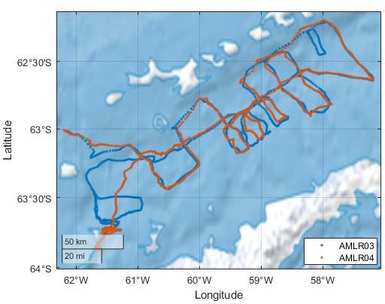
Figure 1. Map of the path of AMLR03 and AMLR04 Slocum gliders in the Bransfield Strait.

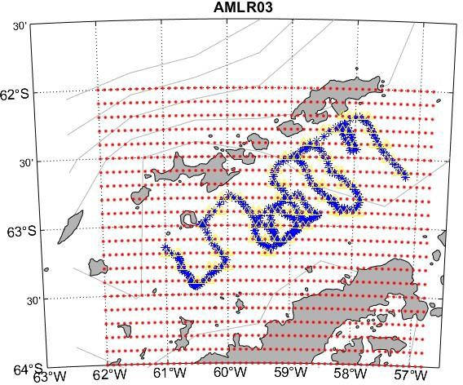

Figure 2. Spatial grid (0.1° by 0.1° grid cells) (red dots are the corners of the grid cells) with AMLR03 dive profile locations (blue *) overlayed.

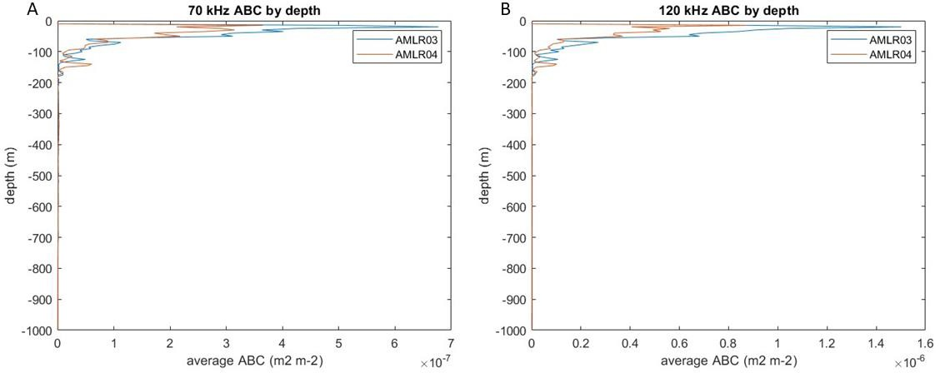

Figure 3. Depth distribution of averaged ABC for AMLR03 (blue) and AMLR04 (orange) using the 70 kHz (A) and 120 kHz (B).

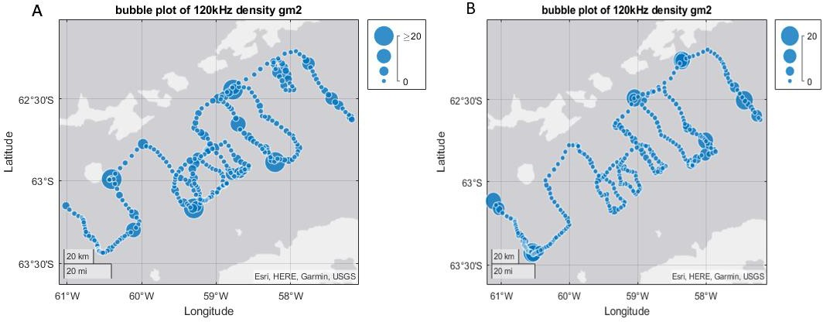

Figure 4. Maps of spatial distribution of krill densities of the 120 kHz for AMLR03 (A) and AMLR04 (B).

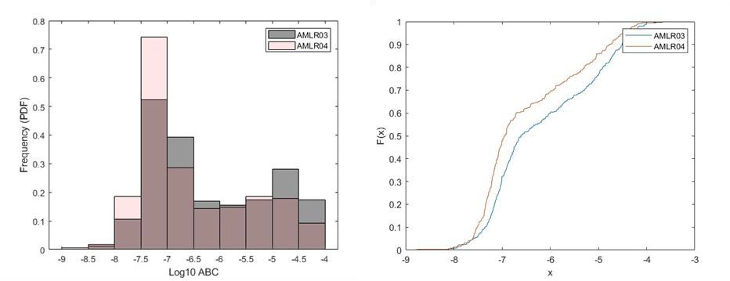
Figure 5. Empirical comparisons of acoustic estimates of biomass density from two gliders during the 2023/24 austral summer (A) Histograms of 120kHz log10 ABC for each profile; (B) Empirical cumulative distribution of biomass for both AMLR03 (blue) and AMLR04 (orange).

