OcamlLex - Lexical Analyser

Condensed representation

Intro
We will study the condensed representation of a suite of positive numbers. In principle condensing
is expressing each element of the suite by its gap to a reference value, named “base”. For instance,
the following suite:

S: 149 147 147 151 151 151 150 150 162 162 143 143

can be condensed referring to 150 as a base:

150-1 150-3 150-3 150+1 150 +1 150+1 150 150 150+12 150+12 150-7 150-7

The condensed representation states first the base then the gaps. Base is separated from gaps by $.
And when there are n consecutive occurrences of a same element in the suite, the representation is:

• for element different of the base: n times + (resp. -) followed by a white gap.
Examples:
base is 150 and “b” symbolizes white gap, then “151 151 151” becomes “+++1b”, “147 147” becomes “−−3b”…

• for element equals to the base: n times 0 followed by a white gap.
Example: base is 150 and “b” symbolizes white gap, then “150 150” becomes ”00b”

The condensed notation CS of S is thus:

CS: 150$-1b−−3b+++1b00b++12b−−7b

• Find the alphabet and the regular expression
The alphabet is:
0 1 2 3 4 5 6 7 8 9 $ + -
The regular expression is:
L=(0-9)⁺ $ [(+ -)⁺ (0-9)⁺][0⁺] b

• Find a deterministic automaton
If:
f = 0..9
Then the deterministic automaton is:
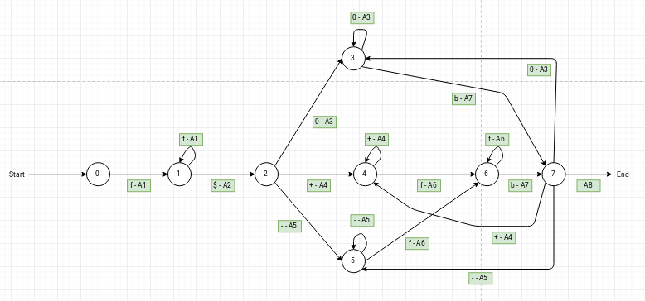

• Find the semantic actions
The semantic actions are:
A1: base = int(symbol), if base is not null then base = base*10+int(symbol)
A2: detect separator $
A3: operator = 0 and increment nb_operator
A4: operator = + and increment nb_operator
A5: operator = - and increment nb_operator
A6: shift = int(symbol), if shift is not null then shift = shift*10+int(symbol)
A7: for each integer in nb_operator, if operator = 0 print(base) else print the result of (base operator shift)
A8: exit the program

• Program the semantic actions.
See the files linked

