## B

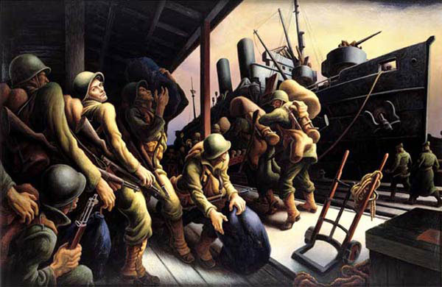

Thomas Hart Benton, "The Year of Peril, Embarkation"

## G

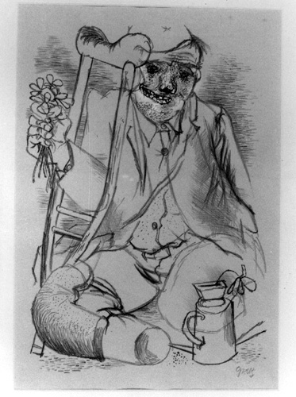

George Grosz, "The Hero", 1936

## H

### Richard Hamilton

b. 1922

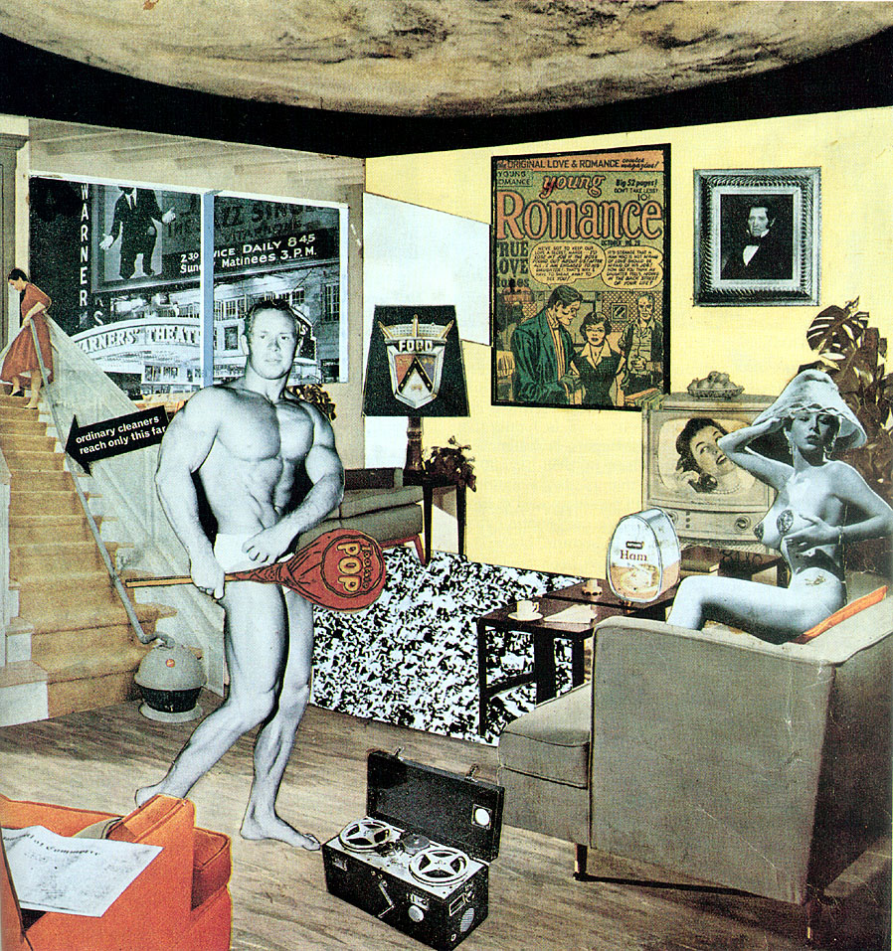

RICHARD HAMILTON, *Just What Is It That Makes Today’s Homes So Different, So Appealing?*, 1956. Collage

Just What Is It That Makes Today’s Homes So Different, So Appealing?,   
1956   
Collage  
10 1/4” x 9 3/4”  
Kunsthalle Tübingen, Tübingen, Germany