# Unit 3: Pop Art and the Return of Realism

### The New York Art World 1955 - 1965, Pop Art and Super Realism

## Unit Student Learning Objectives

### Unit 3: Pop Art and the Return of Realism (one week)

At the end of this unit, students will be able to:

1. Identify artists and describe qualities associated with Pop Art and Super Realism (Course Goals: 1,2,4,5, GE: 1,4,6,7, Core skills: A, D, E)
2. Define key terms associated with these movements and artists (Course Goals: 1,2,4 GE: 1,4,6,7, core skills: A, D, E)
3. Question the theory and philosophy behind the movement, with emphasis on Warhol and commercialism. (Course Goals: 2,3,4,5,6 GE: 1,4,6,7,9 core skills: A, B, C, E, F, G)

## Unit Student Assessments & Activities

### Introduction (ULO 3-4)

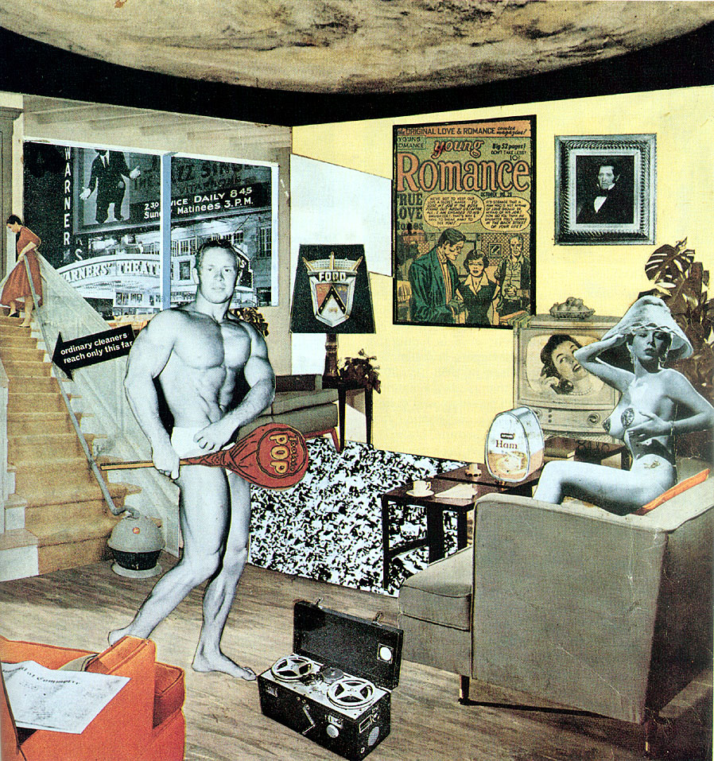

RICHARD HAMILTON, *Just What Is It That Makes Today’s Homes So Different, So Appealing?*, 1956. Collage

The beginning of Pop Art as an artistic movement is often pegged to the British artist **Richard Hamilton**’s 1956 collage *Just What Is It that Makes Today’s Home’s So Different, So Appealing?* and that's where we start our class today. We also look at our local fathers of Pop, **Jasper Johns** and **Robert Rauschenberg**. Both of these artists, whose careers began in New York in the 1950s, show us a style of work that breaks with many of the basic premises of Abstract Expressionism. Yet they also exhibit a quality of painterly expression, which shows they were paying attention to lessons learned in recent abstract painting.

So, what was it that makes these artists so different, so appealing? With a little background into the **Black Mountain College**, **happenings**, and the work of **John Cage**, a musician and composer who used chance to structure musical compositions. His piece *4'33"* is a performance where a pianist sits at a piano for four minutes and forty three seconds without playing anything. The background noise in the auditorium during that time is what he considers the music of the piece. By examining such works, pop artists began to bring ideas such as **chance** and **performance** into the visual arts.

Now that you know a little about **Greenberg** and his drive to push every artistic medium back to is own roots, you can imagine that performance opened up possibilities for artists such as Rauschenberg and Johns. Possibilities which fit outside of the formalist, non-representational work that was receiving most of the attention. Contrary to Greenberg’s wish for each medium to be isolated, we see pieces with representation and narrative, paintings which are also sculptures, sculptures which also serve as backdrops for performance.

Often a distinction arises between the critical nature of British pop art, and the American Pop Art's unapologetic embrace of consumer culture. But let’s not be too broad in this generalization, as the underlying unease we see in the Abstract Expressionists also shows up in pieces like the giant *F-111* by **James Rosenquist**, which features a young child blissfully having her hair done at a beauty salon, while a nuclear mushroom cloud erupts in the background. Or **Andy Warhol**’s pieces from the Birmingham Race riots and the car accidents from his disaster series.

### Textbook : Read Chapter 7 Neo-Dada and Pop Art (ULO 1-3).

Please read Chapter X in *Twentieth Century American Art* by Erika Doss, pages 139-159. Then test your understanding by answering the Textbook Review Questions in the next section.

### Study Guide Review Questions (self assess): (ULO 1-3)

The answer to these questions can be found in chapter 6 of *Twentieth Century American Art* by Erika Doss.

* What was Claes Oldenburg’s Store? *[Oldenburg rented out a storefront where he displayed plaster objects resembling things you might find in a regular store.]*
* Describe how chance was used in Art, and by which artists? *[The easiest answer is John Cage, who composed music that relied entirely on the incedental sounds that occurred at the time of each performance. ]*
* Describe Theater Piece No.1 at Black Mountain College? *[]*
* What were the images of that Jasper Johns painted? *[answer]*
* What were Robert Rauschenberg’s Combines? *[answer]*
* How was Pop art different from Beat and Funk art? *[answer]*

### **Readings**: (ULO 3, 4)

#### Introduction

*Warhol once* [*said about Coca-Cola*](http://www.amazon.com/exec/obidos/ASIN/0156717204/ref=nosim/0sil8)*:*

What's great about this country is that America started the tradition where the richest consumers buy essentially the same things as the poorest. You can be watching TV and see Coca-Cola, and you know that the President drinks Coke, Liz Taylor drinks Coke, and just think, you can drink Coke, too. A Coke is a Coke and no amount of money can get you a better Coke than the one the bum on the corner is drinking. All the Cokes are the same and all the Cokes are good. Liz Taylor knows it, the President knows it, the bum knows it, and you know it.

*As much as I look at the work of Andy Warhol, it always comes back to this quote for me. When you think about the* [*AbExers*](glossary.html) *quest for Individualism, and the cold-war fears of communist conformity, you have to give him credit for seeing it this way.*

*This article by William Wilson, examines another quote by Warhol that deals with a similar theme: "*I want to be a machine*". On one level, if we are all machines, it brings us close together, the way that Coke does. But it also has a sinister side to it too doesn't it? It makes us think of non-feeling entities, cold robots, many of the things that people who don't enjoy Warhol's work see in him. If you are interested, you can find the* [*full texts*](http://www.warholstars.org/andywarhol/articles/william/wilson.html) *and more information about the author at* [*this website*](http://www.warholstars.org/)*.*

#### Main Points

Before we begin, I want to outline the most important points to look for in this article:

1. The author believes **repetition without perfection** makes Warhol great
2. This brings up a interesting point that we will examine again in this course: **Failure can be more beautiful than perfecton.**
3. When Andy Warhol says "I want to be a machine" he gives us great insight into both his artistic work and his personal life. Warhol shows us an interesting example of someone who tries so hard just to fit in, and yet becomes a rock star because he has such a unique vision. If you see this in Andy Warhol, then you understand why he is still important to us as artists today.

#### "Prince of Boredom: The Repetitions and Passivities of Andy Warhol"

Preface (2004)

When an essay has been published thirty-five years ago, its meaning changes as its implicit context becomes explicit. My essay about Andy Warhol was printed in March, 1968, when much less was known about Andy - he was not over-shadowed by his images and other people’s ideas about him. The dreadful title imposed by an editor, *The Prince of Boredom*, echoed a desperate journalistic notion, and for me misrepresented my themes...

**by William S. Wilson, 1968**

The paintings of Andy Warhol present repeated or magnified images: flower-flower-flower; car-crash-car-crash, car-crash; FLOWER-FLOWER-Flower. The images are applied through a [silk-screen](glossary.html), and can be repeated with a number of variations. The silk-screens are made from photographs taken by someone else, and the screening is often done by someone else in Warhol's factory, so that the artist's part can be isolated as the choice of images and the decision to repeat the image and perhaps to magnify it.

Silk-screening makes repetition part of the meaning of the image. Even one silk-screened print is felt as a repetition, and Warhol repeats these images until repetition is magnified into a theme of variance and invariance, and of the success and failures of identicalness. The silk-screening is a technique allowing precise delineations, but it is used sloppily by Warhol, allowing sentiment and lack of sentiment, care and carelessness, to jostle together.

Since the medium could easily be used with more precision, and is not, the purpose must be to call attention to the fact of repetition by not repeating precisely. So Warhol succeeds at failing to repeat, and this failure suggests that successful repetition is to be pitied, while the failure to repeat is to be feared.

...

In some paintings the images are not repeated by addition but by multiplication: that is, the image is magnified (not 100 cans of soup, but one can magnified 100 times). This magnification of an image out of all proportion to the rest of experience, rendering it unmanageable and a trifle overbearing, is a variation on a theme of passivity, even as multiplication is a variation of addition.

Warhol's movies thrive on passivity, magnification, and repetition. Sleep shows a man sleeping for six hours, and repeats one reel in an endless loop, which removes the variety of actual sleep. Blow Job shows only the man being acted upon, the one who enjoys or suffers the action - the patient, as it were, not the agent. Eat presents a painter chewing, chewing, chewing, and the camera passively records the non-action. Sleep, sex, and nutrition are parts of life that make repeated demands on a person, and that demand repetition in their satisfaction...

Warhol has announced his ambition to be a machine: "The reason I'm painting this way is because I want to be a machine. Whatever I do, and do machine-like, is because it is what I want to do." Since a machine is capable of endless and perfect repetitions (see [Masters and Johnson, Human Sexual Response](http://en.wikipedia.org/wiki/Human_sexual_response_cycle), for descriptions of machines no one could hope to emulate), and since Warhol is not, we can say that he can only succeed in failing to fulfil this ambition, succeed in showing that when repetition is an ideal, it is unattainable. But this failed machine is destined to succeed as a flower, as Dennis Hopper's photograph on the cover of December 1964 Art Forum suggests. The early paint-by-number flower paintings, and the silk-screened flowers from a magazine photograph, present flowers as an object of thought or feeling by means of flower-like methods of thought: passivity, repetition. This identity of method and object gives the flower paintings their special authority: petal repeats petal, blossom repeats blossom, picture repeats picture. ...

These works of Andy Warhol seem to omit happiness or joy, even pleasure, as out of the question, perhaps because such emotions do not lend themselves to repetition, and do not follow from passivity. But the melancholy in these works is offset by the daylight to be found in the perfect expression of a feeling: there's a joy in seeing sadness perfectly portrayed. When Warhol shows repetition as an ideal of mindlessness, like an ideal it recedes from the grasp of man, who is condemned to variety, novelty and precarious margins. But even as Warhol shows that repetition cannot be achieved, he shows that it cannot be avoided. He shows repetition as a glory, as a jest, and as a riddle, and he shows the sufferance in suffering. No wonder that in the Exploding Plastic Inevitable, that epiphenomenon, he has Nico sing, ["Let me be your mirror! Let me be your mirror! Let me be your mirror!"](http://www.youtube.com/watch?v=an9DoVBHHr8)

William S. Wilson 1968

### Presentation: Artist Slideshows (ULO 1-4)

* Beginnings of Pop:
  + Hamilton
  + Cage
* A blending of media
  + Johns
  + Rauschenberg
  + Claes Oldenburg
* Pop and commercialism
  + Roy Lichtenstein
  + James Rosenquist
  + Andy Warhol
* Super realism
  + Chuck Close
  + Duane Hanson

### Interactive activities: artwork identification, and terminology (multiple chances, self assess)(ULO 1, 2)

* Identify artwork images from the slideshows
* Identify names of Pop Artists
  + Jasper Johns
  + Richard Hamilton
  + Roy Lichtenstein
  + Claes Oldenburg
  + Robert Rauschenberg
  + James Rosenquist
  + Andy Warhol
* Identify names of Super Realists
  + Chuck Close
  + Duane Hanson
* What was Black Mountain College and what were happenings?
* How did performance art influence the work of artists such as Robert Rauschenberg and Claes Oldenburg?*[By experimenting with performance as an artistic medium, artists in the 1960's started adding many artistic elements into their work. Painting, performance, sculpture all became mixed together to make one piece.]*
* How do Pop artists continue Abstract Expressionism’s use of scale?*[Artists like James Rosenquist continued to make huge paintings, sometimes so big they had to wrap around the room.]*
* What is encaustic, and who used it? *[Oil paint mixed into wax, Jasper Johns]*
* Why is printmaking important to pop art?*[Printmaking made it possible for Pop artists to copy directly the images and methods of commercial art.]*
* How does Warhol play with the "idea" or "role" of the artist in society? *[One possible anwer: Unlike Abstract Expressionsits, who were all about the Individual, and the "signature mark" of the artists, Warhol pushed in the other direction, describing himself as "a machine" or "like everybody else".]*

#### Multiple Choice

* Pop art can be seen as a reaction against:
  1. Consumer Culture
  2. Minimalism
  3. **Abstract Expressionism**
  4. Figurative Painting

1. Which of the following is not a reason Jasper Johns gives for painting targets, maps and numbers?
   1. They are pre-formed, conventional, depersonalized elements.
   2. They suggest the world rather than suggesting personality.
   3. **They are political symbols which adds an additional layer of meaning.**
   4. One thinks of them as having a certain quality, and then in time these qualities change.
2. John Cage made the piece 4’33”, where the pianist played nothing in front of an audience for four minutes and thirty three seconds. This piece demonstrated:
   1. that in minimalism artists were trying to come up with ways to make art with almost nothing.
   2. **the artworks can be created by chance, in this case the chance noises that occurred in the concert hall during the performance of the piece.**
   3. that even Robert Rauschenberg could make music if he felt like it.
   4. that short amounts of time actually feel very long when there is nothing to distract us.
3. Robert Rauschenberg called his early works “combines” because:
   1. it was a combination of the work of Jackson Pollock and Jasper Johns.
   2. **he made artwork by combining several things together: animals, paint, pillows, magazine images, and so on.**
   3. he saw them as combining his love of performance, sculpture and painting together.
   4. they combined images of real life with abstract painting.
4. Which of the following did Andy Warhol not say:
   1. “But when you see a gruesome picture over and over again, it doesn’t really have any effect.”
   2. “I like boring things. I like things to be exactly the same over and over again.”
   3. “I reason why I’m painting this way is that I want to be a machine.”
   4. **“The present painter is concerned not with his own feelings or with the mystery of his own personality but with the penetration into the world mystery.”**
5. Which is an example of a Pop artists continuing Abstract Expressionism’s use of scale?
   1. **James Rosenquist's painting *F-111* is so big it wrapped around the room.**
   2. John Cage was a musician who used chance as a scale.
   3. Objects hung off of and out of Rauschenberg's combines.
   4. The colors in Lichtenstein's paintings were reminiscent of Abstract Expressionist color.

### Discussion Board relating to slideshows and readings (ULO 1-4)

### Additional Artists to Study (ULO 1)

*You will not be tested on the following material, but if you are interested in studying further anything we discussed this week, these artists could also fit into this category*

* David Hockney
* Alex Katz
* Wayne Thiebaud
* Tom Wesselmann

### Optional links for further self-study (ULO 1-4)

*You will not be tested on the following material, but if you are interested in studying further anything we discussed this week, these links are a good place to start:*

* MOMA's 1997 show of [Jasper Johns](http://www.moma.org/interactives/exhibitions/1996/johns/index.html)
* A close look at Jasper John's [*Perilous Night*](http://www.nga.gov/feature/artnation/johns/index.shtm)
* [Claes Oldenburg website](http://oldenburgvanbruggen.com/)
* Claes Oldenburg [interview](http://www.askyfilledwithshootingstars.com/wordpress/?p=1371)
* [David Hockney Website](http://www.hockneypictures.com/)
* Alex Katz [interview](http://www.artinfo.com/news/story/9528/alex-katz/)
* Andy Warhol - [The Elvis Works](http://www.elvisinfonet.com/spotlight_warhol_ang.html)