Crash Report

# Report is generated on 20 December 2020

## Yesterday (19 December 2020):

* Number of accidents: 226
* Number of people injured: 94
* Number of people killed: 0

### Streets with the highest number of accidents

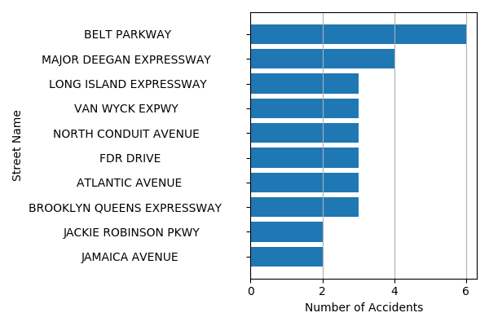

## Last Week (13 December 2020 - 19 December 2020):

* Number of accidents: 1667
* Number of people injured: 733
* Number of people killed: 6

### Streets with the highest number of accidents

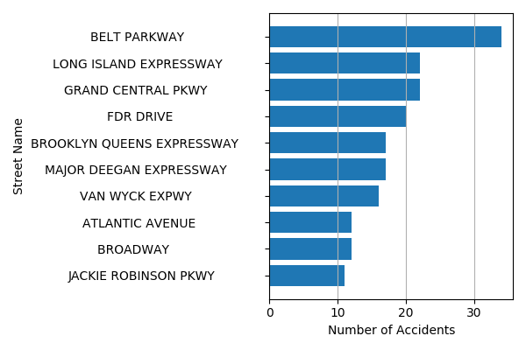

## Last Month (20 November 2020 - 19 December 2020):

* Number of accidents: 7478
* Number of people injured: 3293
* Number of people killed: 22

### Streets with the highest number of accidents

