Crash Report

# Report is generated on 17 December 2020

## Yesterday (16 December 2020):

* Number of accidents: 201
* Number of people injured: 78
* Number of people killed: 3

### Streets with the highest number of accidents

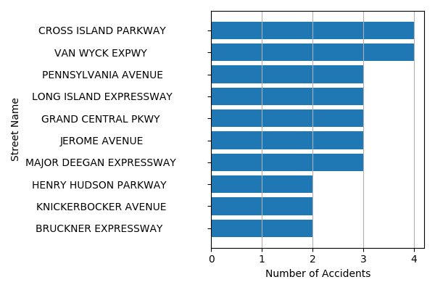

## Last Week (10 December 2020 - 16 December 2020):

* Number of accidents: 1657
* Number of people injured: 723
* Number of people killed: 5

### Streets with the highest number of accidents

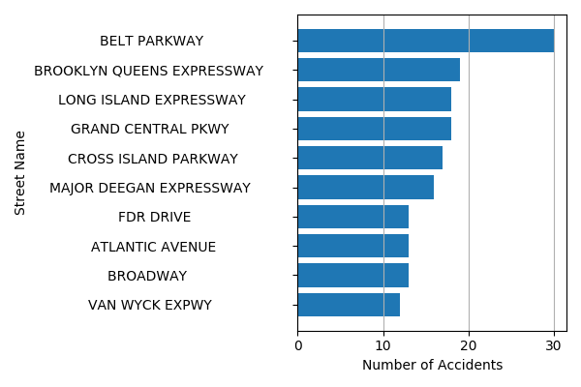

## Last Month (17 November 2020 - 16 December 2020):

* Number of accidents: 7593
* Number of people injured: 3294
* Number of people killed: 24

### Streets with the highest number of accidents

