Crash Report

# Report is generated on 20 December 2020

## Yesterday (19 December 2020):

* Number of accidents: 226
* Number of people injured: 94
* Number of people killed: 0

### Streets with the highest number of accidents

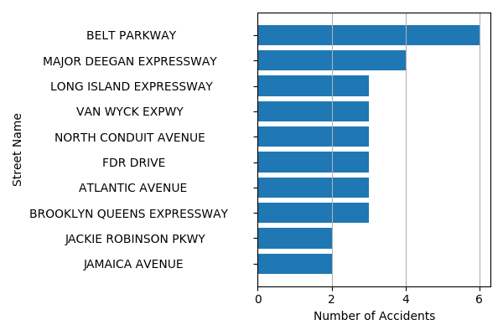

## Last Week (13 December 2020 - 19 December 2020):

* Number of accidents: 1667
* Number of people injured: 733
* Number of people killed: 6

### Streets with the highest number of accidents

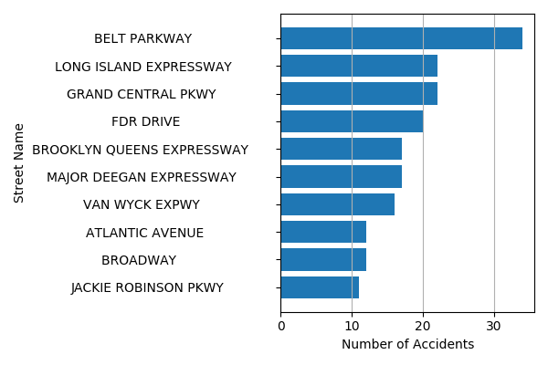

## Last Month (20 November 2020 - 19 December 2020):

* Number of accidents: 7478
* Number of people injured: 3293
* Number of people killed: 22

### Streets with the highest number of accidents

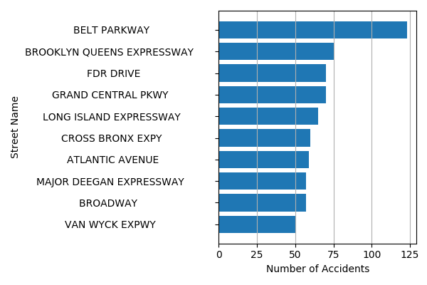

## List of streets where accidents are more likely to occur tomorrow:

1. JACKIE ROBINSON PKWY
2. FOSTER AVENUE
3. WOODHAVEN BOULEVARD
4. OCEAN AVENUE
5. UNIVERSITY AVENUE
6. 4 AVENUE
7. LEFFERTS BOULEVARD
8. HUTCHINSON RIVER PARKWAY
9. 3 AVENUE
10. 2 AVENUE