Crash Report

# Report is generated on 21 December 2020

## Yesterday (20 December 2020):

* Number of accidents: 194
* Number of people injured: 91
* Number of people killed: 0

### Streets with the highest number of accidents

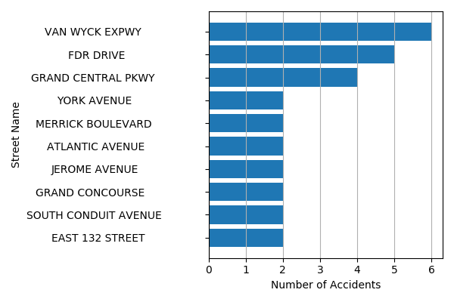

## Last Week (14 December 2020 - 20 December 2020):

* Number of accidents: 1697
* Number of people injured: 772
* Number of people killed: 6

### Streets with the highest number of accidents

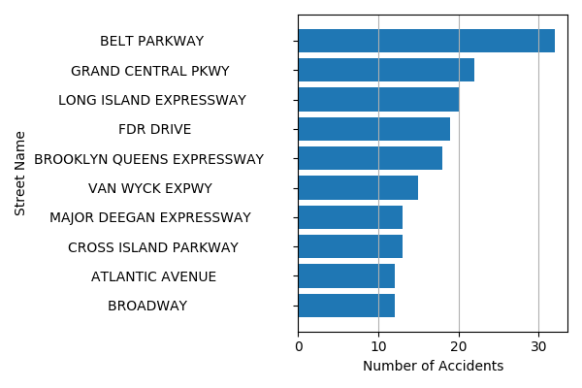

## Last Month (21 November 2020 - 20 December 2020):

* Number of accidents: 7490
* Number of people injured: 3291
* Number of people killed: 22

### Streets with the highest number of accidents

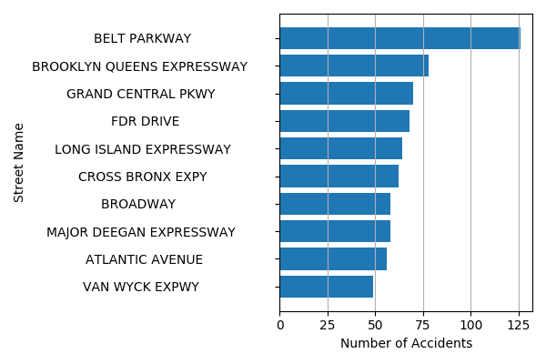

## List of streets where accidents are more likely to occur tomorrow:

1. 78 AVENUE
2. WEST 75 STREET
3. VALENTINE AVENUE
4. BRADFORD STREET
5. WEST 170 STREET
6. NARROWS ROAD NORTH
7. 3 AVENUE
8. CROSS ISLAND PARKWAY
9. EAST 204 STREET
10. BROOKLYN QUEENS EXPRESSWAY