Crash Report

# Report is generated on 17 December 2020

## Yesterday (16 December 2020):

* Number of accidents: 201
* Number of people injured: 78
* Number of people killed: 3

### Streets with the highest number of accidents

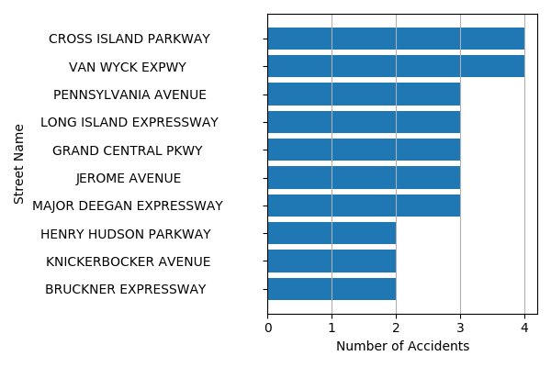

## Last Week (10 December 2020 - 16 December 2020):

* Number of accidents: 1657
* Number of people injured: 723
* Number of people killed: 5

### Streets with the highest number of accidents

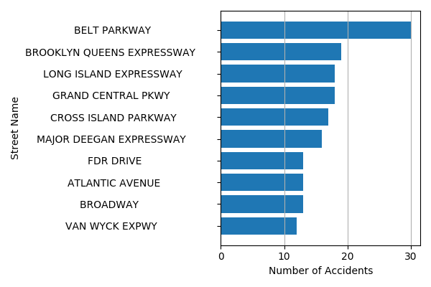

## Last Month (17 November 2020 - 16 December 2020):

* Number of accidents: 7593
* Number of people injured: 3294
* Number of people killed: 24

### Streets with the highest number of accidents

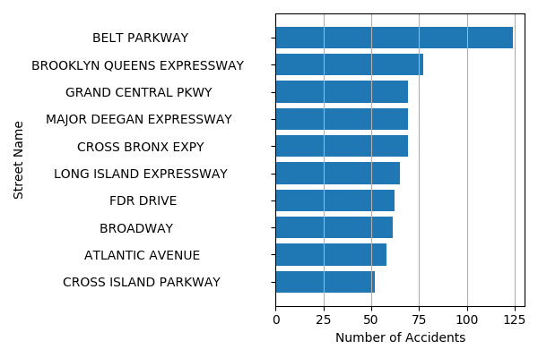

## List of streets where accidents are more likely to occur tomorrow:

1. WEST FORDHAM ROAD
2. EAST 160 STREET
3. BELT PARKWAY
4. FARMERS BOULEVARD
5. 85 STREET
6. VAN WYCK EXPWY
7. PARK AVENUE
8. EAST TREMONT AVENUE
9. PROSPECT AVENUE
10. EAST 55 STREET