Codebook for tidy_df

Autogenerated data summary from dataMaid

2019-11-15 14:10:41

# Data report overview

The dataset examined has the following dimensions:

|  |  |
| --- | --- |
| Feature | Result |
| Number of observations | 10299 |
| Number of variables | 91 |

# Codebook summary table

|  |  |  |  |  |  |
| --- | --- | --- | --- | --- | --- |
| Label | Variable | Class | # unique values | Missing | Description |
|  | **obs_id** | integer | 10299 | 0.00 % |  |
|  | **subject_id** | integer | 30 | 0.00 % |  |
|  | **activity_id** | integer | 6 | 0.00 % |  |
|  | **activity_name** | factor | 6 | 0.00 % |  |
|  | **exp_class** | numeric | 2 | 0.00 % |  |
|  | **time_body_acceler_mean_x** | numeric | 10292 | 0.00 % |  |
|  | **time_body_acceler_mean_y** | numeric | 10299 | 0.00 % |  |
|  | **time_body_acceler_mean_z** | numeric | 10293 | 0.00 % |  |
|  | **time_gravity_acceler_mean_x** | numeric | 10296 | 0.00 % |  |
|  | **time_gravity_acceler_mean_y** | numeric | 10298 | 0.00 % |  |
|  | **time_gravity_acceler_mean_z** | numeric | 10299 | 0.00 % |  |
|  | **time_body_acceler_jerk_mean_x** | numeric | 10299 | 0.00 % |  |
|  | **time_body_acceler_jerk_mean_y** | numeric | 10299 | 0.00 % |  |
|  | **time_body_acceler_jerk_mean_z** | numeric | 10299 | 0.00 % |  |
|  | **time_bodygyro_mean_x** | numeric | 10298 | 0.00 % |  |
|  | **time_bodygyro_mean_y** | numeric | 10299 | 0.00 % |  |
|  | **time_bodygyro_mean_z** | numeric | 10297 | 0.00 % |  |
|  | **time_bodygyrojerk_mean_x** | numeric | 10295 | 0.00 % |  |
|  | **time_bodygyrojerk_mean_y** | numeric | 10299 | 0.00 % |  |
|  | **time_bodygyrojerk_mean_z** | numeric | 10298 | 0.00 % |  |
|  | **time_body_acceler_magnitude_mean** | numeric | 10296 | 0.00 % |  |
|  | **time_gravity_acceler_magnitude_mean** | numeric | 10296 | 0.00 % |  |
|  | **time_body_acceler_jerk_magnitude_mean** | numeric | 10292 | 0.00 % |  |
|  | **time_bodygyro_magnitude_mean** | numeric | 10298 | 0.00 % |  |
|  | **time_bodygyrojerk_magnitude_mean** | numeric | 10293 | 0.00 % |  |
|  | **freq_body_acceler_mean_x** | numeric | 10295 | 0.00 % |  |
|  | **freq_body_acceler_mean_y** | numeric | 10292 | 0.00 % |  |
|  | **freq_body_acceler_mean_z** | numeric | 10295 | 0.00 % |  |
|  | **freq_body_acceler_meanfreq_x** | numeric | 10299 | 0.00 % |  |
|  | **freq_body_acceler_meanfreq_y** | numeric | 10299 | 0.00 % |  |
|  | **freq_body_acceler_meanfreq_z** | numeric | 10299 | 0.00 % |  |
|  | **freq_body_acceler_jerk_mean_x** | numeric | 10293 | 0.00 % |  |
|  | **freq_body_acceler_jerk_mean_y** | numeric | 10296 | 0.00 % |  |
|  | **freq_body_acceler_jerk_mean_z** | numeric | 10294 | 0.00 % |  |
|  | **freq_body_acceler_jerk_meanfreq_x** | numeric | 10298 | 0.00 % |  |
|  | **freq_body_acceler_jerk_meanfreq_y** | numeric | 10299 | 0.00 % |  |
|  | **freq_body_acceler_jerk_meanfreq_z** | numeric | 10298 | 0.00 % |  |
|  | **freq_bodygyro_mean_x** | numeric | 10297 | 0.00 % |  |
|  | **freq_bodygyro_mean_y** | numeric | 10296 | 0.00 % |  |
|  | **freq_bodygyro_mean_z** | numeric | 10297 | 0.00 % |  |
|  | **freq_bodygyro_meanfreq_x** | numeric | 10298 | 0.00 % |  |
|  | **freq_bodygyro_meanfreq_y** | numeric | 10299 | 0.00 % |  |
|  | **freq_bodygyro_meanfreq_z** | numeric | 10299 | 0.00 % |  |
|  | **freq_body_acceler_magnitude_mean** | numeric | 10296 | 0.00 % |  |
|  | **freq_body_acceler_magnitude_meanfreq** | numeric | 10299 | 0.00 % |  |
|  | **freq_body_acceler_jerk_magnitude_mean** | numeric | 10290 | 0.00 % |  |
|  | **freq_body_acceler_jerk_magnitude_meanfreq** | numeric | 10299 | 0.00 % |  |
|  | **freq_bodygyro_magnitude_mean** | numeric | 10297 | 0.00 % |  |
|  | **freq_bodygyro_magnitude_meanfreq** | numeric | 10299 | 0.00 % |  |
|  | **freq_bodygyrojerk_magnitude_mean** | numeric | 10293 | 0.00 % |  |
|  | **freq_bodygyrojerk_magnitude_meanfreq** | numeric | 10299 | 0.00 % |  |
|  | **angle_time_body_acceler_mean_gravity** | numeric | 10299 | 0.00 % |  |
|  | **angle_time_body_acceler_jerkmean_gravitymean** | numeric | 10299 | 0.00 % |  |
|  | **angle_time_bodygyromean_gravitymean** | numeric | 10299 | 0.00 % |  |
|  | **angle_time_bodygyrojerkmean_gravitymean** | numeric | 10299 | 0.00 % |  |
|  | **angle_x_gravitymean** | numeric | 10299 | 0.00 % |  |
|  | **angle_y_gravitymean** | numeric | 10299 | 0.00 % |  |
|  | **angle_z_gravitymean** | numeric | 10299 | 0.00 % |  |
|  | **time_body_acceler_st_dev_x** | numeric | 10295 | 0.00 % |  |
|  | **time_body_acceler_st_dev_y** | numeric | 10297 | 0.00 % |  |
|  | **time_body_acceler_st_dev_z** | numeric | 10297 | 0.00 % |  |
|  | **time_gravity_acceler_st_dev_x** | numeric | 10288 | 0.00 % |  |
|  | **time_gravity_acceler_st_dev_y** | numeric | 10293 | 0.00 % |  |
|  | **time_gravity_acceler_st_dev_z** | numeric | 10296 | 0.00 % |  |
|  | **time_body_acceler_jerk_st_dev_x** | numeric | 10290 | 0.00 % |  |
|  | **time_body_acceler_jerk_st_dev_y** | numeric | 10296 | 0.00 % |  |
|  | **time_body_acceler_jerk_st_dev_z** | numeric | 10293 | 0.00 % |  |
|  | **time_bodygyro_st_dev_x** | numeric | 10292 | 0.00 % |  |
|  | **time_bodygyro_st_dev_y** | numeric | 10296 | 0.00 % |  |
|  | **time_bodygyro_st_dev_z** | numeric | 10296 | 0.00 % |  |
|  | **time_bodygyrojerk_st_dev_x** | numeric | 10292 | 0.00 % |  |
|  | **time_bodygyrojerk_st_dev_y** | numeric | 10295 | 0.00 % |  |
|  | **time_bodygyrojerk_st_dev_z** | numeric | 10291 | 0.00 % |  |
|  | **time_body_acceler_magnitude_st_dev** | numeric | 10294 | 0.00 % |  |
|  | **time_gravity_acceler_magnitude_st_dev** | numeric | 10294 | 0.00 % |  |
|  | **time_body_acceler_jerk_magnitude_st_dev** | numeric | 10294 | 0.00 % |  |
|  | **time_bodygyro_magnitude_st_dev** | numeric | 10298 | 0.00 % |  |
|  | **time_bodygyrojerk_magnitude_st_dev** | numeric | 10297 | 0.00 % |  |
|  | **freq_body_acceler_st_dev_x** | numeric | 10294 | 0.00 % |  |
|  | **freq_body_acceler_st_dev_y** | numeric | 10297 | 0.00 % |  |
|  | **freq_body_acceler_st_dev_z** | numeric | 10296 | 0.00 % |  |
|  | **freq_body_acceler_jerk_st_dev_x** | numeric | 10291 | 0.00 % |  |
|  | **freq_body_acceler_jerk_st_dev_y** | numeric | 10294 | 0.00 % |  |
|  | **freq_body_acceler_jerk_st_dev_z** | numeric | 10290 | 0.00 % |  |
|  | **freq_bodygyro_st_dev_x** | numeric | 10297 | 0.00 % |  |
|  | **freq_bodygyro_st_dev_y** | numeric | 10293 | 0.00 % |  |
|  | **freq_bodygyro_st_dev_z** | numeric | 10295 | 0.00 % |  |
|  | **freq_body_acceler_magnitude_st_dev** | numeric | 10298 | 0.00 % |  |
|  | **freq_body_acceler_jerk_magnitude_st_dev** | numeric | 10296 | 0.00 % |  |
|  | **freq_bodygyro_magnitude_st_dev** | numeric | 10296 | 0.00 % |  |
|  | **freq_bodygyrojerk_magnitude_st_dev** | numeric | 10292 | 0.00 % |  |

# Variable list

## obs_id

|  |  |
| --- | --- |
| Feature | Result |
| Variable type | integer |
| Number of missing obs. | 0 (0 %) |
| Number of unique values | 10299 |
| Median | 5150 |
| 1st and 3rd quartiles | 2575.5; 7724.5 |
| Min. and max. | 1; 10299 |

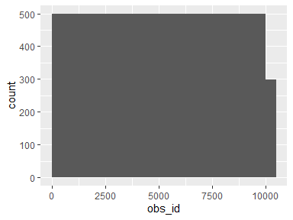

## subject_id

|  |  |
| --- | --- |
| Feature | Result |
| Variable type | integer |
| Number of missing obs. | 0 (0 %) |
| Number of unique values | 30 |
| Median | 17 |
| 1st and 3rd quartiles | 9; 24 |
| Min. and max. | 1; 30 |

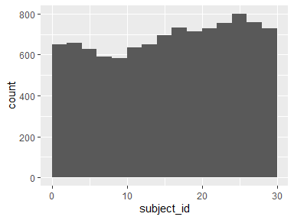

## activity_id

|  |  |
| --- | --- |
| Feature | Result |
| Variable type | integer |
| Number of missing obs. | 0 (0 %) |
| Number of unique values | 6 |
| Median | 4 |
| 1st and 3rd quartiles | 2; 5 |
| Min. and max. | 1; 6 |

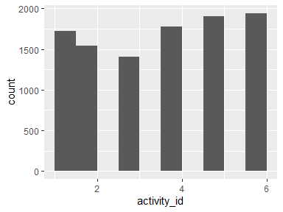

## activity_name

|  |  |
| --- | --- |
| Feature | Result |
| Variable type | factor |
| Number of missing obs. | 0 (0 %) |
| Number of unique values | 6 |
| Mode | “LAYING” |
| Reference category | LAYING |

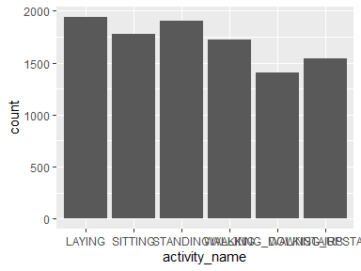

* Observed factor levels: "LAYING", "SITTING", "STANDING", "WALKING", "WALKING_DOWNSTAIRS", "WALKING_UPSTAIRS".

## exp_class

|  |  |
| --- | --- |
| Feature | Result |
| Variable type | numeric |
| Number of missing obs. | 0 (0 %) |
| Number of unique values | 2 |
| Median | 1 |
| 1st and 3rd quartiles | 1; 2 |
| Min. and max. | 1; 2 |

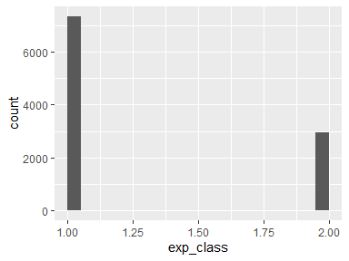

## time_body_acceler_mean_x

|  |  |
| --- | --- |
| Feature | Result |
| Variable type | numeric |
| Number of missing obs. | 0 (0 %) |
| Number of unique values | 10292 |
| Median | 0.28 |
| 1st and 3rd quartiles | 0.26; 0.29 |
| Min. and max. | -1; 1 |

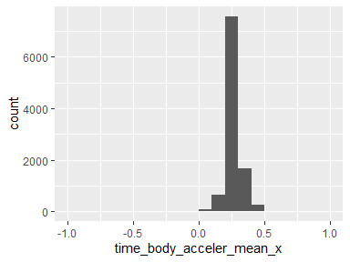

## time_body_acceler_mean_y

|  |  |
| --- | --- |
| Feature | Result |
| Variable type | numeric |
| Number of missing obs. | 0 (0 %) |
| Number of unique values | 10299 |
| Median | -0.02 |
| 1st and 3rd quartiles | -0.02; -0.01 |
| Min. and max. | -1; 1 |

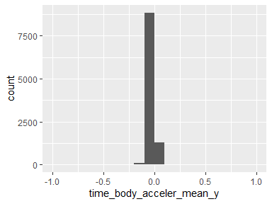

## time_body_acceler_mean_z

|  |  |
| --- | --- |
| Feature | Result |
| Variable type | numeric |
| Number of missing obs. | 0 (0 %) |
| Number of unique values | 10293 |
| Median | -0.11 |
| 1st and 3rd quartiles | -0.12; -0.1 |
| Min. and max. | -1; 1 |

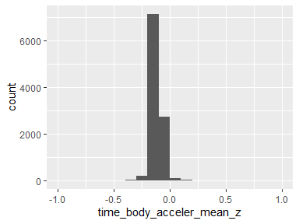

## time_gravity_acceler_mean_x

|  |  |
| --- | --- |
| Feature | Result |
| Variable type | numeric |
| Number of missing obs. | 0 (0 %) |
| Number of unique values | 10296 |
| Median | 0.92 |
| 1st and 3rd quartiles | 0.81; 0.95 |
| Min. and max. | -1; 1 |

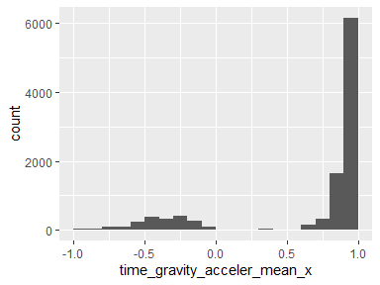

## time_gravity_acceler_mean_y

|  |  |
| --- | --- |
| Feature | Result |
| Variable type | numeric |
| Number of missing obs. | 0 (0 %) |
| Number of unique values | 10298 |
| Median | -0.14 |
| 1st and 3rd quartiles | -0.24; 0.12 |
| Min. and max. | -1; 1 |

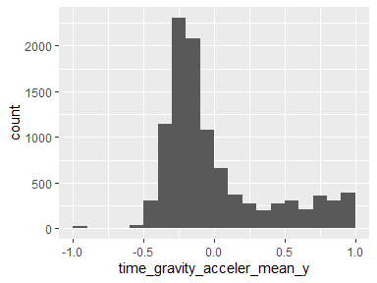

## time_gravity_acceler_mean_z

|  |  |
| --- | --- |
| Feature | Result |
| Variable type | numeric |
| Number of missing obs. | 0 (0 %) |
| Number of unique values | 10299 |
| Median | 0.04 |
| 1st and 3rd quartiles | -0.12; 0.22 |
| Min. and max. | -1; 1 |

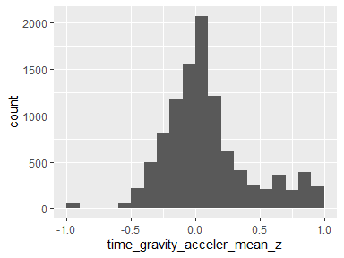

## time_body_acceler_jerk_mean_x

|  |  |
| --- | --- |
| Feature | Result |
| Variable type | numeric |
| Number of missing obs. | 0 (0 %) |
| Number of unique values | 10299 |
| Median | 0.08 |
| 1st and 3rd quartiles | 0.06; 0.09 |
| Min. and max. | -1; 1 |

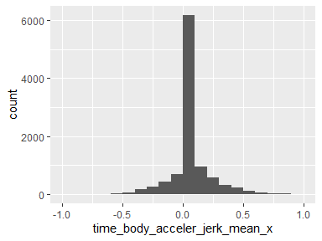

## time_body_acceler_jerk_mean_y

|  |  |
| --- | --- |
| Feature | Result |
| Variable type | numeric |
| Number of missing obs. | 0 (0 %) |
| Number of unique values | 10299 |
| Median | 0.01 |
| 1st and 3rd quartiles | -0.02; 0.03 |
| Min. and max. | -1; 1 |

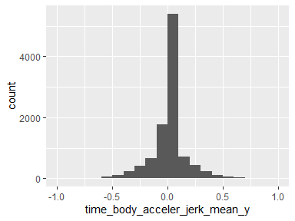

## time_body_acceler_jerk_mean_z

|  |  |
| --- | --- |
| Feature | Result |
| Variable type | numeric |
| Number of missing obs. | 0 (0 %) |
| Number of unique values | 10299 |
| Median | 0 |
| 1st and 3rd quartiles | -0.03; 0.02 |
| Min. and max. | -1; 1 |

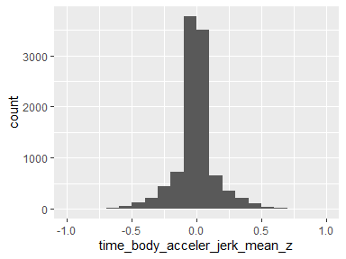

## time_bodygyro_mean_x

|  |  |
| --- | --- |
| Feature | Result |
| Variable type | numeric |
| Number of missing obs. | 0 (0 %) |
| Number of unique values | 10298 |
| Median | -0.03 |
| 1st and 3rd quartiles | -0.05; -0.01 |
| Min. and max. | -1; 1 |

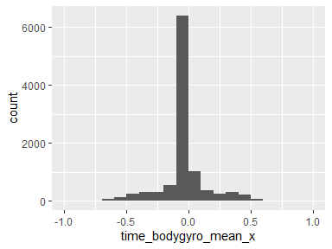

## time_bodygyro_mean_y

|  |  |
| --- | --- |
| Feature | Result |
| Variable type | numeric |
| Number of missing obs. | 0 (0 %) |
| Number of unique values | 10299 |
| Median | -0.07 |
| 1st and 3rd quartiles | -0.1; -0.05 |
| Min. and max. | -1; 1 |

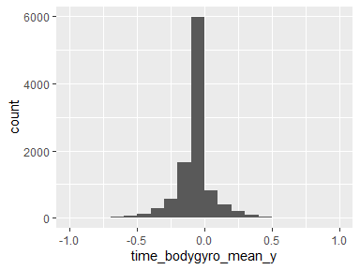

## time_bodygyro_mean_z

|  |  |
| --- | --- |
| Feature | Result |
| Variable type | numeric |
| Number of missing obs. | 0 (0 %) |
| Number of unique values | 10297 |
| Median | 0.09 |
| 1st and 3rd quartiles | 0.06; 0.11 |
| Min. and max. | -1; 1 |

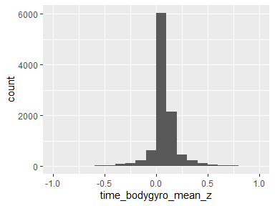

## time_bodygyrojerk_mean_x

|  |  |
| --- | --- |
| Feature | Result |
| Variable type | numeric |
| Number of missing obs. | 0 (0 %) |
| Number of unique values | 10295 |
| Median | -0.1 |
| 1st and 3rd quartiles | -0.12; -0.08 |
| Min. and max. | -1; 1 |

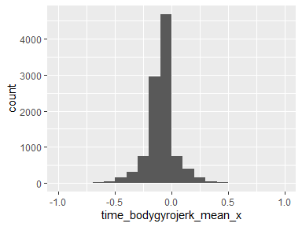

## time_bodygyrojerk_mean_y

|  |  |
| --- | --- |
| Feature | Result |
| Variable type | numeric |
| Number of missing obs. | 0 (0 %) |
| Number of unique values | 10299 |
| Median | -0.04 |
| 1st and 3rd quartiles | -0.06; -0.03 |
| Min. and max. | -1; 1 |

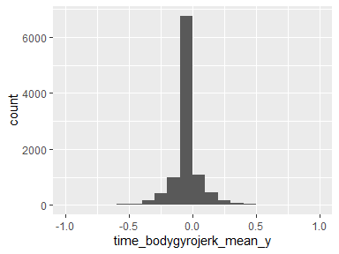

## time_bodygyrojerk_mean_z

|  |  |
| --- | --- |
| Feature | Result |
| Variable type | numeric |
| Number of missing obs. | 0 (0 %) |
| Number of unique values | 10298 |
| Median | -0.05 |
| 1st and 3rd quartiles | -0.08; -0.03 |
| Min. and max. | -1; 1 |

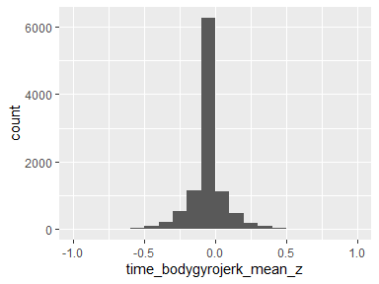

## time_body_acceler_magnitude_mean

|  |  |
| --- | --- |
| Feature | Result |
| Variable type | numeric |
| Number of missing obs. | 0 (0 %) |
| Number of unique values | 10296 |
| Median | -0.87 |
| 1st and 3rd quartiles | -0.98; -0.12 |
| Min. and max. | -1; 1 |

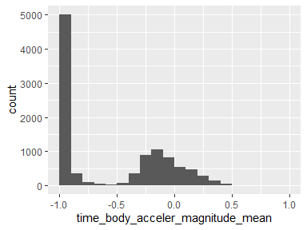

## time_gravity_acceler_magnitude_mean

|  |  |
| --- | --- |
| Feature | Result |
| Variable type | numeric |
| Number of missing obs. | 0 (0 %) |
| Number of unique values | 10296 |
| Median | -0.87 |
| 1st and 3rd quartiles | -0.98; -0.12 |
| Min. and max. | -1; 1 |

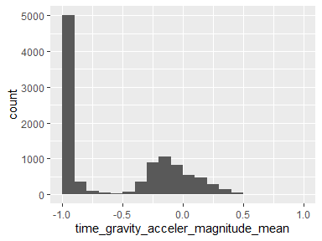

## time_body_acceler_jerk_magnitude_mean

|  |  |
| --- | --- |
| Feature | Result |
| Variable type | numeric |
| Number of missing obs. | 0 (0 %) |
| Number of unique values | 10292 |
| Median | -0.95 |
| 1st and 3rd quartiles | -0.99; -0.3 |
| Min. and max. | -1; 1 |

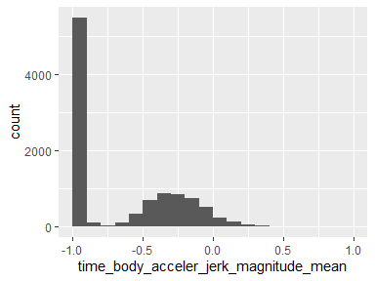

## time_bodygyro_magnitude_mean

|  |  |
| --- | --- |
| Feature | Result |
| Variable type | numeric |
| Number of missing obs. | 0 (0 %) |
| Number of unique values | 10298 |
| Median | -0.82 |
| 1st and 3rd quartiles | -0.98; -0.25 |
| Min. and max. | -1; 1 |

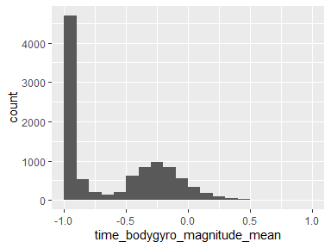

## time_bodygyrojerk_magnitude_mean

|  |  |
| --- | --- |
| Feature | Result |
| Variable type | numeric |
| Number of missing obs. | 0 (0 %) |
| Number of unique values | 10293 |
| Median | -0.96 |
| 1st and 3rd quartiles | -0.99; -0.55 |
| Min. and max. | -1; 1 |

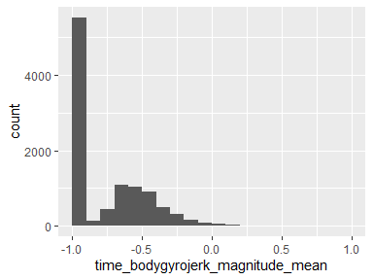

## freq_body_acceler_mean_x

|  |  |
| --- | --- |
| Feature | Result |
| Variable type | numeric |
| Number of missing obs. | 0 (0 %) |
| Number of unique values | 10295 |
| Median | -0.95 |
| 1st and 3rd quartiles | -0.99; -0.26 |
| Min. and max. | -1; 1 |

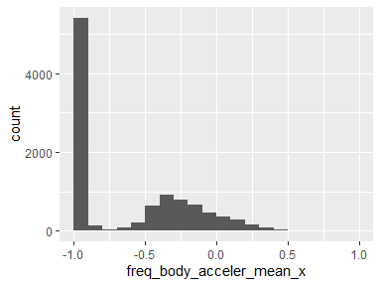

## freq_body_acceler_mean_y

|  |  |
| --- | --- |
| Feature | Result |
| Variable type | numeric |
| Number of missing obs. | 0 (0 %) |
| Number of unique values | 10292 |
| Median | -0.86 |
| 1st and 3rd quartiles | -0.98; -0.1 |
| Min. and max. | -1; 1 |

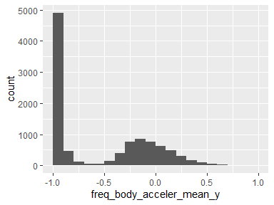

## freq_body_acceler_mean_z

|  |  |
| --- | --- |
| Feature | Result |
| Variable type | numeric |
| Number of missing obs. | 0 (0 %) |
| Number of unique values | 10295 |
| Median | -0.9 |
| 1st and 3rd quartiles | -0.98; -0.37 |
| Min. and max. | -1; 1 |

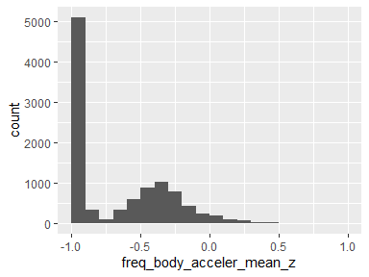

## freq_body_acceler_meanfreq_x

|  |  |
| --- | --- |
| Feature | Result |
| Variable type | numeric |
| Number of missing obs. | 0 (0 %) |
| Number of unique values | 10299 |
| Median | -0.24 |
| 1st and 3rd quartiles | -0.42; -0.02 |
| Min. and max. | -1; 1 |

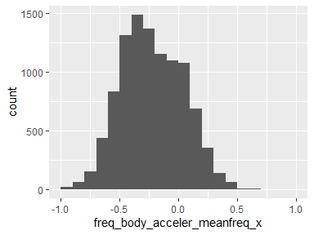

## freq_body_acceler_meanfreq_y

|  |  |
| --- | --- |
| Feature | Result |
| Variable type | numeric |
| Number of missing obs. | 0 (0 %) |
| Number of unique values | 10299 |
| Median | 0 |
| 1st and 3rd quartiles | -0.14; 0.18 |
| Min. and max. | -1; 1 |

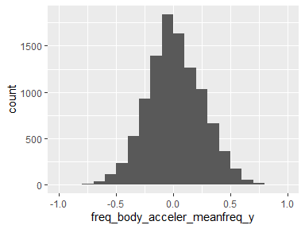

## freq_body_acceler_meanfreq_z

|  |  |
| --- | --- |
| Feature | Result |
| Variable type | numeric |
| Number of missing obs. | 0 (0 %) |
| Number of unique values | 10299 |
| Median | 0.06 |
| 1st and 3rd quartiles | -0.14; 0.25 |
| Min. and max. | -1; 1 |

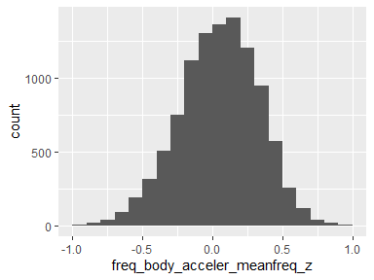

## freq_body_acceler_jerk_mean_x

|  |  |
| --- | --- |
| Feature | Result |
| Variable type | numeric |
| Number of missing obs. | 0 (0 %) |
| Number of unique values | 10293 |
| Median | -0.95 |
| 1st and 3rd quartiles | -0.99; -0.33 |
| Min. and max. | -1; 1 |

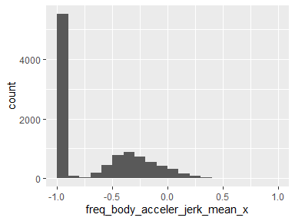

## freq_body_acceler_jerk_mean_y

|  |  |
| --- | --- |
| Feature | Result |
| Variable type | numeric |
| Number of missing obs. | 0 (0 %) |
| Number of unique values | 10296 |
| Median | -0.93 |
| 1st and 3rd quartiles | -0.98; -0.26 |
| Min. and max. | -1; 1 |

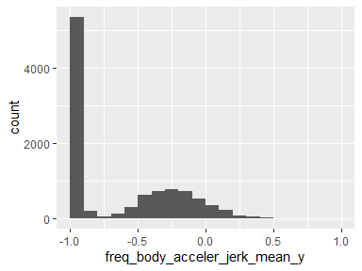

## freq_body_acceler_jerk_mean_z

|  |  |
| --- | --- |
| Feature | Result |
| Variable type | numeric |
| Number of missing obs. | 0 (0 %) |
| Number of unique values | 10294 |
| Median | -0.95 |
| 1st and 3rd quartiles | -0.99; -0.51 |
| Min. and max. | -1; 1 |

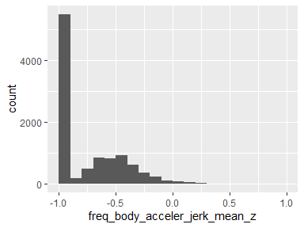

## freq_body_acceler_jerk_meanfreq_x

|  |  |
| --- | --- |
| Feature | Result |
| Variable type | numeric |
| Number of missing obs. | 0 (0 %) |
| Number of unique values | 10298 |
| Median | -0.05 |
| 1st and 3rd quartiles | -0.3; 0.2 |
| Min. and max. | -1; 1 |

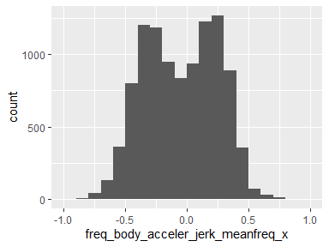

## freq_body_acceler_jerk_meanfreq_y

|  |  |
| --- | --- |
| Feature | Result |
| Variable type | numeric |
| Number of missing obs. | 0 (0 %) |
| Number of unique values | 10299 |
| Median | -0.24 |
| 1st and 3rd quartiles | -0.43; 0.01 |
| Min. and max. | -1; 1 |

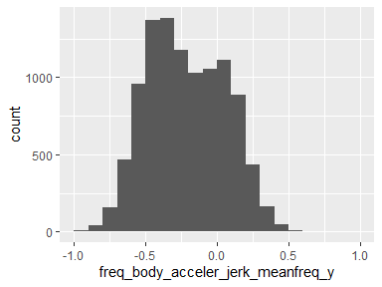

## freq_body_acceler_jerk_meanfreq_z

|  |  |
| --- | --- |
| Feature | Result |
| Variable type | numeric |
| Number of missing obs. | 0 (0 %) |
| Number of unique values | 10298 |
| Median | -0.1 |
| 1st and 3rd quartiles | -0.33; 0.09 |
| Min. and max. | -1; 1 |

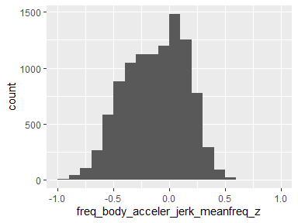

## freq_bodygyro_mean_x

|  |  |
| --- | --- |
| Feature | Result |
| Variable type | numeric |
| Number of missing obs. | 0 (0 %) |
| Number of unique values | 10297 |
| Median | -0.89 |
| 1st and 3rd quartiles | -0.99; -0.38 |
| Min. and max. | -1; 1 |

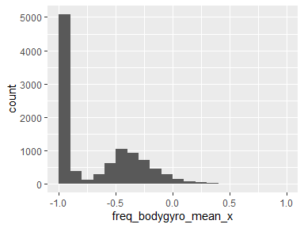

## freq_bodygyro_mean_y

|  |  |
| --- | --- |
| Feature | Result |
| Variable type | numeric |
| Number of missing obs. | 0 (0 %) |
| Number of unique values | 10296 |
| Median | -0.92 |
| 1st and 3rd quartiles | -0.98; -0.47 |
| Min. and max. | -1; 1 |

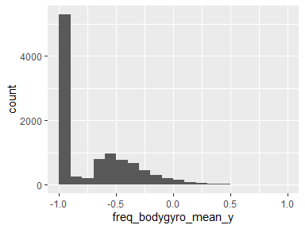

## freq_bodygyro_mean_z

|  |  |
| --- | --- |
| Feature | Result |
| Variable type | numeric |
| Number of missing obs. | 0 (0 %) |
| Number of unique values | 10297 |
| Median | -0.89 |
| 1st and 3rd quartiles | -0.99; -0.32 |
| Min. and max. | -1; 1 |

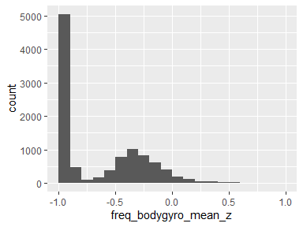

## freq_bodygyro_meanfreq_x

|  |  |
| --- | --- |
| Feature | Result |
| Variable type | numeric |
| Number of missing obs. | 0 (0 %) |
| Number of unique values | 10298 |
| Median | -0.1 |
| 1st and 3rd quartiles | -0.27; 0.07 |
| Min. and max. | -1; 1 |

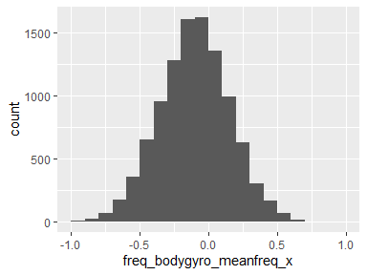

## freq_bodygyro_meanfreq_y

|  |  |
| --- | --- |
| Feature | Result |
| Variable type | numeric |
| Number of missing obs. | 0 (0 %) |
| Number of unique values | 10299 |
| Median | -0.17 |
| 1st and 3rd quartiles | -0.36; 0.01 |
| Min. and max. | -1; 1 |

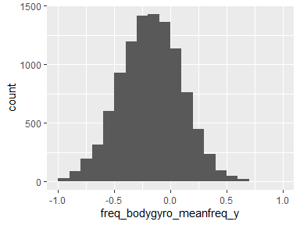

## freq_bodygyro_meanfreq_z

|  |  |
| --- | --- |
| Feature | Result |
| Variable type | numeric |
| Number of missing obs. | 0 (0 %) |
| Number of unique values | 10299 |
| Median | -0.05 |
| 1st and 3rd quartiles | -0.23; 0.12 |
| Min. and max. | -1; 1 |

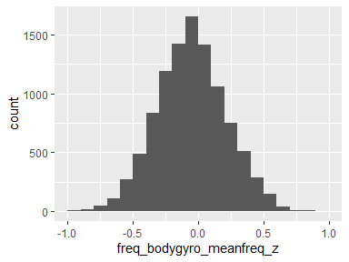

## freq_body_acceler_magnitude_mean

|  |  |
| --- | --- |
| Feature | Result |
| Variable type | numeric |
| Number of missing obs. | 0 (0 %) |
| Number of unique values | 10296 |
| Median | -0.88 |
| 1st and 3rd quartiles | -0.98; -0.22 |
| Min. and max. | -1; 1 |

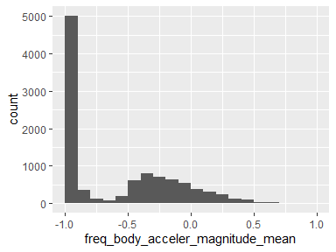

## freq_body_acceler_magnitude_meanfreq

|  |  |
| --- | --- |
| Feature | Result |
| Variable type | numeric |
| Number of missing obs. | 0 (0 %) |
| Number of unique values | 10299 |
| Median | 0.07 |
| 1st and 3rd quartiles | -0.1; 0.24 |
| Min. and max. | -1; 1 |

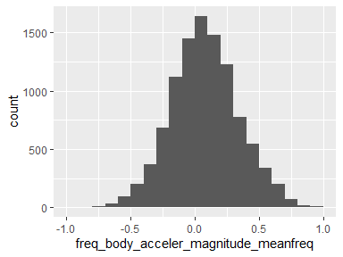

## freq_body_acceler_jerk_magnitude_mean

|  |  |
| --- | --- |
| Feature | Result |
| Variable type | numeric |
| Number of missing obs. | 0 (0 %) |
| Number of unique values | 10290 |
| Median | -0.93 |
| 1st and 3rd quartiles | -0.99; -0.26 |
| Min. and max. | -1; 1 |

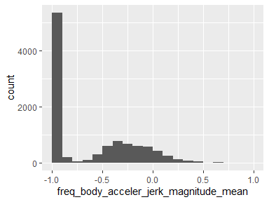

## freq_body_acceler_jerk_magnitude_meanfreq

|  |  |
| --- | --- |
| Feature | Result |
| Variable type | numeric |
| Number of missing obs. | 0 (0 %) |
| Number of unique values | 10299 |
| Median | 0.16 |
| 1st and 3rd quartiles | 0; 0.36 |
| Min. and max. | -1; 1 |

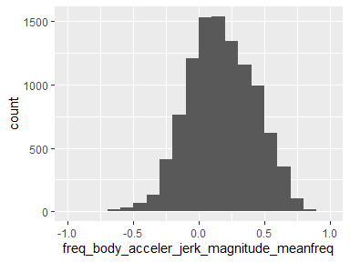

## freq_bodygyro_magnitude_mean

|  |  |
| --- | --- |
| Feature | Result |
| Variable type | numeric |
| Number of missing obs. | 0 (0 %) |
| Number of unique values | 10297 |
| Median | -0.88 |
| 1st and 3rd quartiles | -0.98; -0.45 |
| Min. and max. | -1; 1 |

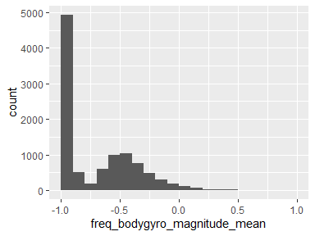

## freq_bodygyro_magnitude_meanfreq

|  |  |
| --- | --- |
| Feature | Result |
| Variable type | numeric |
| Number of missing obs. | 0 (0 %) |
| Number of unique values | 10299 |
| Median | -0.05 |
| 1st and 3rd quartiles | -0.23; 0.15 |
| Min. and max. | -1; 1 |

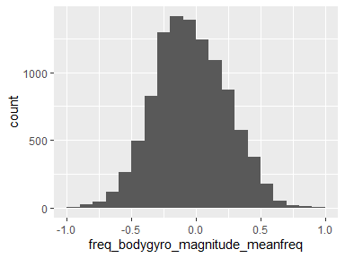

## freq_bodygyrojerk_magnitude_mean

|  |  |
| --- | --- |
| Feature | Result |
| Variable type | numeric |
| Number of missing obs. | 0 (0 %) |
| Number of unique values | 10293 |
| Median | -0.95 |
| 1st and 3rd quartiles | -0.99; -0.61 |
| Min. and max. | -1; 1 |

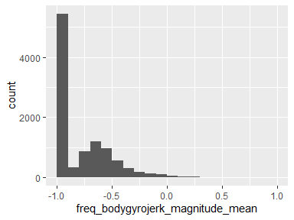

## freq_bodygyrojerk_magnitude_meanfreq

|  |  |
| --- | --- |
| Feature | Result |
| Variable type | numeric |
| Number of missing obs. | 0 (0 %) |
| Number of unique values | 10299 |
| Median | 0.14 |
| 1st and 3rd quartiles | -0.02; 0.29 |
| Min. and max. | -1; 1 |

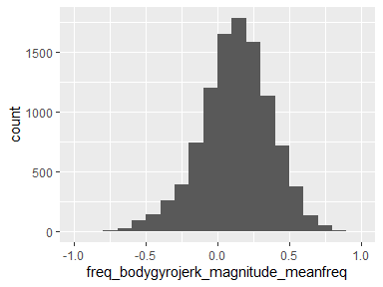

## angle_time_body_acceler_mean_gravity

|  |  |
| --- | --- |
| Feature | Result |
| Variable type | numeric |
| Number of missing obs. | 0 (0 %) |
| Number of unique values | 10299 |
| Median | 0.01 |
| 1st and 3rd quartiles | -0.12; 0.15 |
| Min. and max. | -1; 1 |

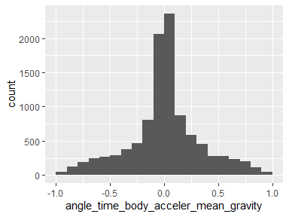

## angle_time_body_acceler_jerkmean_gravitymean

|  |  |
| --- | --- |
| Feature | Result |
| Variable type | numeric |
| Number of missing obs. | 0 (0 %) |
| Number of unique values | 10299 |
| Median | 0.01 |
| 1st and 3rd quartiles | -0.29; 0.29 |
| Min. and max. | -1; 1 |

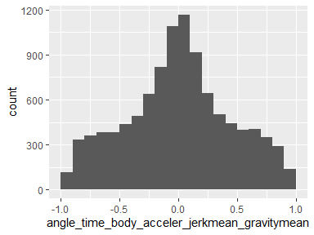

## angle_time_bodygyromean_gravitymean

|  |  |
| --- | --- |
| Feature | Result |
| Variable type | numeric |
| Number of missing obs. | 0 (0 %) |
| Number of unique values | 10299 |
| Median | 0.02 |
| 1st and 3rd quartiles | -0.49; 0.54 |
| Min. and max. | -1; 1 |

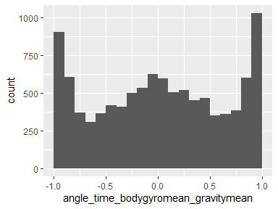

## angle_time_bodygyrojerkmean_gravitymean

|  |  |
| --- | --- |
| Feature | Result |
| Variable type | numeric |
| Number of missing obs. | 0 (0 %) |
| Number of unique values | 10299 |
| Median | -0.01 |
| 1st and 3rd quartiles | -0.39; 0.37 |
| Min. and max. | -1; 1 |

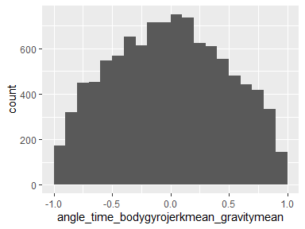

## angle_x_gravitymean

|  |  |
| --- | --- |
| Feature | Result |
| Variable type | numeric |
| Number of missing obs. | 0 (0 %) |
| Number of unique values | 10299 |
| Median | -0.72 |
| 1st and 3rd quartiles | -0.82; -0.52 |
| Min. and max. | -1; 1 |

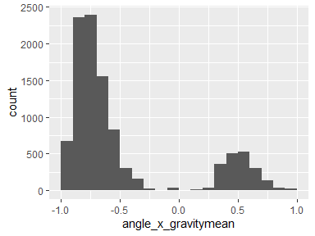

## angle_y_gravitymean

|  |  |
| --- | --- |
| Feature | Result |
| Variable type | numeric |
| Number of missing obs. | 0 (0 %) |
| Number of unique values | 10299 |
| Median | 0.18 |
| 1st and 3rd quartiles | 0; 0.25 |
| Min. and max. | -1; 1 |

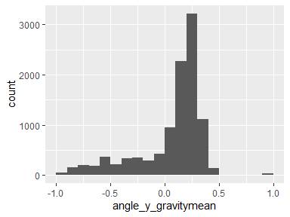

## angle_z_gravitymean

|  |  |
| --- | --- |
| Feature | Result |
| Variable type | numeric |
| Number of missing obs. | 0 (0 %) |
| Number of unique values | 10299 |
| Median | 0 |
| 1st and 3rd quartiles | -0.13; 0.1 |
| Min. and max. | -1; 1 |

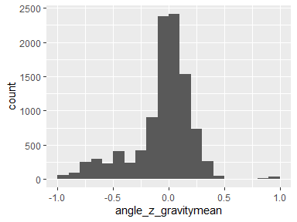

## time_body_acceler_st_dev_x

|  |  |
| --- | --- |
| Feature | Result |
| Variable type | numeric |
| Number of missing obs. | 0 (0 %) |
| Number of unique values | 10295 |
| Median | -0.94 |
| 1st and 3rd quartiles | -0.99; -0.25 |
| Min. and max. | -1; 1 |

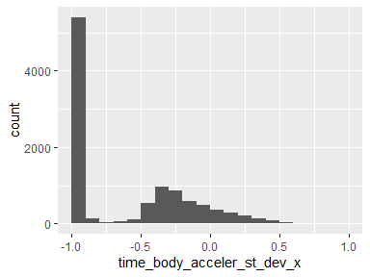

## time_body_acceler_st_dev_y

|  |  |
| --- | --- |
| Feature | Result |
| Variable type | numeric |
| Number of missing obs. | 0 (0 %) |
| Number of unique values | 10297 |
| Median | -0.84 |
| 1st and 3rd quartiles | -0.98; -0.06 |
| Min. and max. | -1; 1 |

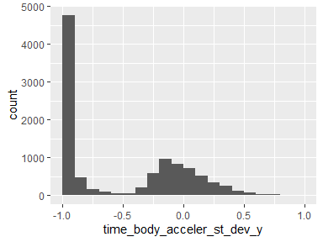

## time_body_acceler_st_dev_z

|  |  |
| --- | --- |
| Feature | Result |
| Variable type | numeric |
| Number of missing obs. | 0 (0 %) |
| Number of unique values | 10297 |
| Median | -0.85 |
| 1st and 3rd quartiles | -0.98; -0.28 |
| Min. and max. | -1; 1 |

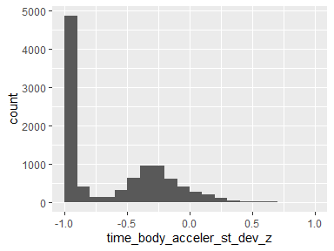

## time_gravity_acceler_st_dev_x

|  |  |
| --- | --- |
| Feature | Result |
| Variable type | numeric |
| Number of missing obs. | 0 (0 %) |
| Number of unique values | 10288 |
| Median | -0.98 |
| 1st and 3rd quartiles | -0.99; -0.96 |
| Min. and max. | -1; 1 |

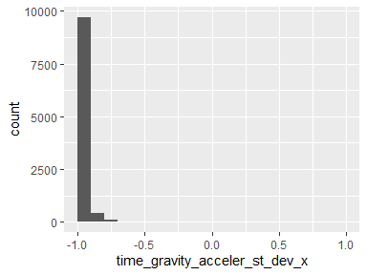

## time_gravity_acceler_st_dev_y

|  |  |
| --- | --- |
| Feature | Result |
| Variable type | numeric |
| Number of missing obs. | 0 (0 %) |
| Number of unique values | 10293 |
| Median | -0.98 |
| 1st and 3rd quartiles | -0.99; -0.95 |
| Min. and max. | -1; 1 |

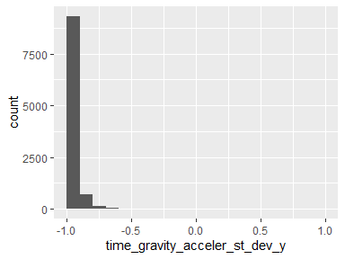

## time_gravity_acceler_st_dev_z

|  |  |
| --- | --- |
| Feature | Result |
| Variable type | numeric |
| Number of missing obs. | 0 (0 %) |
| Number of unique values | 10296 |
| Median | -0.97 |
| 1st and 3rd quartiles | -0.99; -0.93 |
| Min. and max. | -1; 1 |

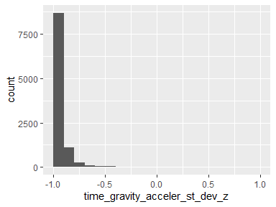

## time_body_acceler_jerk_st_dev_x

|  |  |
| --- | --- |
| Feature | Result |
| Variable type | numeric |
| Number of missing obs. | 0 (0 %) |
| Number of unique values | 10290 |
| Median | -0.95 |
| 1st and 3rd quartiles | -0.99; -0.29 |
| Min. and max. | -1; 1 |

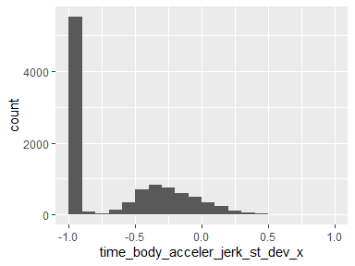

## time_body_acceler_jerk_st_dev_y

|  |  |
| --- | --- |
| Feature | Result |
| Variable type | numeric |
| Number of missing obs. | 0 (0 %) |
| Number of unique values | 10296 |
| Median | -0.93 |
| 1st and 3rd quartiles | -0.99; -0.22 |
| Min. and max. | -1; 1 |

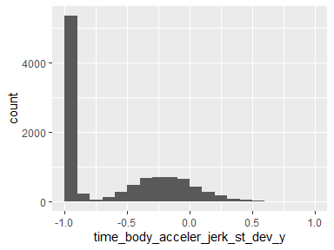

## time_body_acceler_jerk_st_dev_z

|  |  |
| --- | --- |
| Feature | Result |
| Variable type | numeric |
| Number of missing obs. | 0 (0 %) |
| Number of unique values | 10293 |
| Median | -0.95 |
| 1st and 3rd quartiles | -0.99; -0.55 |
| Min. and max. | -1; 1 |

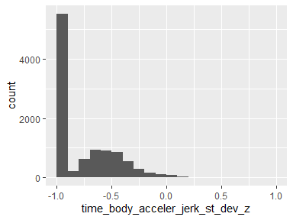

## time_bodygyro_st_dev_x

|  |  |
| --- | --- |
| Feature | Result |
| Variable type | numeric |
| Number of missing obs. | 0 (0 %) |
| Number of unique values | 10292 |
| Median | -0.9 |
| 1st and 3rd quartiles | -0.99; -0.48 |
| Min. and max. | -1; 1 |

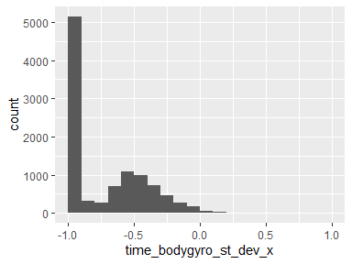

## time_bodygyro_st_dev_y

|  |  |
| --- | --- |
| Feature | Result |
| Variable type | numeric |
| Number of missing obs. | 0 (0 %) |
| Number of unique values | 10296 |
| Median | -0.91 |
| 1st and 3rd quartiles | -0.98; -0.45 |
| Min. and max. | -1; 1 |

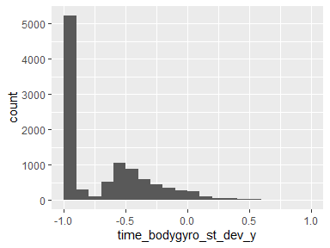

## time_bodygyro_st_dev_z

|  |  |
| --- | --- |
| Feature | Result |
| Variable type | numeric |
| Number of missing obs. | 0 (0 %) |
| Number of unique values | 10296 |
| Median | -0.88 |
| 1st and 3rd quartiles | -0.99; -0.34 |
| Min. and max. | -1; 1 |

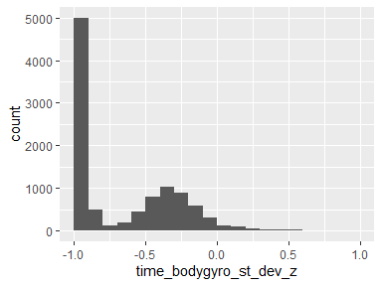

## time_bodygyrojerk_st_dev_x

|  |  |
| --- | --- |
| Feature | Result |
| Variable type | numeric |
| Number of missing obs. | 0 (0 %) |
| Number of unique values | 10292 |
| Median | -0.93 |
| 1st and 3rd quartiles | -0.99; -0.49 |
| Min. and max. | -1; 1 |

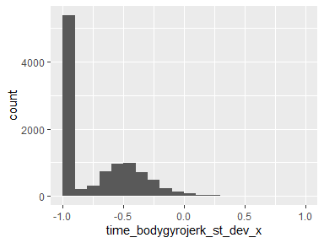

## time_bodygyrojerk_st_dev_y

|  |  |
| --- | --- |
| Feature | Result |
| Variable type | numeric |
| Number of missing obs. | 0 (0 %) |
| Number of unique values | 10295 |
| Median | -0.95 |
| 1st and 3rd quartiles | -0.99; -0.63 |
| Min. and max. | -1; 1 |

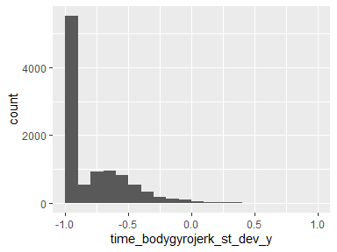

## time_bodygyrojerk_st_dev_z

|  |  |
| --- | --- |
| Feature | Result |
| Variable type | numeric |
| Number of missing obs. | 0 (0 %) |
| Number of unique values | 10291 |
| Median | -0.95 |
| 1st and 3rd quartiles | -0.99; -0.51 |
| Min. and max. | -1; 1 |

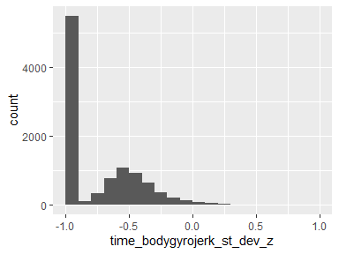

## time_body_acceler_magnitude_st_dev

|  |  |
| --- | --- |
| Feature | Result |
| Variable type | numeric |
| Number of missing obs. | 0 (0 %) |
| Number of unique values | 10294 |
| Median | -0.84 |
| 1st and 3rd quartiles | -0.98; -0.24 |
| Min. and max. | -1; 1 |

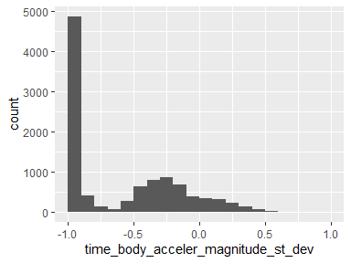

## time_gravity_acceler_magnitude_st_dev

|  |  |
| --- | --- |
| Feature | Result |
| Variable type | numeric |
| Number of missing obs. | 0 (0 %) |
| Number of unique values | 10294 |
| Median | -0.84 |
| 1st and 3rd quartiles | -0.98; -0.24 |
| Min. and max. | -1; 1 |

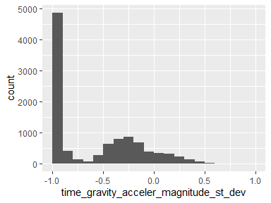

## time_body_acceler_jerk_magnitude_st_dev

|  |  |
| --- | --- |
| Feature | Result |
| Variable type | numeric |
| Number of missing obs. | 0 (0 %) |
| Number of unique values | 10294 |
| Median | -0.93 |
| 1st and 3rd quartiles | -0.99; -0.27 |
| Min. and max. | -1; 1 |

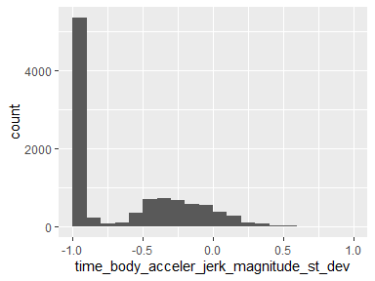

## time_bodygyro_magnitude_st_dev

|  |  |
| --- | --- |
| Feature | Result |
| Variable type | numeric |
| Number of missing obs. | 0 (0 %) |
| Number of unique values | 10298 |
| Median | -0.83 |
| 1st and 3rd quartiles | -0.98; -0.39 |
| Min. and max. | -1; 1 |

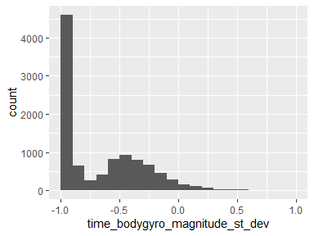

## time_bodygyrojerk_magnitude_st_dev

|  |  |
| --- | --- |
| Feature | Result |
| Variable type | numeric |
| Number of missing obs. | 0 (0 %) |
| Number of unique values | 10297 |
| Median | -0.94 |
| 1st and 3rd quartiles | -0.99; -0.61 |
| Min. and max. | -1; 1 |

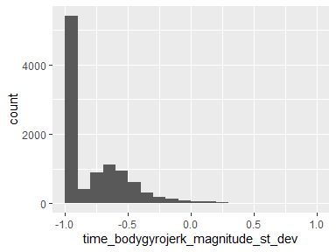

## freq_body_acceler_st_dev_x

|  |  |
| --- | --- |
| Feature | Result |
| Variable type | numeric |
| Number of missing obs. | 0 (0 %) |
| Number of unique values | 10294 |
| Median | -0.94 |
| 1st and 3rd quartiles | -0.99; -0.25 |
| Min. and max. | -1; 1 |

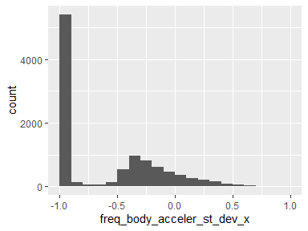

## freq_body_acceler_st_dev_y

|  |  |
| --- | --- |
| Feature | Result |
| Variable type | numeric |
| Number of missing obs. | 0 (0 %) |
| Number of unique values | 10297 |
| Median | -0.83 |
| 1st and 3rd quartiles | -0.98; -0.09 |
| Min. and max. | -1; 1 |

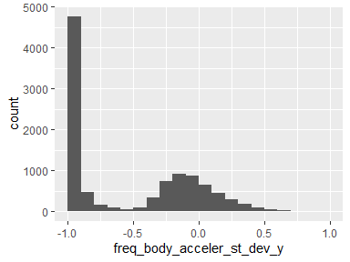

## freq_body_acceler_st_dev_z

|  |  |
| --- | --- |
| Feature | Result |
| Variable type | numeric |
| Number of missing obs. | 0 (0 %) |
| Number of unique values | 10296 |
| Median | -0.84 |
| 1st and 3rd quartiles | -0.98; -0.3 |
| Min. and max. | -1; 1 |

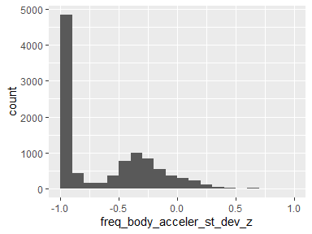

## freq_body_acceler_jerk_st_dev_x

|  |  |
| --- | --- |
| Feature | Result |
| Variable type | numeric |
| Number of missing obs. | 0 (0 %) |
| Number of unique values | 10291 |
| Median | -0.96 |
| 1st and 3rd quartiles | -0.99; -0.32 |
| Min. and max. | -1; 1 |

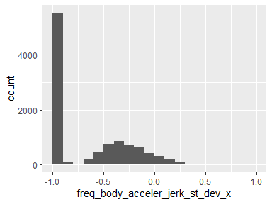

## freq_body_acceler_jerk_st_dev_y

|  |  |
| --- | --- |
| Feature | Result |
| Variable type | numeric |
| Number of missing obs. | 0 (0 %) |
| Number of unique values | 10294 |
| Median | -0.93 |
| 1st and 3rd quartiles | -0.99; -0.24 |
| Min. and max. | -1; 1 |

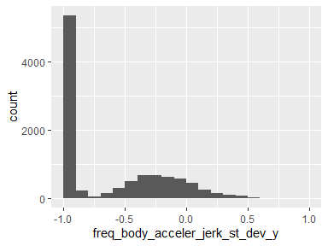

## freq_body_acceler_jerk_st_dev_z

|  |  |
| --- | --- |
| Feature | Result |
| Variable type | numeric |
| Number of missing obs. | 0 (0 %) |
| Number of unique values | 10290 |
| Median | -0.96 |
| 1st and 3rd quartiles | -0.99; -0.59 |
| Min. and max. | -1; 1 |

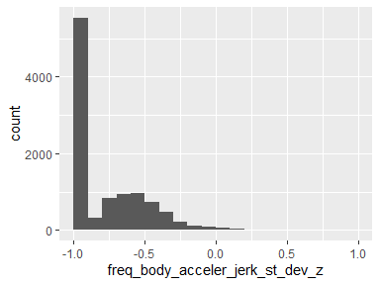

## freq_bodygyro_st_dev_x

|  |  |
| --- | --- |
| Feature | Result |
| Variable type | numeric |
| Number of missing obs. | 0 (0 %) |
| Number of unique values | 10297 |
| Median | -0.91 |
| 1st and 3rd quartiles | -0.99; -0.52 |
| Min. and max. | -1; 1 |

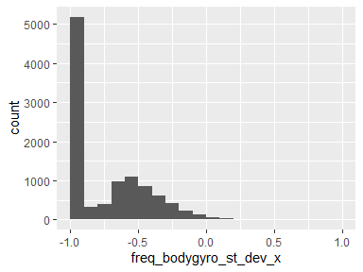

## freq_bodygyro_st_dev_y

|  |  |
| --- | --- |
| Feature | Result |
| Variable type | numeric |
| Number of missing obs. | 0 (0 %) |
| Number of unique values | 10293 |
| Median | -0.91 |
| 1st and 3rd quartiles | -0.98; -0.44 |
| Min. and max. | -1; 1 |

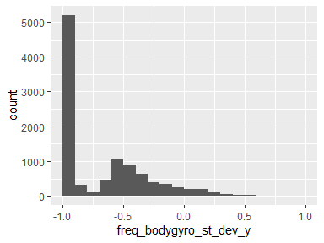

## freq_bodygyro_st_dev_z

|  |  |
| --- | --- |
| Feature | Result |
| Variable type | numeric |
| Number of missing obs. | 0 (0 %) |
| Number of unique values | 10295 |
| Median | -0.89 |
| 1st and 3rd quartiles | -0.99; -0.42 |
| Min. and max. | -1; 1 |

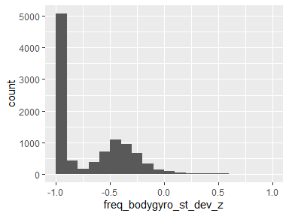

## freq_body_acceler_magnitude_st_dev

|  |  |
| --- | --- |
| Feature | Result |
| Variable type | numeric |
| Number of missing obs. | 0 (0 %) |
| Number of unique values | 10298 |
| Median | -0.85 |
| 1st and 3rd quartiles | -0.98; -0.38 |
| Min. and max. | -1; 1 |

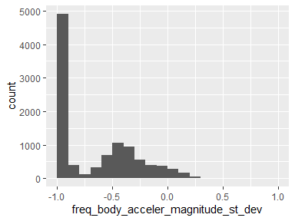

## freq_body_acceler_jerk_magnitude_st_dev

|  |  |
| --- | --- |
| Feature | Result |
| Variable type | numeric |
| Number of missing obs. | 0 (0 %) |
| Number of unique values | 10296 |
| Median | -0.93 |
| 1st and 3rd quartiles | -0.99; -0.31 |
| Min. and max. | -1; 1 |

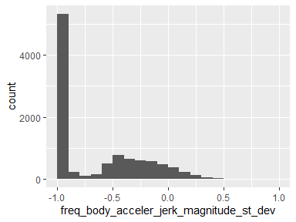

## freq_bodygyro_magnitude_st_dev

|  |  |
| --- | --- |
| Feature | Result |
| Variable type | numeric |
| Number of missing obs. | 0 (0 %) |
| Number of unique values | 10296 |
| Median | -0.83 |
| 1st and 3rd quartiles | -0.98; -0.47 |
| Min. and max. | -1; 1 |

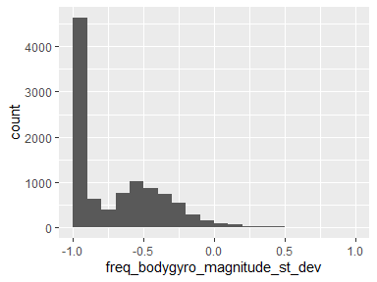

## freq_bodygyrojerk_magnitude_st_dev

|  |  |
| --- | --- |
| Feature | Result |
| Variable type | numeric |
| Number of missing obs. | 0 (0 %) |
| Number of unique values | 10292 |
| Median | -0.94 |
| 1st and 3rd quartiles | -0.99; -0.64 |
| Min. and max. | -1; 1 |

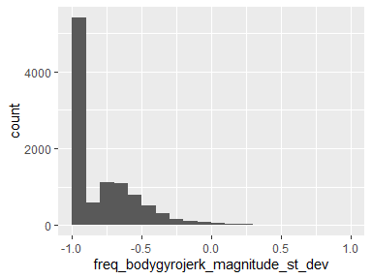

Report generation information:

* Created by acraig29 (username: lisbo).
* Report creation time: Fri Nov 15 2019 14:10:45
* Report was run from directory: C:/Users/lisbo/OneDrive/IT Courses/JohnHopkins DS/Module3/assignment/alldata
* dataMaid v1.3.2 [Pkg: 2019-07-27 from CRAN (R 3.6.1)]
* R version 3.6.1 (2019-07-05).
* Platform: x86_64-w64-mingw32/x64 (64-bit)(Windows >= 8 x64 (build 9200)).
* Function call: makeDataReport(data = tidy_df, mode = c("summarize", "visualize", "check"), smartNum = FALSE, file = "codebook_tidy_df.Rmd", checks = list( character = "showAllFactorLevels", factor = "showAllFactorLevels", labelled = "showAllFactorLevels", haven_labelled = "showAllFactorLevels", numeric = NULL, integer = NULL, logical = NULL, Date = NULL), listChecks = FALSE, maxProbVals = Inf, codebook = TRUE, reportTitle = "Codebook for tidy_df")