Texas A&M Disc Golf Club Website

**Team Royal Flush**

Andrew Cramer

Alok Chandrawal

Chandler Ochs

Prathiksha Prasad

Snehasish Sen

Vignesh Babu Manjunath Gandudi

**Team Roles**

Scrum Master: Prathiksha Prasad

Product Owner: Chandler Ochs

**Customer Meeting**

Date: Thursday, October 15th

Time: 8 PM - 8:30PM (Zoom)

**Github Repo**

<https://github.com/acramer/tamu-disc-golf>

**Pivotal Tracker**

<https://www.pivotaltracker.com/n/projects/2467338>

**Heroku Deployment**

<http://tamudiscgolf.herokuapp.com>

**User Stories Implemented**

1. Feature: Upcoming Events List

As an event creator

So that I keep members up to date with upcoming events

I want to have a list of upcoming events on the landing page

1. Feature: Social Media Links

As a club officer

So that I can keep members up to date with upcoming events

I want to have links to all social media pages on the landing page

1. Feature: Photo Gallery

As a club officer

So that I can attract new members

I want to have a gallery of recent photos from club activities on the landing page

1. Tech: Product Architecture

As a stakeholder

So that I have a stable website

I want to have a list of tools and platforms best suitable for the application

1. Feature: Node.js Project Created

As a club owner

I want a node.js project initialized

so that my club information can be displayed in the form of a website

1. Feature: Heroku Hosting

As a user

I want the website to be hosted on Heroku

So that I can access it using the internet

1. Feature: Basic Express Routing

As a site owner and maintainer

I want basic routing done

So that the site information can be spread across multiple pages

1. Feature: Front-end testing

As a customer

I want testing to be integrated with the development process

So that a more robust product is created

1. Feature: Continuous Integration/Continuous Development Github Pipeline

As a site owner

I want continuous integration used in the development process

So that I can be sure that releases have fewer bugs

1. Feature: Login Button

As a content provider

I want a login button to be present on the landing page

So that members can log in to view special content and add content

1. Feature: Navigation Bar

As a user of the site

I want to have a navigation bar displayed at the top of all pages

So that I can easily navigate between pages on the site

1. Feature: Add specified NavBar Buttons

As a club owner

I want to be able to access specified pages through the navbar

So that my members can access the pages.

1. Feature: About Us section

As a site owner and maintainer

I want to a have a description about the club

**Design Diagram**

Given below is the design diagram based on the elements implemented in this iteration. The elements are static as of now. In the future iterations, the static elements will be made dynamic and the design diagram will be updated accordingly.

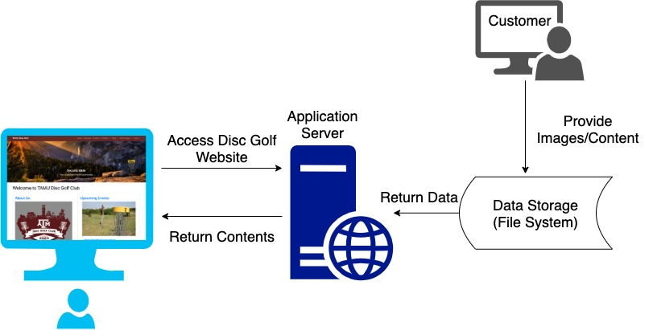

**Unit Testing and Code Coverage**

* Test cases: 36 passing (2s)
* Code coverage: 76.92%
* Unit testing using mocha and javascript.
* Enabled continuous integration on the GitHub repository.
* To view the latest unit testing results and code coverage:
  1. Navigate to <https://github.com/acramer/tamu-disc-golf/actions>
  2. Click on latest push to master
  3. Click build, then expand the line ‘npm test’
* To run the tests on your local:
  1. Clone the repository
  2. cd into tamu-disc-golf
  3. Run the command: $ npm test

**User Story Changes**

1. The “‘About Us’ section” feature requires the details about the club to be updated. In this iteration, we have added some details to the best of our knowledge. The team is waiting for more information from the customer. Suitable updates will be made in the future.
2. We added the following new user stories. We did so after our meeting with the customer and understanding the new requirements. These stories will be addressed in the upcoming iterations.
   1. Create Join Club Button
   2. Create ‘Competitive Teams’ Section
   3. Create ‘Officers’ Section
   4. Create ‘Local Courses’ Section
   5. Create ‘Lost & Found’ Section
   6. Create ‘News/Recent Events’ Section
   7. Add Advanced Express Routing
   8. Make project dynamic
   9. Add TAMU Marketplace link
   10. Make ‘Competitive Teams’ Section dynamic
   11. Make ‘Officers’ Section dynamic
   12. Make ‘Local Courses’ Section dynamic
   13. Make ‘Lost & Found’ Section dynamic
   14. Make ‘News/Recent Events’ Section dynamic
3. The “Social Media” links feature requires links to the club’s social media pages. In this iteration the icons redirected to the respective social media homepages. The team is waiting for the club's social media page links from the customer. Suitable updates will be made in the future.

**Customer Feedback**

The customer was excited to see the first version of the website hosted on heroku. The customer appreciated some of the features like image carousel for gallery and scrolling functionality for upcoming events. The customer will give us more information on the About Us section, and social media webpage links in the future.

Overall the customer was happy with the first version and informed us that they would get back to us in a few days if there are any more changes that need to be done.