Texas A&M Disc Golf Club Website

**Team Royal Flush**

Andrew Cramer

Alok Chandrawal

Chandler Ochs

Prathiksha Prasad

Snehasish Sen

Vignesh Babu Manjunath Gandudi

**Team Roles**

Scrum Master: Prathiksha Prasad

Product Owner: Chandler Ochs

**Github Repo**

<https://github.com/acramer/tamu-disc-golf>

**Pivotal Tracker**

<https://www.pivotaltracker.com/n/projects/2467338>

**Heroku Deployment**

<http://tamudiscgolf.herokuapp.com>

**User Stories Implemented**

1. Create Backend Server

As a club organizer

I want the site to utilize a backend server

So that the website can be dynamic

1. 'Competitive Teams' Section

As a club organizer

I want competitive team information to be displayed on the site

So that members can easily see that information

1. 'Officers' Section

As club official

I want each officer to have a section with their image and information

So that the site is more personal

1. 'Lost & Found' Section

As a club organizer

I want lost and found information to be displayed on the site

So that members can easily access that information

1. ‘Local Courses’ Section - Groundwork done, not fully implemented yet

As a club organizer

I want local course information to be displayed on the site

So that members can easily access that information

**Design Diagram**

Given below is the design diagram based on the elements implemented in this iteration. A database was set up in this iteration. Different components are currently static and dynamic interactions with the database will be added in the upcoming iterations.

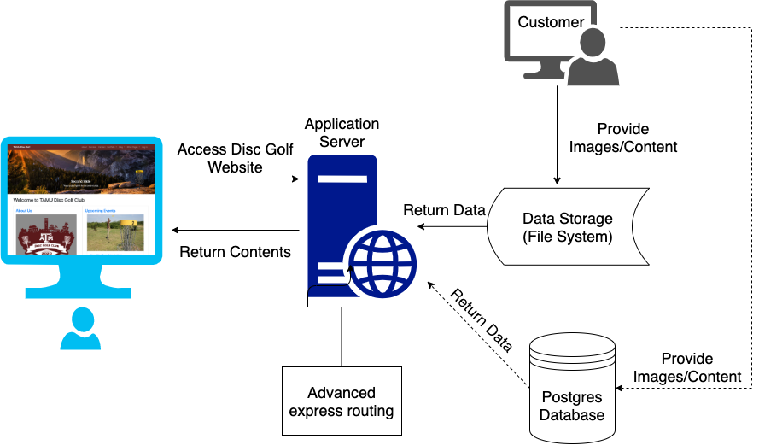

**Unit Testing and Code Coverage**

* Test cases: 39 passing (1s)
* Code coverage: % Stmts = 83.33, % Branch = 70, % Funcs = 66.67, % Lines = 83.1
* Unit testing using mocha and javascript.
* Enabled continuous integration on the GitHub repository.
* To view the latest unit testing results and code coverage:
  1. Navigate to <https://github.com/acramer/tamu-disc-golf/actions>
  2. Click on latest push to master
  3. Click build, then expand the line ‘npm test’
* To run the tests on your local:
  1. Clone the repository
  2. cd into tamu-disc-golf
  3. Run the command: $ npm test

**User Story Changes**

1. **Officers Section:** we have currently placed placeholder images instead of the actual portraits of the officers, and we will add the respective portraits in the next iteration when we get them from the customer. Also currently we have used placeholder text instead of officers information. In the next iteration we will add the information once we obtain the data from the customer.
2. **Local Courses**: We have only done the groundwork for this story. We will be using google Maps APIs to fetch all the nearby disc golf courses being offered. The first Google maps API “**textsearch**” returns the “**place_id**” of all the places nearby. Then, we need to use the “**details**” API to fetch all details about that place. The details include name, rating, formatted_phone_number, website, url and review of every location.   
   The final page should take in radius as an argument and list all the places and its details according to what the above APIs return.

**Customer Feedback**

We deployed the changes made in this iteration to heroku and requested the customer for feedback. The customer was excited to see several elements fall in place. The customer appreciated all the efforts put by the team to add new features to the website.

In this iteration, the customer provided some basic information about Officers and Competitive teams. We have included the provided information in the current version of the website. The details will be enhanced in the future iterations when we get an update from the customer.