Texas A&M Disc Golf Club Website

**Team Royal Flush**

Andrew Cramer

Alok Chandrawal

Chandler Ochs

Prathiksha Prasad

Snehasish Sen

Vignesh Babu Manjunath Gandudi

**Team Roles**

Scrum Master: Prathiksha Prasad

Product Owner: Chandler Ochs

**Github Repo**

<https://github.com/acramer/tamu-disc-golf>

**Pivotal Tracker**

<https://www.pivotaltracker.com/n/projects/2467338>

**Heroku Deployment**

<http://tamudiscgolf.herokuapp.com>

**User Stories Implemented**

1. DB Migration Setup:

As a technical lead

I want automatic DB migrations to be set up along with development databases on local

So that DB changes made by developers are managed systematically without conflicts.

1. Log In Permissions:

As a technical lead

I want appropriate permissions to be set up for different modules

So that only authorized members of the club can update the contents of different modules.

1. Registration Page and form:

As a club owner

I want a registration form available from log in page

So that new members can join the club more easily.

1. Email form validation:

As an administrator I want to ensure that the email address entered by the user at registration is ensured to be in the form of an email so that I can contact specific users on the site.

1. CICD pipeline with postgres server creation and seeding:

As a site owner I want a postgres server and sequelize seeding as part of the CICD pipeline so that releases can continue to have few bugs now that it is dynamic.

1. Dynamic Nav Bar:

As a user I want the options on the nav bar to change with user log in so the options available are more applicable to what I am doing at the moment and my experience is more personal

1. Pages and forms for editing user attributes:

As a user I want pages with forms that allow me to change personal information so that I can use my account long term

1. Site Footer always below or on the bottom of the page.

As a user I want the footer of page to be on the bottom of the window for all pages where the body doesn't fill the window so that my experience is better.

1. Registration, Login and Edit Profile success/error flashing:

As a user I want success and error messages to be flashed on the registration, login and edit profile pages so that I can know what I am doing right or wrong in my interactions.

1. Lost and Found Code Refactoring:

As a technical lead

I want automatic DB migrations for lost and found to be set up along with development databases on local

So that lost and found DB changes made by developers are managed systematically without conflicts.

1. “Local Courses” Section:

As a club organizer I want local course information to be displayed on the site, so that members can easily access that information.

1. “Add Admin Page to manage all website data”

As an admin I want to perform CRUD operations on the website to keep the website updated. Provide a page to perform all CRUD operations with a simple GUI.

1. “News/Events Section”

As a club organizer I want news to be displayed on the site So that members can easily access that information.

**User Stories Unfinished**

1. “News/Events Section”

The size of the calendar and the events display cards have some cosmetic issues involving CSS. These will be worked upon in the coming days.

**Design Diagram**

Given below is the design diagram based on the elements implemented in this iteration. Several components that were in progress in the previous iteration have been completed. All the data interactions have been moved to the database and all the components are dynamic with handlebar implementations.

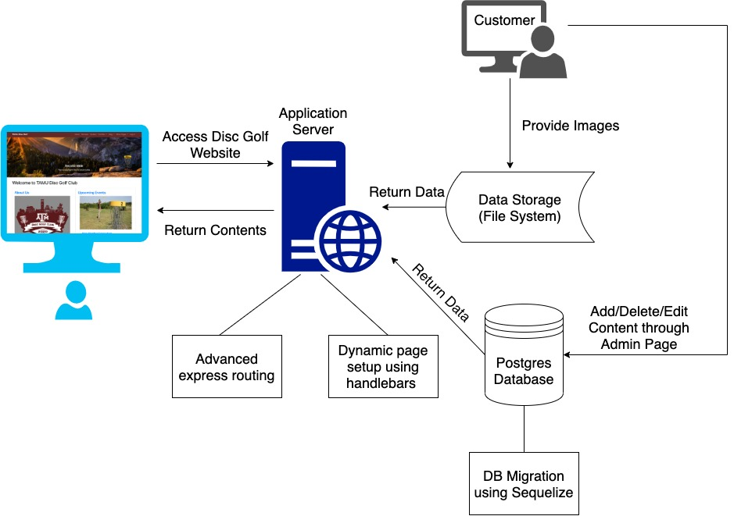

**Unit Testing and Code Coverage (need to update this with latest build)**

* Test Cases: 78 passing (5s)
* Code Coverage:
  + % Stmts = 85.34, % Branch = 63.19, % Funcs = 90, % Lines = 86.22
* Unit testing using mocha, zombie and javascript.
* Enabled continuous integration on the GitHub repository.
* To view the latest unit testing results and code coverage:
  1. Navigate to <https://github.com/acramer/tamu-disc-golf/actions>
  2. Click on latest push to master
  3. Click build, then expand the line ‘npm test’
* To run the tests on your local:
  1. Install and run Postgres
  2. Create a postgres db named tamu_disc_golf
  3. Create a postgres user with the username: postgres and the password: root
  4. Clone the repository
  5. cd into tamu-disc-golf
  6. Run the command: $ npm install
  7. Run the command: $ npm test

**Customer Feedback**

We deployed the changes made in this iteration to heroku and requested the customer for feedback. The customer was satisfied with the progress made and the current shape of the project. The customer was thrilled to see some new modules such as local courses and admin pages implemented along with some core functionalities such as log-in and registration.

We are still waiting on more information from the customer for a few sections of the website like About and Officers. We have added placeholders that can be updated by the customer through the admin page.