ACRCloudUniversalSDK Document V1.0.0

Overview 2
Usage Steps 2
API Reference 3
1 ACRCloudConfig 3
2 ACRCloudClient 4
2.1 initWithConfig 4
2.2 startRecognize 4
2.3 startRecognize(userParams) 4
2.4 cancel 4
2.5 runAutoRecognize 5
2.6 cancelAutoRecognize 5
2.7 requestRadioMetadataAsyn 5
2.8 putAudioData 6
2.9 release 6
3 IACRCloudListener 6
3.1 onResult 6
3.2 onVolumeChanged 6
4 IACRCloudRadioMetadataListener 7
4.1 onRadioMetadataResult 7
5 IACRCloudPartnerDeviceInfo 7
5.1 getGPS 7
5.2 getRadioFrequency 7
5.3 getDeviceId 8
5.4 getDeviceModel 8
Best Practices 8
Sequence Diagram 9
1、 Manual Recognition 9
2、 Automatic Recognition 10

Overview
- Manual Recognition
Your end users can manually click on “an recognition button” and your APP can call “startRecognize” of “ACRCloudClient” to start one recognition, the maximum time of each recognition session is 12s, it can be dynamically adjusted in ACRCloud server, when there is a result, SDK will callback “IACRCloudListener.onResult” you registered.
- Automatic Recognition
When your APP starts up, you can call “runAutoRecognize” of “ACRCloudClient” to start automatic recognition, and sdk will start recognition at intervals of 20s, when there is a result, SDK will callback“IACRCloudListener.onResult”you registered.
- Radio Metadata Search
You can use the GPS, frequency, type[FM/AM] to query the radio meta information and EPG information.
- Record Mode Of SDK
AudioRecord: Defaule source of SDK is MediaRecorder.AudioSource.MIC [8000 Hz mono 16bit], you can use “ACRCloudConfig.recorderConfig.source” to replace it with others sources.
Tinyalsa[pcm_read]: SDK can support record by tinyalsa.
CustomRecorder: You can implement IACRCloudRecorder, and set it to “ACRCloudConfig.userRecorderEngine”, and SDK will use your own recorder.

Usage Steps
- Apply for Host、Access Key、Access Secret
China: http://console.acrcloud.cn/signin
Other Country: https://console.acrcloud.com/signin
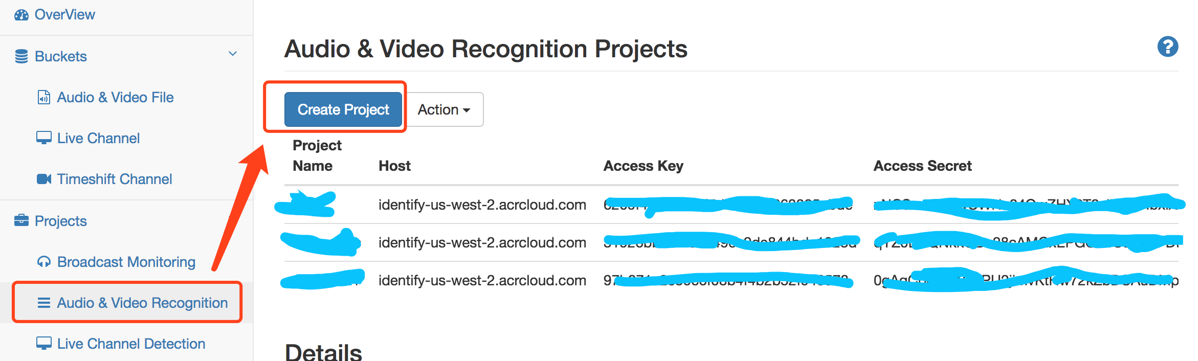
- Configure ACRCloudConfig according to different needs. You can replace the XXXXXX of the MainActivity in the Demo Project with your own access_keys to use the basic recognition.
- Register the callback function. You can implement IACRCloudListener, and set it to ACRCloudConfig.acrcloudListener.
- If you want to recognize radio[FM] music, you need to implement IACRCloudPartnerDeviceInfo, and set it to ACRCloudConfig.acrcloudPartnerDeviceInfo.
- Call ACRCloudClient.initWithConfig to init the SDK.
- Call ACRCloudClient.startRecognize to recognize, the result will be returned to you by IACRCloudListener.onResult.
- If you switch radio station, you need to call ACRCloudClient.cancel to clear audio buffer data.

API Reference

1 ACRCloudConfig
host | Project Host
accessKey | Project Access Key
accessSecret | Project Access Secret
hostAuto | Automatic Recognition Project Host, If you want auto recognition, you need two Access Key.
accessKeyAuto | Automatic Project Access Key
accessSecretAuto | Automatic Project Access Secret
acrcloudListener | An object of IACRCloudListener, callback listener.
acrCloudPartnerDeviceInfo | Some information of partner,  an object of IACRCloudPartnerDeviceInfo.
recorderType | Record Type:  ACRCloudConfig.RecorderType.USER: User-defined audio Record  ACRCloudConfig.RecorderType.DEFAULT: Android AudioRecord  ACRCloudConfig.RecorderType.TINYALSA: Tinyalsa
recorderConfig | Object of ACRCloudConfig.RecorderConfig
  channels | Channel, default is 1
  rate | Sample rate, default is 8000 Hz
  source | AudioRecord source  Defaule:  MediaRecorder.AudioSource.MIC
  isVolumeCallback | Is volume callback is required.
  card | Tinyalsa card
  device | Tinyalsa device
  periodSize | Period size
  periods | Period
  reservedRecordBufferMS | Reverse time of audio buffer  for Pre-record
protocol | HTTP Protocol:  ACRCloudConfig.NetworkProtocol.HTTP  ACRCloudConfig.NetworkProtocol.HTTPS
sessionTotalTimeoutMS | Default 30s
requestOnceTimeoutMS | Default 5s
autoRecognizeIntervalMS | Default 20s

2 ACRCloudClient
You can only create an object of ACRCloudClient and can reuse it multiple times.

2.1 initWithConfig
Prototype | public boolean initWithConfig(ACRCloudConfig config)
Function | Init SDK with ACRCloudConfig  If you set  ACRCloudConfig.recorderConfig.reservedRecordBufferMS > 0, SDK will start to prerecord. You can stop it by “stopPreRecord”.
Parameter | ACRCloudConfig
Return | True: suss  False: fail

2.2 startRecognize
Prototype | public boolean startRecognize()
Function | Start to recognize, SDK also will start recording.
Parameter | none
Return | True: suss  False: fail

2.3 startRecognize(userParams)
Prototype | public boolean startRecognize(Map<String, String> userParams)
Function | Start to recognize with user’s params.
Parameter | Map<String, String> userParams: the parameters of user
Return | True: suss  False: fail

2.4 cancel
Prototype | public void cancel()
Function | Cancel recognition, and it will also stop recording.
Parameter | none
Return | none

2.5 runAutoRecognize
Prototype | public boolean runAutoRecognize()
Function | Turn on automatic recognition  Start recognition at intervals of “ACRCloudConfig.autoRecognizeIntervalMS”
Parameter | none
Return | True: suss  False: fail

2.6 cancelAutoRecognize
Prototype | public boolean cancelAutoRecognize()
Function | Cancel auto recognition
Parameter | none
Return | none

2.7 requestRadioMetadataAsyn
Prototype | public boolean requestRadioMetadataAsyn(  String gpsLat,  String gpsLng,  List<String> freq, ACRCloudConfig.RadioType radioType, IACRCloudRadioMetadataListener radioMetadataListener)
Function | Search for station information asynchronously.
Parameter | gpsLat: latitude, accurate to two decimal places.  gpsLng: longitude, accurate to two decimal places.  Freq: Freq of radio.  radioType: ACRCloudConfig.RadioType.FM/AM  radioMetadataListener: Listener of Results.
Return | True: suss  False: fail

2.8 putAudioData
Prototype | public boolean putAudioData(byte[] buffer)
Function | You can put audio stream data.  If you set ACRCloudConfig.recorderType = ACRCloudConfig.RecorderType.USER,  SDK will process the external audio data.
Parameter | Buffer: PCM 16bit audio data.  Sample rate and channels of buffer is in ACRCloudConfig.RecorderConfig.
Return | True: suss  False: fail

2.9 release
Prototype | public void release()
Function | Release all resources of ACRCloudClient.
Parameter | none
Return | none

3 IACRCloudListener
The interface of listener of results.

3.1 onResult
Prototype | public void onResult(ACRCloudResult results)
Function | Return result of recognition.
Parameter | Results.getResult(): json result.  https://www.acrcloud.com/docs/acrcloud/metadata/
Return | none

3.2 onVolumeChanged
Prototype | public void onVolumeChanged(double volume)
Function | If you do not need volume, set  ACRCloudConfig.recorderConfig.isVolumeCallback = false
Parameter | none
Return | none

4 IACRCloudRadioMetadataListener

4.1 onRadioMetadataResult
Prototype | public abstract void onRadioMetadataResult(String result);
Function | This is the radio information query callback interface.
Parameter | JSON Result:
  name | Radio name
  short_name | Radio short name
  type | Radio Type: FM/AM
  freq | Radio frequency
  logo | Logo
  playlist | Current EPG, UTC time
  playing-name | Program name
  playing-anchors | Program anchors
  start_time_utc | Program start time, UTC
  end_time_utc | Program end time, UTC
  external_ids | 3rd ids
  genres | genres
Return | none

5 IACRCloudPartnerDeviceInfo
User’s device information interface. You need to implement this interfaceto provide sdk with information about your device, ACRCloud server uses this information for authentication. You create an object of this interface, and set it to ACRCloudConfig.acrCloudPartnerDeviceInfo.

5.1 getGPS
GPS, format：latitude + comma + longitude, Example: 39.98,116.29

5.2 getRadioFrequency
If you are currently playing a radio station, you can provide us with radio information, format: type + comma + frequency, Example: FM,88.7

5.3 getDeviceId
The unique label of the device, we will be certified according to this information. You must give me this information.

5.4 getDeviceModel
The model number of the device.

Best Practices
- Prerecord
If you set ACRCloudConfig.recorderConfig.reservedRecordBufferMS > 0, default is 3s, Sdk will open the recording in advance, When the user clicks on the recognition, sdk will use the reserved audio data to identify it, so the recognition speed will be faster.
- Display Result
If you turn on automatic recognition, the default time interval is 20s. We recommend that the recognition result be displayed until the next result.
- You can update the UI in “onResult”
- Please refer to the demo project “ACRCloudUniversalSDKDemo” for other details.

Sequence Diagram

Manual Recognition
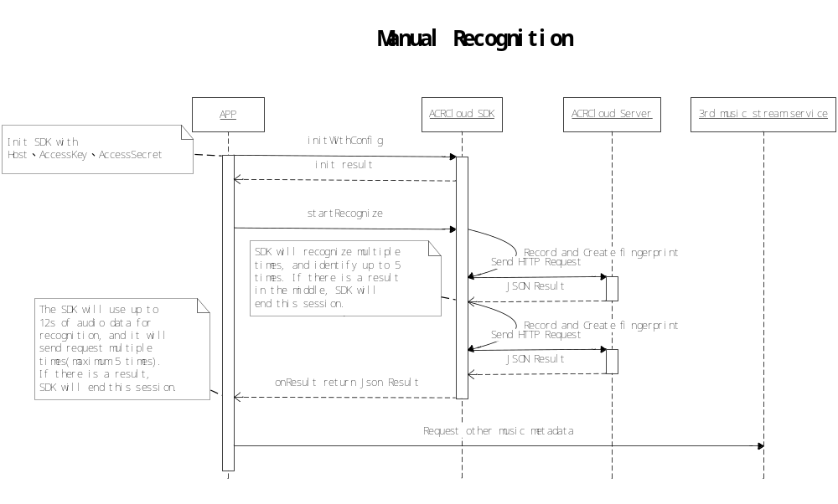

Automatic Recognition
