Local Push Stream Tool Document
- Create a monitor project in the corresponding area.
https://console.acrcloud.com/monitoring/custom
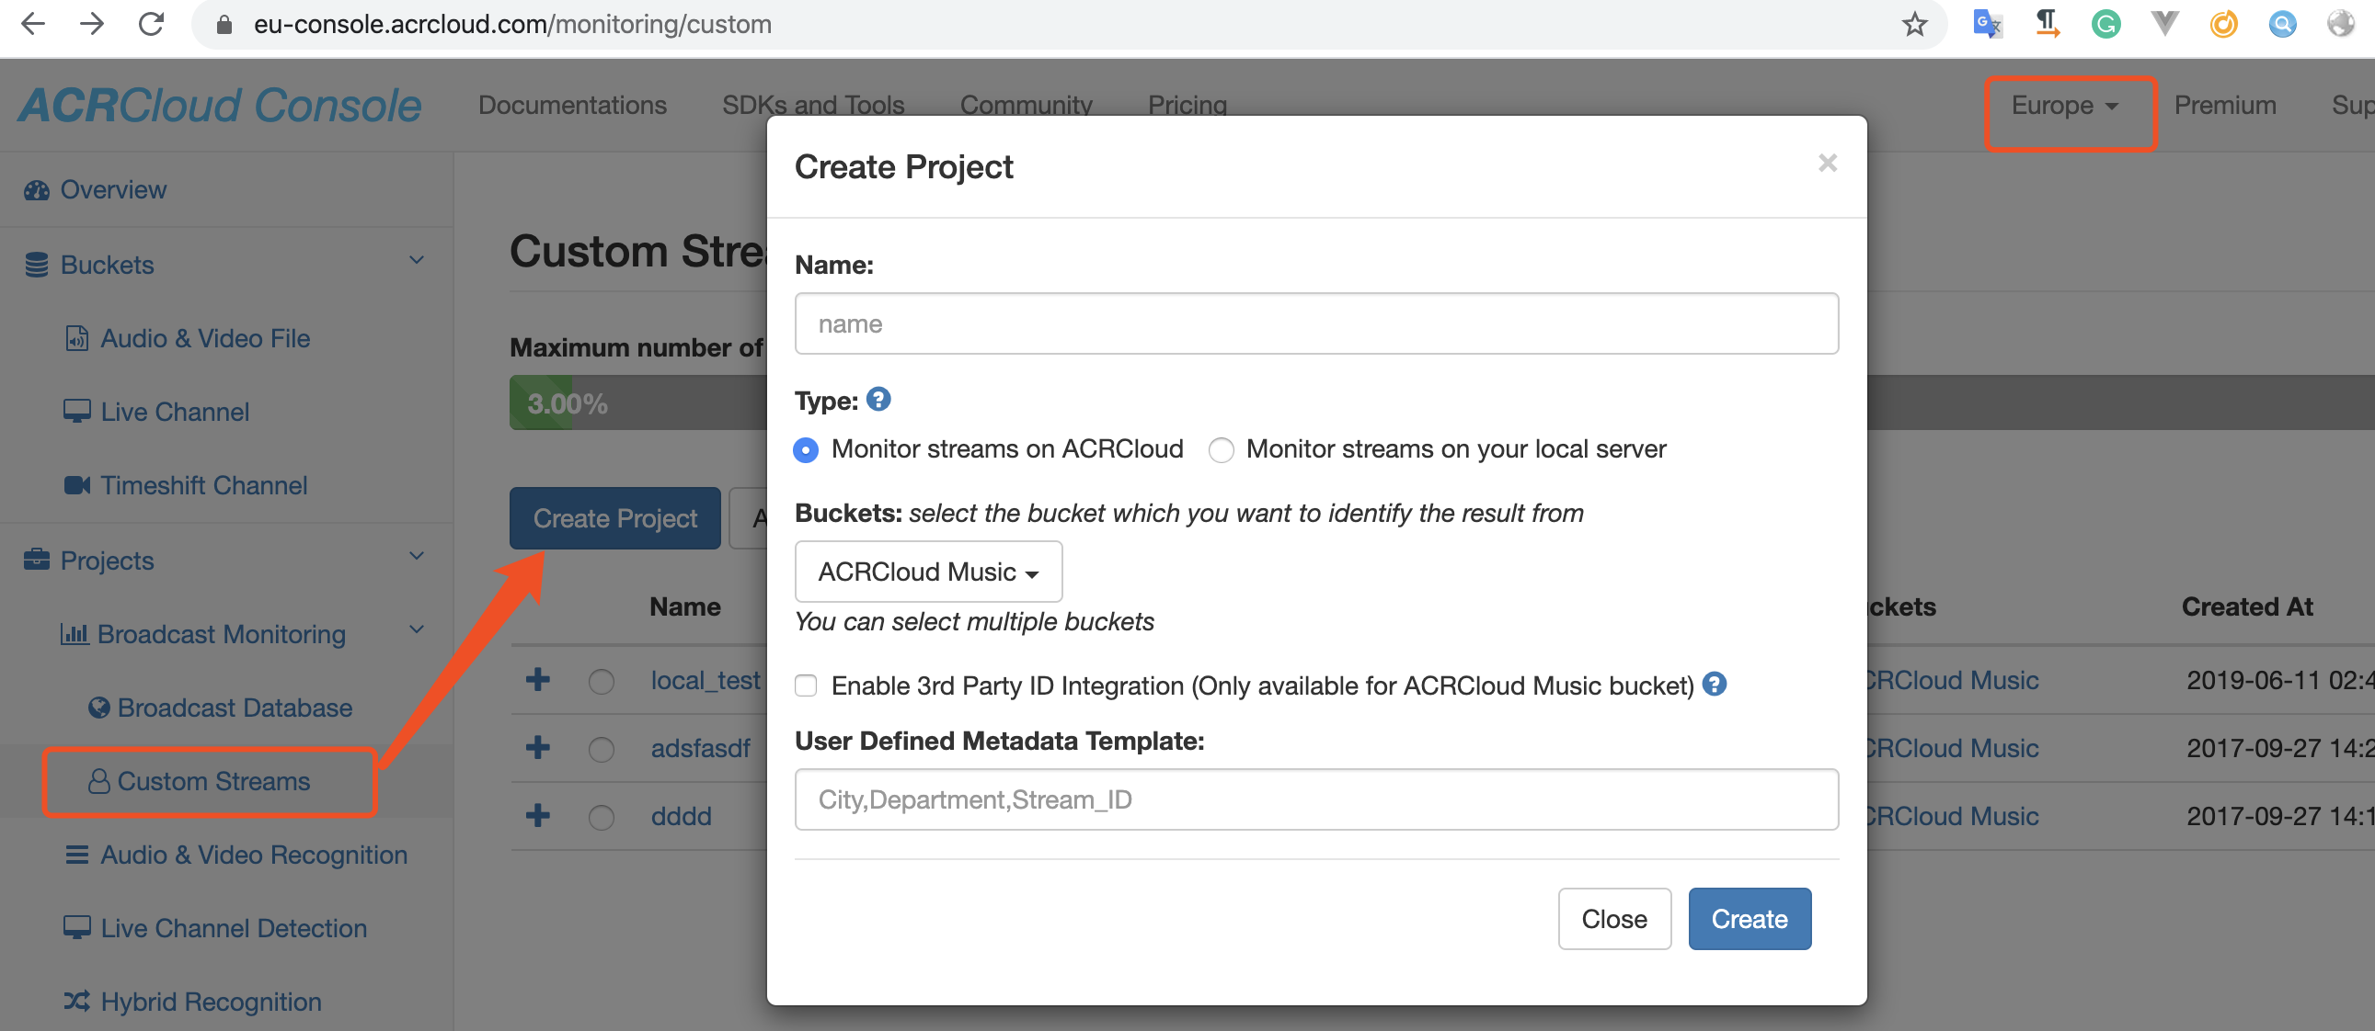
- Add your local streams to your project.
Note: If you want to push video stream, you need to add “type=video” to “User-defined Fields”. When this step is done, please contact us, we will configure some parameters for your project.
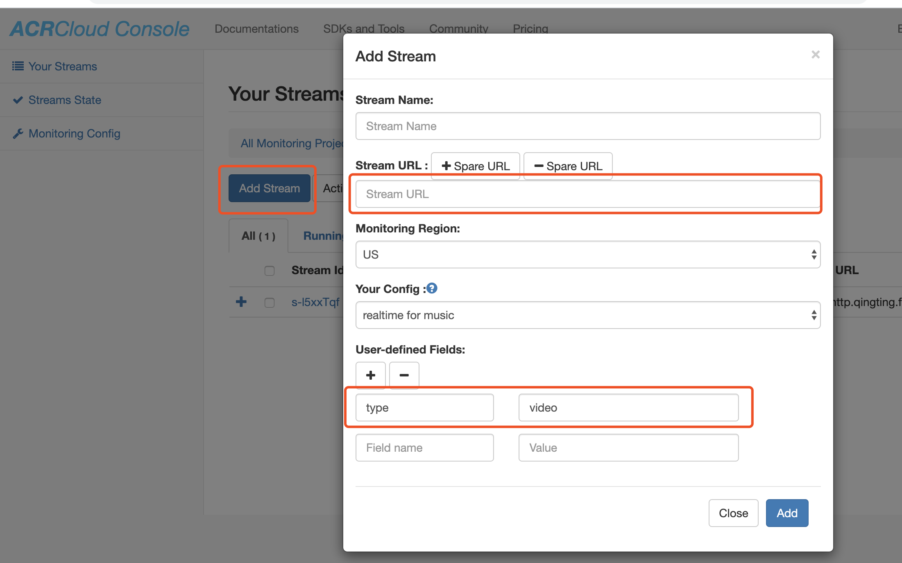
- Create account keys.
https://console.acrcloud.com/account/keys
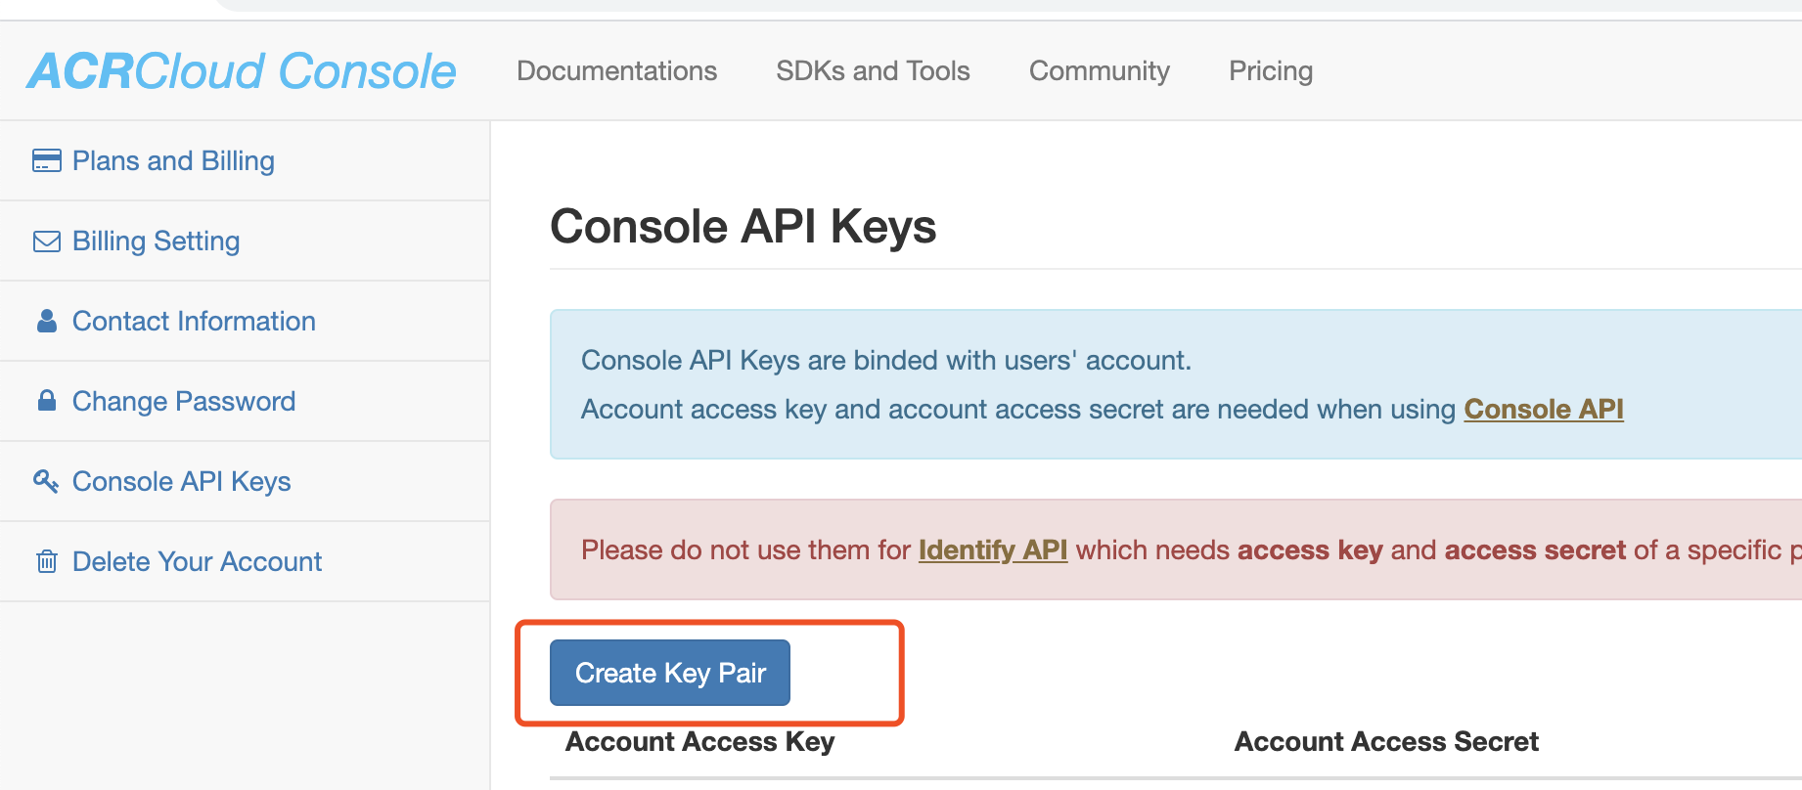
- Install FFmpeg, you can directly download the executable file.
http://ffmpeg.org/download.html
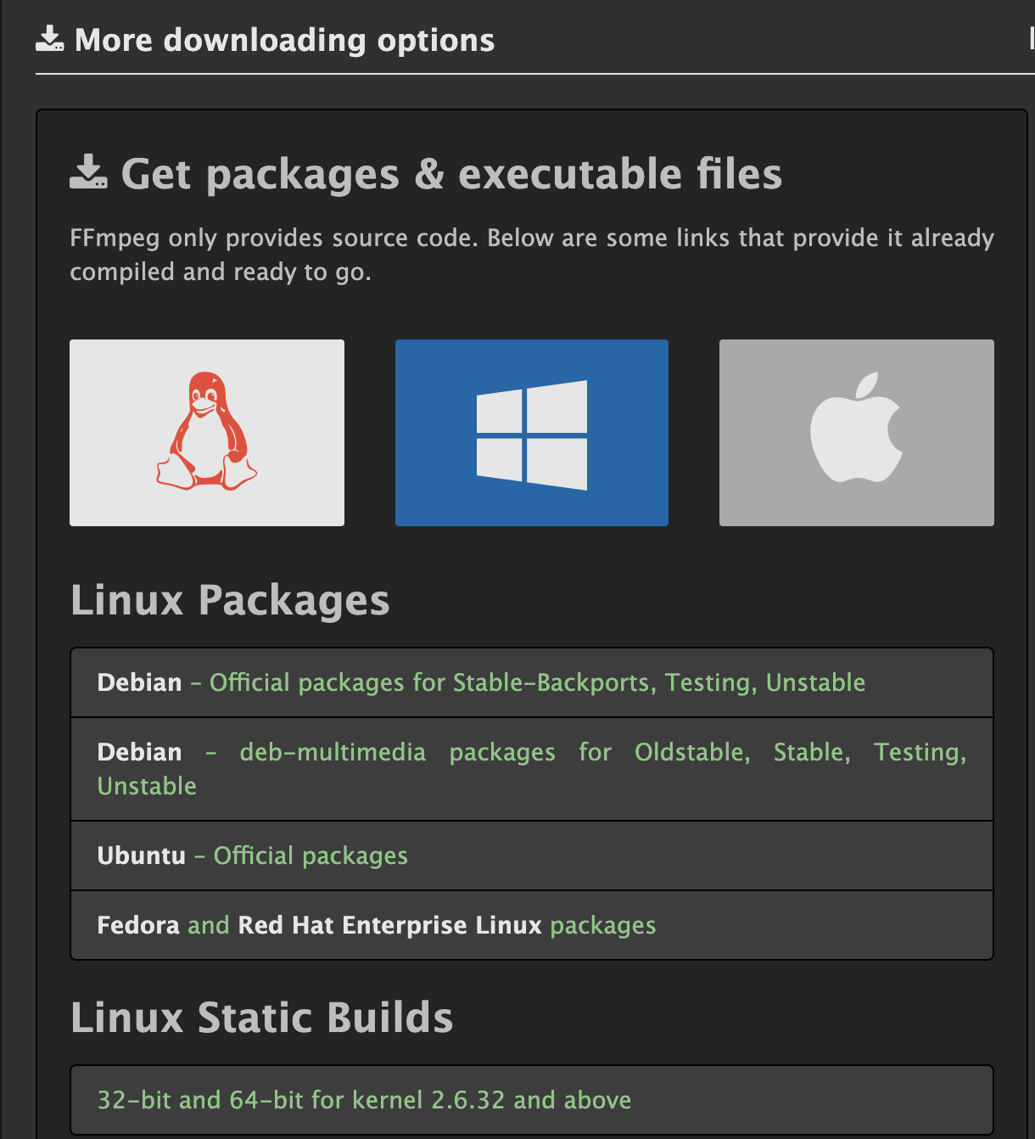
- Download the push tool and update “config.ini”
account_access_key: your account’s key, you can view it on https://console.acrcloud.com/account/keys
account_access_secret: your account’s secret, you can view it on https://console.acrcloud.com/account/keys
project_name: your project’s name.
push_tool: the path of ffmpeg in your OS, you can also add this path to $PATH, and configure “push_tool = ffmpeg”.
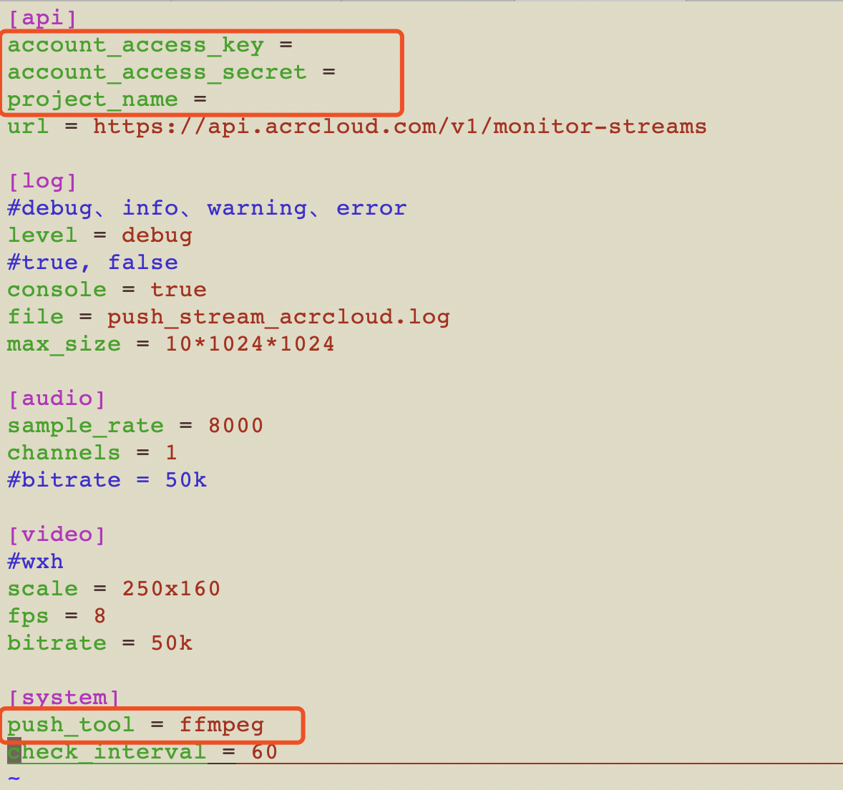
- Run the push tool with “start.sh”, you can also stop it with “stop.sh”
- Check your streams is “Running”, If no, please contact us.

