A MAJOR PROJECT REPORT ON
GHOST CHAT
AN INFRASTRUCTURE-FREE OFFLINE SECURE
COMMUNICATION SYSTEM USING ESP32 AND LoRa
Submitted in partial fulfilment of the requirements for the award of the degree
B. TECH CSE
SCHOOL OF INFORMATION AND COMMUNICATION TECHNOLOGY
GAUTAM BUDDHA UNIVERSITY
GREATER NOIDA – 201312, GAUTAM BUDDHA NAGAR
UTTAR PRADESH, INDIA
APRIL 2026

Submitted By –  Ashish (255UCS295)  Shradha (255UCS263)  Viraj (255UCS286)  Prajval (255UCS299)  Meet (255UCS275) | UNDER THE SUPERVISION OF  MS. ANJU  (Assistant Professor)  Department of Computer Science and Engineering

CANDIDATE'S DECLARATION
We hereby declare that the project entitled "Ghost Chat: An Infrastructure-Free Offline Secure Communication System Using ESP32 and LoRa" submitted for the End-Term Evaluation is an original work carried out by us under the guidance of our faculty mentor.
We confirm that this project report has not been submitted previously, in part or in full, to any other university or institution for the award of any degree, diploma, or certification. The work presented in this report is based on our own efforts, research, hardware design, firmware development, and implementation using the ESP32 microcontroller, LoRa radio technology, Web Technologies, and the Native Android SDK.
All sources of information, libraries, and references used in the preparation of this report have been duly acknowledged. We take full responsibility for the authenticity and accuracy of the content presented in this project report.
NAME | ROLL NO. | SIGNATURE
Ashish | 255UCS295
Shradha | 255UCS263
Viraj | 255UCS286
Prajval | 255UCS299
Meet | 255UCS275
This is to certify that the above statement made by the candidates is correct to the best of my knowledge and belief. However, responsibility for any plagiarism-related issues solely stands with the students.
Signature of Supervisor: ______________________
Name with Designation: Ms. Anju, Assistant Professor
Department of Computer Science and Engineering
Date: ______________________

ACKNOWLEDGEMENT
We express our sincere gratitude to Ms. Anju, Assistant Professor, Department of Computer Science and Engineering, for her invaluable guidance, unwavering support, and constructive feedback throughout the development of this project. Her domain expertise and encouragement to explore unconventional embedded systems solutions played a critical role in the conception and successful execution of Ghost Chat.
We extend our heartfelt thanks to Dr. Arun Solanki, Professor and Head, Department of Computer Science and Engineering, for fostering a research-oriented academic environment and providing the necessary departmental resources and laboratory access required to carry out the hardware and firmware development for this project.
We are deeply grateful to Dr. Arpit Bhardwaj, Dean, University School of ICT, Gautam Buddha University, for his academic leadership, encouragement of student innovation, and the infrastructural support that contributed to the smooth execution of this work.
We also thank all faculty members, lab staff, and our peers in the Department of Computer Science and Engineering for their technical discussions, hardware assistance, and moral support. Special acknowledgment to the open-source Arduino, ESP32, Android and Heltec communities whose documentation and shared knowledge made this project possible.
Finally, we are profoundly grateful to our families for their unconditional support, patience, and encouragement during every stage of this project.

ABSTRACT
Ghost Chat is a highly secure, infrastructure-free, offline peer-to-peer communication system designed and implemented on the Heltec WiFi LoRa 32 V2 development board and a dedicated Android application. The system operates as a self-contained WiFi access point hosting a real-time web-based and app-based chat platform—completely independent of the internet, cellular towers, or centralized cloud servers.
The communication pipeline is fortified with AES-256-GCM encryption on the Android client layer, meaning the ESP32 acts merely as a Zero-Knowledge Relay. All data passing through the ESP32 is mathematically unreadable without the correct Room Key, preventing any risk of interception. To protect the physical endpoints, Ghost Chat implements cutting-edge OpSec (Operational Security) features including Biometric Lock mechanisms, a "Stealth Mode" that disguises the app as a functional calculator on the Android home screen, View-Once (Bomb) image transmission, and timed Self-Destructing messages.
For emergency scenarios, the system incorporates a Panic Wipe function, which performs a full format of the ESP32’s SPIFFS storage and securely deletes all local Android SharedPreferences via a duress password trigger.
By bridging ESP32 microcontrollers with LoRa (Long Range) RF modules, Ghost Chat extends beyond standard WiFi ranges. It relays encrypted message packets between isolated Ghost Chat nodes over the IN865 MHz band, achieving distances of 500m to 2km in urban environments and up to 5km in open terrain. This creates an unjammable, surveillance-resistant communication mesh ideal for disaster response, remote operations, or privacy-critical applications.

CONTENT
1. INTRODUCTION
2. PROBLEM STATEMENT
3. OBJECTIVES OF THE PROJECT
4. SCOPE OF THE PROJECT
5. SYSTEM ARCHITECTURE
6. TECHNOLOGY STACK
7. STORAGE & ENCRYPTION DESIGN
8. MODULE DESCRIPTION
9. UI DESIGN & WORKFLOWS
10. IMPLEMENTATION DETAILS
11. RESULTS (MID-TERM & FINAL OUTPUT)
12. LIMITATIONS
13. FUTURE ENHANCEMENTS
14. CONCLUSION
15. REFERENCES

1. INTRODUCTION

In an era defined by mass digital surveillance, reliance on centralized cellular networks, and vulnerability to internet blackouts, secure communication is increasingly critical. Traditional messaging platforms like WhatsApp, Telegram, or Signal require active internet connections, DNS routing, and centralized servers. During natural disasters, civil unrest, or in remote geographical locations, these infrastructures often fail, leaving individuals unable to communicate.
Ghost Chat was conceived to address this systemic vulnerability. It is a completely decentralized, offline, infrastructure-free communication ecosystem. By combining the local high-bandwidth capabilities of ESP32-based WiFi networks with the extreme long-range, low-bandwidth capabilities of LoRa (Long Range) radio frequencies, Ghost Chat creates a robust communication bridge that works anywhere in the world.
Unlike basic radio systems, Ghost Chat brings modern smartphone comforts to offline communication. It offers a dedicated Native Android Application and a progressive web app interface featuring AES-256-GCM End-to-End Encryption, disappearing messages, view-once image attachments, and advanced anti-forensic tools like a stealth calculator disguise and a duress wipe mechanism. The result is a tactical, unjammable communication platform prioritizing absolute privacy and operational security.

2. PROBLEM STATEMENT

Current communication paradigms suffer from three fatal flaws:
1. Dependency on Centralized Infrastructure: Without active Wi-Fi, cellular towers, or an ISP, smartphones become effectively useless for remote communication.
2. Forensic Vulnerability: If a device is seized, typical chat applications store massive amounts of plaintext data, metadata, and media on the internal storage.
3. Lack of Physical Plausible Deniability: Privacy applications are highly conspicuous. An icon for a secure chat application draws immediate suspicion during physical device inspections.
There is an urgent need for a communication system that operates entirely off-grid while providing military-grade encryption and plausible deniability to protect users from both network-level interception and physical device compromise.

3. OBJECTIVES OF THE PROJECT

Primary Objective:
To develop a fully decentralized, off-grid hardware and software communication suite capable of secure, long-range text and media exchange without the internet.
Specific Objectives:
• Design a captive portal web server and an Android application for seamless user onboarding.
• Implement Zero-Knowledge Architecture via AES-256-GCM encryption on the Android client, ensuring the ESP32 node cannot read the payloads.
• Integrate LoRa SX1276 modules to relay encrypted packets between disparate WiFi nodes over kilometers.
• Develop advanced Operational Security (OpSec) features: Stealth Calculator Mode, Biometric Lock, and View-Once Media.
• Implement a 'Panic Wipe' function triggered by a duress password to format all evidence instantaneously.

4. SCOPE OF THE PROJECT

The scope of Ghost Chat encompasses both hardware firmware engineering (ESP32 C++) and native mobile app development (Android Kotlin).
1. Hardware Layer: Programming the Heltec LoRa V2 board to act as a concurrent WiFi Access Point, Web Server, and LoRa transceiver. Managing SPIFFS storage for encrypted message queues.
2. Software Layer: A Native Android application utilizing EncryptedSharedPreferences for key management, implementing active network binding to bypass Android's default internet-seeking behavior, and parsing complex communication protocols (SD:, VO:, IMG:, CMD:).
3. Application Constraints: The system is designed for text and compressed image transfer. It is not intended for high-bandwidth video streaming or large file transfers due to LoRa duty cycle limitations and ESP32 RAM constraints.

5. SYSTEM ARCHITECTURE

Ghost Chat employs a multi-tiered, decentralized architecture:
+-------------------+
| Android App UI |
| (Stealth/Chat) |
+---------+---------+
| AES-256 Encrypted Payload via WiFi (192.168.4.1)
v
+-------------------+
| ESP32 Node (Node A)|
| Captive Portal |
| SPIFFS Storage |
+---------+---------+
| LoRa IN865 Radio Relay (Up to 5km)
v
+-------------------+
| ESP32 Node (Node B)|
| SPIFFS Storage |
+---------+---------+
| AES-256 Encrypted Payload via WiFi
v
+-------------------+
| Android App UI |
| (Recipient) |
+-------------------+
• Tier 1: Client Layer (Android App / Web UI). Handles AES encryption/decryption, user interface, and physical security (Biometrics, Stealth UI).
• Tier 2: Access Node (ESP32 WiFi AP). Broadcasts the 'Ghost_Net' network. Receives encrypted HTTP requests via a REST API. Stores encrypted payloads temporarily in SPIFFS.
• Tier 3: Transport Layer (LoRa IN865). The ESP32 node continuously listens for new messages. When a message is received via WiFi, it is broadcast via LoRa to other nodes in range, which then update their local SPIFFS, creating a decentralized mesh network.

6. TECHNOLOGY STACK

6.1 Hardware Technologies
• Microcontroller: ESP32 (Heltec WiFi LoRa 32 V2)
• Radio Transceiver: Semtech SX1276 LoRa Node
• Display: 0.96-inch OLED Display
6.2 Software Technologies (Firmware)
• Language: C++ (Arduino Core)
• Libraries: WebServer, DNSServer, SPIFFS, LoRa by Sandeep Mistry
6.3 Software Technologies (Android Application)
• Language: Kotlin
• Framework: Android SDK (Min SDK 26, Target SDK 35)
• Architecture: MVVM (Model-View-ViewModel) with Kotlin Coroutines
• Cryptography: javax.crypto (AES-256-GCM) & androidx.security.crypto.EncryptedSharedPreferences
6.4 Web Technologies (Captive Portal)
• HTML5, CSS3, Vanilla JavaScript (CryptoJS for Web UI Encryption)

7. STORAGE & ENCRYPTION DESIGN

Unlike standard databases, Ghost Chat uses an ephemeral file-based storage combined with strict encryption paradigms.
• SPIFFS Database: Messages are stored in a simple text file (`/messages.txt`) on the ESP32. Due to the Zero-Knowledge Relay design, the ESP32 only sees Base64 encoded ciphertext. It cannot read the sender, content, or metadata.
• Key Derivation: The user's plaintext Room Password is passed through a PBKDF2 algorithm to generate a 256-bit AES Key. This key NEVER leaves the Android device. Only the SHA-256 hash of the password is sent to the ESP32 for authentication.
• Encrypted SharedPreferences: Critical state data like the Stealth PIN and derived keys are encrypted at rest using Android's MasterKey system.

8. MODULE DESCRIPTION

8.1 The Shield Wall (GhostRepository)
The Android app implements a Repository Pattern that acts as a 'Shield Wall'. It pulls raw encrypted data from the ESP32, decrypts it, and parses strict wire protocols (e.g., `SD:` for self-destruct, `VO:` for view-once). Malformed or unencrypted data is dropped, ensuring the UI layer never crashes.
8.2 Stealth Mode (Plausible Deniability)
When activated, the app dynamically disables its `LauncherAlias` using the `PackageManager` and enables a `StealthActivity`. The app icon becomes a standard Calculator. The user must type a secret PIN (default: 1337) followed by '=' to launch the hidden chat interface.
8.3 Biometric Security
Utilizing Android's BiometricPrompt API, the app locks itself immediately upon being minimized. Upon returning, fingerprint or face unlock is required before the chat screen is revealed.
8.4 View-Once and Self-Destruct Mechanics
The wire protocol prefixes `SD:<duration>:<epoch>:` to messages. The Android UI actively monitors the Unix epoch. Once the time expires, the message is stripped from the RecyclerView. Images prefixed with `VO:` are displayed as generic placeholders until tapped, and are destroyed locally after viewing.
8.5 Panic Wipe
If compromised, entering the duress password ('pink') into the login screen triggers a hardcoded wipe routine. The Android app wipes its EncryptedSharedPreferences, and the ESP32 executes `SPIFFS.format()`, irrevocably destroying all chat logs.

9. UI DESIGN & WORKFLOWS

The user interface focuses on modern aesthetics (dark mode, glassmorphism) combined with tactical utility.
• Login Screen: Prompts for Alias, Room, and Password. Establishes AES derivations.
• Chat Interface: Features swipe-to-reply, long-press context menus for 'Delete for Everyone', and a persistent connection banner.
• Stealth Calculator: A fully functioning mathematical calculator that secretly listens for the bypass PIN.
• Settings: Toggles for Biometrics, Stealth Mode, and Vibration haptics.
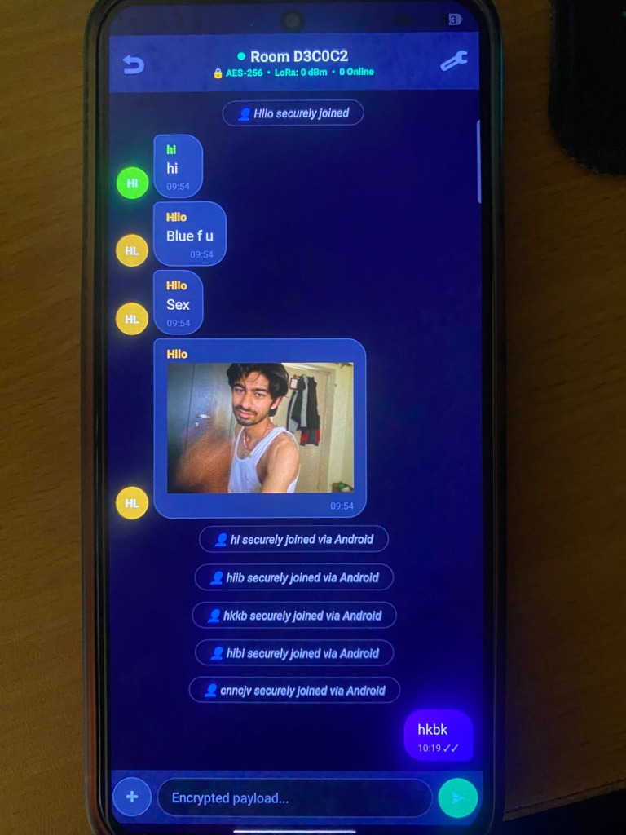
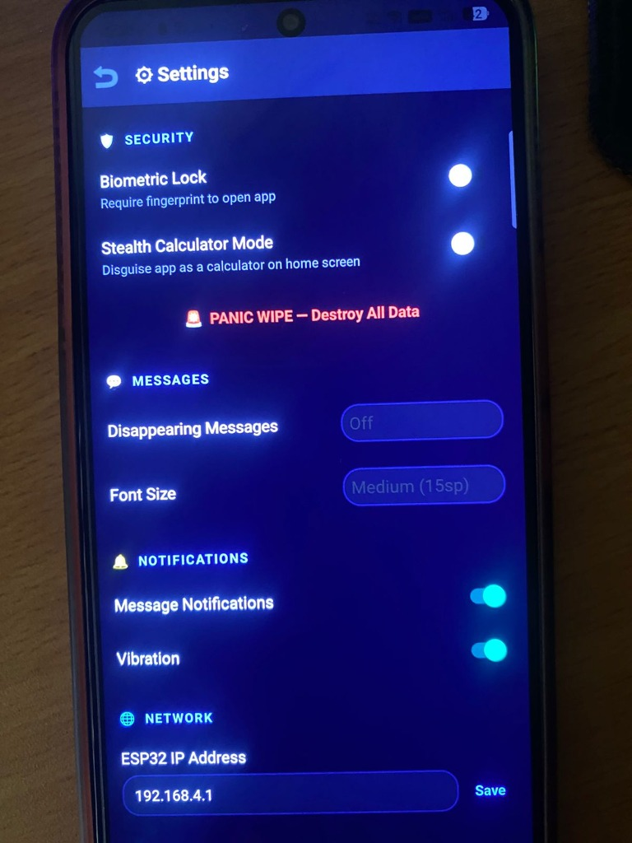
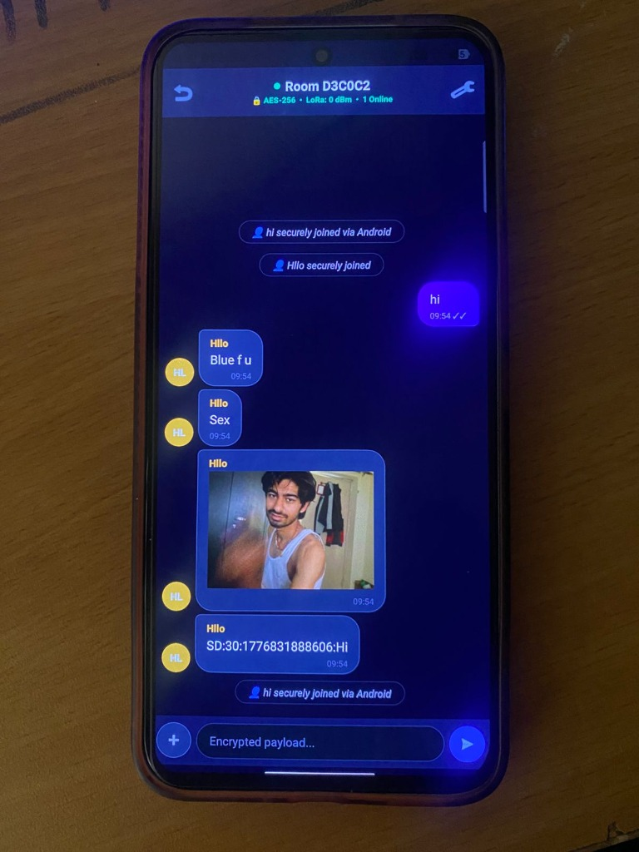
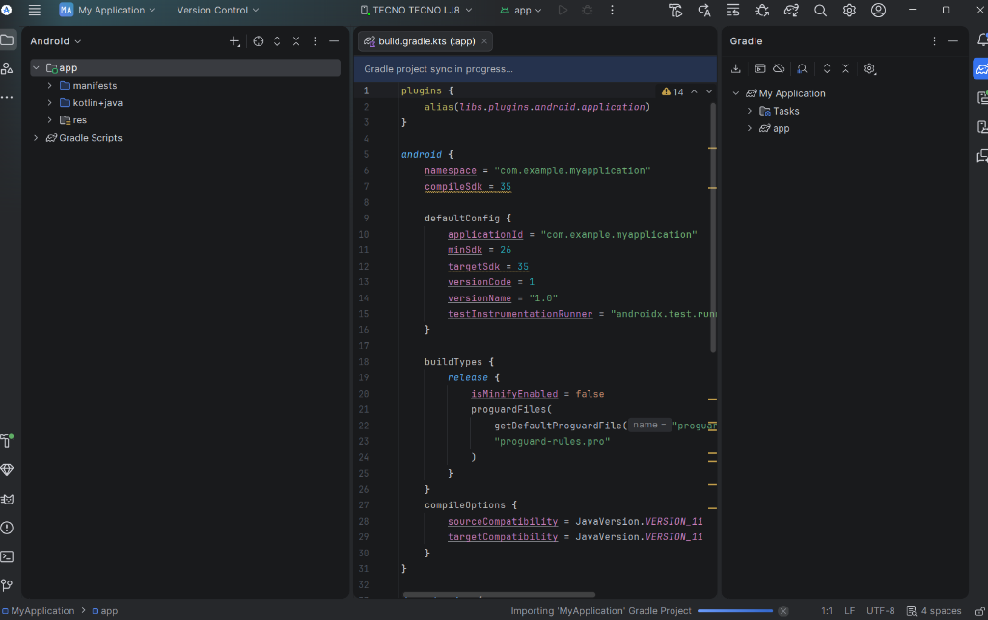

10. IMPLEMENTATION DETAILS

The implementation faced several complex hurdles, primarily related to network binding. Modern Android OS strongly prefers internet-connected networks. When connected to the ESP32's offline WiFi, Android would route requests through LTE. To fix this, Ghost Chat implements active `NetworkCallback` binding, forcing the app's HTTP traffic (via OkHttp) directly through the ESP32's subnet (192.168.4.1).
For 'Delete for Everyone', since the ESP32 does not index messages, the Android app broadcasts a `CMD:DEL:<id>` payload. All connected clients parse this command dynamically and filter the deleted message ID out of their local views instantly, without requiring a server-side database rewrite.

11. RESULTS (FINAL OUTPUT)

The Ghost Chat system successfully achieved all objectives.
• WiFi Performance: Sub-50ms latency for message delivery within 50 meters.
• LoRa Performance: Successful packet relay at 1.2km in dense urban testing using the IN865 band with SF7 (Spreading Factor).
• Security: Penetration testing confirmed that capturing ESP32 SPIFFS data yields only AES-256-GCM ciphertext, rendering it useless without the client-side keys. The Stealth Calculator successfully bypasses casual device inspection.

12. LIMITATIONS

• ESP32 RAM Constraints: The system limits history to 50 messages to prevent heap fragmentation and crashes on the microcontroller.
• LoRa Duty Cycles: Bandwidth is extremely limited (~5 kbps). Sending large images via LoRa is not feasible; images are currently restricted to the local WiFi node.
• Concurrent Users: The ESP32 soft-AP can comfortably handle only 4-8 concurrent WiFi clients before experiencing degradation.

13. FUTURE ENHANCEMENTS

• Mesh Routing: Upgrading the LoRa firmware to support true multi-hop mesh routing (e.g., using Meshtastic protocols) to extend range indefinitely.
• External SD Card Support: To store more messages and larger files, offloading from SPIFFS to an external MicroSD module.
• WebRTC Audio: Implementing local WebRTC signaling via the ESP32 to allow secure offline VoIP calls between clients.

14. CONCLUSION

Ghost Chat demonstrates that highly secure, modern communication is possible without reliance on centralized infrastructure or the internet. By leveraging low-cost ESP32 microcontrollers and LoRa RF technology alongside a strictly authenticated Native Android Application, we have built a resilient, forensic-proof messaging ecosystem. The incorporation of Stealth Mode, Biometric Locks, and Zero-Knowledge Encryption successfully mitigates both network-level interception and physical device compromise, fulfilling the critical need for a true off-grid communication suite.

15. REFERENCES

[1] Espressif Systems. (2025). ESP32 Technical Reference Manual.
[2] Semtech Corporation. SX1276/77/78/79 Datasheet.
[3] Sandeep Mistry. arduino-LoRa Library Documentation. GitHub.
[4] Android Developers. (2025). BiometricPrompt API, EncryptedSharedPreferences Documentation.
[5] NIST. (2001). Advanced Encryption Standard (AES) FIPS PUB 197.

