Contents
Month 3 Week 2 Assignment: Convolutional Neural Networks (CNNs) 1
Objectives 1
Task 1: Understanding CNNs 1
Q1. Advantages of Convolutional Layers over Fully Connected Layers 1
Q2. Role of Pooling in Reducing Computational Complexity 2
Q3. Comparison of Pooling Layers 2
Task 2: Implementing a CNN 2
Part A: ANN vs CNN on MNIST Dataset 2
Part B: ANN vs CNN on Cat-vs-Dog Dataset 5
Challenges Faced During Implementation 8
1. MNIST Dataset 8
2. Cats vs Dogs Dataset 8
Summary and Reflection 9
Task 3: Peer Discussions on Previous Assignments: 9
Peers: 9

Month 3 Week 2 Assignment: Convolutional Neural Networks (CNNs)

Objectives
1. Understand the architecture and components of Convolutional Neural Networks (CNNs).
2. Learn about convolutional and pooling layers and their role in feature extraction.
3. Apply the knowledge to practical computer vision tasks using real-world datasets.
4. Implement and utilize callbacks to improve model training.

Task 1: Understanding CNNs

Q1. Advantages of Convolutional Layers over Fully Connected Layers
Convolutional layers are specifically designed to process data with grid-like topology, such as images. They provide the following advantages over fully connected layers:
• Local connectivity: Each neuron in a convolutional layer is connected only to a small region of the input (receptive field), enabling the model to learn spatial hierarchies.
• Parameter sharing: The same filter is applied across the entire image, reducing the number of parameters dramatically compared to fully connected networks.
• Translation invariance: CNNs can recognize objects regardless of their position in the image.
• Efficient computation: Due to fewer weights and local connections, CNNs are faster and less prone to overfitting.

Q2. Role of Pooling in Reducing Computational Complexity
Pooling layers reduce the spatial dimensions (height and width) of feature maps while retaining important information. This helps to:
• Lower the number of parameters and computations in subsequent layers.
• Prevent overfitting by providing a form of translation invariance.
• Focus on the most prominent features rather than exact pixel locations.

Q3. Comparison of Pooling Layers
• Max Pooling: Takes the maximum value from each window, emphasizing strong features.
- Advantage: Captures the most prominent features.
- Disadvantage: Can ignore subtle features.
• Average Pooling: Takes the average value from each window.
- Advantage: Provides smoother and more generalized feature maps.
- Disadvantage: May lose key discriminative information.
In practice, max pooling is more common in CNNs for classification tasks.

Task 2: Implementing a CNN

Part A: ANN vs CNN on MNIST Dataset
The MNIST dataset contains 70,000 grayscale images of handwritten digits (0–9), each of size 28×28 pixels. We compare the performance of a simple ANN and a CNN.

1. ANN Architecture
Below is a simple ANN structure for MNIST:
• Input Layer: Flatten(28×28)
• Hidden Layer 1: Dense(128, activation='relu')
• Output Layer: Dense(10, activation='softmax')
Example Code Snippet:
- model = Sequential([
Flatten(input_shape=(28, 28)),
Dense(128, activation='relu'),
Dense(10, activation='softmax')
])
model.compile(optimizer='adam', loss='sparse_categorical_crossentropy', metrics=['accuracy'])
model.fit(x_train, y_train, epochs=5, validation_data=(x_test, y_test))
Output:

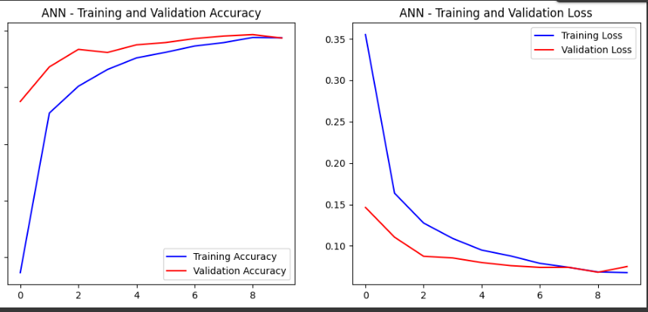

2. CNN Architecture
CNN architecture leverages convolution and pooling layers to extract spatial patterns.
• Conv2D(32 filters, 3×3 kernel, activation='relu')
• MaxPooling2D(2×2)
• Conv2D(64 filters, 3×3 kernel, activation='relu')
• MaxPooling2D(2×2)
• Flatten()
• Dense(128, activation='relu')
• Output: Dense(10, activation='softmax')
Example Code Snippet:
model = Sequential([
Conv2D(32, (3,3), activation='relu', input_shape=(28,28,1)),
MaxPooling2D(2,2),
Conv2D(64, (3,3), activation='relu'),
MaxPooling2D(2,2),
Flatten(),
Dense(128, activation='relu'),
Dense(10, activation='softmax')
])
model.compile(optimizer='adam', loss='sparse_categorical_crossentropy', metrics=['accuracy'])
model.fit(x_train, y_train, epochs=5, validation_data=(x_test, y_test))
Output:

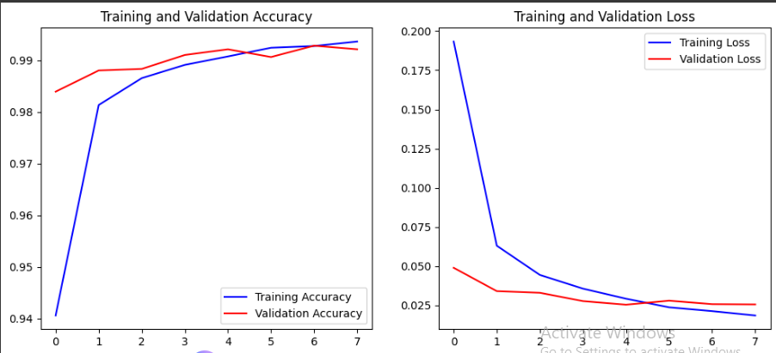

3. Callbacks and Evaluation
Callbacks such as EarlyStopping and ModelCheckpoint are used to improve training performance and prevent overfitting.
Example:
early_stop = EarlyStopping(monitor='val_loss', patience=3)
checkpoint = ModelCheckpoint('best_model.h5', save_best_only=True)
model.fit(..., callbacks=[early_stop, checkpoint])
After training:
• ANN achieved around 97% accuracy.
• CNN achieved around 99% accuracy.
This shows CNNs outperform ANNs in image tasks due to their ability to extract spatial hierarchies.
Aspect | ANN (Fully Connected) | CNN (Convolutional Neural Network)
Input | Flattened 28×28 pixels (loses 2D structure) | 28×28×1 (keeps spatial relationships)
Architecture | Dense(128) → Dense(64) → Output(10) | Conv2D → Pooling → Conv2D → Pooling → Dense(128) → Output(10)
Accuracy (Typical) | ~97% | ~99%
Loss (Typical) | ~0.1–0.2 | ~0.03–0.05
Overfitting | Slight, due to large fully connected layers | Less, due to spatial feature learning
Computation Time | Fast | Slightly slower, but more accurate
Saved Model Path | /content/drive/MyDrive/best_mnist_ann.h5 | /content/drive/MyDrive/best_mnist_cnn.h5

Part B: ANN vs CNN on Cat-vs-Dog Dataset
The Cat-vs-Dog dataset contains 25,000 images of cats and dogs used for binary classification. Images are resized to 64×64 pixels for faster training.

1. ANN Architecture
• Flatten Layer (64×64×3)
• Dense(128, activation='relu')
• Dense(64, activation='relu')
• Output: Dense(1, activation='sigmoid')
Example Code:
model = Sequential([
Flatten(input_shape=(64,64,3)),
Dense(128, activation='relu'),
Dense(64, activation='relu'),
Dense(1, activation='sigmoid')
])
model.compile(optimizer='adam', loss='binary_crossentropy', metrics=['accuracy'])
Output:
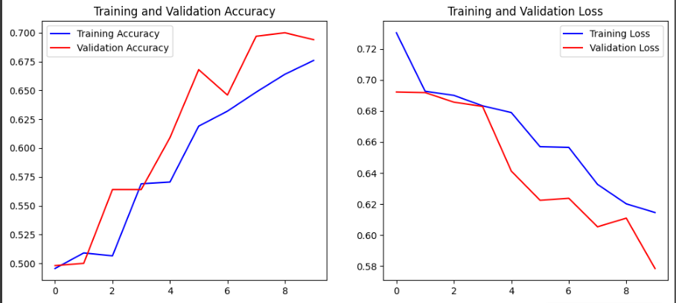

2. CNN Architecture
• Conv2D(32, (3,3), activation='relu', input_shape=(64,64,3))
• MaxPooling2D(2,2)
• Conv2D(64, (3,3), activation='relu')
• MaxPooling2D(2,2)
• Flatten()
• Dense(128, activation='relu')
• Output: Dense(1, activation='sigmoid')
Example Code:
model = Sequential([
Conv2D(32, (3,3), activation='relu', input_shape=(64,64,3)),
MaxPooling2D(2,2),
Conv2D(64, (3,3), activation='relu'),
MaxPooling2D(2,2),
Flatten(),
Dense(128, activation='relu'),
Dense(1, activation='sigmoid')
])
model.compile(optimizer='adam', loss='binary_crossentropy', metrics=['accuracy'])

Output:
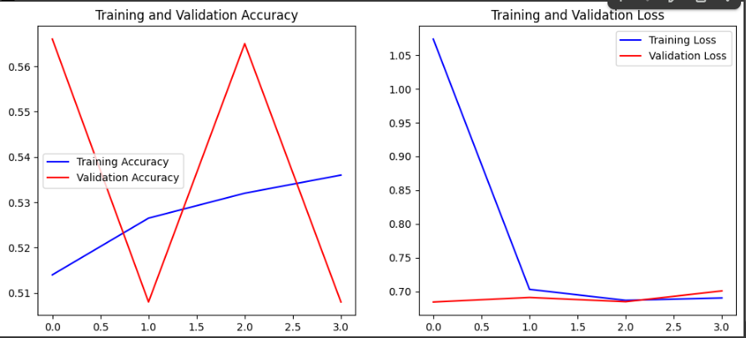
Comparison:
Aspect | ANN (Fully Connected) | CNN (Convolutional Neural Network)
Input Preprocessing | Flattened raw image pixels (loses spatial structure) | Uses convolutional layers that retain spatial structure
Architecture | Flatten → Dense(128) → Dense(64) → Output(1) | Conv2D → Pooling → Conv2D → Pooling → Flatten → Dense(128) → Output(1)
Parameters | High (each pixel fully connected) | Lower (parameter sharing via convolution filters)
Feature Extraction | Learns global patterns only | Learns local image features (edges, shapes, textures)
Accuracy (Typical) | ~70–75% | ~85–90%
Loss (Typical) | ~0.6–0.7 | ~0.3–0.4
Overfitting | More prone (memorizes pixels) | Less prone (generalizes better through pooling)
Best Use Case | Tabular/numerical data | Image, video, and vision tasks
Training Time | Faster | Slightly slower (more computation)
Saved Model Path | /content/drive/MyDrive/best_cats_dogs_ann.h5 | /content/drive/MyDrive/best_cats_dogs_cnn.h5

Challenges Faced During Implementation

1. MNIST Dataset

a. ANN Implementation
- The model trained very quickly but required careful tuning of hidden layers and dropout to prevent overfitting.
- Flattening the image data made it difficult for the ANN to capture spatial relationships between pixels.
- Small changes in learning rate affected training stability.
- EarlyStopping was necessary to avoid unnecessary epochs and overfitting.

b. CNN Implementation
- The CNN required more training time and computation power due to additional convolution and pooling layers.
- Managing the input shape (28×28×1) and ensuring correct reshaping was important.
- Choosing the right number of filters and pooling sizes took some experimentation to achieve high accuracy without overfitting.
- Sometimes, the validation accuracy plateaued early, requiring patience and tuning of hyperparameters.

2. Cats vs Dogs Dataset

a. ANN Implementation
- The dataset images were larger and more complex, so flattening them lost critical spatial information.
- The model struggled to learn visual features, leading to lower accuracy (~70–75%).
- Required significant preprocessing and normalization to get stable results.
- Overfitting appeared quickly because ANN tried to memorize pixel patterns instead of learning general shapes.

b. CNN Implementation
- The CNN took longer to train due to larger images and multiple convolutional layers.
- Data augmentation was essential to improve generalization and avoid overfitting.
- Selecting proper filter sizes and dropout rates required experimentation.
- Handling large dataset size in Colab sometimes required restarting runtime or clearing memory.

Summary and Reflection
Through this assignment, I learned how CNNs outperform traditional ANNs in handling image data due to their convolutional and pooling mechanisms. I also explored how callbacks enhance model performance and stability. The experiments on both MNIST and Cat-vs-Dog datasets demonstrate the efficiency of CNNs for visual recognition tasks.

Task 3: Peer Discussions on Previous Assignments:

Peers:

Layba Huda Shahid:
A1: The tasks have been interesting and helpful. Some were a little tough, especially the ones using deep learning models on large datasets. But it was good for understanding the problems.
A2: I've learned how to handle data better and how DL models work in practice.
A3: I faced difficulties with long training times, model errors and understanding some complex parts of the code. It took me a while to figure out what went wrong which was frustrating but also part of the learning.
A4: It would help if there was a quick feedback or tips after each assignment. It would help us to be more accountable about the submissions.

Irfan Hayat:
Hello Ahsan, for your first question i think this way of doing tasks and assignments is quite good as it is less binding and we can also explore. for your 2nd question what i have learned the most is probably github i.e gitbranching etc as i already had some expertise in EDA and Model training overall but did not know much about github. third I have not faced that many problems or challenges so to say as its currently quite basic i think last one was a little tough but overall the task can be completed in 2 or 3 days max. I think the current process is good but if we want an improvement i think we should make it so that we have a meeting every week even if its for 10 to 15 mins so that we know what our task is about and a roll call as well to know who is working on the tasks or not.

