Week 4 Assignment Report – Buildable ML/DL Fellowship
This report covers two major machine learning tasks:
- Classification (Weather Data)
- Regression (PakWheels Used Cars)
Contents
Part A – Classification: Weather Data 2
1. Introduction 2
2. Data Cleaning & Preparation 2
3. Exploratory Data Analysis & Visualization 2
4. Model Building 2
5. Model Evaluation 2
6. Conclusion 2
Part B – Regression: PakWheels Used Cars 3
1. Introduction 3
2. Data Cleaning & Preparation 3
3. Exploratory Data Analysis & Visualization 3
4. Model Building 3
5. Model Evaluation 3
6. Conclusion 3
Outputs 4

Part A – Classification: Weather Data

1. Introduction
The weather dataset consists of both numerical and categorical features. The target variable is `Weather Type`, which includes categories such as Sunny, Rainy, Cloudy, and Snowy. The objective of this task is to predict the weather type using machine learning classification models.

2. Data Cleaning & Preparation
- Handled anomalies such as humidity values greater than 100% and extreme wind speeds.
- Encoded categorical features (`Season`, `Cloud Cover`, `Location`).
- Normalized numerical features to ensure consistency.
- Performed an 80/20 train-test split with stratification.

3. Exploratory Data Analysis & Visualization
- Summary statistics (mean, median, standard deviation) revealed seasonal weather trends.
- Histograms showed distributions for temperature, humidity, and wind speed.
- Scatter plots identified negative correlation between temperature and humidity, and positive correlation between humidity and precipitation.
- Box plots highlighted outliers in wind speed and UV index.
- Correlation heatmap confirmed strong feature interactions.

4. Model Building
- Logistic Regression: baseline, interpretable linear model.
- Decision Tree: captured non-linear relationships.
- Random Forest: ensemble approach providing robust generalization.

5. Model Evaluation
Evaluation metrics were accuracy, precision, recall, and F1-score.
Model | Accuracy | Precision | Recall | F1-Score
Logistic Regression | 86.6% | 86.7% | 86.6% | 86.6%
Decision Tree | 90.4% | 90.4% | 90.4% | 90.4%
Random Forest | 91.6% | 91.6% | 91.6% | 91.6%

6. Conclusion
Random Forest achieved the best performance, offering a balance between accuracy and generalization. EDA confirmed important correlations (e.g., Humidity–Precipitation, Temperature–Visibility). Future work includes hyperparameter tuning and advanced ensemble methods such as XGBoost or LightGBM.

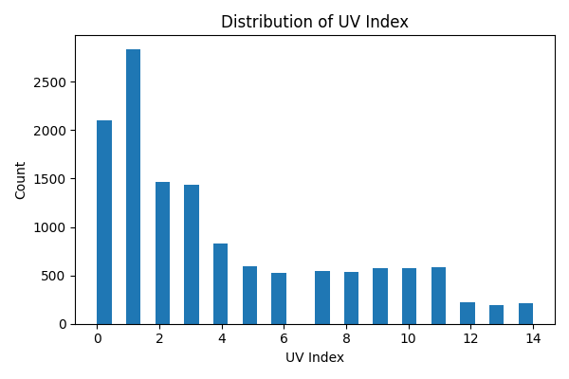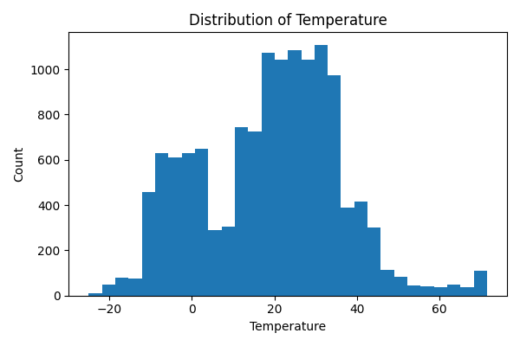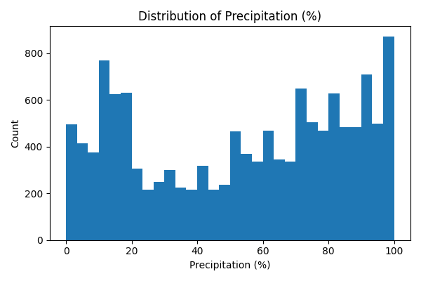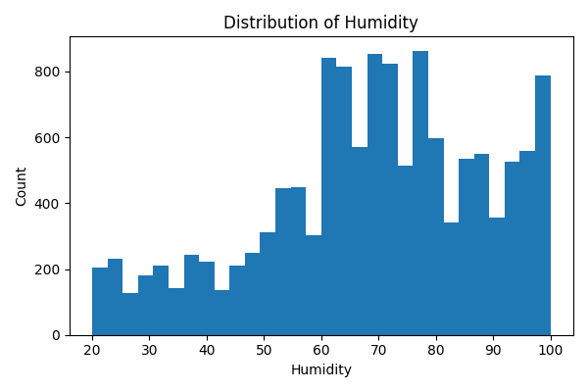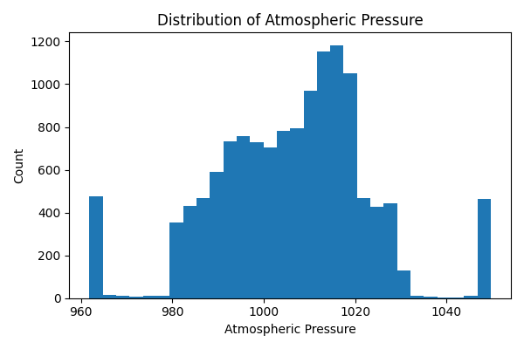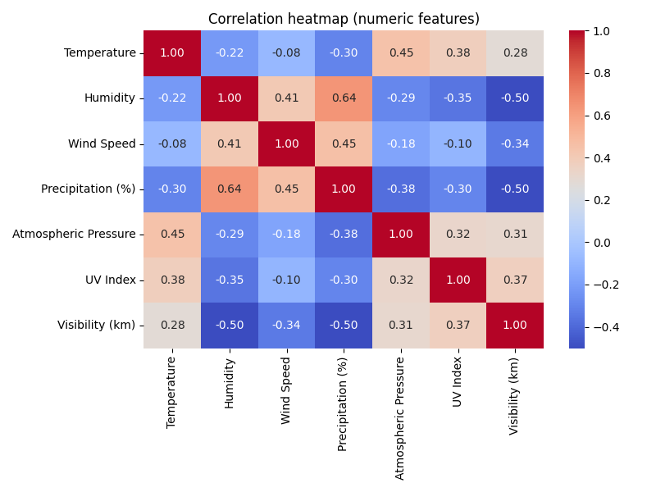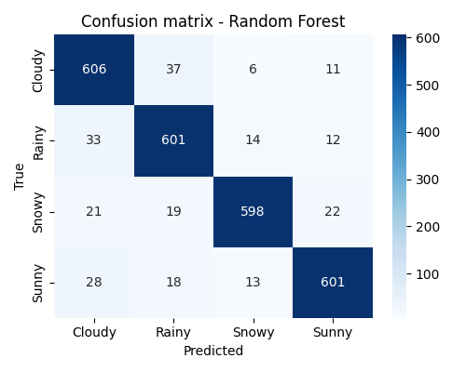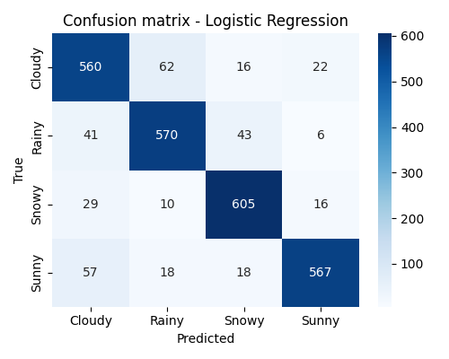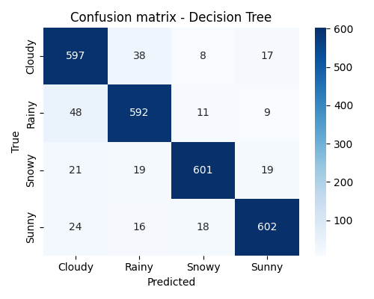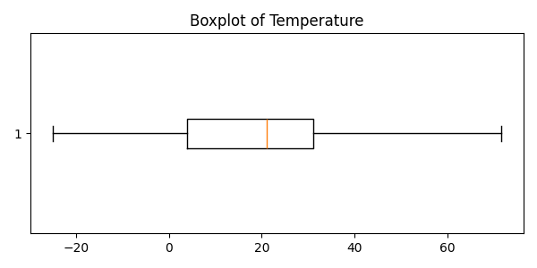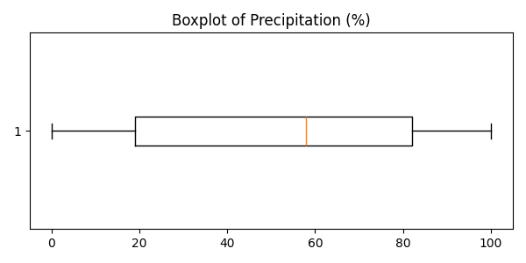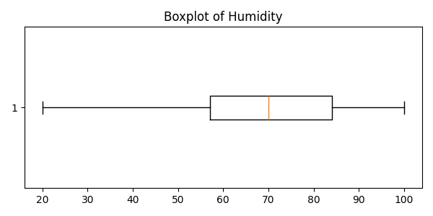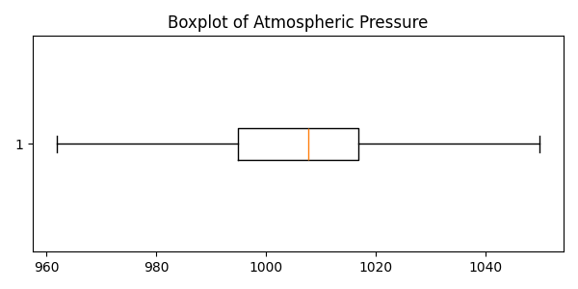

Part B – Regression: PakWheels Used Cars

1. Introduction
The PakWheels dataset contains over 78,000 used car listings with 13 features, including car make, model, year, engine capacity, and mileage. The target variable is `Price` (continuous). The objective is to predict car prices using regression techniques.

2. Data Cleaning & Preparation
- Missing values handled (median for numeric features, mode for categorical features).
- Outliers capped in variables like mileage and price.
- Feature engineering included applying a log transformation on `Price` to reduce skewness.
- One-hot encoding applied to categorical variables such as fuel type and transmission.
- Normalization applied to numerical features for consistency.

3. Exploratory Data Analysis & Visualization
- Summary statistics showed a median car price of ~4.5M PKR with large variance.
- Histograms revealed mileage distribution skewed towards lower values for newer cars.
- Scatter plots: newer cars and higher engine capacity strongly correlated with higher price.
- Box plots by body type highlighted price differences across categories.
- Correlation heatmap confirmed that price is most correlated with `Year` and `Engine CC`.

4. Model Building
A Random Forest Regressor was trained on the cleaned and processed dataset. Random Forest was chosen for its ability to handle non-linear relationships and large datasets.

5. Model Evaluation
- Root Mean Squared Error (RMSE) was used as the main evaluation metric.
- Residual plots indicated a fairly random distribution of errors, suggesting no major bias.
- Actual vs Predicted plots showed strong alignment, with most predictions close to actual values.

6. Conclusion
The analysis confirmed that car price is strongly influenced by production year, engine capacity, and mileage. Random Forest provided a robust baseline performance. Future improvements could involve feature selection, hyperparameter tuning, and trying gradient boosting algorithms.

Outputs
- Cleaned datasets saved as `classification_cleaned.csv` and `regression_cleaned.csv`.
- Figures saved in `classification/document_figures/` and `regression/ document_figures/`.
- Two Jupyter Notebooks containing the code and analysis for classification and regression tasks.
