Lab-01-Sensor Robotics

Students: Alexis GIBERT / Souha GHAZOUANI

The goal of this experiment is to measure distance using IR light reflection and to familiarize oneself with the signal-distance characteristics of IR photodiodes and IR phototransistors. The exercise will be conducted in a Python software environment. The xyz-table will move a flat surface closer to the circuit from a perpendicular direction. The circuit will measure the distance between the flat surface and itself based on the intensity of light reflection. Raw analog-to-digital converted (ADC) values of both the photodiode and phototransistor will be forwarded to a personal computer to prepare a distance versus signal level characteristic curve. The main objective of this lab is to generate a figure containing this distance-signal level curve along with the source code and a report.

# Schematic diagram

Figure 1 : Schematic diagram of the distance measurement system

In the unity follower configuration (Figure2), the output voltage ($Us$) equals the input voltage ($Ue$). This means $Us=Ue$. Despite the seemingly redundant setup, operational amplifiers have low output impedance, acting effectively as a voltage source. This feature is advantageous in our case because the input voltage has a low ability to drive the load. Therefore, a follower can be used as a buffer or isolation stage.

In the subtractor configuration, it is employed for differential measurements in this signal processing circuit. The setup is used to find the difference between two input voltages, scaled by the ratio of resistances $R_{2}$ and $R_{1}$ (Figure2).

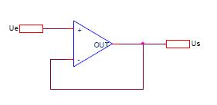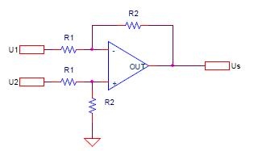

Figure 2 : Unity follower op-amp (left) and subtractor op-amp amplifier circuits (right)

1. The potential level set up between the two resistors, at the input terminal of the unity follower, is determined by the voltage divider formed by $R_{4}=220Ω$ and $R_{5}=5Ω$. The voltage at this point is given by the formula:
$$\boxed{V=V_{DD}×\left(\frac{R_{5}}{R_{5}+R_{4}}\right)=5×\left(\frac{5}{5 + 220}\right)=0.11111…V}$$

2. The value of the gain of the second OpAmp ($U1B$) is determined by the feedback resistor $R_{7}=27kΩ$ and the input resistor $R_{9}=1kΩ$. The gain is given by the formula:

$$\boxed{Gain=\frac{R_{7}}{R_{9}}=\frac{27}{1}=27}$$

# Code: distance_measurement_plot.py

import numpy as np

import matplotlib.pyplot as plt

def plot_mesurement(text,i):

    [measurement_array, max_distance] = np.load(f'./numpy_array_of_infra_measurement_{text}.npy', allow_pickle=True, encoding='bytes')

    measurement_array = measurement_array[::-1]

    phototransistor_values = measurement_array[:, 0]

    photodiode_values = measurement_array[:, 1]

    plt.subplot(1,2,i)

    plt.plot(photodiode_values, label='Photodiode', color='blue')

    plt.plot(phototransistor_values, label='Phototransistor', color='green')

    plt.title(f'Infra Measurement for {text}')

    plt.xlabel('Distance (cm)')

    plt.ylabel('ADC Values')

    plt.xlim(0, max_distance*1000)

    plt.legend()

plt.figure(figsize=(16, 6))

plot_mesurement('paper',1)

plot_mesurement('alu',2)

plt.show()

# Plots of the measurement characteristics

The setup was placed in a box to avoid disturbances from ambient light. Paper and aluminum surfaces were positioned at various distances for each measurement conducted.

The ideal graph (Figure 3) illustrates the relationship between ADC values (0 to 255 / 8 bits) and distance for a photodiode and a phototransistor. The blue curve corresponds to the photodiode, while the green curve represents the phototransistor. The shape of the blue curve is influenced by the voltage divider circuit (resistors), operational amplifier configuration, and the physical properties of the photodiode.

At far distances (~0.04m), the diode allows current flow, resulting in zero potential difference. At close distances (~0.01m), excessive current inhibits diode conductivity, leading to a linear increase in potential difference.

Concerning the phototransistor, its value increases more or less linearly until a certain point, then slightly decreases due to distance and light scattering on the surface.

In the aluminum graph (Figure 3), interferences are observed at distances close to zero due to aluminum's reflective nature, creating a mirror effect. This results in less precise readings due to the absence of light diffusion and slightly offset sensor positioning.

Conversely, the paper graph (Figure 3) demonstrates more promising results due to light scattering by paper, providing a more accurate perception by the sensor.

The difference in ADC value range between the paper and aluminum graphs is likely attributed to the amount of light detected by the sensor in each scenario. When the sensor is close to paper, light diffusion allows lighter to reach the sensor, leading to a higher ADC value. Conversely, the aluminum surface reflects more light, potentially causing inaccurate readings.

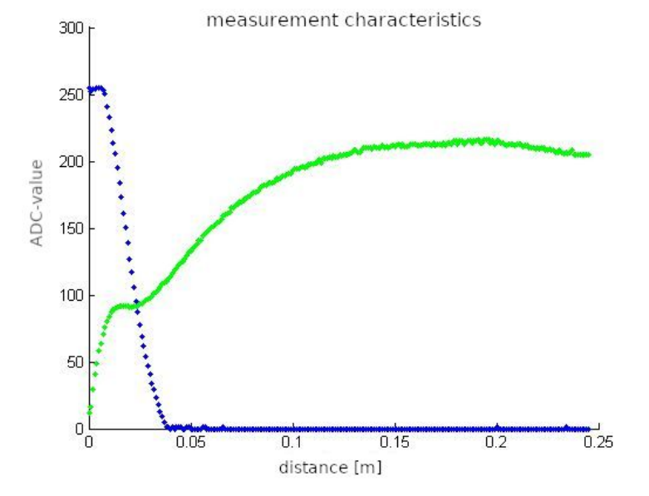

Figure 3 : Measurement characteristics from left to right : ideal, paper and aluminium