Lab-05-Ultrasound

Students: Alexis GIBERT / Souha GHAZOUANI

# Goals

The goals of the project include implementing ultrasound time-of-flight for distance measurement, exploring the resonance frequency of the ultrasound transmitter, and gaining familiarity with active RC band-pass filters.

# Schematic vs Real

|  |  |
| --- | --- |
|  | Breadboard - Handbook | Mbed  Photo circuit breadboard |

# Become familiar with RC band-pass filter

A band-pass filter or bandpass filter (BPF) is a device that passes frequencies within a certain range and rejects (attenuates) frequencies outside that range. It's the opposite of a band-stop filter.

Bandpass filters are crucial components in both wireless transmitters and receivers. In transmitters, they limit the signal bandwidth to the allocated transmission band, preventing interference with other stations. For receivers, they allow only signals within a selected frequency range to be processed, while blocking out unwanted frequencies. This helps prevent receiver saturation or damage, reduces interference, and optimizes signal-to-noise ratio and sensitivity. Well-designed bandpass filters maximize signal transmission efficiency and minimize interference, allowing for more signal transmitters in a system without compromising performance.

|  |  |
| --- | --- |
|  |  |

Inverting Band Pass Filter Circuit (on the left) Active Band Pass Frequency Response (on the right)

## Corner Frequency (Cut-off Points)

The corner frequencies, denoted as $f_{c1}$ and $f_{c2}$, are where the filter's response starts to roll off. For a second-order band-pass filter, these frequencies can be calculated using the formula:

|  |  |
| --- | --- |
| $$f_{c1}=\frac{1}{2πR_{1}C_{1}}$$ | $$f_{c2}=\frac{1}{2πR_{2}C_{2}}$$ |

With $R_{1}$ and $R_{2}$ are the resistances and $C_{1}$ and $C_{2}$ are the capacitances in the filter circuit.

## Gain

The gain of the band-pass filter can be calculated at the center frequency $f_{0}$ using the formula:

|  |  |
| --- | --- |
| $$G =-\frac{R_{2}}{R_{1}}$$ | with $R_{1}$ and $R_{2}$ are the resistances in the filter circuit. |

## Circuit Layout

The layout of the active RC band-pass filter typically consists of operational amplifiers (op-amps) and passive components like resistors and capacitors. The op-amp provides the necessary gain and buffering for the filter.

* + 1. A basic layout includes two cascaded stages: a high-pass filter stage followed by a low-pass filter stage, creating a band-pass response. Les deux sont des filtres passe band Inverting Band Pass Filter Circuit

|  |  |
| --- | --- |
|  |  |

# Readings

## oscilloscope_TektronixTDS2024.pdf

[FAIRE UN RESUME AVANT LE TP]

## function_generator_HamegHM8030_6.pdf

[FAIRE UN RESUME AVANT LE TP]

## Active band pass filter article

### Inverting Band Pass Filter Circuit

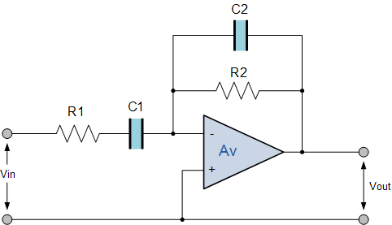

This type of band pass filter is designed to have a much narrower pass band. The centre frequency and bandwidth of the filter is related to the values of R1, R2, C1 and C2. The output of the filter is again taken from the output of the op-amp

How does the active band-pass filter work (you can find this in the receiver as well): <http://www.electronics-tutorials.ws/filter/filter_1.html> , filter_2, filter_3, ..., filter_7 (What we will use: inverting band-pass filter, among the active band-pass filters; but please read the other circuits as well.)

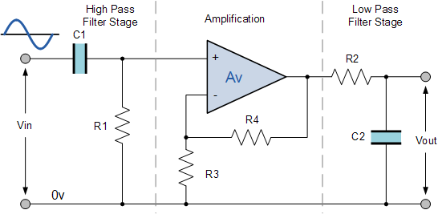

# Questions

## Please calculate the cut-off frequencies and gains of the filters on the receiver side; try to match the parts of the schematic drawing and the real circuit.

Following the circuit we have

|  |  |  |
| --- | --- | --- |
|  | Ideal | Real |
| $$f_{C1}$$ | $$\frac{1}{2π×1200×4.7×{10}^{-9}}=28218,96 Hz$$ | Value |
| $$f_{C2}$$ | $$\frac{1}{2π×67000×47×{10}^{-12}}=50541.42 Hz$$ | Value |
| $$f_{C3}$$ | $$\frac{1}{2π×1200×8.2×{10}^{-9}}=16174.28 Hz$$ | Value |
| $$f_{C4}$$ | $$\frac{1}{2π×80000×22×{10}^{-12}}=90428.94 Hz$$ | Value |

For gains we have:

|  |  |  |
| --- | --- | --- |
|  | Ideal | Real |
| $$f_{C1}$$ | $$G_{1}=-\frac{67}{1.2}=-55.83$$ | Value |
| $$f_{C2}$$ | $$G_{2}=-\frac{80}{1.2}=-66.66$$ | Value |

## Analysis of the transmitter with different excitations

Signals of the probes with the same amplitude-range

Photo

Ideal excitation frequency (function generator), and try two fairly non-ideal values as well (range 35-45 KHz),

Values

Photo

## Distance measurement

Control signal from RC0, with different time-resolution (what you should see: 5 square signal bumps with 40 KHz, then 300 msec. silence

Photo

Return time / time-difference of the first returning signal packet (wave-envelope)

Photo

Measure distance

Photo

Measure the distance of the ceiling

Photo