Austin Crumrine

BIT-445-O500

Part 2: Summary

1. My approach to the problem was to first import the Excel file into the IBM SPSS Modeler, then alter some parts of the variables in the ‘Types’ tab by changing ‘Measurement’ for all of the variables to ‘Nominal’, and changing the ‘Role’ for them to both. Afterwards I pressed ‘Read Values’ so the program could import the values for each variable, then I previewed it to make sure they were imported correctly. Then I went to the ‘Modeling’ tab in Modeller, filtered by ‘Association’ and double clicked the first pentagon ‘Apriori’ since for this problem we have to use that method of association. I double-clicked on the Apriori icon that is linked to the Excel file, and updated fields to ‘Use custom field assignments’, used transactional format and first chose ‘FIN’ for the ID, then ‘IDs are contiguous’ and chose the content to be ‘STAT’. Before running it, I changed the mode to ‘Expert’, and made sure it was using ‘Rule Confidence’. Finally I made sure the model used partitioned data and changed antecedent support to 15%, minimum rule confidence to 70%, and the maximum number of antecedents to 2. Running the algorithm created a new linked tile called ‘FIN & STAT’ which had a prism on it which I double clicked, opening a window with the results. Lastly I changed the criteria on the menu to include ‘Rule ID’, ‘Lift’, and ‘Instances’.
2. 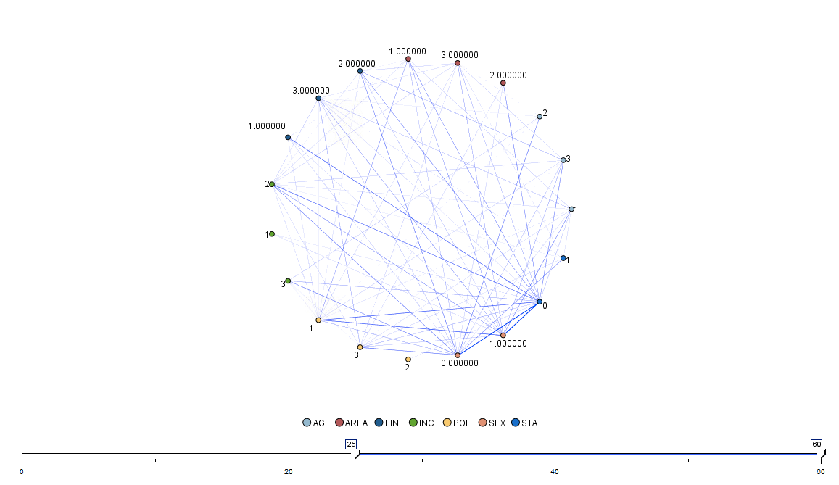

WEB Node

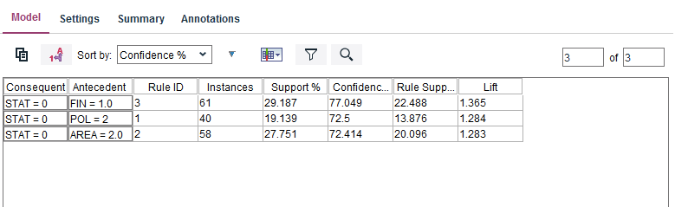

Model Screen Results

1. The derived association rules are . I would describe the derived association rules to someone who is unfamiliar with analytics techniques
2. According to the analysis, the data shows that for Democrats, the state economic outlook is better, and that the state economic outlook being better has an association with financial status being worse than last year and a salary of 20k-35k a year. The model screen suggests that people who are in a bad financial status have high hopes (1.365 times more likely) for the state economy to improve compared to the past. Northeastern Montana residents believe the economic outlook is better than it was last year (1.283 times). Independent political party members also think the outlook for the economy has improved compared to last year 1.284 times more likely).