The idea here is to provide all the steps needed to allow you to be able to set up and run this project from scratch. In order to accomplish this task, I am providing this guideline to make our life easier. Because that will require lots of sub-tasks to be performed at specific order, because of the interdependencies some APIs have.
To facilitate as much as possible the cross-platform development process, I have chosen the following basic premisses:
- GNU Compiler Collection (http://en.wikipedia.org/wiki/GNU_Compiler_Collection) – because I am interested in working with C++ standards in all possible Operation Systems the supports it, such as Linux, Android, Mac OS X, Windows (with Mingw tool sets) and more;
- Open Source Editors – Gimp (http://www.gimp.org/); Blender (http://www.blender.org/) and others; Eclipse (https://eclipse.org/) it is an integrated development environment (IDE) with Eclipse CDT (http://eclipse.org/cdt/) -C/C++ Development Tooling;
- C++ (http://en.wikipedia.org/wiki/C%2B%2B)- C++ still one of the best programming language game in game industry; it also allows us to integrate with the Lua Programming Language (www.lua.org) allowing scriptiong programming, therefore, we can get the advantages of both worlds;
By following this idea of a non-specific development environment, we are free to add, change, replace or choose the best options for the project, without being afraid of choosing something that would eventually become deprecated, payed or discontinued at any time.http://www.mingw.org/category/wiki/download
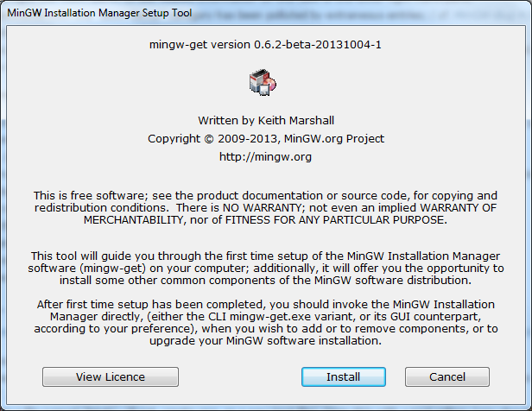
Choose
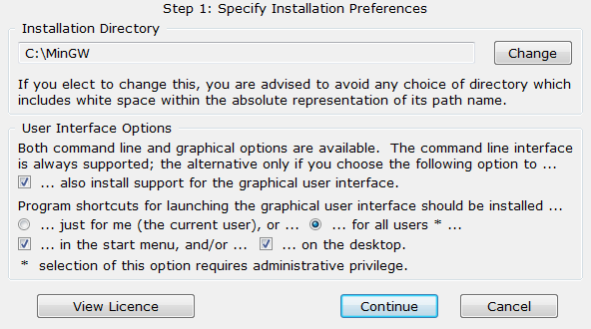
Accept defaults
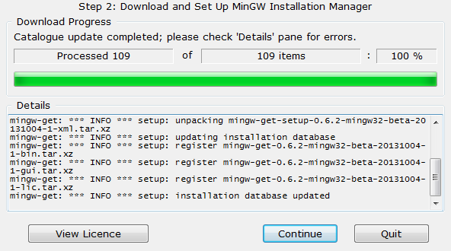
Mark for installation the following packages:
- Mingw-developer-toolkit
- Mingw32-base
- Mingw32-gcc-c++
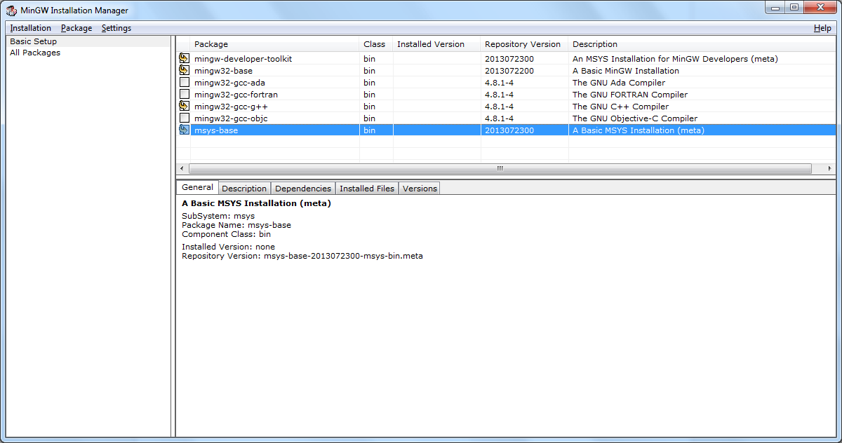
And also:
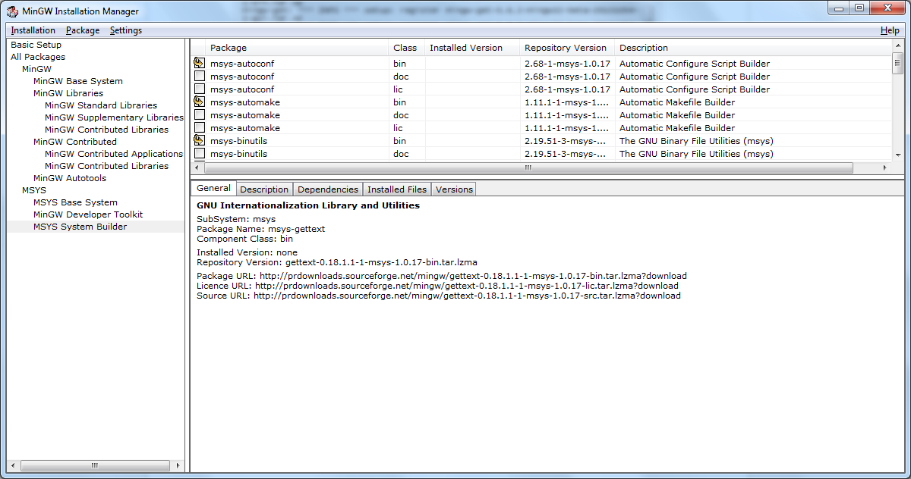
Then apply changes:
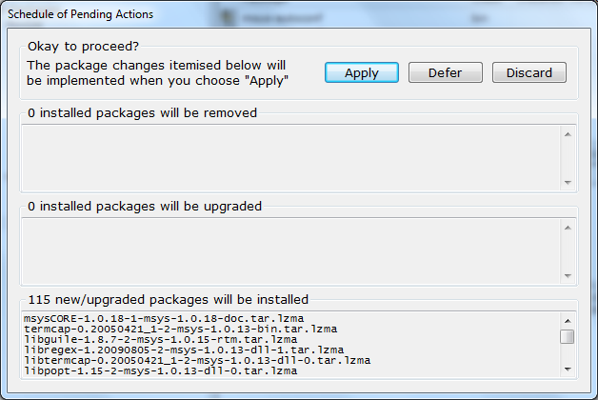

msysCORE-1.0.18-1-msys-1.0.18-doc.tar.lzma
termcap-0.20050421_1-2-msys-1.0.13-bin.tar.lzma
libguile-1.8.7-2-msys-1.0.15-rtm.tar.lzma
libregex-1.20090805-2-msys-1.0.13-dll-1.tar.lzma
libtermcap-0.20050421_1-2-msys-1.0.13-dll-0.tar.lzma
libpopt-1.15-2-msys-1.0.13-dll-0.tar.lzma
libiconv-1.14-1-msys-1.0.17-dll-2.tar.lzma
libopenssl-1.0.0-1-msys-1.0.13-dll-100.tar.lzma
liblzma-5.0.3-1-msys-1.0.17-dll-5.tar.lzma
libltdl-2.4-1-msys-1.0.15-dll-7.tar.lzma
libintl-0.18.1.1-1-msys-1.0.17-dll-8.tar.lzma
libxml2-2.7.6-1-msys-1.0.13-dll-2.tar.lzma
libexpat-2.0.1-1-msys-1.0.13-dll-1.tar.lzma
libgmp-5.0.1-1-msys-1.0.13-dll-10.tar.lzma
libcrypt-1.1_1-3-msys-1.0.13-dll-0.tar.lzma
libgdbm-1.8.3-3-msys-1.0.13-dll-3.tar.lzma
libbz2-1.0.6-1-msys-1.0.17-dll-1.tar.lzma
zlib-1.2.7-1-msys-1.0.17-dll.tar.lzma
texinfo-4.13a-2-msys-1.0.13-bin.tar.lzma
vim-7.3-2-msys-1.0.16-bin.tar.lzma
rsync-3.0.8-1-msys-1.0.17-bin.tar.lzma
perl-5.8.8-1-msys-1.0.17-bin.tar.lzma
sed-4.2.1-2-msys-1.0.13-bin.tar.lzma
libminires-1.02_1-2-msys-1.0.13-dll.tar.lzma
patch-2.6.1-1-msys-1.0.13-bin.tar.lzma
openssl-1.0.0-1-msys-1.0.13-bin.tar.lzma
openssh-5.4p1-1-msys-1.0.13-bin.tar.lzma
mktemp-1.6-2-msys-1.0.13-bin.tar.lzma
m4-1.4.16-2-msys-1.0.17-bin.tar.lzma
tar-1.23-1-msys-1.0.13-bin.tar.lzma
make-3.81-3-msys-1.0.13-bin.tar.lzma
less-436-2-msys-1.0.13-bin.tar.lzma
grep-2.5.4-2-msys-1.0.13-bin.tar.lzma
findutils-4.4.2-2-msys-1.0.13-bin.tar.lzma
diffutils-2.8.7.20071206cvs-3-msys-1.0.13-bin.tar.lzma
libmagic-5.04-1-msys-1.0.13-dll-1.tar.lzma
file-5.04-1-msys-1.0.13-bin.tar.lzma
dos2unix-7.1-1-msys-1.0.17-bin.tar.lzma
coreutils-5.97-3-msys-1.0.13-bin.tar.lzma
bash-3.1.23-1-msys-1.0.18-bin.tar.xz
xz-5.0.3-1-msys-1.0.17-bin.tar.lzma
gzip-1.3.12-2-msys-1.0.13-bin.tar.lzma
msysCORE-1.0.18-1-msys-1.0.18-ext.tar.lzma
bzip2-1.0.6-1-msys-1.0.17-bin.tar.lzma
gawk-3.1.7-2-msys-1.0.13-bin.tar.lzma
w32api-3.14-3-msys-1.0.12-dev.tar.lzma
msysCORE-1.0.18-1-msys-1.0.18-dev.tar.lzma
msysCORE-1.0.18-1-msys-1.0.18-bin.tar.lzma
libltdl-2.4-1-mingw32-dll-7.tar.lzma
libgmp-5.1.2-1-mingw32-dll-10.tar
libmpfr-3.1.2-2-mingw32-dll-4.tar
libmpc-1.0.1-2-mingw32-dll-3.tar
libgettextpo-0.18.3.2-1-mingw32-dll-0.tar.xz
libiconv-1.14-3-mingw32-dll-2.tar
libexpat-2.1.0-1-mingw32-dll-1.tar
libquadmath-4.8.1-4-mingw32-dll-0.tar
libgomp-4.8.1-4-mingw32-dll-1.tar
libstdc++-4.8.1-4-mingw32-dll-6.tar
libpthread-2.9.1-1-mingw32-dll-2.tar
libssp-4.8.1-4-mingw32-dll-0.tar
libgcc-4.8.1-4-mingw32-dll-1.tar
libintl-0.18.3.2-1-mingw32-dll-8.tar.xz
libiconv-1.14-3-mingw32-dev.tar.lzma
libiconv-1.14-3-mingw32-bin.tar.lzma
gettext-0.18.3.2-1-mingw32-dev.tar.xz
gettext-0.18.3.2-1-mingw32-bin.tar.xz
libltdl-2.4-1-mingw32-dev.tar.lzma
libtool-2.4-1-mingw32-bin.tar.lzma
automake1.11-1.11.1-1-mingw32-bin.tar.lzma
automake1.10-1.10.2-1-mingw32-bin.tar.lzma
automake1.9-1.9.6-3-mingw32-bin.tar.lzma
automake1.8-1.8.5-1-mingw32-bin.tar.lzma
automake1.7-1.7.9-1-mingw32-bin.tar.lzma
automake1.6-1.6.3-1-mingw32-bin.tar.lzma
automake1.5-1.5-1-mingw32-bin.tar.lzma
automake1.4-1.4p6-1-mingw32-bin.tar.lzma
automake-4-1-mingw32-bin.tar.lzma
autoconf2.5-2.68-1-mingw32-bin.tar.lzma
autoconf2.1-2.13-4-mingw32-bin.tar.lzma
autoconf-10-1-mingw32-bin.tar.lzma
libopts-5.10.1-1-msys-1.0.15-dll-25.tar.lzma
libguile-1.8.7-2-msys-1.0.15-dll-17.tar.lzma
libarchive-2.8.3-1-msys-1.0.13-dll-2.tar.lzma
lndir-1.0.1-2-msys-1.0.13-bin.tar.lzma
inetutils-1.7-1-msys-1.0.13-bin.tar.lzma
guile-1.8.7-2-msys-1.0.15-bin.tar.lzma
flex-2.5.35-2-msys-1.0.13-bin.tar.lzma
diffstat-1.54-1-msys-1.0.17-bin.tar.lzma
cvs-1.12.13-2-msys-1.0.13-bin.tar.lzma
coreutils-5.97-3-msys-1.0.13-ext.tar.lzma
bsdcpio-2.8.3-1-msys-1.0.13-bin.tar.lzma
bsdtar-2.8.3-1-msys-1.0.13-bin.tar.lzma
bison-2.4.2-1-msys-1.0.13-bin.tar.lzma
autogen-5.10.1-1-msys-1.0.15-bin.tar.lzma
msys-base-2013072300-msys-bin.meta
mingw32-autotools-2010090601-mingw32-bin.meta
mingw-developer-toolkit-2013072300-msys-bin.meta
mingwrt-3.21-mingw32-dll.tar.xz
w32api-3.17-2-mingw32-dev.tar.lzma
mingwrt-3.21-mingw32-dev.tar.xz
binutils-2.24-1-mingw32-bin.tar.xz
gcc-core-4.8.1-4-mingw32-dev.tar.lzma
libz-1.2.8-1-mingw32-dll-1.tar
gdb-7.6.1-1-mingw32-bin.tar.lzma
make-3.82.90-2-mingw32-cvs-20120902-bin.tar.lzma
gcc-core-4.8.1-4-mingw32-lic.tar.lzma
gcc-core-4.8.1-4-mingw32-bin.tar.lzma
gcc-c++-4.8.1-4-mingw32-dev.tar.lzma
gcc-c++-4.8.1-4-mingw32-bin.tar.lzma
mingw32-base-2013072200-mingw32-bin.meta
autoconf-2.68-1-msys-1.0.17-bin.tar.lzma
automake-1.11.1-1-msys-1.0.13-bin.tar.lzma
binutils-2.19.51-3-msys-1.0.13-bin.tar.lzma
gcc-3.4.4-3-msys-1.0.13-bin.tar.lzma

add C:\MinGW\bin;C:\MinGW\msys\1.0\bin to System Environment Path

click on C:\MinGW\msys\1.0\msys.bat to open MSYS (the linux like console)

run explorer . just to make sure where you are. It should be opening the folder like this:
C:\MinGW\msys\1.0\home\<your_profile>

then create a win_32 folder in wich we shall be working to prepare the development intra-structure and all the compilations process required.

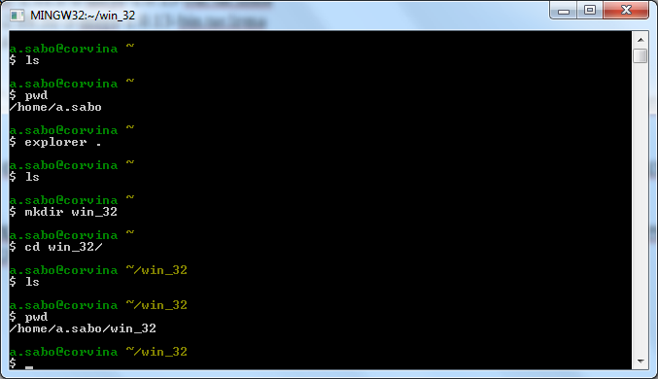
$ mount C:/MinGW/ /mingw

$ ls /mingw
bin include lib libexec mingw32 msys share var

check to see if the library path are reached:

$ ld --verbose | grep SEARCH_DIR | tr -s ' ;' \\012
SEARCH_DIR("/mingw/mingw32/lib")
SEARCH_DIR("/mingw/lib")
SEARCH_DIR("/usr/local/lib")
SEARCH_DIR("/lib")
SEARCH_DIR("/usr/lib")

Download and install cmake (cmake-3.2.2-win32-x86.zip) from http://www.cmake.org/download
Don't forget o add it to the system path as well, ‘cause you should be able to run it from msys console eventually.

if it is ok, then you are done with mingw requirements.

API: Boost
Location: http://www.boost.org/users/history/version_1_53_0.html

Procedures:
- Download boost_1_53_0.zip and extract it into win_32 folder you just created;
- cd boost_1_53_0/tools/build/v2/
- ./bootstrap.sh --with-toolset=mingw stage variant=debug,release threading=multi link=static
- ./b2 install --prefix=/mingw
- cd ../../../
- b2 toolset=gcc

alternativelly:
./bootstrap.sh gcc
b2 toolset=gcc

copy headers from:
<boost_src>boost to /mingw/include
and
<boost_src>stage/lib to /mingw/lib

and that is it!

API: Ogre3D
Module: Ogredeps (required to get Ogre3D compiled)
Location: https://bitbucket.org/cabalistic/ogredeps

Procedures:
Extract cabalistic-ogredeps-a9a856daa857.zip into the win_32 folder;
cd cabalistic-ogredeps-a9a856daa857
cmake . -G "MSYS Makefiles"
make
make install

Module: Ogre 3D
https://bitbucket.org/sinbad/ogre/src/4578da5bf5b00fdf023b87e98099d647c5cb92ab?at=v1-9-0

Procedures:
Extract sinbad-ogre-f40744b1106a.zip into the win_32 folder and copy ogredeps folder from cabalistic-ogredeps-a9a856daa857 previously built to here;
cd sinbad-ogre-f40744b1106a
cmake . -G "MSYS Makefiles" -DCMAKE_INSTALL_PREFIX=/mingw -DOGRE_DEPENDENCIES_DIR=./ogredeps -DCMAKE_BUILD_TYPE:STRING=Release -DOGRE_BUILD_SAMPLES:BOOL=OFF -DOGRE_BUILD_RENDERSYSTEM_D3D11:BOOL=OFF -DOGRE_BUILD_RENDERSYSTEM_D3D9:BOOL=OFF

Make sure that the summary shows something like this (specially Use Boost: enabled):

------------------------------------------------------
FEATURE SUMMARY
------------------------------------------------------

Building components:
+ Paging
+ Property
+ Terrain
+ RTShader System
+ RTShader System Core Shaders
+ RTShader System Extensions Shaders
+ Volume
+ Overlay
Building plugins:
+ BSP scene manager
+ Cg program manager
+ Octree scene manager
+ Portal connected zone scene manager
+ Particle FX
Building rendersystems:
+ OpenGL
Building executables:
+ Tools
Building core features:
+ DDS image codec
+ FreeImage codec
+ ZIP archives

Build type: dynamic
Threading support: background (boost)
Use double precision: disabled
Assert mode: standard
Allocator type: nedmalloc (pooling)
STL containers use allocator: enabled
Strings use allocator: disabled
Memory tracker (debug): disabled
Memory tracker (release): disabled
Use Boost: enabled

------------------------------------------------------

make
make install

API: Bullet physics
Location: https://code.google.com/p/bullet/downloads/detail?name=bullet-2.82-r2704.zip&can=2&q=

Procedures:

Before moving on, this library may be required by bullet compilation process; I
Download freeglut-2.8.1.tar.gz from http://freeglut.sourceforge.net/ extract it and build it:
./configure --prefix=/mingw && make && make install

Download bullet-2.82-r2704.zip and extract it into the win_32 folder;
cmake . -G "MSYS Makefiles" -DCMAKE_INSTALL_PREFIX=/mingw
make
make install

manually copy src to /mingw/include/BULLET

Troubleshoting:
In Mingw, you may face some crash issue, while compiling code: http://bulletphysics.org/Bullet/phpBB3/viewtopic.php?t=9636

To workaround this, search for patch_for_bullet-2.82.zip in that page, download and overwrite all files in the bullet-2.82 folder;

API: Cegui-deps
Location: http://static.cegui.org.uk/docs/current/building_deps.html

Procedures:
Download cegui-deps-0.8.x-src from http://static.cegui.org.uk/docs/current/building_deps.html and extract it into win_32 folder you just created;

cmake . -G "MSYS Makefiles" -DCEGUI_BUILD_EFFECTS11:BOOL=OFF
make

Download cegui-0.8.4.zip from http://cegui.org.uk/download
Extract it into the win_32 folder and copy dependencies from cegui-deps to this folder;

cmake . -G "MSYS Makefiles" -DCMAKE_INSTALL_PREFIX:PATH=/mingw -DCEGUI_BUILD_RENDERER_OGRE:BOOL=ON -DCEGUI_BUILD_RENDERER_DIRECT3D10:BOOL=OFF -DCEGUI_BUILD_RENDERER_DIRECT3D9:BOOL=OFF
make
make install

Ps. check if headers was copied properly (/mingw/include or C:\MinGW\include\cegui-0\CEGUI); if you find this just move CEGUI to upper folder instead C:\MinGW\include\CEGUI or /mingw/include/CEGUI is what you should get); check the same issue for the lib folder: they should be located at /mingw/lib

Troubleshoting:
if you get compilation issues such as “pngwin.def:1: syntax error”, reffer to http://cegui.org.uk/forum/viewtopic.php?f=3&t=6629
the workaround is:
edit the beginning of the file where line equals LIBRARY and add the library name; i.e. LIBRARY pngwin, for instance; repeat this process for pngwin.def, libexpat.def, libexpatw.def files and you are done.

API: ObreBullet
Location: https://bitbucket.org/alexeyknyshev/ogrebullet/src

Download and extract https://bitbucket.org/alexeyknyshev/ogrebullet/get/wip.zip into alexeyknyshev-ogrebullet-a6645634f10a
cd alexeyknyshev-ogrebullet-a6645634f10a

cmake . -G "MSYS Makefiles" -DCMAKE_INSTALL_PREFIX=/mingw -DBoost_INCLUDE_DIR=/mingw/include -DOGRE_INCLUDE_DIR=/mingw/include/OGRE -DBULLET_INCLUDE_DIR=/mingw/include/bullet -DBULLET_INCLUDE_COLLISION_DIR=/mingw/include/bullet -DBULLET_INCLUDE_CONVEXDECOMPOSITION_DIR=/mingw/include/BULLET/Extras/ConvexDecomposition -DBULLET_INCLUDE_DYNAMICS_DIR=/mingw/include/BULLET -DBULLET_INCLUDE_LINEARMATH_DIR=/mingw/include/BULLET -DBULLET_INCLUDE_SOFTBODY_DIR=/mingw/include/BULLET

make
make install

Troubleshoting:
Compilation issues such as:
OgreBulletCollisionsDebugContact.cpp:35:29: fatal error: OgreFontManager.h: No such file or directory #include "OgreFontManager.h"
^
compilation terminated.
make[2]: *** [CMakeFiles/OgreBulletCollisions.dir/Collisions/src/Debug/OgreBulletCollisionsDebugContact.cpp.obj] Error 1
make[1]: *** [CMakeFiles/OgreBulletCollisions.dir/all] Error 2
make: *** [all] Error 2

You can work arround it by editing the following files:
OgreBulletCollisionsDebugContact.cpp → change line 35 to #include "Overlay/OgreFontManager.h"
OgreBulletCollisionsMeshToShapeConverter.cpp → change line 35 to #include "Extras/ConvexDecomposition/ConvexBuilder.h"

API: libtheoraplayer
Location: http://sourceforge.net/p/libtheoraplayer/code/190/tree/tags/1.0.0/

First: Download libtheoraplayer dependencies:
libogg-1.3.2.zip, libvorbis-1.3.5.zip and libtheora-1.1.1.zip from https://www.xiph.org/downloads/

Extract and compile each one with:
./configure --prefix=/mingw && make && make install

Download snapshot and extract it into win_32 folder. You should have the folder:
C:\MinGW\msys\1.0\home\a.sabo\win_32\libtheoraplayer-code-190-tags-1.0.0

From now on, the easiest way to get the remaining project compiled is to get Code::Blocks. This is why these projects already have pre-defined projects ready to use, or that easily be imported from other formats such as MS Visual Studio.

Code::Blocks is also free and can be download here (http://www.codeblocks.org/downloads)
You may choose codeblocks-13.12-setup.exe installer because you already have mingw installed.

Set up the default compiler in settings to detect ant use MinGW:
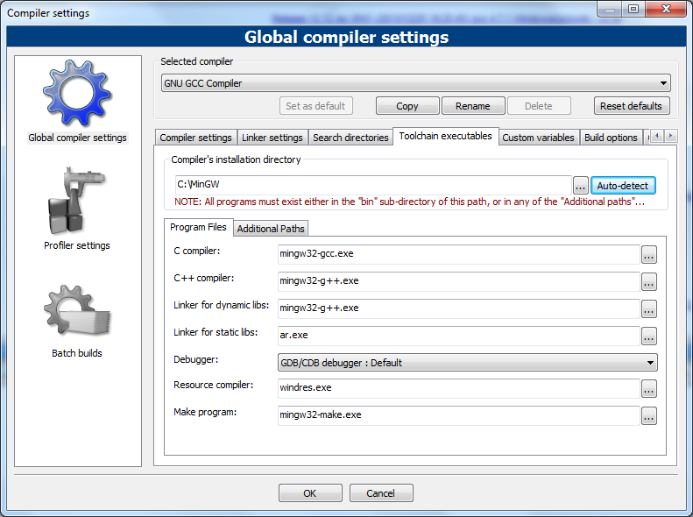

Import C:\MinGW\msys\1.0\home\a.sabo\win_32\libtheoraplayer-code-190-tags-1.0.0\libtheoraplayer_2012.sln and choose yes to all questions.
Save the whole workspace as libtheoraplayer.workspace for futher use.
Now we must make some adjustments to compile the library in the workspace properly:
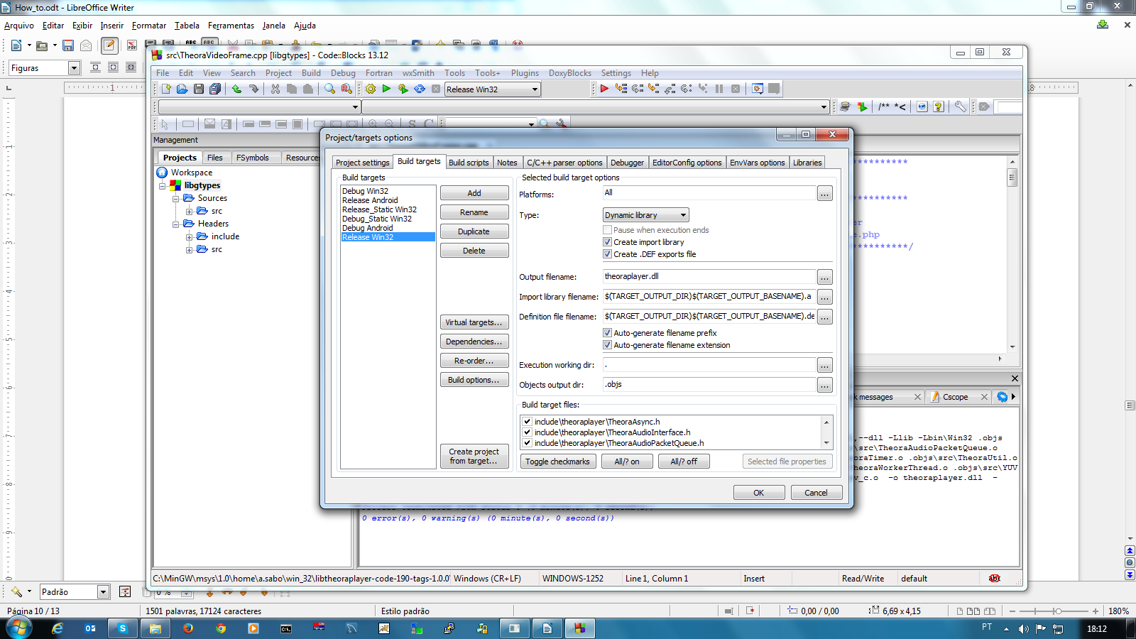
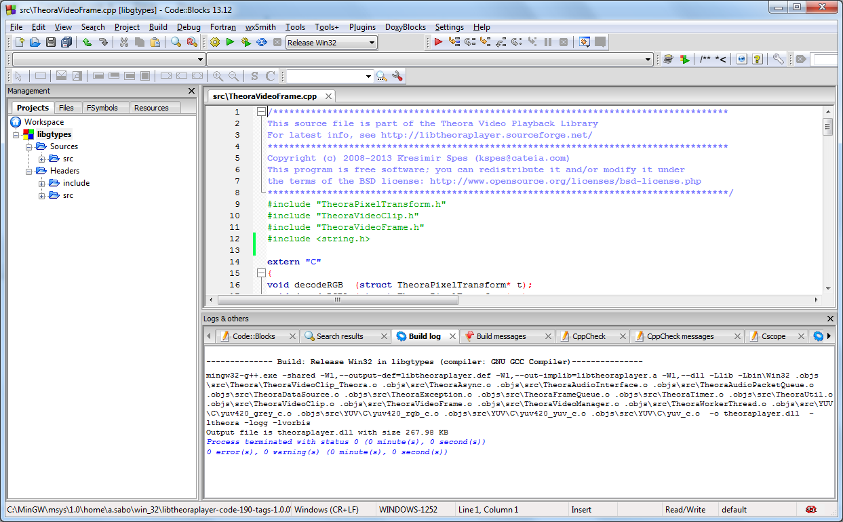
Troubleshoting:
if you get error: ‘memset’ was not declared in this scope issues, such as in
http://stackoverflow.com/questions/2505365/compiler-error-memset-was-not-declared-in-this-scope

add #include <string.h> at the top of TheoraVideoFrame.cpp

You'll have to copy libtheoraplayer.a to /mingw/lib and libtheoraplayer.dll to /mingw/bin manually; then copy all corresponding header files as well.

API: OpenAL
Location:https://sourceforge.net/projects/openal-soft/
Download openal-soft-1.15.1.tar.bz2 and extract it into the win_32 folder.
cmake . -G "MSYS Makefiles" -DCMAKE_INSTALL_PREFIX=/mingw
make
make install

API: OgreOggSound
Location: https://sourceforge.net/projects/ogreoggsound/

Download OgreOggSound-v1.26.7z and extract it into the win_32 folder.
With Code::Blocks import the project from OgreOggSoundLib_vc9.vcproj (MS Visual Studio project);
Select “Release Win32” build profile (dinamically library, for it is a plugin);
Open project Properties and set up the Build target: make sure Output filename is set to: .\lib\libOgreOggSoundLib.a
Add compiler flag -std=gnu++11 (not -std=c++11)

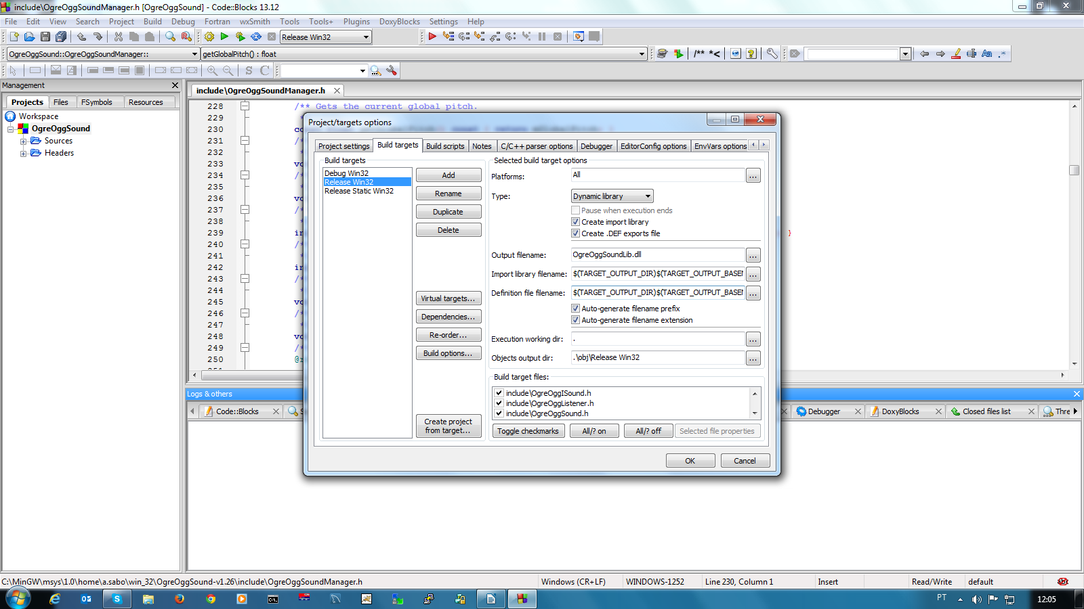
Open project Options and setup Search directories to add the missing header files location, as follow:

OgreOggSoundPrereqs.h

set → define HAVE_EFX 0
also remove efx-util from linked libraries
add BOOST_THREAD_USE_LIB to #defines tab

Throubleshotting:
OBS: PARA COMPILAR, TIVE QUE ADICIONAR A LINHA #include <AL/alext.h> E TROCAR
if (!buffer)
{
// Load audio file
sound->_openImpl(_openStream(file));
}
POR

if (!buffer)
{
// Load audio file
Ogre::DataStreamPtr streamedFilePtr = _openStream(file);
sound->_openImpl(streamedFilePtr);
}
CONFORME DESCRITO EM
http://www.ogre3d.org/forums/viewtopic.php?f=1&t=81607

API: Ogre3D Video Plugin
Location:https://sourceforge.net/p/ogrevideo/code/HEAD/tree/trunk/
Download ogrevideo-code-112-trunk.zip and extract it into the win_32 folder.

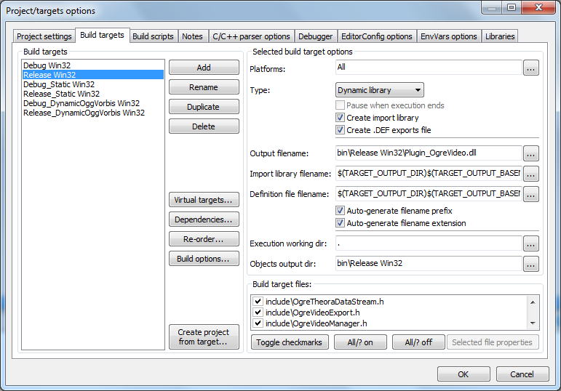
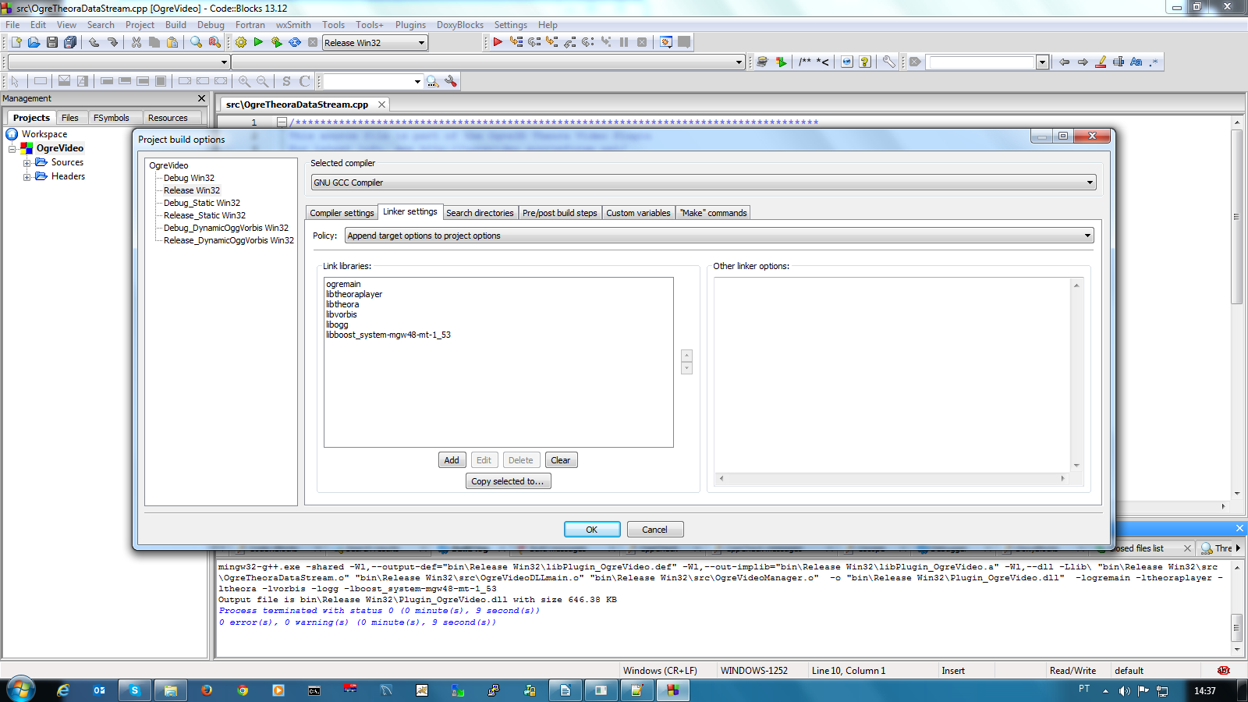
Troubleshooting:
Compilation issues:
include/OgreVideoManager.h:27:8: error: using typedef-name 'Ogre::TexturePtr' after 'class'

Solution:
http://cegui.org.uk/forum/viewtopic.php?f=10&t=6555#p30834

Edit OgreVideoManager.h and replace:

class TexturePtr;
by:
class Texture;
template<typename T> class SharedPtr;
typedef SharedPtr<Texture> TexturePtr;

C:\MinGW\msys\1.0\home\a.sabo\win_32\ogrevideo-code-112-trunk\src\OgreVideoManager.cpp:64:3: error: 'mPlugInName' was not declared in this scope

Solution:
Comment out these lines:
// mPlugInName = "TheoraVideoPlugin";
// mDictionaryName = mPlugInName;

API: Ogre3D Video Plugin
Location:https://sourceforge.net/p/ogrevideo/code/HEAD/tree/trunk/
Download ogrevideo-code-112-trunk.zip and extract it into the win_32 folder.

Import tinyxml.sln in Code::Blocks and build Release Win32 profile.
