Home Assignments
From the Postman collection use the below API's
1) S17 - DOM to Selenium Code
DOM to Selenium Code Give the DOM as input Leaftaps login and generate the playwright typescript /Selenium Java or any thing of your choice
with Different models using temperature
------------------------------------------------------------------------------------------
Output

{
"id": "chatcmpl-2121dadc-2727-4aa3-a06f-a9a9c1b26016",
"object": "chat.completion",
"created": 1768875005,
"model": "qwen/qwen3-32b",
"choices": [
{
"index": 0,
"message": {
"role": "assistant",
"content": "import org.openqa.selenium.By;\nimport org.openqa.selenium.WebDriver;\nimport org.openqa.selenium.WebElement;\n\npublic class LeadForm {\n private WebDriver driver;\n\n public LeadForm(WebDriver driver) {\n this.driver = driver;\n }\n\n public WebElement getCompanyNameField() {\n return driver.findElement(By.id(\"createLeadForm_companyName\"));\n }\n\n public WebElement getLastNameField() {\n return driver.findElement(By.id(\"createLeadForm_lastName\"));\n }\n\n public WebElement getFirstNameField() {\n return driver.findElement(By.id(\"createLeadForm_firstName\"));\n }\n\n public WebElement getSubmitButton() {\n return driver.findElement(By.name(\"submitButton\"));\n }\n}",
"reasoning": "Okay, let's see. The user wants me to extract the given DOM elements and provide Selenium Java code without using IDs that have numbers. The DOM has four input elements: company name, last name, first name, and a submit button.\n\nFirst, I need to identify the elements. The first three are text inputs with IDs like createLeadForm_companyName, etc. The submit button has an ID with a number, ext-gen630. The user said not to use IDs with numbers, so for the submit button, I can't use By.id.\n\nLooking at the submit button, it has a class \"smallSubmit\", name \"submitButton\", and value \"Create Lead\". So I can use By.name or By.cssSelector. Maybe By.name is simpler here.\n\nFor the text fields, their IDs don't have numbers. Wait, the IDs are createLeadForm_companyName, createLeadForm_lastName, createLeadForm_firstName. Those don't have numbers. So maybe using By.id is okay for those. But the user said not to use ID if the value has a number in it. Wait, the IDs for the text fields don't have numbers. The submit button's ID has \"ext-gen630\" which includes numbers. So for the submit button, avoid ID.\n\nSo for the text fields, using By.id is acceptable. For the submit button, use By.name or By.cssSelector. Let me check the attributes again. The submit button has name=\"submitButton\" and value=\"Create Lead\". Using By.name(\"submitButton\") would work. Alternatively, By.xpath with the value attribute. But maybe By.name is better here.\n\nNow, writing the code. The user wants Java code without explanations. So I need to create a class with methods to locate each element. Using WebDriver, findElement with appropriate By strategies.\n\nFor the company name input: By.id(\"createLeadForm_companyName\")\nLast name: By.id(\"createLeadForm_lastName\")\nFirst name: By.id(\"createLeadForm_firstName\")\nSubmit button: By.name(\"submitButton\")\n\nAlternatively, for the submit button, could also use By.cssSelector(\"input.smallSubmit[name='submitButton']\") but By.name is simpler.\n\nSo the code would have methods returning these By objects. The user might want to store them as variables or methods. Let me structure it as a page object model class.\n\nWait, the user didn't specify a page object model, but just the code. Maybe just the code to locate each element. Let me check the example again.\n\nThe user provided four input elements. The code should have four locators. Let me write the Java code using By.id for the first three and By.name for the submit button.\n\nSo the code would be:\n\nimport org.openqa.selenium.By;\nimport org.openqa.selenium.WebDriver;\nimport org.openqa.selenium.WebElement;\n\npublic class LeadForm {\n private WebDriver driver;\n\n public LeadForm(WebDriver driver) {\n this.driver = driver;\n }\n\n public WebElement getCompanyNameField() {\n return driver.findElement(By.id(\"createLeadForm_companyName\"));\n }\n\n public WebElement getLastNameField() {\n return driver.findElement(By.id(\"createLeadForm_lastName\"));\n }\n\n public WebElement getFirstNameField() {\n return driver.findElement(By.id(\"createLeadForm_firstName\"));\n }\n\n public WebElement getSubmitButton() {\n return driver.findElement(By.name(\"submitButton\"));\n }\n}\n\nWait, but the user said \"provide me the selenium java code\" and \"do not use ID if the value has number in it\". The IDs for the first three fields don't have numbers, so it's okay. The submit button's ID has numbers, so we avoid it by using name.\n\nYes, this should work. Let me make sure there are no other attributes that could be used. For example, the submit button has a value \"Create Lead\", so another option is By.xpath(\"//input[@value='Create Lead']\"), but using By.name is more efficient.\n\nSo the code above should meet the requirements. The user didn't ask for methods, but perhaps just the By statements. But the example in the problem statement shows methods returning WebElements. Maybe the user expects that structure. So the code is correct.\n"
},
"logprobs": null,
"finish_reason": "stop"
}
],
****************************************************************
2)S21 - MultiLingual
Ask to generate any content in diff languages (Japanese,Tamil,Telugu of your choice) and check whether the ouput is correct .
---------------------------------------------------------------------------
Output: Kannada and Tamil
You can verify the output in 2 ways
1)Copy the output and paste in chatgpt qwen or cany chatagent for translation

2)You can also send the response generated in a langauage say Japanese,Tamil or Telugu) as request to the S21 - MultiLingual API in postman collection and verify it

(Use atleast 2 different models from groq)

{
"id": "chatcmpl-17bef1f8-b55c-4c36-b302-ad5deb351460",
"object": "chat.completion",
"created": 1768875180,
"model": "moonshotai/kimi-k2-instruct-0905",
"choices": [
{
"index": 0,
"message": {
"role": "assistant",
"content": "Kannada \nಅಪ್ಲಿಕೇಶನ್ ತೆರೆಯಿರಿ, ರುಜುವಾತುಗಳನ್ನು ನಮೂದಿಸಿ, ಮತ್ತು ಲಾಗಿನ್ ಬಟನ್ ಮೇಲೆ ಕ್ಲಿಕ್ ಮಾಡಿ.\n\nTamil \nபயன்பாட்டை திறக்கவும், நற்சான்றுகளை உள்ளிடவும், பின்னர் உள்நுழைவு பொத்தானை சொடுக்கவும்."
},
"logprobs": null,
"finish_reason": "stop"
}
],

{
"id": "chatcmpl-d03c7aec-4485-4d2b-8ac1-702ecd7be4ed",
"object": "chat.completion",
"created": 1768875637,
"model": "qwen/qwen3-32b",
"choices": [
{
"index": 0,
"message": {
"role": "assistant",
"content": "<think>\nOkay, let's tackle this translation task. The user wants the test instructions translated into Telugu and Japanese. The original sentence is: \"Open the application, enter the credentials, and click on the login button.\"\n\nFirst, I'll break down each part of the sentence to ensure accurate translation. \n\nStarting with Telugu. I need to make sure the verbs are correctly conjugated and the terms are appropriate. \"Open the application\" would be \"వర్షించు\" for \"open,\" but wait, \"వర్షించు\" is more like \"rain.\" Maybe \"ఓపెన్ చేయండి\" is better. \"Application\" is \"అప్లికేషన్.\" Then \"enter the credentials\" – \"పాస్వర్డ్ ఇమెయిల్\" but \"credentials\" is a bit more general. Maybe \"సమాచారం నమోదు చేయండి\" which means \"enter the information.\" Finally, \"click on the login button\" – \"లాగిన్ బటన్పై క్లిక్ చేయండి.\"\n\nNow for Japanese. The structure is similar. \"Open the application\" is \"アプリケーションを開きます。\" \"Enter the credentials\" – \"資格情報を入力します。\" Here, \"credentials\" is translated as \"資格情報,\" which is the standard term. \"Click on the login button\" – \"ログインボタンをクリックします。\" \n\nI should double-check the Japanese terms. \"資格情報\" is correct for credentials in the context of login. Also, the verbs are in the plain form, which is typical for instructions. \n\nWait, in Telugu, maybe \"అప్లికేషన్ ను ఓపెన్ చేయండి\" is better. Also, \"credentials\" might be more accurately translated as \"ప్రమాణ సమాచారం\" but \"సమాచారం నమోదు చేయండి\" is more general. Maybe \"ప్రమాణ సమాచారం నమోదు చేయండి\" would be better. \n\nFor Japanese, the sentence structure is correct. Each step is a separate sentence, which is standard for instructions. \n\nI think that's it. Let me put it all together.\n</think>\n\nతెలుగు: అప్లికేషన్ ను ఓపెన్ చేయండి, ప్రమాణ సమాచారం నమోదు చేయండి, లాగిన్ బటన్పై క్లిక్ చేయండి.\n\nJapanese: アプリケーションを開きます。資格情報を入力します。ログインボタンをクリックします。"
},
"logprobs": null,
"finish_reason": "stop"
}
],
******************************************************************************
3)S16-Transcriptions
Try to generate the meeting summary of your office meeting or any files of your choice and Extract the text
(Use whisper-large-v3 and also the whisper-large-v3 Turbo)
Output:

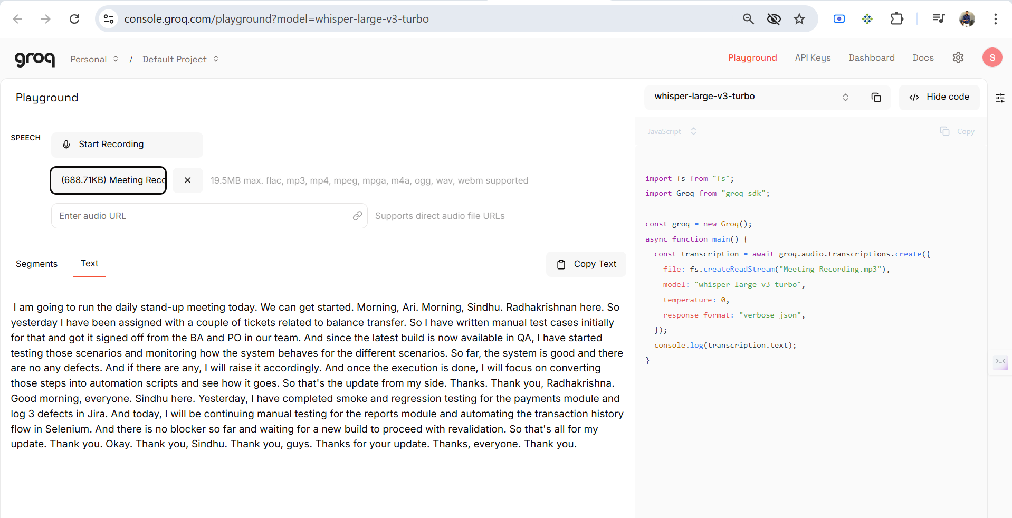
I am going to run the daily stand-up meeting today. We can get started. Morning, Ari. Morning, Sindhu. Radhakrishnan here. So yesterday I have been assigned with a couple of tickets related to balance transfer. So I have written manual test cases initially for that and got it signed off from the BA and PO in our team. And since the latest build is now available in QA, I have started testing those scenarios and monitoring how the system behaves for the different scenarios. So far, the system is good and there are no any defects. And if there are any, I will raise it accordingly. And once the execution is done, I will focus on converting those steps into automation scripts and see how it goes. So that's the update from my side. Thanks. Thank you, Radhakrishna. Good morning, everyone. Sindhu here. Yesterday, I have completed smoke and regression testing for the payments module and log 3 defects in Jira. And today, I will be continuing manual testing for the reports module and automating the transaction history flow in Selenium. And there is no blocker so far and waiting for a new build to proceed with revalidation. So that's all for my update. Thank you. Okay. Thank you, Sindhu. Thank you, guys. Thanks for your update. Thanks, everyone. Thank you.
Also tried by recoding
hey hi everyone and yeah so my update today is uh right now i'm working on um one of the tpm topics so yeah and uh towards the release where we have a 1.11 and 1.12 yeah so i will be focusing on that today and also by end of the day i will update if any findings something yeah and then i'll get a bug for that yeah so far so good yeah i'll keep continuing on this uh towards the release task. Thank you.
************************************************************************
4)S09 - TextFromImage-Url

Use the vision model to extract the text from multilingual
Used the multiligual model to extract the text:
The image shows a screenshot of a workspace for testing and debugging API requests.
Output:
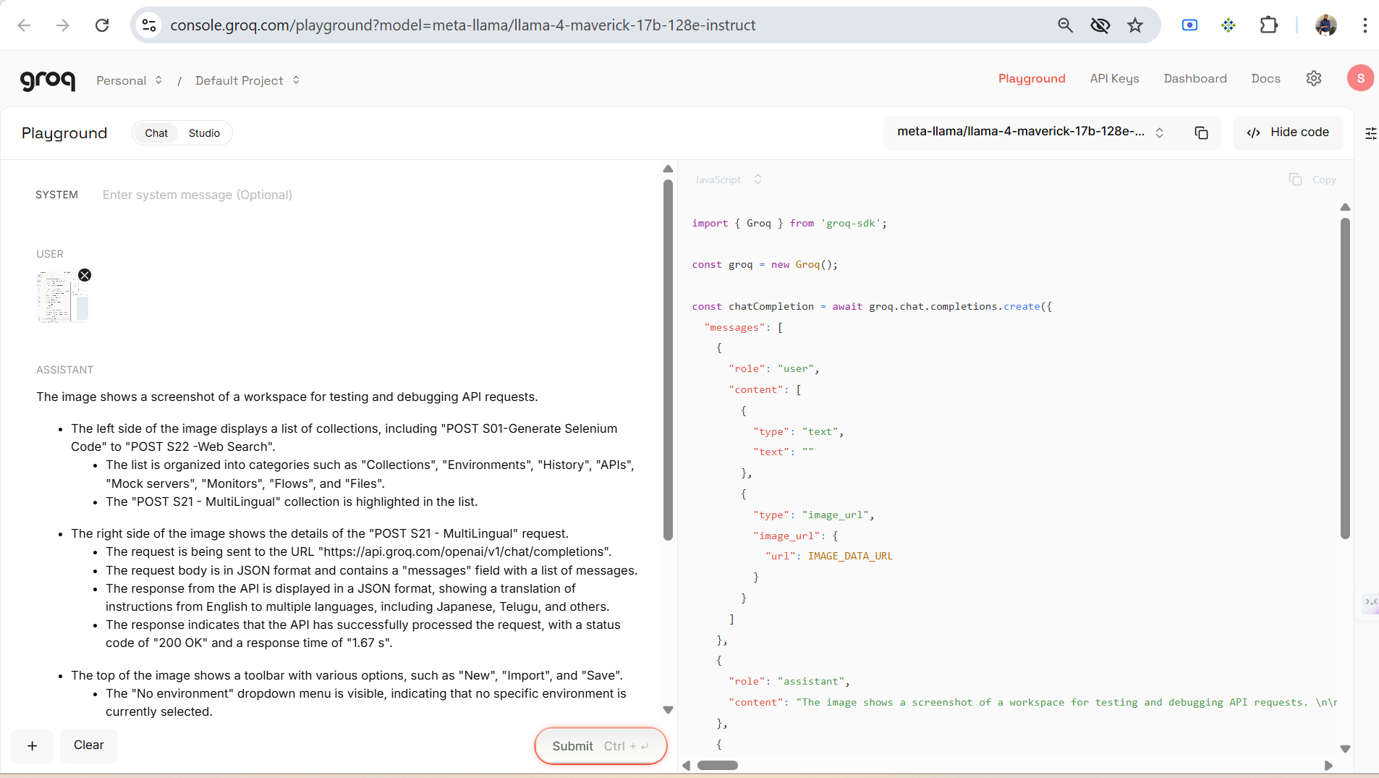
* The left side of the image displays a list of collections, including "POST S01-Generate Selenium Code" to "POST S22 -Web Search".
* The list is organized into categories such as "Collections", "Environments", "History", "APIs", "Mock servers", "Monitors", "Flows", and "Files".
* The "POST S21 - MultiLingual" collection is highlighted in the list.
* The right side of the image shows the details of the "POST S21 - MultiLingual" request.
* The request is being sent to the URL "https://api.groq.com/openai/v1/chat/completions".
* The request body is in JSON format and contains a "messages" field with a list of messages.
* The response from the API is displayed in a JSON format, showing a translation of instructions from English to multiple languages, including Japanese, Telugu, and others.
* The response indicates that the API has successfully processed the request, with a status code of "200 OK" and a response time of "1.67 s".
* The top of the image shows a toolbar with various options, such as "New", "Import", and "Save".
* The "No environment" dropdown menu is visible, indicating that no specific environment is currently selected.
* The "Share" button is available for sharing the request or response.

Overall, the image suggests that the user is testing and debugging an API request for multilingual support, and is reviewing the response to ensure that it is correctly translating instructions into different languages.

