Phase-2-Week-5 – Home Assignment -> Prepared own Project-Demo
Inventory Management:
Used ChatGPT to prepare the prompt to ready for Backend and Front and DB details to get Architecure.md file to prepare.
based on the above file first implemented with Backend +DB and Front end.
Role based Access Inventory Management application.
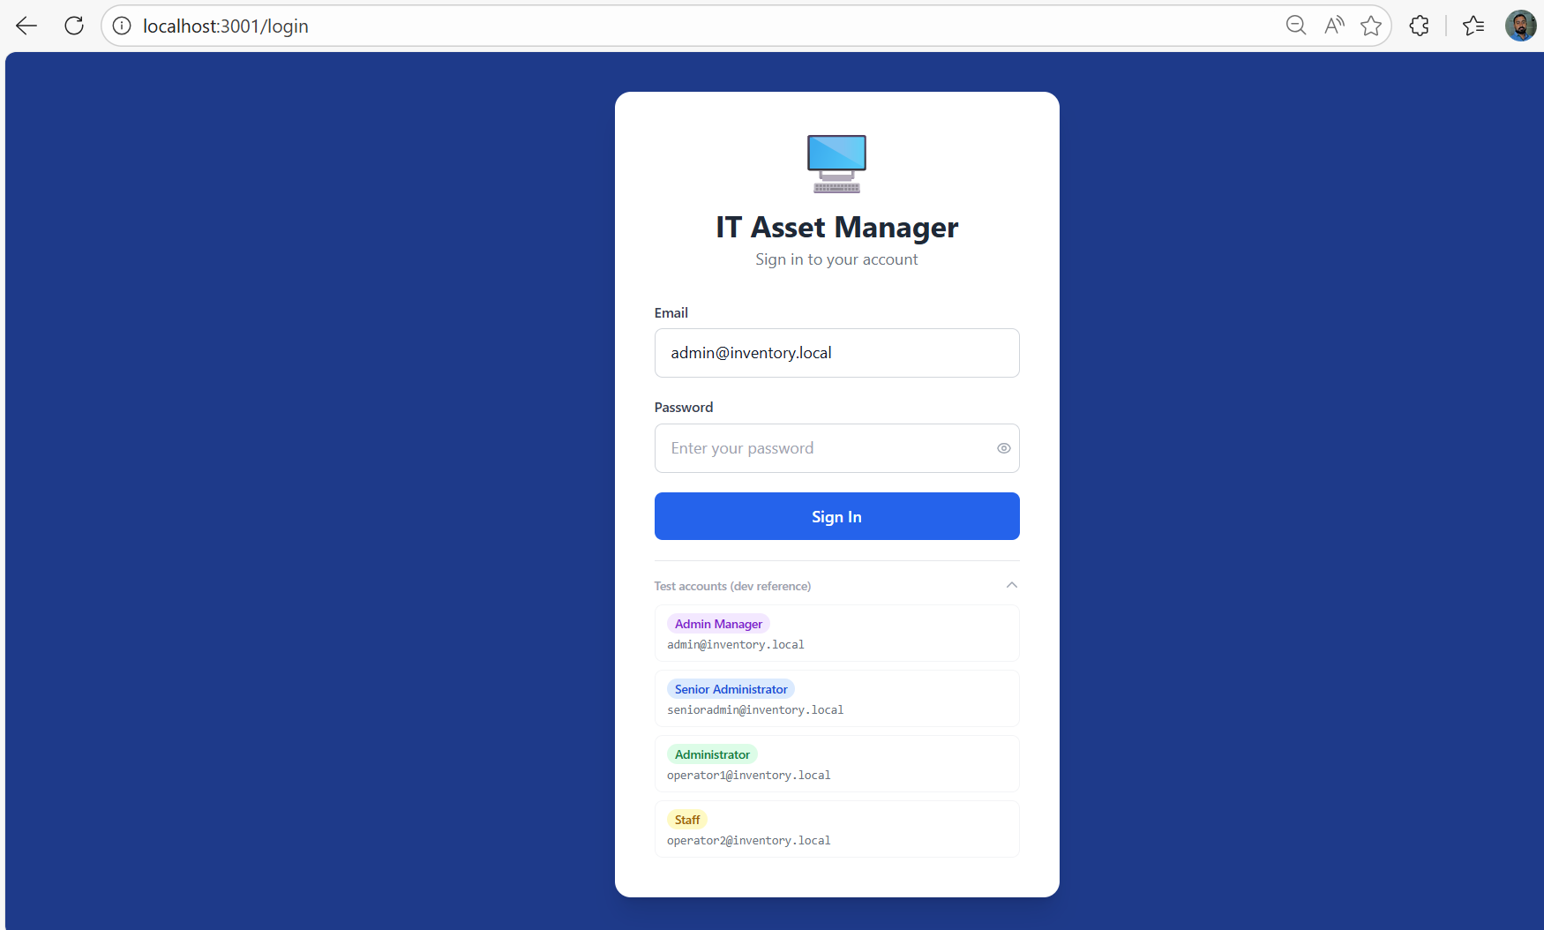
After login, the logged in user can see sub menu and Dashboard based on role.
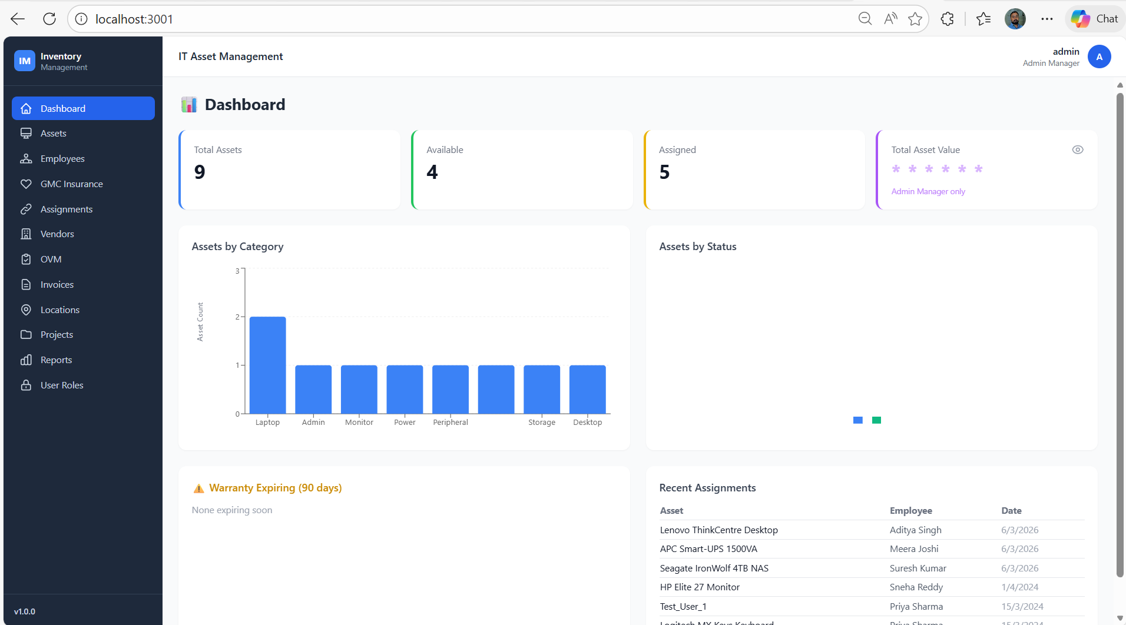
Asset management:
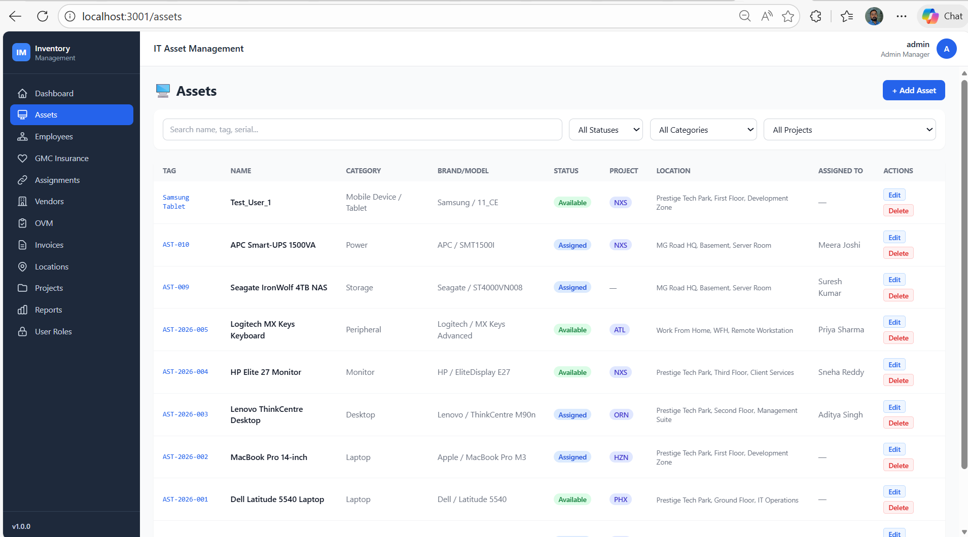
Operational Vendor Management:
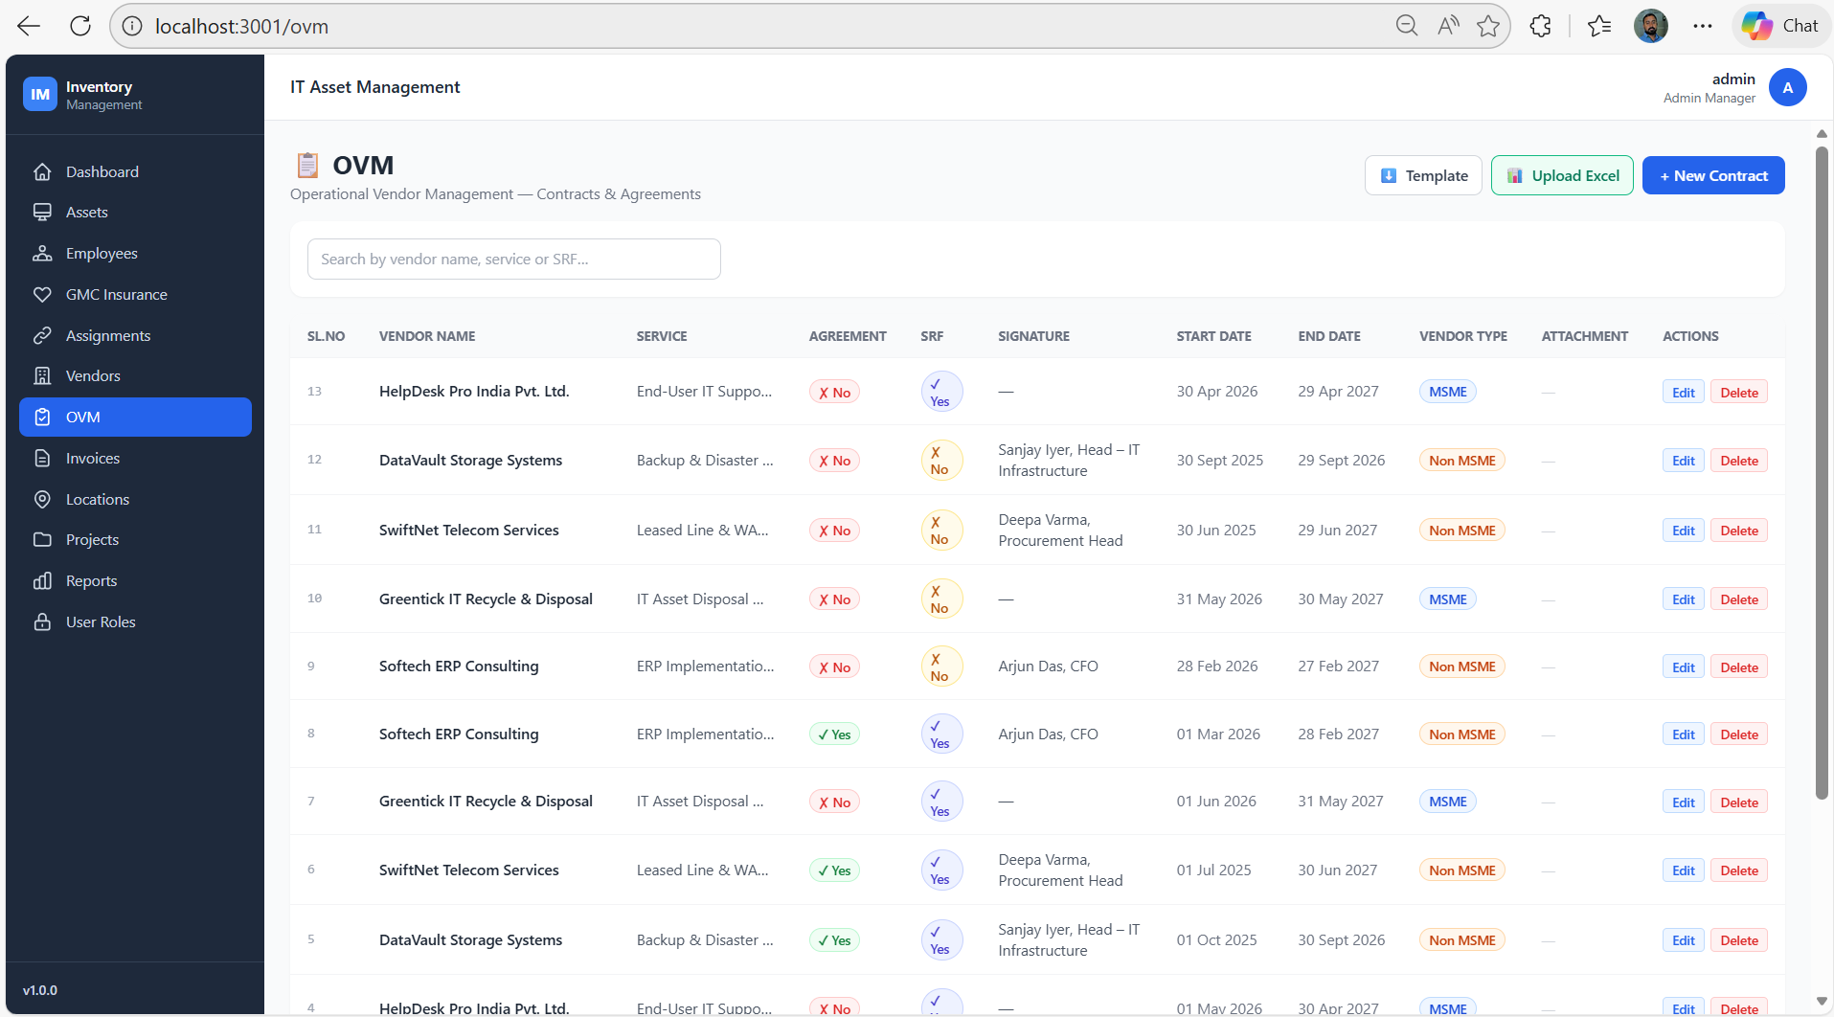
User Roles screen :
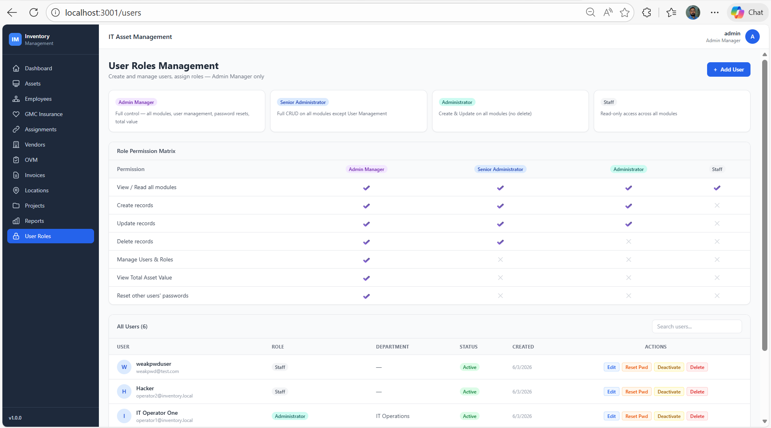
Also done some Automation execution Test to check the application quality:
