Phase-2-week-9 Home Assignment – Sanjeevi
With Test Leaf portal create Leads and fix the issue occurred.
Faced two issues:
Change Password Ok button – Handled this popup. – Fixed PASSED.
Create Lead – Entered all the create lead values on left side of the panel instead of main container. – Fixed – PASSED
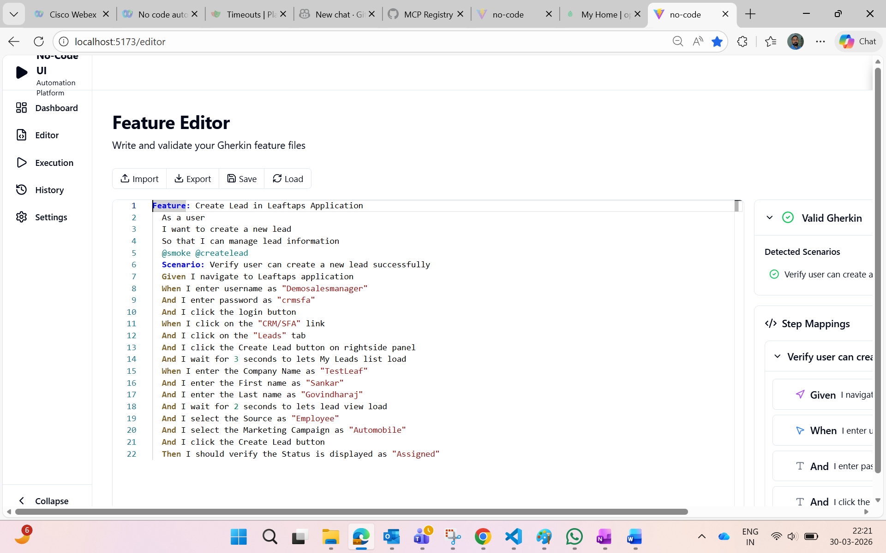
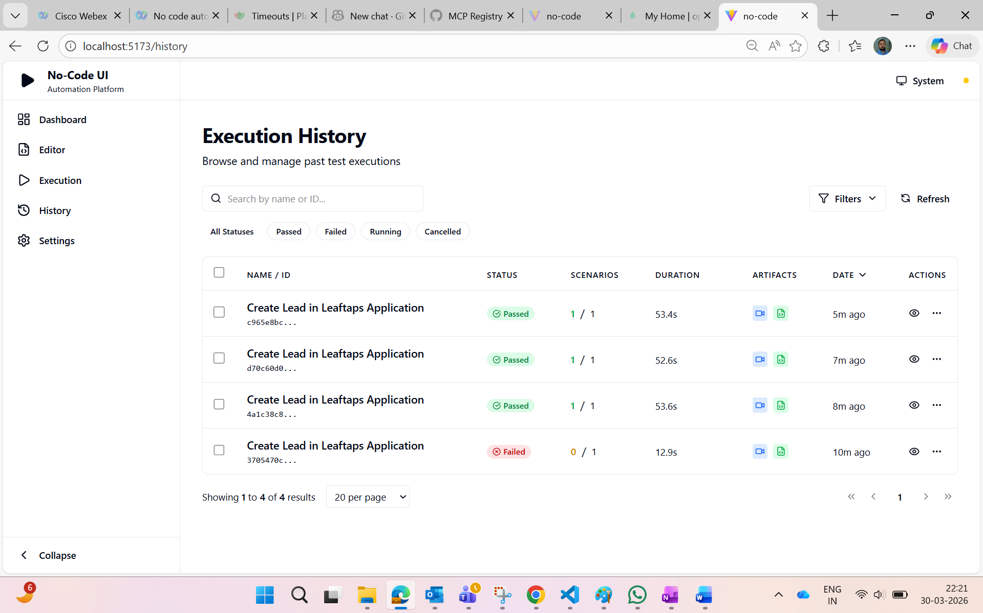
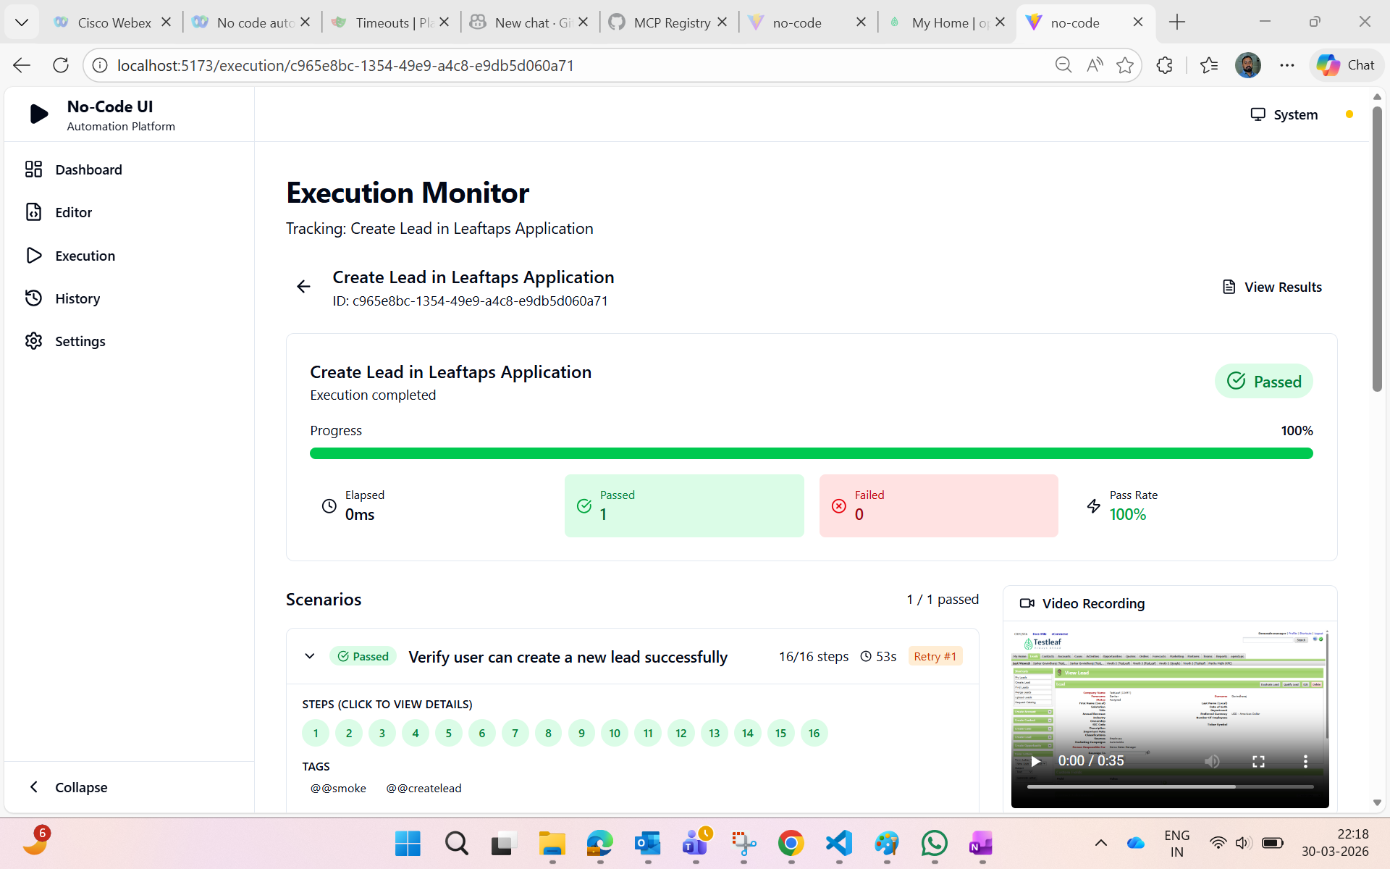
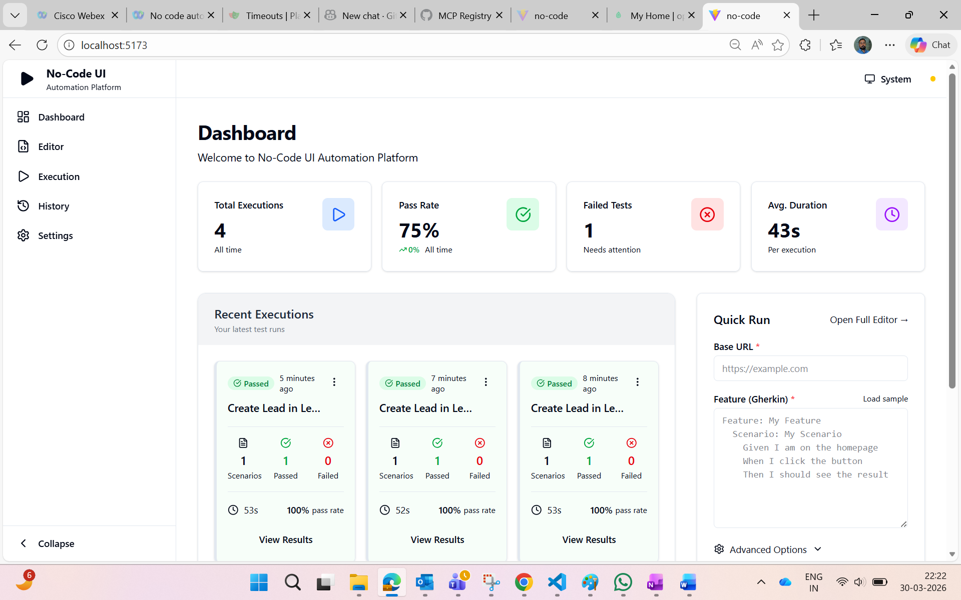

Use different portal to test.
