Sanjeevi - Phase-2-Week-6 – Home Assignment – Completed.
Resume chatbot along with Lang Chain implementation:
Before starting the new conversation validation handled on Conversation ID and Delete History button disabled.
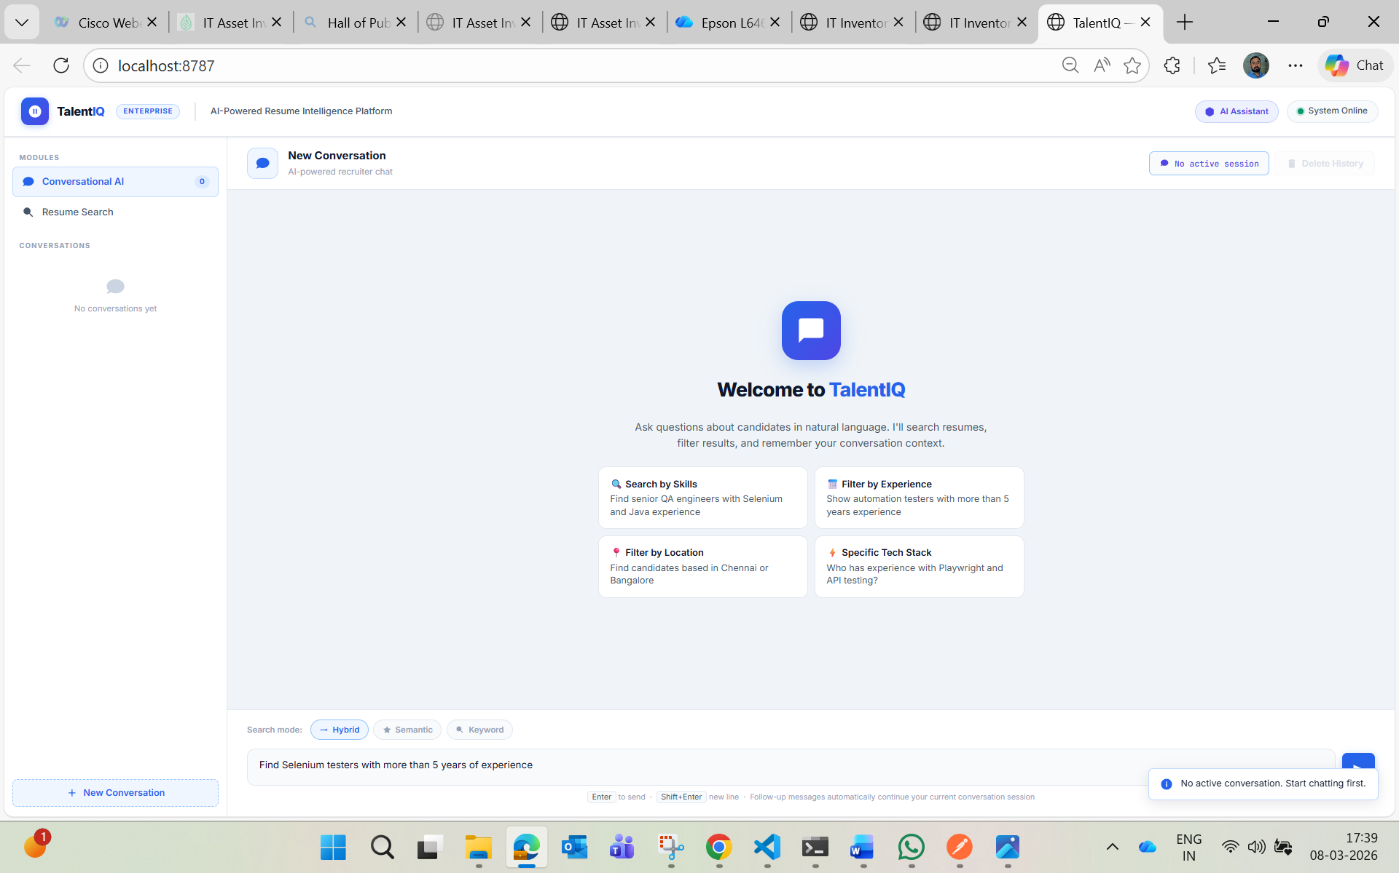

Search: "message": "Find Selenium testers with more than 5 years of experience"

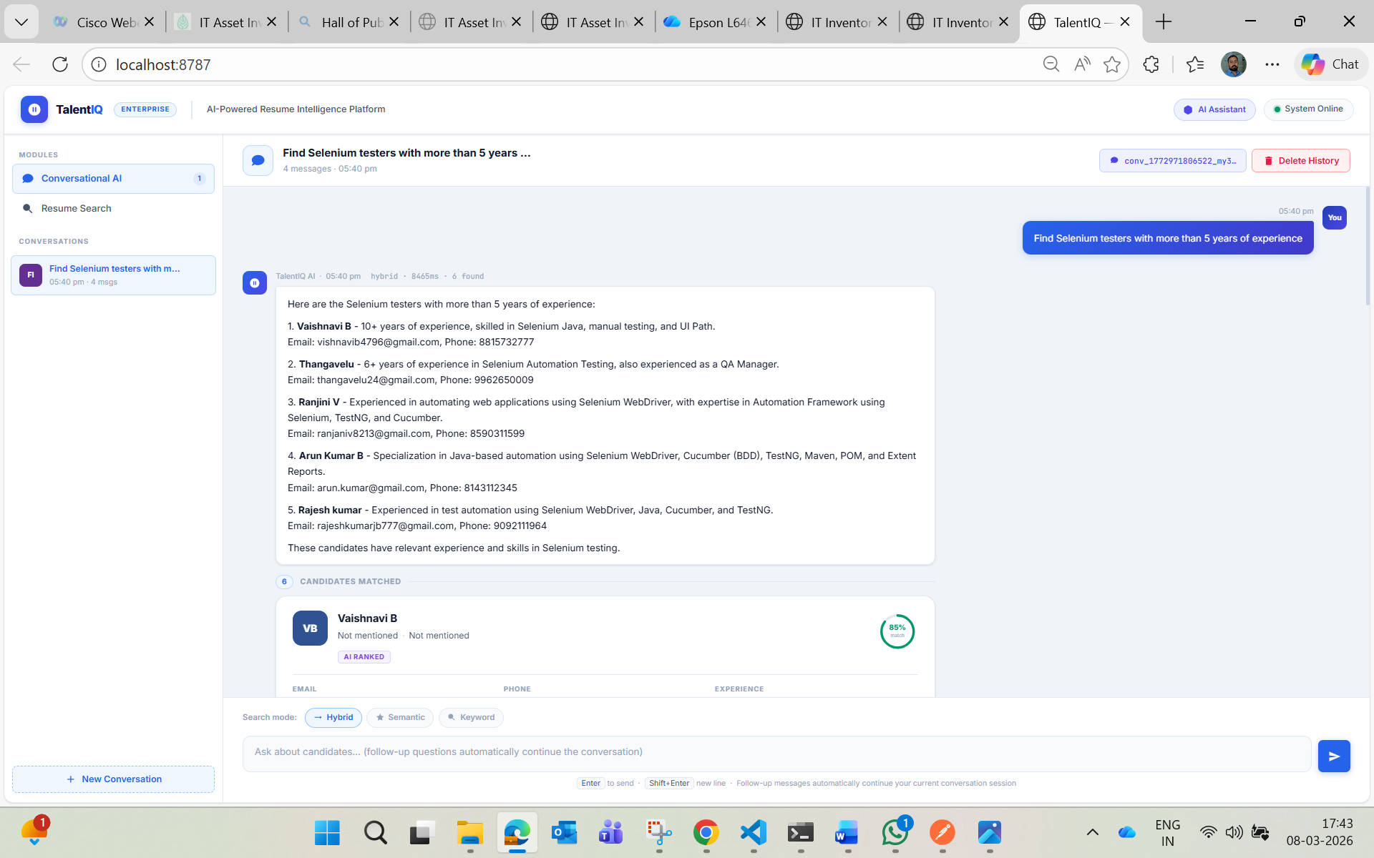
Continue conversation follow up:
"message": "From those, filter only candidates only above 10 years",
"conversationId": "{{conversationId}}"
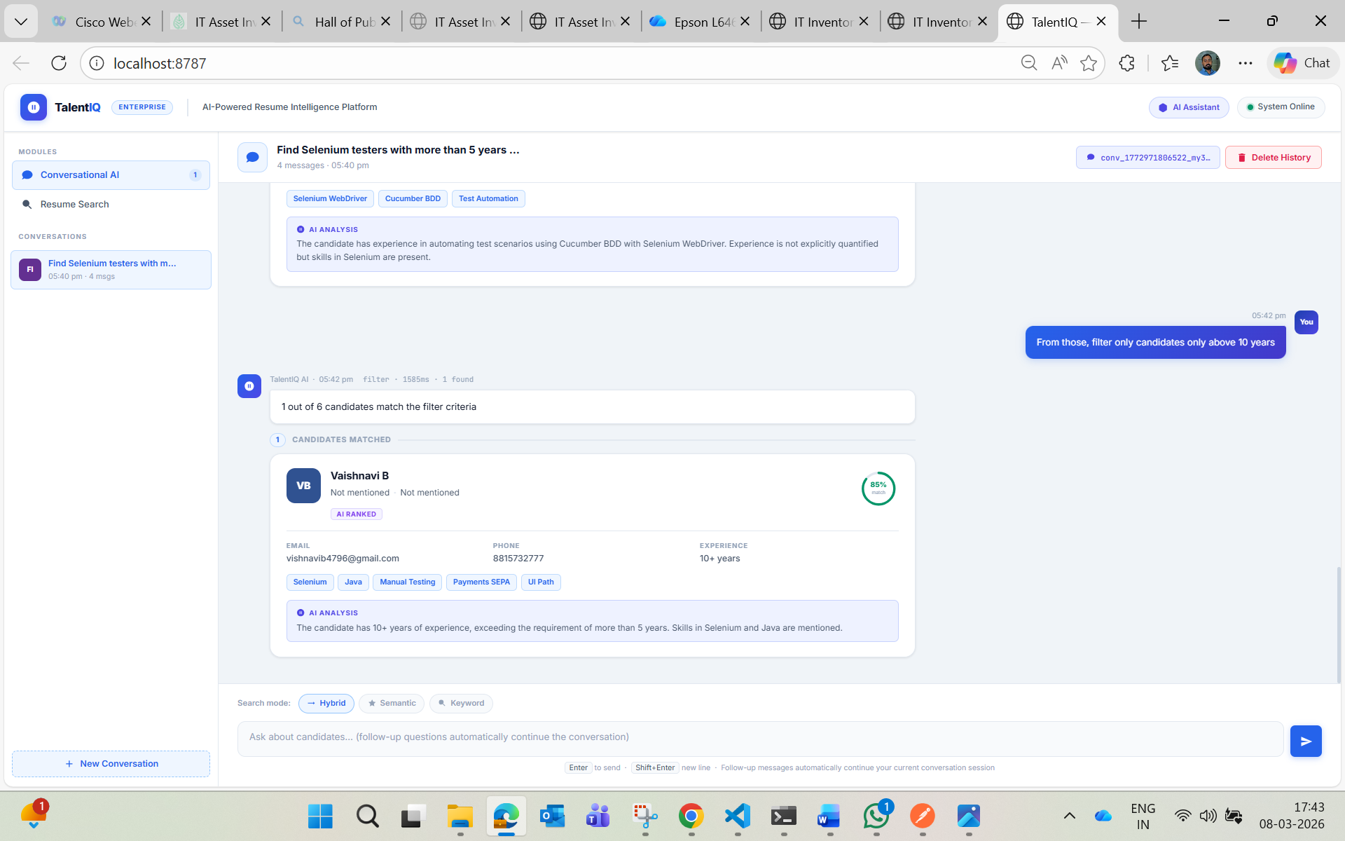
Search:
"message": "Now show me only the ones in Bangalore",
"conversationId": "{{conversationId}}"
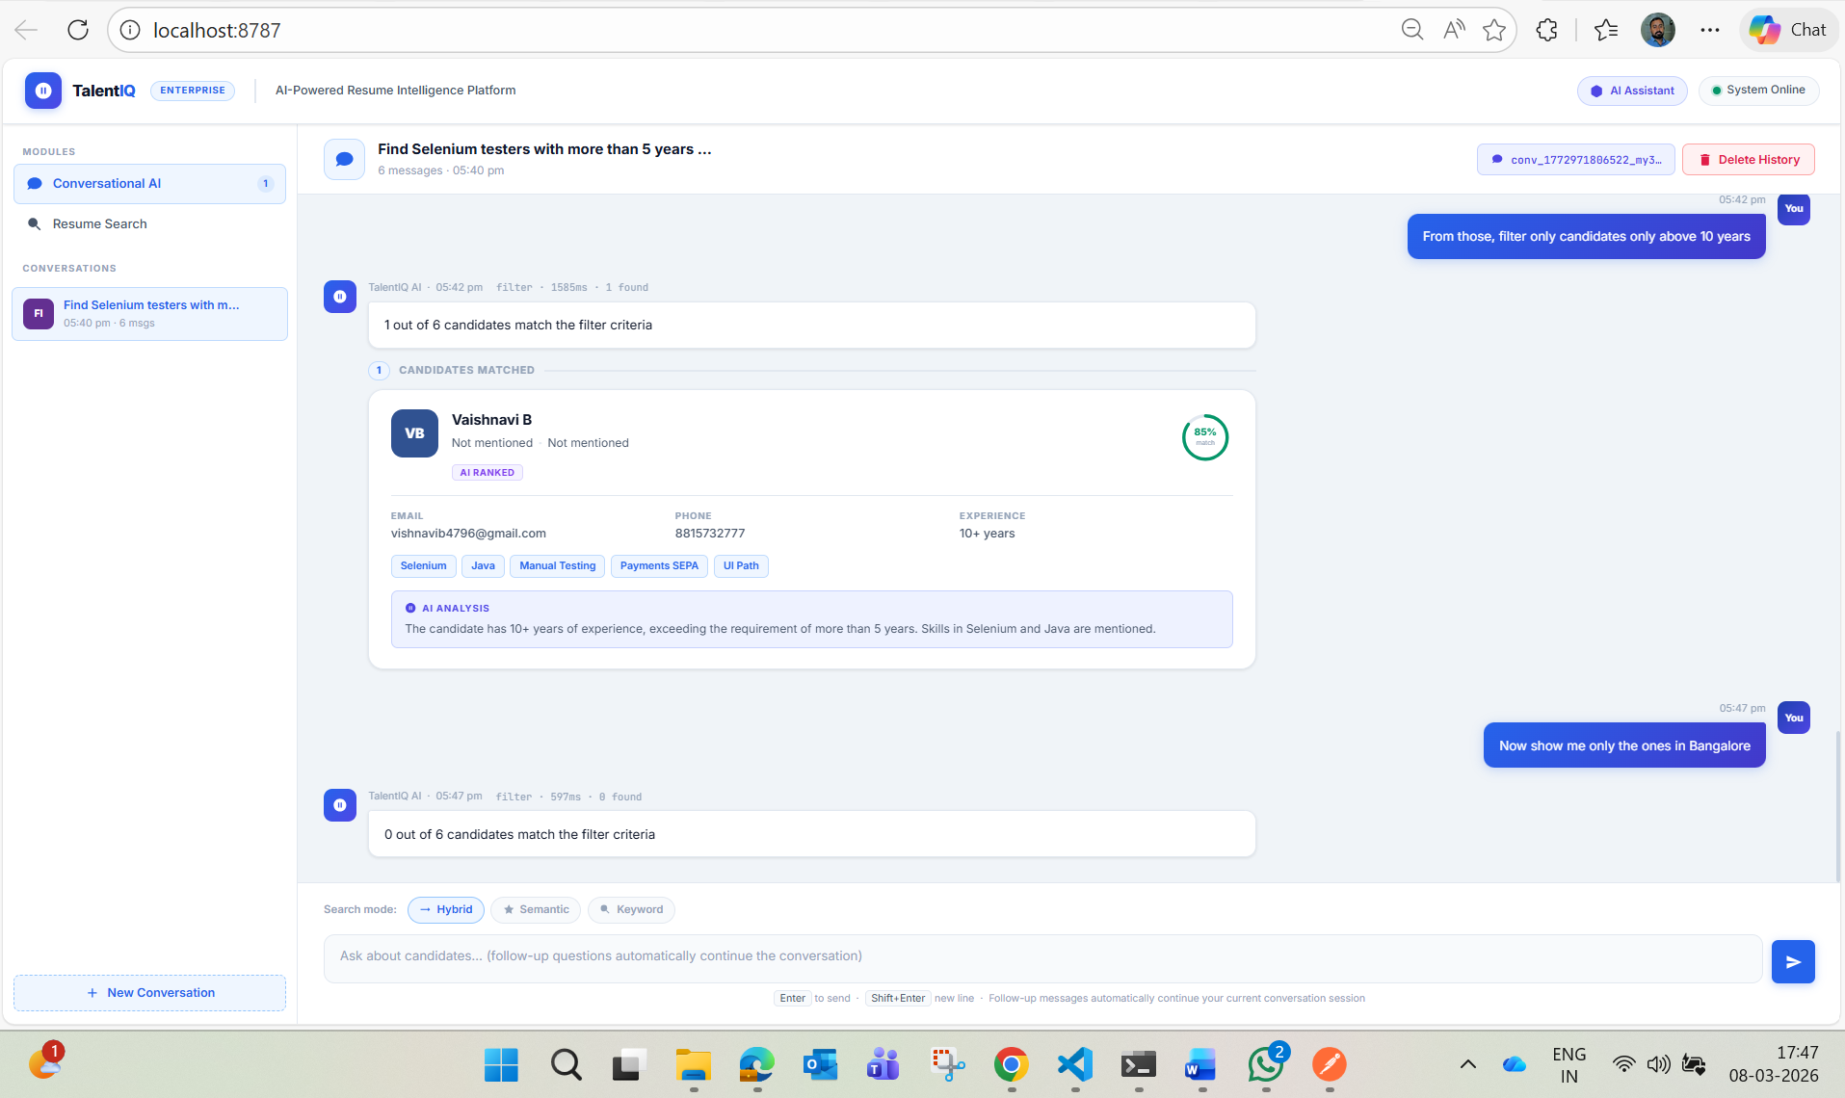
Same results as API:
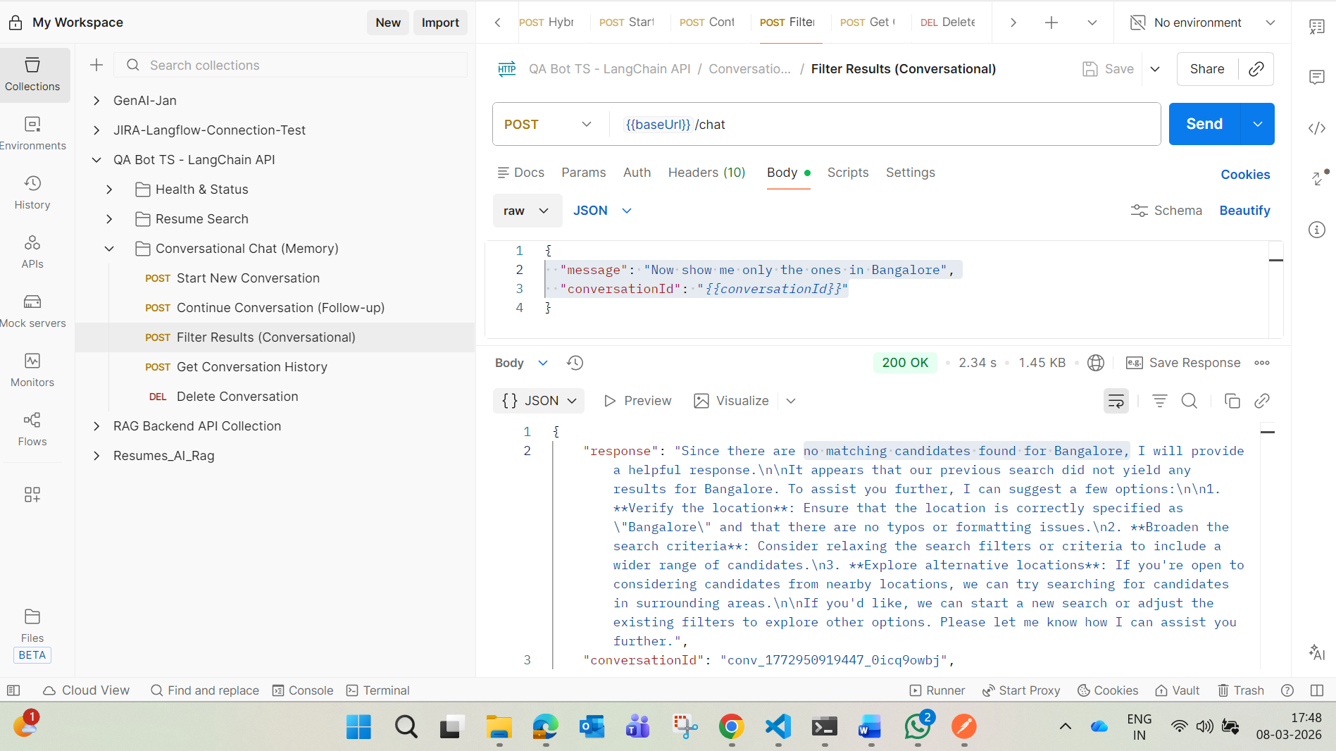

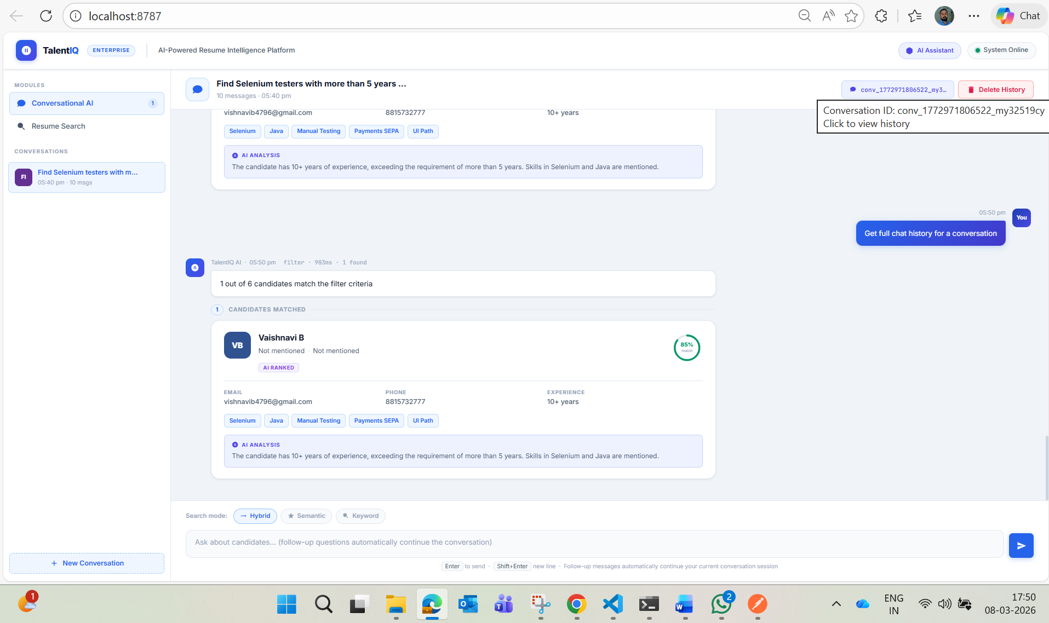
Delete Confirmation:
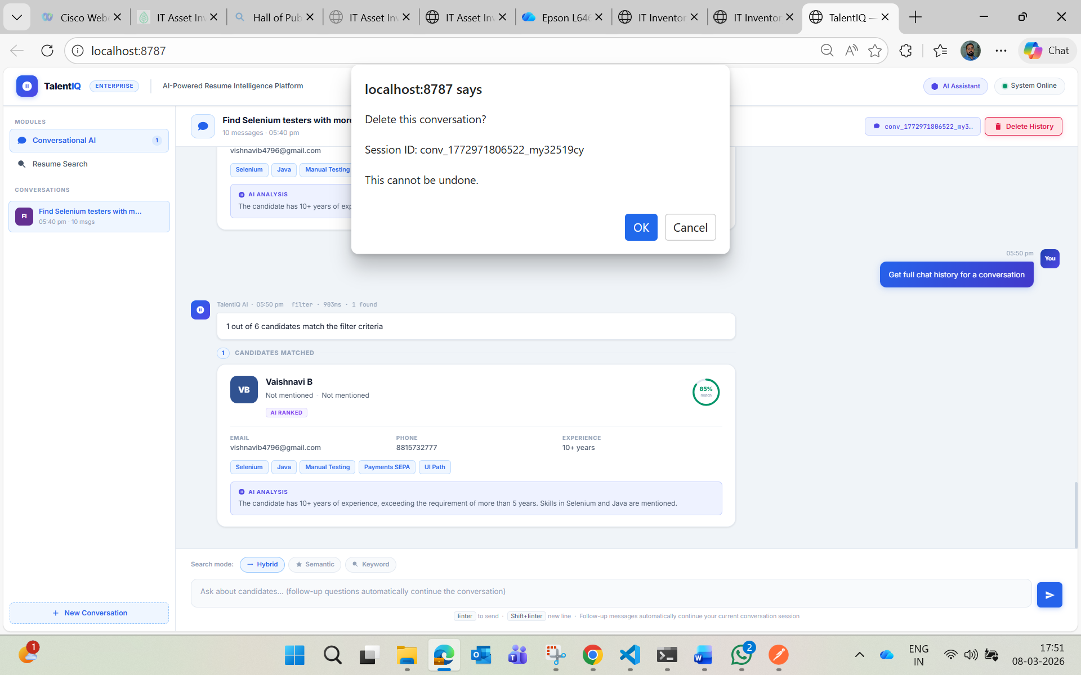

After delete when tried again:
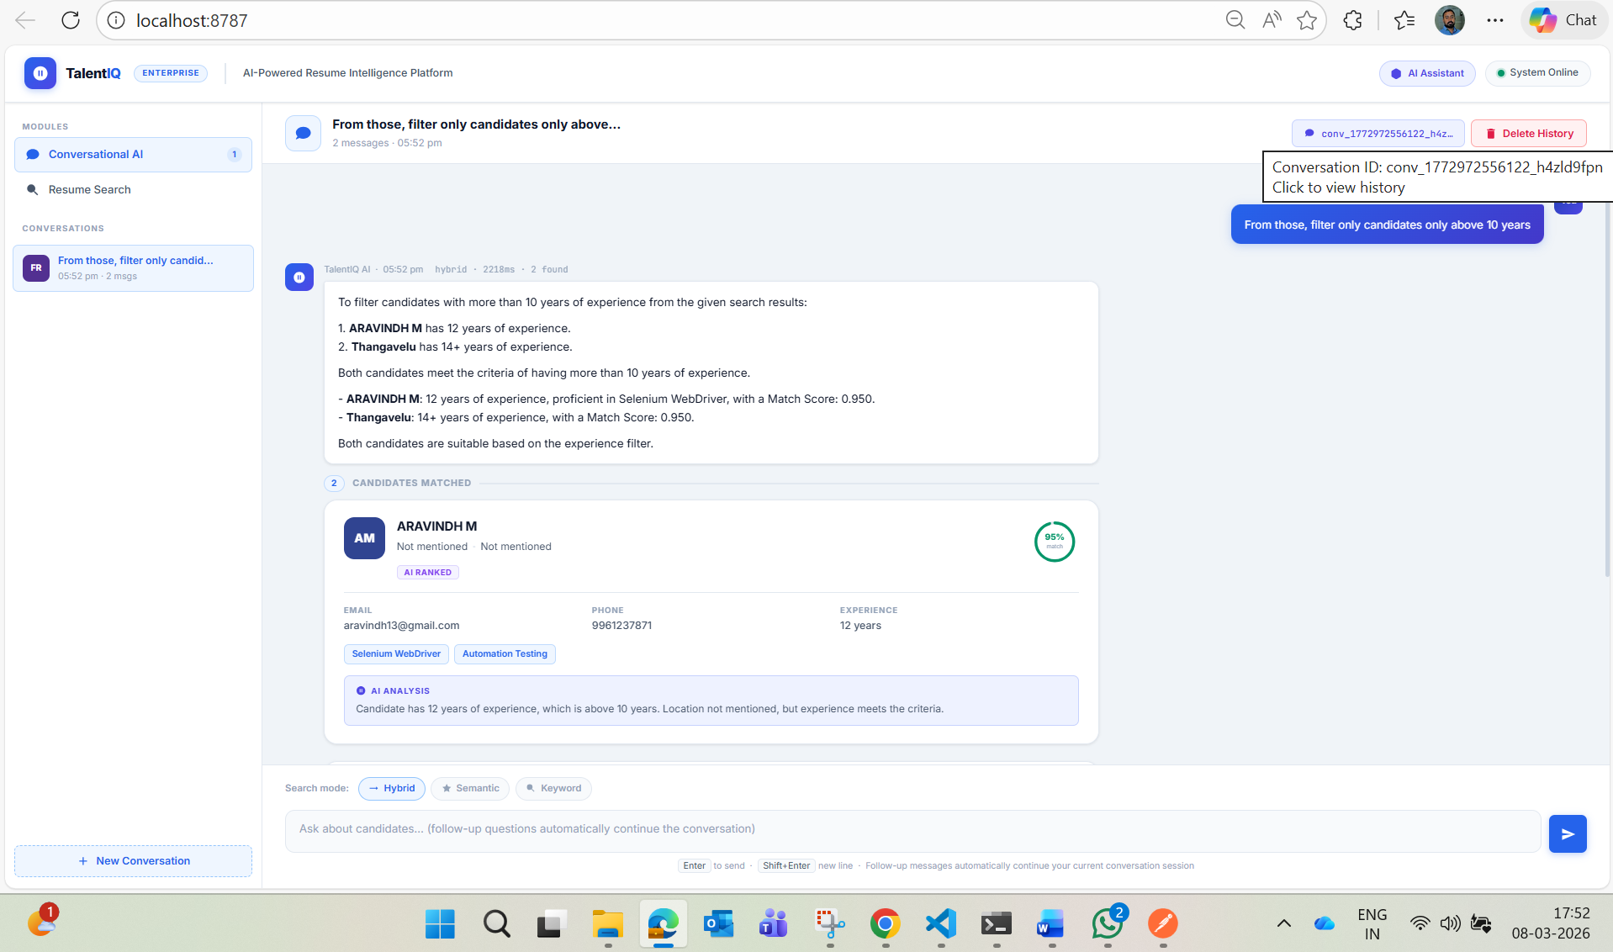
Conversation Deleted successfully:
