Phase-2-Week-1 – Home Assignment:
Input PDF finance document file used:
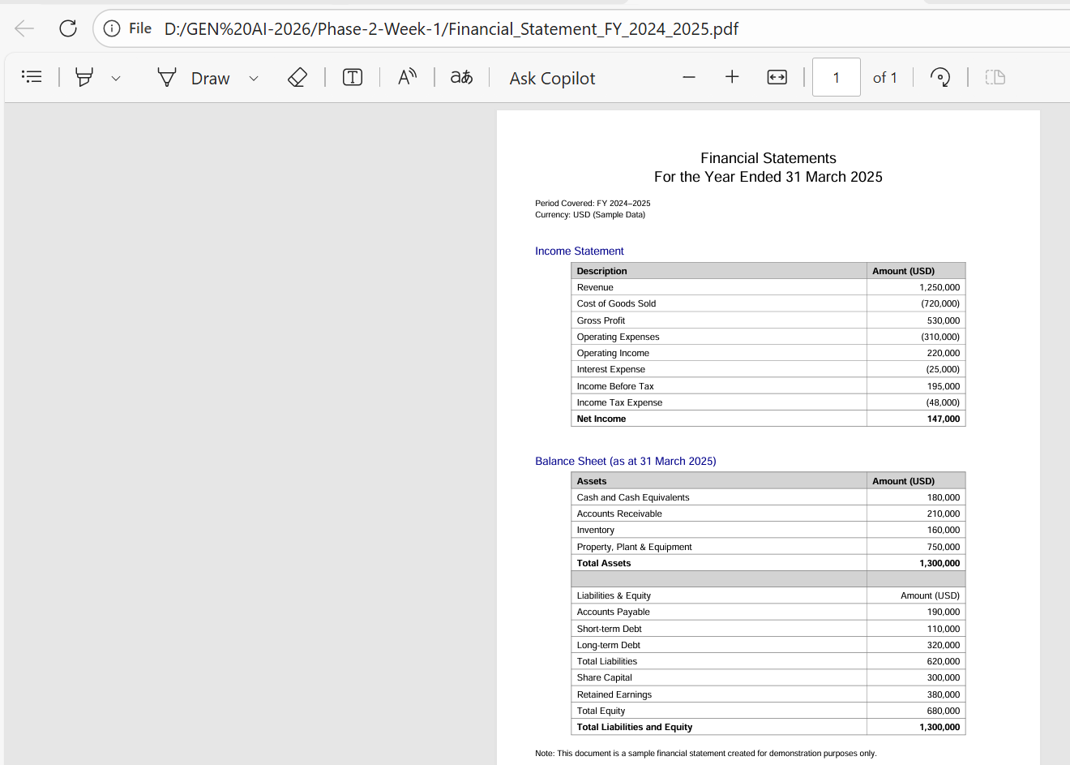
Output:
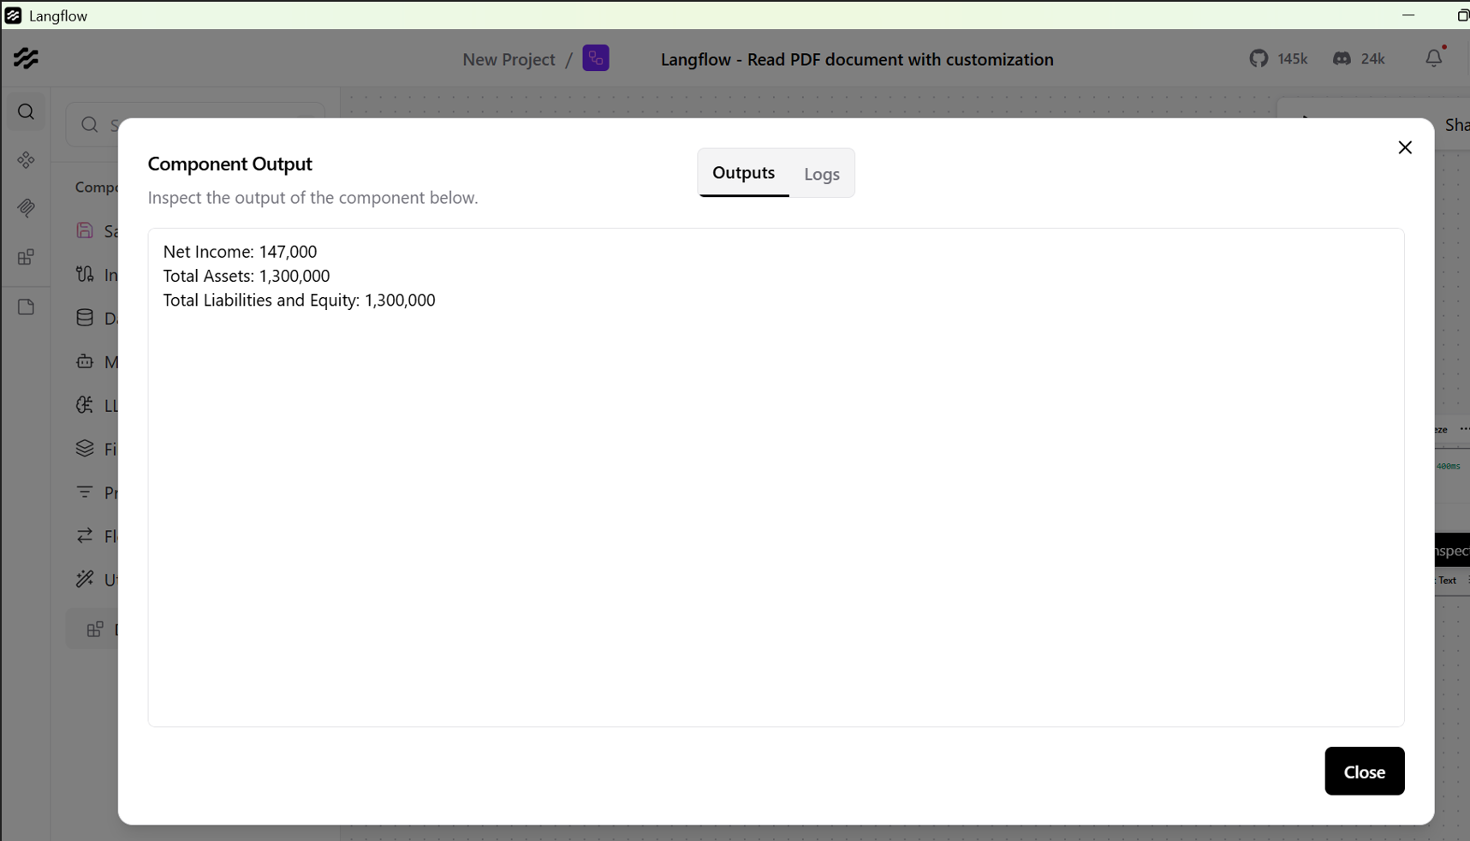

Langflow Test case generated and UserStory Review Agent:
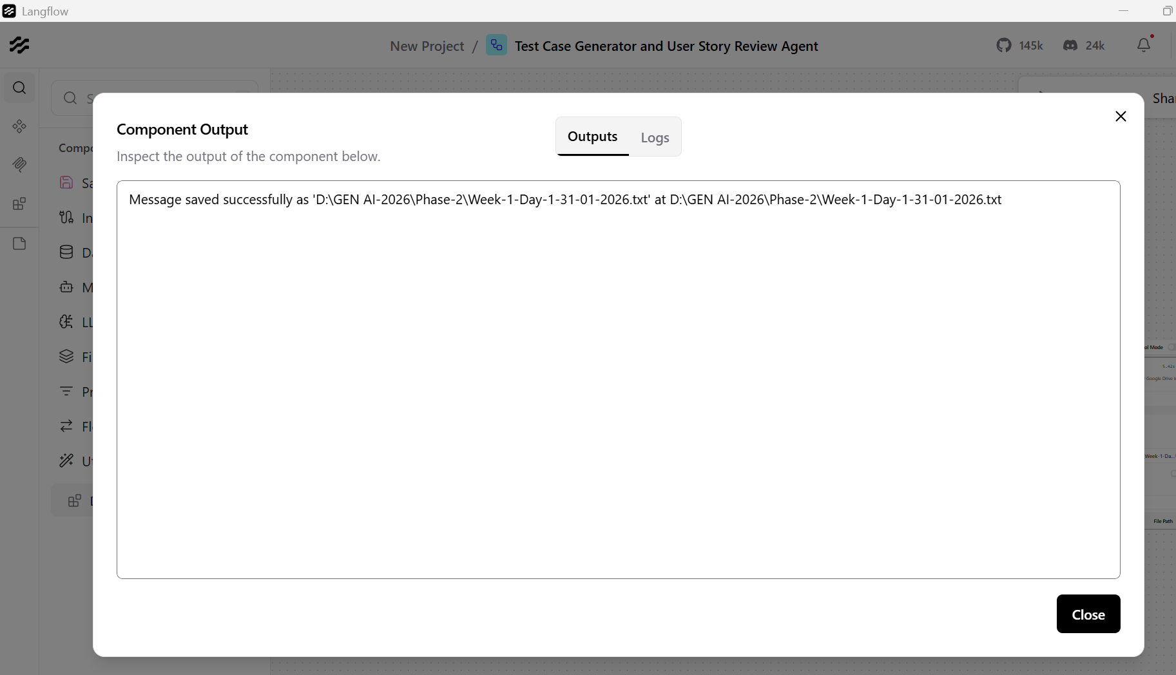
Output in HTML format:
