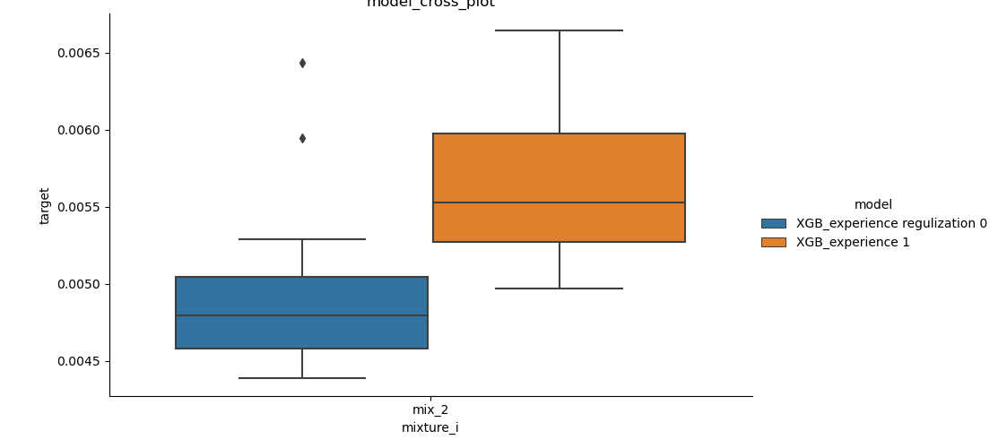
- Figure1: after some regularization, the result of XGBoost will perform better: this pictures follows in this way 1) Set negative value to 0. 2) Set >1 value to 1 3) if model thought there are no gas or liquid, set relative material fraction to be zero. For instance: if model says there are no gas, the material fraction in gas will set to [0:0]

