**CGG – Data Geoscientist Graduate Position. Task 2 24.02.2023**

**Questions**

* Can you identify the data/document type for each image?
* What metadata do you feel is most important for each image?
* What additional data could be extracted from the images to enrich subsurface data sets?

**Picture 1:**

This picture looks like a typical well-log at completion. It include a cross section on the left, gamma-ray, stratigraphic and resistance logs among other information. The most important metadata would be the well name or identifier, the location of the well, the date the log was recorded, and the specific type of well log being shown. Additional data that could be extracted from the log might include formation thicknesses, porosity, permeability, and fluid properties from the information logs at the bottom.

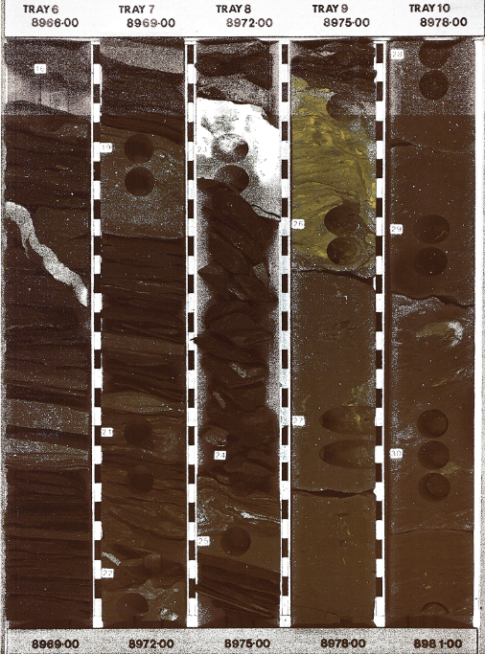

**Picture 2:**

The picture depicts a 2D image of the cross-section of 5 core-samples. The most important metadata would be the core identifier and the depth of the core. The intensity of the pixels, the colour of the cracks, the grain separation can be used to determine the lithology, mineralogy, grain size, rock strength and sedimentary structures. Additional information about the well-location and purpose can also be useful in the metadata.

**Picture 3:**

The picture depicts a seismic reflection survey. The most important metadata is the well-location, orientation of the cross section, the scale, location of the faults, depth of the well. Additional data that can be extracted would be useful is the date the survey was conducted, the seismic frequency range used, locations of folds and densities of rock.

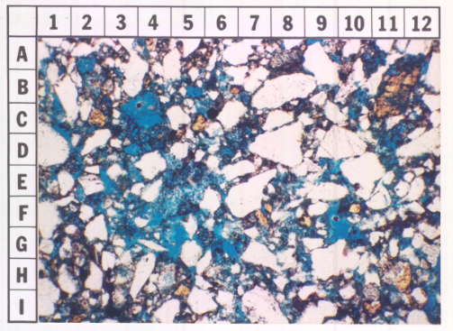**Picture 4:**

Picture 4 is a thin section usually used for a petrographic thin section analysis. The most important metadata would be the sample identifier, the location where the sample was taken from the wellbore, the pixel intensities and the date the sample was retrieved. From the colour of the minerals, one can deduce the mineralogy, texture, the concentration of a desired material and the origin of the rock (ie, metamorphosed) shown by the phases and orientation of the minerals.

**Picture 5:**

Picture 5 looks like a cross-secition of a deep-sea well-plug which is usually used in a well completion diagram. The most important metadata would be the well name or identifier, the location of the well, the date the diagram was created, and the type of completion being shown. Additional data that could be extracted from the diagram might include casing sizes, cementing depths, drill water zones, slurry zones and depth of the well.

**Picture 6:**

The picture is analysis the drilling rate and gass content of a piece of stratigraphy. This is typically used in drilling or logging analysis documents. The most important metadata would be the well name or identifier, the location of the well, the date the analysis was conducted, and the specific type of measurement being shown. Additional data that could be extracted from the analysis might include lithology, porosity, permeability, profitability of the well, degradation of the well and inherently the lifetime of the well. It can also be used to indicate any mechanical failure or test out any new technology.

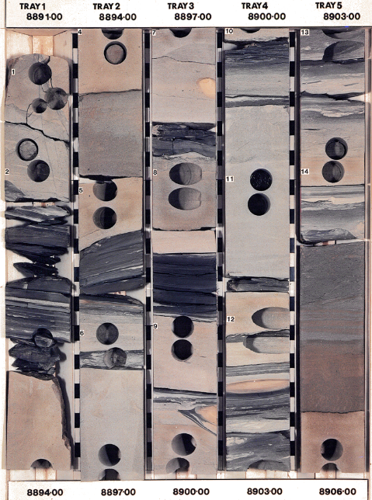

**Picture 7:**

Similar to picture 2, picture 5 depicts a 2D image of the cross-section of 5 core-samples. The most important metadata would be the core identifier and the depth of the core. The intensity of the pixels, the colour of the cracks, the grain separation can be used to determine the lithology, mineralogy, grain size, rock strength and sedimentary structures. Additional information about the well-location and purpose can also be useful in the metadata. The main difference is the lithology and stratigraphy of this core set. We see a much lighter rock, possibly sand-stone with pickets of a darker rock – possibly shale. This could indicate an area with high-porosity and a higher likelihood to be reservoir bearing rock.