Quotation:
(a snapshot image had to be removed for RTF export)
Comment:
This shows the decrease in BrCa and decrease in HRT
{Zbuk 2012@3} sente:/sentelib/Zbuk+2012

impact of HRT cessation appears most significant and ... (pp. 1)
"impact of HRT cessation appears most significant and immediate in countries with the largest absolute decline in HRT use."
largest absolute decline

the magnitude of the decline in breast cancer ... (pp. 1)
"the magnitude of the decline in breast cancer incidence, and its timing with respect to HRT cessation, shows considerable variability between nations"
magntidue and time lag varies

Snapshot (2015-05-23 23:15:05 +1200) (pp. 3)
"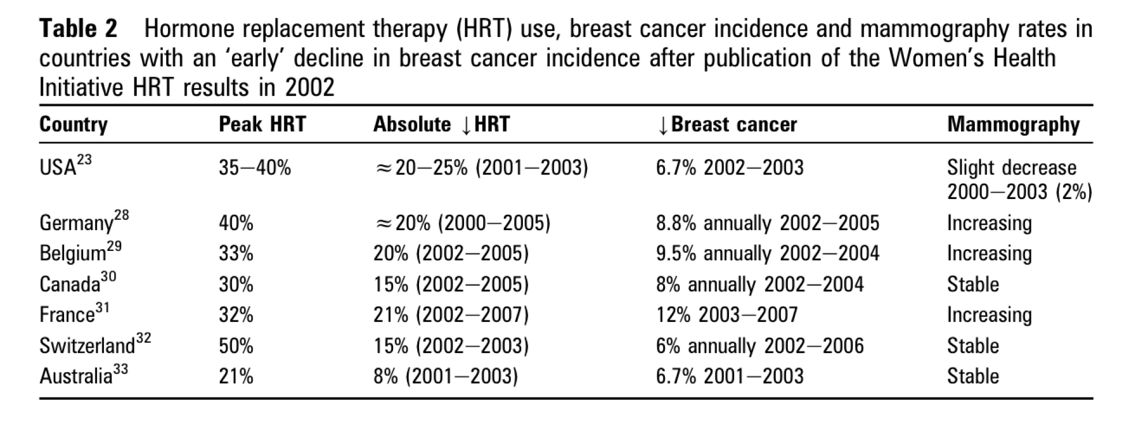"
This shows the decrease in BrCa and decrease in HRT

Current HRT users, on the other hand, had ... (pp. 81)
"Current HRT users, on the other hand, had a significantly increased risk, which was largest for current users of combined HRT (RR = 2.00), but also significantly increased in current users of estrogen-only HRT (RR = 1.30)."
Combined HRT risk, RR = 2.00, much higher than the 1.32, or 1.24, or 1.42 depending on what you see

In 1996, an Oxford-based group began collecting risk-factor ... (pp. 81)
"In 1996, an Oxford-based group began collecting risk-factor (including HRT use) and follow-up data from 1,084,110 women in the United Kingdom aged 50-64 who attended the national breast screening programme. The initial results of this Million Women Study were reported in 2003 after a 2.6-year median follow-up, at which time 6096 breast cancers had been recorded"
So, the cumulative incidence would be something like 562 per 100, 000

it was not until publication of the results ... (pp. 81)
"it was not until publication of the results of the Women’s Health Initiative (WHI) study in 2002 [9] and the Million Women Study in 2003 [10] that women and doctors started reconsidering the use of HRT and as a consequence sales of HRT started to drop sharply [11]"
Two major studies: (1) Women's Health Initiative Study 2002, and 2) Million Women Study in 2003, two studies coming out after each other. The E/P combination of HRT was very popular and people knew that they were associated with increased risk of breast cancer. Now the question is, whether with reduction in the sales and usage of HRT, do the risks of breast cancer or the incidence of breast cancer coming down as well? This is what this study is about.

Overall breast cancer risk was significantly increased in ... (pp. 81)
"Overall breast cancer risk was significantly increased in the com-bined HRT trial (hazard ratio [HR] = 1.24), and this risk was similar across age groups, increased with duration of use and was most apparent in women who had used HRT before entry into the trial [13]"
HR = 1.24 for E/P trial lower than the cohort study result

Report from the Nurses’ Health Study was the ... (pp. 81)
"Report from the Nurses’ Health Study was the first large study to find a significantly increased risk of breast cancer both for estrogen-only HRT (RR = 1.32) and for combined HRT (estrogen plus progestagen) (RR = 1.41) [12]. Subsequently, a comprehensive overview of all the available case-control and cohort data from 51 studies, involving 17,949 women with breast cancer and 35,916 controls, showed that the increased risk of breast cancer was confined to current and recent use of HRT [8]. Among these current and recent users, breast cancer risks increased with duration of use and reached a 56% rel-ative increase after more than 15 years of use. The excess risk was reduced after cessation of use of HRT and largely disappeared after about 5 years"
RR = 1.32, or RR = 1.41, plus after 15 years of use RR = 1.56??

The Million Women Study was the first to ... (pp. 81)
"The Million Women Study was the first to clearly establish that the risk of fatal breast cancer was also significantly increased in current users (RR = 1.22)"
RR = 1.22

This observation generated the hypothesis that HRT use ... (pp. 81)
"This observation generated the hypothesis that HRT use is particu-larly associated with lobular breast cancer subtypes (pure lobular or ducto-lobular breast cancer)."
Lobular more than ductal?

If the association between breast cancer risk and HRT to be real, then: (pp. 82)
"If the association between breast cancer risk and current use of HRT is indeed real, the following effects are to be expected as a consequence of the drop in use of HRT. 1. An overall decrease in the incidence of breast cancer, mainly in women aged 50-60 years, who are most likely to be current users of HRT. This decrease would be most pronounced in populations with the highest prevalence and longest duration of combined HRT use. 2. A drop in the incidence of lobular breast cancer, which is sharper than the incidence reduction in ductal breast cancer. Similarly, a drop in ER+ and/or PR+ and low-grade breast cancer would be more pronounced than a drop in ER− and/or PR− and high-grade breast cancer. 3. A (partial) reversal of the changed age-specific incidence pattern, i.e. the previously discussed ‘incidence peak’, would be expected."
This decrease would be most pronounced in populations with highest prevalene and longest duration. Which means, if we can stratify the prevalence and then we test the %, see if there is a relationship between % of usage (both pre and post) and the subsequent reduction,

Increase in br ca associated with mammographic screening (pp. 82)
Role of Mammographic screening

Mammography or Not (pp. 82)
"Geneva investigators showed that the incidence peak was present only among women who had ever used HRT, regardless of whether they had undergone mammography screening or not"
HRT and Br Ca

Tumor doubling time of 50-100 days, and 30-35 ... (pp. 82)
"tumor doubling time of 50-100 days, and 30-35 tumor doublings needed to achieve a tumor size of 1 cm diameter, a single malignant tumor cell requires 5-10 years to grow to a clinically and/or mammographically detectable cell mass (i.e. 1 cm)."
How long does it take for a tumor to grow and what are the calculations?

What is the cause of HRT and Br Ca? (pp. 82)
New expression of estrogen, or what?

Snapshot (2015-05-24 15:24:15 +1200) (pp. 83)
"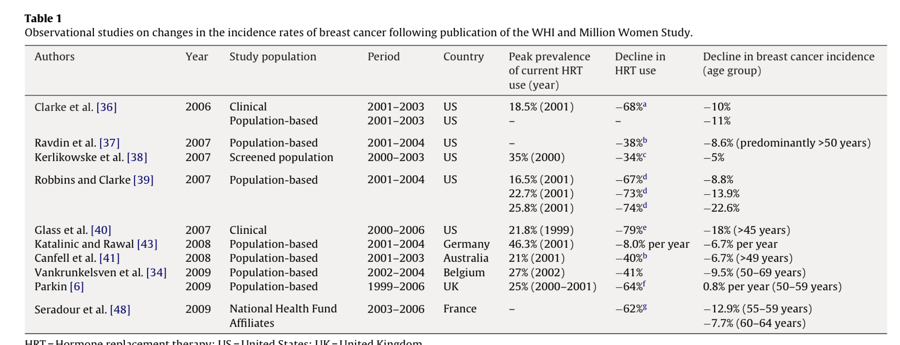"
Extent of reduction is something what we are findings as well. Let's see, we got US, Germany, Australia, Belgium, France, but not UK as we could not get authentic data for the year range of 1998 - 2001

Inthe Kaiser Permanente data set, for example, the ... (pp. 84)
"Inthe Kaiser Permanente data set, for example, the reduction in mam-mography use was about 2-7%, and it is very unlikely that this is a major explanation of the much larger reductions in breast cancer rates [36]. In addition, follow-up data from the WHI study provide further evidence against changes in mammography use being an explanation for the observed reduction in the incidence of breast cancer, since the 2% difference in frequency of mammography use between 2002 and 2003 for women using HRT is insufficient to account for the 43% reduction in the incidence of breast cancer [44]. The observed sharp drop in breast cancer incidence in France between 2000 and 2006, despite a 30% increase in mammography screening rates in the 50-74-year-olds, is further supportive of a role for HRT in breast carcinogenesis"
Explanation as to why drop in mammography is not sufficient to explain the drop in Br Ca following discontinuation of the HRT

