### Association of HRT with Breast Cancer: findings from aggregated data from 25 countries

### Summary

The purpose of this paper is to analyse the association between adoption of hormone replacement therapy in 25 countries and the rates of breast cancer in those countries.

### Data and Methods

1. A spreadsheet on the rates of adoption was prepared from published papers
2. From the Globoscan database, data on the incidence rates and mortality were abstracted and put into the spreadsheet. This composite data came from the following tables:

**Table 1. Trends in HRT use**

|  |  |  |
| --- | --- | --- |
| *Country*  *Population*  *Age-range* | *HRT use* | *References* |
| Australia  Population-based survey  40 years and older | Peaked in 2001 at 21% and Decreased to 12% by 2002  Returned to 19% by 2003 | (Main and Robinson, 2008, MacLennan et al., 2004, Zbuk and Anand, 2012) |
| Canada  National Population Health Survey  50-69 | Peaked at 30-45% in 2002  Decreased to 15% by 2004 and 13.7% in 2006 | (Zbuk and Anand, 2012, De et al., 2010, Neutel and Morrison, 2010) |
| China  Shanghai Women’s Health Study cohort  “after menopause” | Estimated 3% in 1997-2000 | (Linos et al., 2008) |
| Denmark  Danish Medicines Agency  Age range? | Peaked at 11% in 2003  Decreased to 9.7% in 2004 and to 9% in 2005 | (von Euler-Chelpin, 2011) |
| Finland  Nationwide register study  45 years and older | Peaked at 21% in 2003  Decreased to 12% in 2012 | (Holm et al., 2014) |
| France  National reimbursement data  50-64 years | Peaked in 2001 at 32% Decreased to 11% by 2007 | (Zbuk and Anand, 2012, Seradour et al., 2009) |
| Iceland  Survey (n=561)  47-53 years | 22% in 2004  (Ref Icelandic study 57% of 52-57 year olds 1996-2001) | (Sveinsdóttir and Olafsson, 2006) |
| Israel  HMO population  45 years and older | 20% in 2001  10% in 2007 | (Silverman and Kokia, 2009) |
| Italy  Milan prescriptions file  50-69 years | Estimated at 12% in 2003  6.9% in 1999-2001 | (Manzoli et al., 2004, Crocetti et al., 2010) |
| Japan  Community survey (n=8791)  45-64 years | 2.5% in 1992 | (Nagata et al., 1996) |
| Korea |  | Nil |
| Luxembourg |  | Nil |
| Netherlands  EPIC Cohort  49-70 years | Peaked at 13% 1993 - 1997  Decreased to 11.4% in 2002-2003 and to 6.6% by 2005 | (Soerjomataram et al., 2007, van Duijnhoven et al., 2006) |
| New Zealand  Population-based survey  45-64 years | 20% in 1997  Decreased to 11% in 2002 | (Bilgrami et al., 2004, North and Sharples, 2001) |
| Norway  Oslo Health Study  59-60 years | 46% of 59-60 year olds in 2000-2001 (Oslo)  Decreased in Norway by 67% from 1999 to 2007 | (Meyer et al., 2009, Zbuk and Anand, 2012) |
| Poland  Representative national sample  45-64 years | 12% in 2002 (before WHI Trial results) | (Rachon et al., 2004) |
| Portugal  Cohort (n=382)  “Postmenopausal” | Lifetime prevalence of HRT use unchanged from 1985-2005 | (Lucas and Barros, 2008) |
| Saudi Arabia  Tertiary care hospital chart review  56-59 years | 46% in 2000 (before WHI Trial results) | (Kirkby and Saif, 2004) |
| Spain  Primary healthcare centre population  45-65 years | 11% in 1998  8.6% in 2002 | (Pollán et al., 2010, Zbuk and Anand, 2012, Bermejo and Perez, 2005) |
| Sweden  National pharmacy data  50-59 years | Peaked at 36% in 1999  Declined to 27% in 2002 and 9% in 2007 | (Lambe et al., 2010) |
| Switzerland  Cohort study  45-49 years | 35-50% in 1996  46% in 2002 | (Verkooijen et al., 2008, Bouchardy et al., 2006) |
| United Kingdom  Million Women Study  45-69 years | 27.7% in 1998  25% in 2000-2001  12% in 2006 | (Bromley et al., 2004, Parkin, 2009) |
| United States  National prescription and therapeutic index databases  50-74 years | Peaked at 42% in 2001  Declined to 28% in 2003 | (Hersh et al., 2004) |
| Uruguay |  | Nil |

Based on this table and data obtained from Globoscan, we initially created this dataset:

1. The spreadsheet was then analyzed using Stata 12. The codes, tables, and the figures are presented along with the annotated tables.
2. A variable was created after studying the different years from the literature when different rates of the hormone replacement therapies were observed (see Table 1). These years varied as early as 1992 for Japan and for some countries it ended up in 2012. We also noted that 2008 was the latest year for which incidence data for breast cancer was available from the globoscan. Hence, a variable was created after taking into acount the variation in the prevalence of HRT use to indicate the latest year prior to 2008 for which data were reported. For several countries, no data were obtained (South Korea and Uruguay). For Spain, although two different regions were noted for which breast cancer incidence data were obtained, for these regions, it was not possible to obtain the HRT usage data from teh literature. Therefore, data for the rest of Spain was imputed to indicate HRT usage for Spain alone.
3. In addition to the variable created to reflect the latest year for which data were available, the usage (HRT usage) for that year was entered into the spreadsheet to indicate roughly the usage patterns for all years. This variable was referred to as CorrHRT to indicate the corresponding HRT usage percentage for the year corresponding to the latest year prior to 2008 for which data were available.
4. To further exmine the association between HRT usage and breast cancer incidence, the best estimated usage of HRT was also included, from the available information. This information is coded in the variable HRT Use.
5. The HRT Usage for both the average usage data and the HRT usage for the latest year available were then recoded to indicate high, medium or low usage. For HRT usage data as obtained from the best available estimate, three categories were created based on the distribution. For HRT prevalence corresponding to the latest year before 2008, two categories, high and low usage was created to indicate the low and high cut off values of usage of HRT therapy. The low category was created for those countries who prior to 2008, registered less than 9% usage in HRT, and high user category of countries were those who used between 9-46% HRT.
6. Breast cancer incidence and mortality values for 2008 were tabulated, graphically examined and Kruskal Wallis Test for rank sum tests were conducted to test associations between HRT Usage statistics and mortality or incidence of Breast Cancer in 2008.

### Tables of Results

Table 2. Distribution of the Breast Cancer Screening Programmes in the 25 countries.

|  |  |  |
| --- | --- | --- |
| Type | Freq | Percent |
| National Screening | 11 | 44.00 |
| National plus State | 7 | 28.00 |
| Other | 2 | 8.00 |
| State Only | 5 | 20.00 |
|  |  |  |
| Total | 25 | 100.00 |

Table 3. Distribution of the HRT Usage and the Breast Cancer Incidence and Mortality

|  |  |  |  |  |  |
| --- | --- | --- | --- | --- | --- |
| Variable | Obs | Mean | Std. Dev. | Min | Max |
| HRT Usage | 20 | 17.4 | 13.8 | 2.5 | 46 |
| brca incidence (2008) per 100, 000 PY | 23 | 75.1 | 20.7 | 22.4 | 99.7 |
| brca mortality (2008) per 100, 000 PY | 23 | 15.1 | 3.56 | 5.3 | 20.8 |

Table 4. HRT Use for the year that was closest to 2008 when the breast cancer incidence and motality were reported.

|  |  |  |
| --- | --- | --- |
| HRT Use | Freq. | Percent |
| Low Use (< 9%) | 6 | 30.00 |
| High Use (9-46%) | 14 | 70.00 |
| Total | 20 | 100.00 |

Table 5. HRT Use (High Use versus Low Use) for Breast Cancer Incidence and Mortality

|  |  |  |
| --- | --- | --- |
| HRT Use Levels | brca incidence in 2008 | brca mortality in 2008 |
| Low Use | 74.46 (15.42) | 22.1 (4.80) |
| High Use | 79.5 (16) | 20.3 ( 2.37) |

Table 6. Kruskal-Wallis equality-of-populations rank test for incidence of breast cancer with HRT Use that was closest to 2008 as estimated

|  |  |  |
| --- | --- | --- |
| HRT use levels | Obs | Rank Sum |
| Low Use | 5 | 44.50 |
| High Use | 14 | 145.50 |

* chi-squared = 0.25 with 1 d.f.
* probability = 0.61

Table 7. Kruskal-Wallis equality-of-populations rank test for mortality attributed to breast cancer for HRT Use closest to the year 2008

|  |  |  |
| --- | --- | --- |
| HRT Use Levels | Obs | Rank Sum |
| Low Use | 5 | 48.00 |
| High Use | 14 | 142.00 |

* Chi-squared = 0.034 with 1 d.f.
* P-value = 0.8531

Figure 1. Bar Plot of Incidence of Breast Cancer for Low and High HRT Using Countries (incidence is measured in units of per 100, 000 person-years)

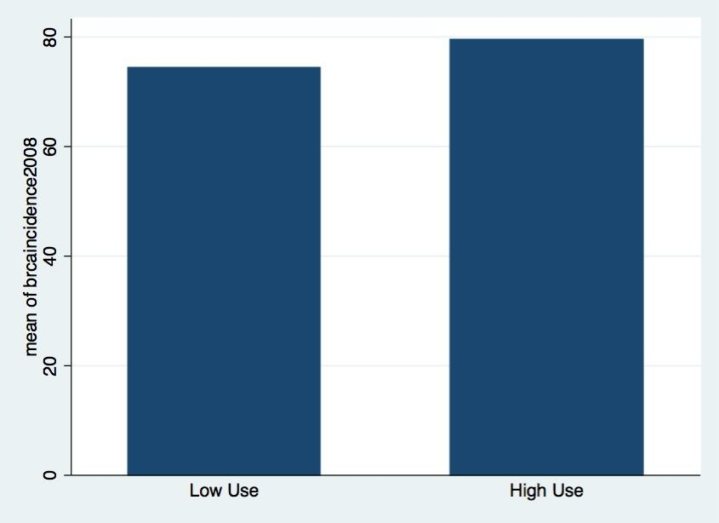

Figure 2. Bar plot of breast cancer mortality per 100, 000 in 2008 for levels of HRT Use

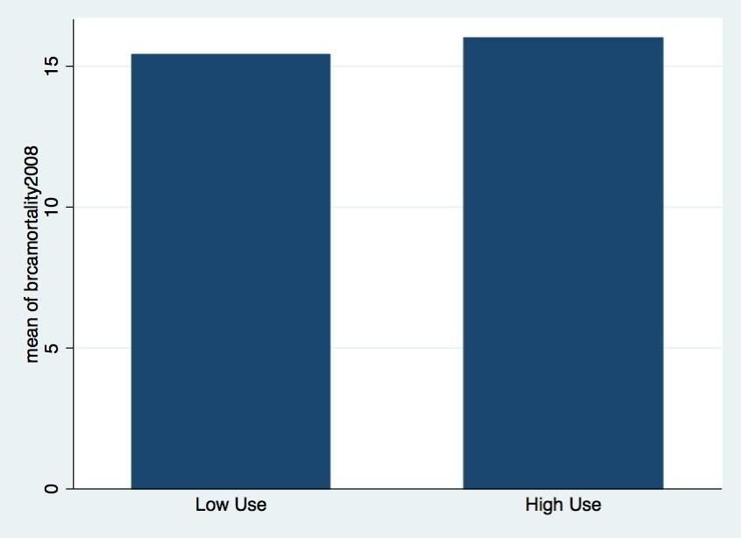

Table 8. Distribution of the Use of HRT at Non-peak levels

|  |  |
| --- | --- |
| HRT Use | mean (SD) |
| Low Use | 78.8 (15.4) |
| Medium Use | 95.7 (4.40) |
| High Use | 83.5 (4.18) |

Table 9. Kruskal-Wallis equality-of-populations rank test for breast cancer incidence with HRT Use Rates

|  |  |  |
| --- | --- | --- |
| HRT Use | Obs | Rank Sum |
| Low Use | 3 | 16.00 |
| Medium Use | 4 | 49.50 |
| High Use | 6 | 29.00 |

* Chi-squared = 9.189 with 3 d.f.

* P-value = 0.026