Contents

1 Contents 1
2 Rezumat în limba română 4
2.1 Stadiul actual 4
2.2 Fundamentare teoretică 5
2.3 Implementare 6
2.4 Rezultate experimentale 7
2.5 Concluzii 10
3 Work Planning 11
4 State of the art 12
4.1 Defining the problem 12
4.2 Existing solutions 12
4.3 Architectures for encoding the input features 13
4.4 Datasets inventory 14
4.5 Conclusions on state of the art 15
5 Theoretical fundamentals 16
5.1 Embeddings and vector spaces 16
5.2 Dimensionality reduction for embedding spaces 17
5.3 Methods for obtaining face embeddings 18
5.4 Methods for obtaining voice embeddings 20
5.5 Transformer attention mechanism 24
5.6 Loss functions for cross-modal identity learning 26
5.6.1 InfoNCE and temperature scaling 26
5.6.2 Supervised Contrastive Loss 26
5.6.3 Orthogonal Projection Loss 26
5.6.4 The effect of identity count on loss function performance 27
5.7 Evaluation metrics 27
5.7.1 Equal Error Rate 27
5.7.2 Rank-1 Retrieval Accuracy 28
6 Implementation 29
6.1 System overview and pipeline architecture 29
6.2 Dataset creation and organization 30
6.2.1 MAVCeleb dataset structure 30
6.2.2 Cross-Language sampling strategy 30
6.2.3 Corpus of Romanian faces and voices 31
6.3 Face and voice feature extraction 32
6.3.1 Face embedding extraction 32
6.3.2 Voice embedding extraction 33
6.3.3 Embedding storage format 33
6.4 Model architecture 33
6.4.1 Modality Translators 33
6.4.2 Transformer Cross Attention 34
6.4.3 Joint Classifier 35
6.4.4 Review of the implementation stages 36
6.5 Training configuration 36
6.5.1 Compound Loss Function 36
6.5.2 Optimizer and learning rate 37
6.5.3 Regularization and Early Stopping 38
6.5.4 Hardware, training runtime, and checkpointing 38
6.6 Evaluation protocols 40
6.6.1 Closed-Set validation 40
6.6.2 Urdu cross-lingual evaluation 41
6.6.3 Zero-Shot evaluation on MavCeleb and Romanian 41
6.7 Embedding space visualization 42
7 Experimental results 43
7.1 Comparison of architectural components 43
7.1.1 Comparison of ResNet18 and ECAPA-TDNN 44
7.1.2 Comparison of Orthogonal Projection Loss and Supervised Contrastive Loss 45
7.1.3 Effect of identity pool scale and multilingualism 45
7.1.4 Comparison of VGG16 and ArcFace as face encoders 46
7.1.5 Synthesis 47
7.2 Cross-lingual evaluation 47
7.2.1 Evaluation protocol 47
7.2.2 Verification performance 48
7.2.3 Score distribution analysis 50
7.2.4 Retrieval performance 50
7.2.5 Embedding space visualization 51
7.3 Romanian zero-shot evaluation 52
7.3.1 Evaluation protocol 52
7.3.2 Results 53
7.3.3 Comparison with Urdu result 53
7.4 The linguistic proximity paradox 53
7.4.1 Proposed explanation 54
7.4.2 Implications 54
7.5 Limitations 54
7.5.1 Protocol differences from baseline comparisons 54
7.5.2 Romanian evaluation scale and centroid averaging 54
7.5.3 Identity count relative to zero-shot generalization 54
7.5.4 Transformer fusion module not exercised at inference 55
8 Conclusions 56
9 References 57
10 Appendix 61
10.1 Loss functions and training utilities (utils.py) 61
10.2 Training loop and model initialization (train.py) 63
10.3 Model architecture definitions (models.py) 66
10.4 Dataset loading and preprocessing (dataset.py) 68
10.5 RO-FaceVoice Corpus Construction (build youtube_corpus.py) 70
10.6 Multilingual embedding extraction pipeline (extract_all_features.py) 74

Rezumat în limba română

Stadiul actual
Stabilirea automată a corelației informaționale dintre față și voce se bazează pe o corelație matematică între geometria feței unei persoane și trăsăturile acustice ale vocii sale. Oamenii asociază intuitiv o voce cu geometria facială a vorbitorului, pe baza unor proprietăți biologice comune, precum structura maxilarului, grosimea gâtului și forma cavității nazale [1]. Provocarea non-trivială pentru arhitecturile biometrice contemporane constă în transpunerea acestei corelații într-un spațiu vectorial computațional unificat, dificultate determinată de eterogenitatea statistică și structurală profundă a celor două modalități: o matrice facială bidimensională, respectiv o formă de undă acustică unidimensională sau o reprezentare spectrografică de tip mel [2]. În spațiul latent comun rezultat, embeddingurile față-voce ale aceleiași identități converg, în timp ce cele ale unor identități diferite diverg.
Variabilitatea lingvistică introduce o dificultate suplimentară. Inventarul fonemic, spațiul vocalic și prozodia articulatorie ale limbii engleze diferă substanțial de cele ale unor limbi precum urdu sau română, astfel încât arhitecturile optimizate exclusiv pe corpusuri în limba engleză nu reușesc să generalizeze corespondențele față-voce pentru vorbitori ai unor limbi nevăzute la antrenare [3], [4]. Setul de date multilingv MAVCeleb [5], utilizat pe parcursul acestei lucrări, a fost conceput tocmai pentru a aborda această constrângere de asociere încrucișată lingvistică. Provocarea stabilirii automate a corelației informaționale dintre față și voce în context multilingv este formalizată prin competiția internațională FAME (Face-voice Association in Multilingual Environments), care pune la dispoziție seturi de date precum MAVCeleb și un protocol de evaluare standardizat, permițând compararea directă a arhitecturilor propuse de diferite echipe de cercetare.
Cadrul Fusion and Orthogonal Projection (FOP) [6], propus de Saeed și colaboratorii, forțează embeddingurile identităților distincte către un produs scalar de zero și stabilește rezultatul de referință principal pe MAVCeleb, cu o rată de eroare egală (EER) de 29,3% pentru limba engleză și 37,9% pentru urdu. Acesta rămâne, totodată, metoda oficială de evaluare a seriei de competiții FAME [7], [9]. Sistemul MFV-KSD [8], câștigător al ediției FAME 2024, combină agregarea multi-scală a caracteristicilor cu o metodă de disociere în spațiul cunoștințelor, separând variația acustică dependentă de limbă de identitatea vorbitorului și reducând EER-ul pe urdu la 19,9%. O a treia pereche lingvistică (engleză-germană, MAVCeleb v3) a fost introdusă la ediția FAME 2026 [9], unde soluția RFOP [10] relaxează ipoteza de ortogonalitate rigidă a funcției OPL pentru proiecție în regim zero-shot, obținând locul al treilea cu un EER de 33,1%, iar XM-ALIGN [11] ajustează un encoder acustic agnostic la limbă printr-o strategie de aliniere bazată pe eroare medie pătratică. Câștigul ediției a revenit echipei conduse de Simic [12], cu un EER de 23,99%.
Alegerea encoderelor unimodale influențează decisiv performanța sistemului final. ArcFace [18], optimizat printr-o penalizare unghiulară aditivă pe milioane de eșantioane etichetate, depășește semnificativ arhitecturile generice de tip backbone vizual în păstrarea geometriei biometrice faciale, iar ECAPA-TDNN [20], proiectat explicit pentru verificarea vorbitorului, oferă o performanță net superioară rețelelor vizuale adaptate pentru semnal audio, ca urmare a preantrenării pe corpusuri masive și discriminative din punct de vedere al identității. Modelarea geometriei spațiului latent comun se bazează, la rândul ei, pe funcții de cost contrastive: Supervised Contrastive Loss [16] și funcția bidirecțională InfoNCE [15] sunt considerate mecanisme esențiale pentru regăsirea corectă a identității în context încrucișat. Faptul că nici arhitecturile de ultimă generație nu coboară, în prezent, sub un EER de 20% în condiții complet nevăzute-neauzite confirmă persistența problemei.
Aceste constatări motivează direct alegerile arhitecturale din prezenta lucrare. ArcFace iResNet50 [18] și ECAPA-TDNN [20], ambele antrenate cu obiective discriminative de identitate pe corpusuri ample, răspund constrângerii legate de calitatea encoderelor. Antrenarea multilingvă pe seturile MAVCeleb v1-v3 [5], combinată cu eșantionarea încrucișată lingvistică, asigură diversitatea de identități necesară funcției Supervised Contrastive Loss [16]. Diferența de performanță observată între evaluările în urdu și în română cuantifică, la rândul ei, constrângerea reziduală legată de interferența fonetică, discutată ca limitare și direcție de cercetare viitoare.

Fundamentare teoretică
Nucleul sistemului propus îl reprezintă noțiunea de embedding: o funcție învățată care transpune un semnal biometric brut (o imagine facială sau o formă de undă vocală) într-un punct dintr-un spațiu vectorial cu 512 dimensiuni. Deși intrările sunt structural incompatibile (o matrice bidimensională, respectiv o formă de undă unidimensională), ieșirile pot fi proiectate într-un spațiu comun în care un singur operator de comparație rămâne relevant, indiferent de modalitatea de proveniență. Fiecare embedding produs în această arhitectură, fie de ArcFace, fie de ECAPA-TDNN, fie de ieșirea fiecărui Modality Translator, este normalizat L2, plasându-l pe suprafața unei hipersfere unitare.
Această normalizare nu este o alegere cosmetică: rezultatul de la ieșirea sistemului este influențat de factori fără relevanță pentru identitate (luminozitatea imaginii, volumul înregistrării), în timp ce direcția vectorului este considerată invariantă la acești factori și purtătoare a structurii discriminative de identitate. Similaritatea cosinus dintre doi vectori normalizați se reduce astfel la un simplu produs scalar, mărginit în intervalul [-1, 1], unde valoarea 1 indică direcție identică, iar 0 indică ortogonalitate. Într-un spațiu de 512 dimensiuni, doi vectori unitari aleși aleatoriu au un produs scalar așteptat apropiat de zero [31], ceea ce oferă spațiului de embedding suficientă „încăpere" pentru a separa un număr mare de identități diverse fără suprapunere geometrică.
Encoderul facial ArcFace [18] rezolvă o limitare fundamentală a entropiei încrucișate standard: logit-ul unei clase depinde simultan de unghiul dintre vector și centrul clasei, precum și de magnitudinile celor doi vectori, ceea ce permite rețelei să minimizeze eroarea prin simpla inflaționare a magnitudinii, fără a converge efectiv către o separare unghiulară semnificativă. ArcFace elimină acest artificiu prin normalizarea L2 a vectorilor de caracteristici și a ponderilor claselor, introducând totodată o penalizare unghiulară aditivă directă în spațiul unghiular al clasei țintă, ceea ce corespunde unei distanțe geometrice constante pe hipersferă, indiferent de unghiul inițial. Rezultatul este un spațiu de embedding în care similaritatea cosinus reprezintă o măsură calibrată a proximității identității, spre deosebire de rețelele antrenate exclusiv prin entropie încrucișată standard (precum VGGFace sau ResNet), ale căror spații de embedding nu au o organizare unghiulară explicită.
Encoderul vocal ECAPA-TDNN [20] este preantrenat pe VoxCeleb1+2 [21], [22] folosind aceeași funcție de cost bazată pe margine unghiulară aditivă (AAM-SoftMax), aplicată identității vorbitorului. Arhitectura procesează caracteristici de tip mel-filterbank prin convoluții dilatate unidimensionale, care extind exponențial câmpul receptiv fără a crește numărul de parametri, combinate cu atenție de tip squeeze-and-excitation la nivel de canal și agregare multi-scală a caracteristicilor din blocuri succesive. Reprezentarea la nivel de cadru este redusă la un embedding final de utterance prin Attentive Statistics Pooling [52], care calculează atât o medie ponderată prin atenție, cât și o deviație standard ponderată, păstrând astfel informații despre variabilitatea acustică a vorbitorului pe parcursul înregistrării, informație pierdută printr-o simplă mediere.
Deoarece cele două encodere înghețate produc embeddinguri de dimensiuni diferite (512, respectiv 192), fiecare este proiectat în spațiul comun de 512 dimensiuni printr-o rețea Modality Translator dedicată, cu o structură identică, dar dimensiuni de intrare distincte: un strat liniar către un blocaj intermediar de 256 de dimensiuni, urmat de normalizare pe lot, activare neliniară și dropout, apoi un al doilea strat liniar către dimensiunea de ieșire de 512, cu o normalizare L2 finală.
Combinarea celor două embeddinguri translatate este realizată printr-un mecanism de atenție încrucișată de tip Transformer, construit pe baza atenției scalate de tip produs scalar introdusă de Vaswani și colaboratorii [25]. Cele două embeddinguri sunt tratate ca o secvență de lungime 2, iar atenția multi-cap (8 capete, fiecare operând într-un subspațiu de 64 de dimensiuni) permite fiecărui token să acorde atenție simultan celuilalt, în ambele direcții, spre deosebire de metodele statice de fuziune, incapabile să reajusteze ponderile în funcție de calitatea variabilă a semnalului. Ieșirea atenției este stabilizată printr-o conexiune reziduală, urmată de normalizare de strat (LayerNorm), iar cei doi tokeni rezultați sunt mediați și renormalizați L2, producând embeddingul final fuzionat.
Antrenarea este ghidată de o funcție de cost compusă.
Funcția InfoNCE [15] formulează stabilirea corelației dintre față și voce ca o problemă de estimare contrastivă: pentru fiecare embedding facial dintr-un lot, rețeaua trebuie să identifice embeddingul vocal corespunzător dintre toate celelalte prezente în lot, folosind un parametru de temperatură care controlează gradul de concentrare asupra celor mai dificile exemple negative. Supervised Contrastive Loss [16], introdusă de Khosla și colaboratorii, generalizează acest principiu permițând mai multe exemple pozitive per ancoră, definite prin eticheta identității și nu prin indexul perechii, ceea ce permite includerea perechilor încrucișate lingvistic ale aceleiași persoane ca exemple pozitive suplimentare.
Evaluarea performanței de verificare se bazează pe Equal Error Rate (EER) [56], [57], pragul la care rata acceptărilor false este egală cu rata respingerilor false, în timp ce performanța de identificare este măsurată prin acuratețea Rank-1, proporția interogărilor pentru care identitatea corectă este clasată pe primul loc. Pentru inspecția calitativă a geometriei spațiului latent, lucrarea utilizează atât t-SNE [32], cât și UMAP [33], două tehnici neliniare de reducere a dimensionalității; niciuna dintre acestea nu oferă însă o garanție metrică asupra distanțelor reale din spațiul cu 512 dimensiuni, motiv pentru care vizualizările sunt interpretate ca supliment, nu ca substitut, al metricilor cantitative.

Implementare
Sistemul este organizat în două faze operaționale distincte: o primă etapă de extragere a caracteristicilor și o a doua etapă de antrenare și evaluare. Cele două rețele preantrenate, ArcFace și ECAPA-TDNN, rămân înghețate pe tot parcursul antrenării încrucișate, fiind totodată costisitoare din punct de vedere computațional. Extragerea embeddingurilor o singură dată și stocarea lor sub formă de tensori pe disc decuplează complet costul de codificare de bucla de antrenare, reducând fiecare epocă la operații matriciale ușoare pe vectori precalculați. Această decizie arhitecturală a permis parcurgerea a 45 de epoci de antrenare într-un interval de timp rezonabil, folosind un singur GPU Tesla T4 pe platforma Google Colab Pro.
Imaginile faciale sunt procesate prin pachetul InsightFace (modelul buffalo_l), care integrează detecția facială, alinierea și extragerea embeddingului într-o singură etapă, producând un vector de 512 dimensiuni normalizat L2 [18]. Înregistrările vocale sunt procesate prin checkpoint-ul preantrenat ECAPA-TDNN din biblioteca SpeechBrain [20], la o rată de eșantionare de 16 kHz; fiecare clip audio este ajustat la o durată fixă de 3 secunde prin adăugare de zerouri sau decupare centrată, standard confirmat pentru arhitecturile ECAPA-TDNN antrenate pe segmente de această lungime [58]. Fiecare pereche față-voce rezultată este salvată individual, împreună cu eticheta identității și limba sursă a fiecărei modalități, permițând reîncărcarea rapidă în timpul antrenării, fără recalcularea repetată a embeddingurilor.
Setul de antrenare combină trei subseturi din colecția MAVCeleb [5]: v1 (70 de identități, engleză și urdu, dintre care doar 64 dispun de etichete de identitate expuse public, restul de 6 fiind rezervate ca set de test oficial al competiției FAME), v2 (84 de identități, engleză și hindi) și v3 (58 de identități, engleză și germană), rezultând 206 identități etichetate, reduse la 198 de identități unice după eliminarea celor cu date de față sau voce lipsă în oricare dintre limbi. Pentru antrenare este folosită exclusiv componenta engleză a setului v1, în timp ce v2 și v3 contribuie cu ambele limbi, iar înregistrările în urdu din v1 sunt păstrate integral, fiind excluse din antrenare pentru a permite o evaluare încrucișată lingvistică autentică ulterior. O strategie de eșantionare încrucișată lingvistică generează perechi precum o imagine facială în limba engleză asociată cu o înregistrare vocală în urdu, forțând rețeaua să învețe reprezentări ale identității bazate pe trăsături biologice invariante, nu pe corelații fonetice specifice unei singure limbi. Numărul teoretic maxim de perechi generate astfel este de 99.000; numărul efectiv extras este de 98.828, diferența provenind din eșecuri ocazionale ale detectorului facial pe cadre neclare sau cu ocluzii puternice.
O contribuție originală a lucrării o reprezintă corpusul RO-FaceVoice, primul set de evaluare cross-modală față-voce construit pentru limba română. Acoperind 50 de figuri publice românești, alese pentru diversitate de gen și context acustic, corpusul a fost construit prin descărcarea unui singur videoclip YouTube per identitate, folosind utilitarul yt-dlp. Extragerea cadrelor faciale a folosit un detector Haar cascade din biblioteca OpenCV, cu un prag minim de dimensiune de 100×100 pixeli, ales pentru a exclude regiuni faciale prea îndepărtate sau neclare. Videoclipul a fost scanat la cinci poziții temporale distanțate uniform, cu primele 10 secunde omise, întrucât revizuirea manuală a materialelor sursă a arătat frecvent prezența unor elemente de branding sau animații introductive în acest interval, nu a vorbitorului propriu-zis. Extragerea audio a folosit FFmpeg pentru separarea și reeșantionarea pistei audio la 16 kHz. Din cauza compresiei etichetelor survenite la încărcarea datelor, doar 41 dintre cele 50 de identități colectate au fost păstrate pentru matricea finală de evaluare.
Arhitectura sistemului cuprinde patru componente antrenabile, definite în modulul models.py. Cele două rețele Modality Translator proiectează embeddingurile înghețate în spațiul comun de 512 dimensiuni: translatorul facial primește un vector de 512 dimensiuni, iar cel vocal un vector de 192 de dimensiuni, ambele trecând printr-un strat liniar către o dimensiune intermediară de 256, urmat de normalizare pe lot, activare neliniară, dropout, un al doilea strat liniar către dimensiunea de ieșire de 512 și o normalizare L2 finală. Modulul de fuziune bazat pe atenție încrucișată combină cele două embeddinguri proiectate printr-un mecanism de auto-atenție bidirecțională cu 8 capete [25], tratând cei doi vectori ca o secvență de lungime 2, cu ieșirea stabilizată printr-o conexiune reziduală și normalizare de strat. Clasificatorul final proiectează embeddingul fuzionat printr-un strat ascuns de 1024 de neuroni către cele 198 de clase de identitate, oferind supervizare prin entropie încrucișată exclusiv în timpul antrenării; la momentul evaluării, potrivirea se realizează direct prin similaritate cosinus între embeddingurile proiectate, înaintea fuziunii Transformer.
Cele patru componente antrenabile sunt înregistrate într-un singur optimizator Adam [59], cu o rată de învățare inițială de 0,001 și regularizare de tip weight decay de 10⁻⁴ [60]. Funcția de cost compusă combină entropia încrucișată, funcția InfoNCE (pondere 10,0, temperatură 0,1) [15] și Supervised Contrastive Loss (pondere 0,5) [16]; o singură propagare inversă a gradientului actualizează simultan toate cele patru componente. Procesul de antrenare a folosit reducerea ratei de învățare la platou (factor 0,5, răbdare de 5 epoci) și oprire timpurie (răbdare de 15 epoci, aleasă generos pentru a acomoda comportamentul zgomotos al funcției SupCon în primele epoci), convergând la epoca 45, cu o pierdere de validare de 2,3117.

Rezultate experimentale
Contribuția fiecărei decizii arhitecturale și de optimizare a fost izolată printr-o comparație sistematică a componentelor arhitecturale structurată în cinci configurații succesive, în care o singură componentă a fost modificată de la o configurație la următoarea, celelalte fiind menținute constante. Fiecare configurație a fost evaluată pe două seturi de test: setul de evaluare încrucișată lingvistică în urdu (64 de identități cunoscute) și setul zero-shot românesc (41 de identități complet necunoscute, după compresia etichetelor din procesul de încărcare a datelor). Tabelul cu rezultatele complete ale comparației centralizează valorile obținute pentru fiecare dintre cele cinci configurații.
Ca puncte de referință externe, cadrul FOP raportează un EER de 37,90% pe evaluarea în urdu [6], iar câștigătorul competiției FAME 2024 raportează 19,91% [8]. Configurația finală obținută în această lucrare atinge un EER de 9,10%, valoare care nu este direct comparabilă cu niciuna dintre cele două referințe: ambele evaluează în regim complet nevăzut-neauzit (identitate și limbă absente din antrenare), în timp ce rezultatul prezentat aici este obținut sub protocolul identitate-cunoscută, limbă-nevăzută, înregistrări-nevăzute, descris în capitolul de implementare. Această distincție este esențială pentru interpretarea corectă a rezultatului și este discutată explicit ca limitare.
Prima tranziție a înlocuit encoderul vocal ResNet18 (preantrenat pe ImageNet și adaptat pentru a opera pe spectrograme mel) cu ECAPA-TDNN, un model antrenat direct pe date de verificare a vorbitorului. Această schimbare a produs o îmbunătățire de 65% a similarității cosinus pe setul românesc, de la 0,1377 la 0,2532, confirmând că un encoder vocal specializat oferă o bază de pornire superioară unei rețele vizuale adaptate pentru semnal audio.
A doua tranziție a înlocuit funcția de cost Orthogonal Projection Loss (OPL) cu Supervised Contrastive Loss (SupCon) [16], menținând constante perechea de encodere (VGG16, ECAPA-TDNN) și setul de 64 de identități, exclusiv în limba engleză. Contrar așteptărilor, această tranziție a produs un declin al similarității cosinus, de la 0,0382 la 0,0204, EER-ul rămânând practic la nivelul șansei aleatorii. Acest rezultat nu reflectă o slăbiciune intrinsecă a funcției SupCon, ci o proprietate structurală a acesteia: la un lot de 64 de identități, majoritatea eșantioanelor conțin cel mult un singur exemplu al unei identități date, ceea ce lasă termenul de atragere a perechilor pozitive aproape neactivat, antrenarea fiind dominată exclusiv de termenul de respingere. OPL, care impune o țintă de ortogonalitate fixă între toate perechile de identități, indiferent de compoziția lotului, este insensibilă la această raritate și, prin urmare, performează mai fiabil atunci când numărul de identități este redus.
A treia tranziție a menținut funcția de cost SupCon, dar a extins setul de identități de la 64, exclusiv în engleză, la 198, provenite din seturile multilingve MAVCeleb v1, v2 și v3. Această extindere a produs o recuperare substanțială a similarității în urdu, de la 0,0204 la 0,0972, o creștere de 376%, în timp ce similaritatea românească a rămas relativ constantă (de la 0,2252 la 0,2265), iar acuratețea Rank-1 pe setul românesc a crescut de la 0% la 2,44%, depășind pentru prima dată în secvența de comparații pragul de șansă aleatorie. Acest tipar este consistent cu mecanismul identificat anterior: cu 198 de identități distribuite pe trei limbi, loturile de antrenare conțin mult mai frecvent perechi multiple ale aceleiași identități în limbi diferite, oferind funcției SupCon exact semnalul de atragere a perechilor pozitive care lipsea la 64 de identități. Câștigul disproporționat observat pe metrica în urdu, comparativ cu cea românească, este de așteptat, întrucât engleza, hindi, germana și urdu sunt reprezentate în distribuția de antrenare prin MAVCeleb, în timp ce limba română rămâne complet nevăzută în acest stadiu al comparației.
Ultima tranziție a înlocuit encoderul facial VGG16 cu ArcFace (iResNet50) [18], menținând constante encoderul vocal, funcția de cost și setul multilingv de identități. Aceasta a produs cel mai mare câștig izolat din întreaga comparație sistematică: similaritatea cosinus în urdu a crescut de la 0,0972 la 0,4941, o îmbunătățire de 408%, iar EER-ul a scăzut de la 43,60% la 9,10%. Acuratețea Rank-1 în urdu a crescut de la 0% la 79,69%, iar acuratețea Rank-1 pe setul românesc a crescut de la 2,44% la 4,88%, similaritatea corespunzătoare urcând de la 0,2265 la 0,3323. Această tranziție izolează encoderul facial drept principalul blocaj al configurațiilor anterioare: VGG16, antrenat printr-un obiectiv standard de clasificare softmax, impune separabilitate liniară între clase, dar nu constrânge geometria spațiului de embedding dincolo de atât, motiv pentru care similaritatea cosinus dintre două embeddinguri VGG16 nu reprezintă o măsură fiabilă a proximității identității. ArcFace, prin penalizarea sa unghiulară aditivă, impune o separare unghiulară minimă între identități distincte pe hipersfera de embedding, astfel încât similaritatea cosinus corespunde direct proximității identității prin însăși construcția sa. Deoarece etapa de fuziune încrucișată a sistemului se bazează pe similaritatea cosinus ca operație principală de comparație, această proprietate se transferă direct în calitatea alinierii finale față-voce.
Privite împreună, cele patru tranziții indică o ordine clară a importanței componentelor pentru această sarcină: encoderul facial a produs cea mai mare îmbunătățire izolată, urmat de tranziția encoderului vocal și de extinderea multilingvă a setului de identități, aceasta din urmă fiind interpretată mai degrabă drept o corectare a unui deficit introdus de tranziția izolată către SupCon, decât drept un câștig independent. Tranziția funcției de cost, luată separat, la un număr redus de identități, a fost activ dăunătoare, demonstrând că beneficiul SupCon este condiționat de o diversitate suficientă de identități în cadrul fiecărui lot de antrenare.
Evaluarea pe setul în urdu utilizează 64 de identități prezente în distribuția de antrenare prin înregistrările lor în limba engleză, testate însă cu înregistrări noi, în limba urdu, complet nevăzute la antrenare. Sistemul atinge un EER de 9,10%, corespunzător unei acurateți de verificare de 90,90% la pragul echilibrat, și un AUC de 0,9538. Similaritatea cosinus medie pentru perechile genuine este de 0,4941, în timp ce pentru perechile impostor este de aproximativ -0,0022, practic zero, consistent cu proprietatea geometrică a spațiilor de dimensiune ridicată, în care doi vectori unitari aleși independent au un produs scalar așteptat apropiat de zero [31]. Acuratețea Rank-1 pe același set atinge 79,69%.
Evaluarea pe corpusul românesc constituie, spre deosebire de cea în urdu, un protocol autentic de tip identitate-nevăzută, limbă-nevăzută, întrucât cele 41 de identități evaluate sunt complet absente din distribuția de antrenare. Fiecare identitate este reprezentată prin trei imagini faciale și un singur clip vocal; cele trei embeddinguri faciale sunt mediate într-un singur centroid înaintea calculului de similaritate, o alegere metodologică ce reprezintă o limită superioară a performanței, nu o măsură directă a acurateții pe o singură imagine. Sistemul obține o acuratețe Rank-1 de 4,88%, față de un prag de șansă aleatorie de aproximativ 2,44% pentru o galerie de 41 de identități, și o similaritate cosinus medie de 0,3323. Având în vedere dimensiunea redusă a eșantionului, o singură recuperare corectă suplimentară modifică acuratețea raportată cu 2,4 puncte procentuale, astfel încât rezultatul trebuie interpretat ca un semnal preliminar, direcțional pozitiv, al transferului încrucișat lingvistic, nu ca o estimare precisă a capacității de generalizare în regim complet deschis.
Diferența dintre acuratețea Rank-1 de 79,69% în urdu și cea de 4,88% în română este substanțială, dar cele două cifre nu sunt direct comparabile, întrucât evaluează sarcini diferite: generalizarea la o limbă nouă pentru identități cunoscute, respectiv generalizarea simultană la identități și limbă complet noi. Contrar predicției standard, conform căreia limba română, fiind o limbă romanică apropiată lexical de engleză, ar trebui să beneficieze de un transfer mai bun decât urdu, o limbă indo-ariană mai îndepărtată fonetic, rezultatele nu susțin această așteptare: similaritatea în urdu (0,4941, pe identități cunoscute) o depășește pe cea românească (0,3323, pe identități complet necunoscute). O explicație propusă este că, deoarece parametrii ECAPA-TDNN rămân înghețați pe parcursul antrenării încrucișate, encoderul nu se poate adapta la structuri fonetice absente din distribuția sa de preantrenare pe VoxCeleb [21], [22], indiferent de apropierea la nivel de familie lingvistică față de engleză. Reuter și Jessen [17] raportează că scorurile de verificare a vorbitorului pentru embeddinguri înghețate corelează cu o măsură generală a similarității lingvistice, efect mai pronunțat pentru limbile absente din datele de antrenare; vocalele centrale specifice limbii române, /ə/ și /ɨ/, absente atât din engleză, cât și din toate limbile de antrenare MAVCeleb, pot reprezenta o barieră de transfer comparabilă celei impuse de limba urdu [65], în ciuda apropierii de familie lingvistică față de engleză.
Rezultatele trebuie interpretate ținând cont de câteva limitări metodologice. Comparația cu referințele externe (FOP, FAME 2024) este direcțională, nu strictă, întrucât protocoalele de evaluare diferă. Rezultatul pe setul românesc se bazează pe medierea a trei imagini faciale per identitate, reprezentând o limită superioară a performanței, iar dimensiunea redusă a eșantionului (41 de identități) face ca acuratețea raportată să fie sensibilă la variații de câteva puncte procentuale. Setul de antrenare de 198 de identități rămâne, de asemenea, substanțial mai mic decât corpusurile mari de verificare care stau la baza encoderelor preantrenate, precum VoxCeleb (peste 7.000 de vorbitori [21]) sau VGGFace2 (9.131 de identități [19]), ceea ce poate constrânge capacitatea sistemului de generalizare zero-shot către identități complet nevăzute.

Concluzii
Această lucrare a urmărit construirea unui sistem capabil să stabilească automat corelația dintre față și voce, inclusiv atunci când limba vorbită nu a fost văzută la antrenare. Rezultatele, organizate pe cele trei probleme centrale abordate, arată că acest obiectiv este atins în grade diferite, în funcție de cât de departe este împinsă generalizarea față de distribuția de antrenare.
Prima problemă a fost una arhitecturală: ce combinație de encodere, mecanism de fuziune și funcție de cost produce un spațiu de embedding în care similaritatea cosinus are sens. Comparația sistematică a componentelor oferă un răspuns clar: encoderul facial a contat cel mai mult, înlocuirea VGG16 cu ArcFace aducând cea mai mare îmbunătățire izolată din întreaga comparație, iar diversitatea de identități și limbi a fost aproape la fel de importantă, Supervised Contrastive Loss depășind Orthogonal Projection Loss doar odată ce numărul de identități per lot a fost suficient. Ambele constatări converg spre aceeași concluzie: similaritatea cosinus este o metrică relevantă doar atunci când funcția de cost a encoderului impune o structură unghiulară explicită spațiului de embedding.
A doua problemă a fost generalizarea către o limbă nevăzută, pentru identități deja cunoscute. Configurația finală a atins un EER de 9,10% pe evaluarea în urdu, sub protocolul identitate-cunoscută, limbă-nevăzută. Limitarea reziduală provine din encoderul vocal înghețat: ECAPA-TDNN nu se poate adapta la structuri fonetice absente din preantrenarea sa pe VoxCeleb, indiferent cât de mult ar crește setul de identități.
A treia problemă, cea mai puțin rezolvată, a fost generalizarea simultană către o identitate și o limbă nevăzute, testată pe corpusul românesc. O acuratețe Rank-1 de 4,88%, ușor peste pragul de șansă de 2,44%, trebuie interpretată ca un semnal preliminar, nu ca o estimare fiabilă, dat fiind dimensiunea redusă a corpusului RO-FaceVoice (41 de identități, 147 de perechi).
Contribuția originală a lucrării este dublă: corpusul RO-FaceVoice extinde cercetarea în domeniu către limba română, iar comparația sistematică a componentelor oferă dovezi empirice clare privind contribuția fiecărei decizii arhitecturale, confirmând că fiabilitatea similarității cosinus depinde de structura geometrică impusă de funcția de cost a encoderului, nu de mecanismul de fuziune adăugat ulterior.
Mai multe direcții de dezvoltare rezultă direct din limitările identificate mai sus. Extinderea corpusului RO-FaceVoice la o scală comparabilă celorlalte seturi MAVCeleb ar reduce incertitudinea statistică a acurateței raportate pentru limba română și ar permite, totodată, reantrenarea directă a encoderului vocal pe vorbire în limba română, abordând astfel limitarea impusă de encoderul înghețat, nu doar ocolind-o. Într-un sens mai larg, reantrenarea parțială sau înlocuirea ECAPA-TDNN cu un encoder preantrenat pe un set fonetic mai divers ar testa dacă rezultatul obținut pe urdu se generalizează dincolo de perechile lingvistice văzute la antrenare. Confirmarea faptului că aceeași ordine de importanță a componentelor arhitecturale se menține și pentru encodere faciale sau vocale mai recente ar întări, la rândul ei, generalitatea concluziilor comparației sistematice. În final, înțelegerea motivului pentru care modulul de fuziune Transformer nu reușește să îmbunătățească performanța comparației bazate pe translatoare la momentul evaluării, fie din cauza dominanței unei modalități, a diversității insuficiente a perechilor pozitive sau a conexiunii reziduale care ocolește complet atenția, rămâne o direcție de cercetare deschisă, care merită investigată separat.

Work Planning
TASK | START | END
Phase 1: Research and Documentation
Literature review and State of the Art study | 11/20/25 | 1/15/26
Theoretical fundamentals and architecture planning | 1/15/26 | 3/7/26
Phase 2: Baseline Implementation
Baseline model, cross-modal alignment loss, Modality Translator | 3/7/26 | 3/25/26
Loss function tuning, data augmentation, and debugging | 3/25/26 | 4/21/26
Phase 3: Architecture Upgrades
Transformer Cross-Attention fusion integration | 4/21/26 | 5/7/26
RO-FaceVoice corpus collection automation (YouTube pipeline) | 5/7/26 | 5/12/26
Dataset loading, batch-size, and visualization pipeline fixes | 5/12/26 | 5/16/26
Phase 4: Encoder Replacement and Multilingual Training
ECAPA-TDNN voice encoder integration and FAME 2026 challenge submission attempt | 5/16/26 | 5/25/26
Unified multilingual pipeline and SupCon loss integration | 5/25/26 | 5/29/26
Phase 5: Final Architecture and Component Comparison
ArcFace face encoder integration and component comparison study | 5/29/26 | 6/20/26
Urdu evaluation visualizations (t-SNE, UMAP, ROC, DET curve) | 6/20/26 | 7/1/26
Phase 6: Thesis Finalization
Final thesis revisions and submission | 7/1/26 | 7/7/26

State of the art

Defining the problem
Cross-modal face-voice biometric matching involves establishing a mathematical correlation between the geometry of a human face and the acoustic details of their speech. Humans intuitively associate a person’s voice with their face with their facial geometry based on shared biological properties, such as the jaw structure, neck thickness, and nasal cavity shape [1]. Mapping this inherent cross-modal biological correlation into a unified computational vector space presents a highly non-trivial challenge for contemporary biometric architecture. This difficulty is driven primarily by the severe statistical and structural heterogeneity of the constituent modalities, necessitating the reconciliation of unaligned dimensional spaces. Cross-modal biometric verification requires mapping statistically heterogeneous signals specifically, a two-dimensional facial matrix and a one-dimensional acoustic waveform or mel-spectrogram [2] into a unified latent topology. Within this shared vector space, intra-identity face and voice embeddings are forced to converge, while inter-identity embeddings diverge (Fig. 1).

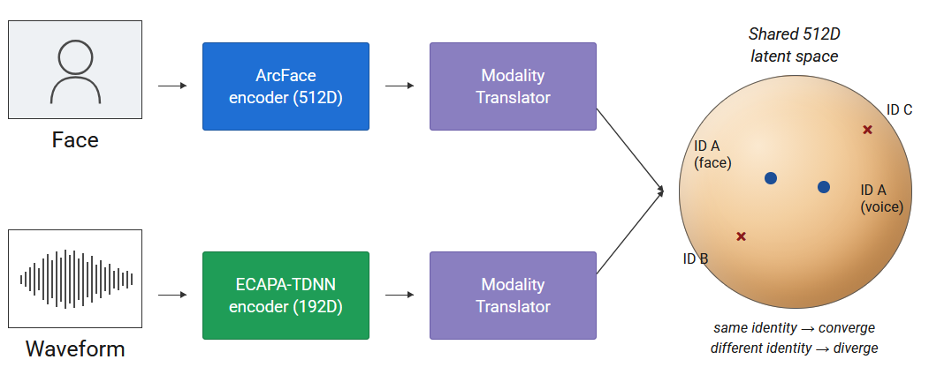
Figure 1. Conceptual illustration of the shared latent space for cross-modal face-voice matching

However, linguistic variance introduces severe domain shift [3][4]. Because the phoneme inventory, vowel space, and articulatory prosody of English diverge fundamentally from languages such as Urdu or Romanian, architectures optimized exclusively on English corpora fail to generalize face-voice correspondences for individuals speaking unseen languages [3]. This specific cross-lingual association constraint forms the core problem addressed by the multilingual MAVCeleb dataset [5] utilized throughout this research.

Existing solutions
Orthogonal Projection and the FAME Challenges: Saeed et al. [6] proposed the Fusion and Orthogonal Projection (FOP) framework, forcing the embeddings of distinct identities toward a dot product of zero to establish the principal MAVCeleb baseline, reporting 29.3% EER on English and 37.9% on Urdu.
FOP is also the official scoring method of the FAME challenge series [7]. At FAME 2024, Tao et al. [8] won the challenge with MFV-KSD, which combined multi-scale feature aggregation with knowledge-space disentanglement to separate language-dependent acoustic variation from a speaker's identity, reducing Urdu EER to 19.9%.FAME 2026 [9] extends the benchmark to a third language pair (English-German, MAVCeleb v3); among its submissions, Hannan et al. [10] relax OPL's rigid orthogonality assumption for zero-shot projection with RFOP, while Fang et al. [11] fine-tune a language-agnostic acoustic encoder using MSE-based embedding alignment with a shared classification head in XM-Align. The FAME 2026 challenge was won by Simic et al. [12], who combined face and voice embeddings with auxiliary age-gender features under an additive angular margin loss, achieving 23.99% EER. Even so, the best unseen-unheard EER values remain above 15%, indicating that cross-lingual generalization is still an open problem.
Fusion and Generative Approaches: Prior work [13] demonstrates that a transformer encoder applied after contrastive pre-alignment achieves superior retrieval performance compared to direct cosine or Euclidean distance scoring, by reframing matching as a classification task; this finding directly motivates the Transformer Cross-Attention fusion module adopted in this thesis. Complementarily, [14] demonstrates that self-supervised cross-modal prediction specifically, the reconstruction of facial geometry from voice signals via a contrastively trained identity module can recover physiologically consistent identity features in the absence of paired labels. This reinforces a central architectural constraint: identity must be actively disentangled from transient acoustic variables, including language and emotional prosody.
Contrastive Learning and Cross-Lingual Transfer: Van den Oord et al. [15] formulate InfoNCE as a noise-contrastive estimation objective, maximizing agreement between a positive face-voice pair against negatives; applied bidirectionally, it directly shapes the shared space for retrieval. Supervised Contrastive Loss (SupCon) [16] generalizes this to multiple positives per anchor, e.g. cross-language recordings of the same identity, but requires sufficient identity diversity per batch, underperforming Orthogonal Projection Loss when only 64 identities are available.
Independently of supervision, Reuter and Jessen [17] show that for frozen ECAPA-TDNN models trained on VoxCeleb, verification scores in cross-lingual trials correlate with measured language similarity, with the effect most pronounced for languages absent from training; this general phenomenon is examined empirically for the Romanian and Urdu evaluation languages later in this thesis

Architectures for encoding the input features
The matching accuracy of a cross-modal biometric system is fundamentally dependent on its network architecture and the preprocessing of its input modalities.
Input Modalities: Facial inputs are tightly cropped and aligned RGB images, focusing on ocular spacing, jawline angle, and cranial proportions. Acoustic inputs bypass traditional MFCCs, which disproportionately compress spectral detail, in favor of raw waveforms or mel-filterbank features, thereby preserving the full spectral envelope required for multi-scale speaker modeling. Face Encoder (ArcFace): The quality of the facial encoder is the dominant factor in cross-modal alignment quality, a dynamic quantified empirically in Chapter 7. Deng et al. [18] introduced ArcFace's Additive Angular Margin Loss, adding an angular penalty between a sample and its class center on the unit hypersphere before the SoftMax, enforcing tighter angular separation between identities than standard cross-entropy. Its iResNet50 backbone, trained on VGGFace2 [19] (3.31M images, 9,131 identities), outputs a frozen, L2- normalized 512D embedding in which cosine similarity reflects identity proximity.
Voice Encoder (ECAPA-TDNN): Desplanques et al. [20] augment Time-Delay Neural Networks with squeeze-and-excitation channel attention and multi-scale temporal aggregation in ECAPA-TDNN, operating directly on mel-filterbank features from 16kHz waveforms. Pretrained on VoxCeleb1+2 [21,22] (7,000+ speakers, 1M+ utterances), it outputs a frozen 192D speaker embedding that generalizes better than audio-adapted visual networks.
Cross-Attention Fusion: Static fusion methods like concatenation, MLPs, or Tanh/Sigmoid gating rely on rigid, unweighted combination and cannot reweight modalities under variable signal quality, for example upweighting voice when illumination is poor [23][24]. Vaswani et al. [25] introduced dynamic Query/Key/Value attention as an alternative to fixed combination rules, allowing a model to compute data-dependent weights between input elements rather than relying on a static aggregation function. In the context of multimodal fusion, this mechanism has been adopted to let each modality attend to relevant features in the other rather than combining them uniformly. [26][27]
Parallel attention heads allow a model to specialize across distinct representational subspaces simultaneously, rather than forcing all cross-modal correspondence through a single shared pattern [25], as illustrated in Figure 2.
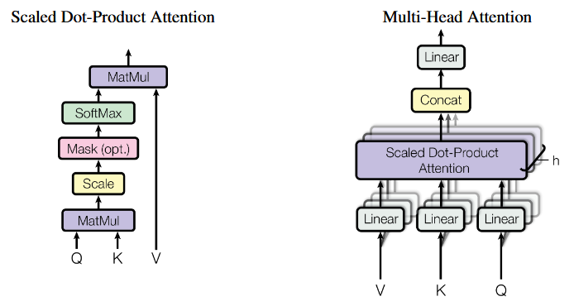
Figure 2. Scaled Dot-Product Attention and Multi-Head Attention mechanisms

Datasets inventory
Avoiding overfitting and achieving real-world generalization requires large-scale, linguistically diverse datasets that capture natural variation in ambient acoustics and lighting. Accurate metadata and linguistic stratification are therefore essential for reliable system evaluation.
Table 1 summarizes the pretraining corpora (VGGFace2, VoxCeleb1+2), the multilingual MAVCeleb splits used for training and cross-lingual evaluation, and the RO-FaceVoice corpus.

Table 1. Primary datasets for cross-modal face-voice biometric research.
Dataset | IDs | Samples | Modality | Languages | Primary Task
VGGFace2 | 9,131 | 3.31M imgs | Face | N/A | Face recognition
VoxCeleb1+2 | 7,245 | 1M+ clips | Face+Voice | English | Speaker verification
MAVCeleb v1 | 70 | 18,385 utt. | Face+Voice | EN, UR | F-V association
MAVCeleb v2 | 84 | 20,715 utt | Face+Voice | EN, HI | F-V association
MAVCeleb v3 | 58 | 3,812 utt. | Face+Voice | EN, DE | F-V association
RO-FaceVoice * | 41 | 147 pairs | Face+Voice | Romanian | F-V association
* RO-FaceVoice: novel corpus introduced in this work.

The MAVCeleb [5] dataset forces models to establish a language-independent baseline by providing identical subjects speaking multiple languages (English/Urdu, English/Hindi, English/German). All the same, emotion can change facial geometry and acoustic pitch [28][29]. Datasets like EmoVoxCeleb[30] force models to apply disentangled learning to separate emotional states from biological properties. Table 2 reports the Equal Error Rates achieved by successive FAME Challenge submissions alongside the result obtained in this work though under a different, less strict evaluation protocol, discussed further in the Implementation and Experimental Results chapters., situating the proposed system within the broader competitive landscape

Table 2. Reported Equal Error Rates across FAME Challenge submissions, including this work's result.
System | Challenge | Urdu EER (%) | Key Contribution
FOP baseline [6] | FAME 2024 | 37.90 | Orthogonal Projection Loss
MFV-KSD (1st) [8] | FAME 2024 | 19.9 | Multi-scale features + knowledge-space disentanglement
RFOP [10] | FAME 2026 | 33.1 | Rethinks OPL geometric rigidity for zero-shot projection
XM-ALIGN [11] | FAME 2026 | TBC | Cross-modal alignment, language-agnostic encoder
This work | — | 9.10* | ArcFace + ECAPA-TDNN + SupCon, known-ID protocol
* Known-identity, unseen-language, unseen-recordings protocol; not directly comparable to the unseen-unheard FAME baseline; XM-ALIGN [11] EER not yet released publicly at time of writing.

Conclusions on state of the art
A synthesis of the prevailing literature isolates three primary architectural directives that motivate the proposed system. Foremost, the representational capacity of the unimodal feature extractors dictates the absolute upper bound of cross-modal alignment accuracy. Face-specific encoders like ArcFace [18] optimized via additive angular margin penalties over millions of identity-labeled samples drastically outperform general-purpose visual backbones in preserving biometric geometry. In the acoustic domain, architectures explicitly designed for speaker verification, such as ECAPA-TDNN [20], provide a demonstrably superior baseline compared to audio-adapted visual networks, largely due to their deep pretraining on massive, speaker-discriminative temporal corpora. Furthermore, the literature establishes contrastive learning objectives specifically Supervised Contrastive Loss [16] and bidirectional InfoNCE [15] are essential mechanisms for directly sculpting the geometry of the shared latent space to facilitate accurate cross-modal identity retrieval. The FAME challenge results indicate that even state-of-the-art architectures still struggle to reach an EER below 20% under truly unseen-unheard cross-lingual evaluation, confirming that cross-lingual generalization remains an unresolved problem This motivates the system developed in this thesis: ArcFace iResNet50 and ECAPA-TDNN, both trained with identity discriminative objectives on large identity-labelled corpora, address the encoder-quality constraint; multilingual training across MAVCeleb v1–v3 with cross-language sampling addresses the identity-diversity constraint for Supervised Contrastive Loss; and the resulting Urdu/Romanian evaluation gap directly quantifies the residual phonetic-entanglement constraint, discussed as a limitation and future-work direction in the Limitations section.

Theoretical fundamentals

Embeddings and vector spaces
At the core of the proposed system is the idea of an embedding: a learned function $f$ that maps a raw biometrical signal; a face image or a speech waveform to a point $z=f\left(x\right)∈R^{d}$ in a $d$-dimensional vector space. The central design assumption of cross-modal biometric matching is that this vector space can be made shared: although the raw inputs are structurally incompatible (a two-dimensional image versus a one-dimensional waveform, processed by entirely different encoder architectures), the outputs $z$ can be projected into a common space $R^{d}(d=512 in this system)$in which a single, simple comparison operator is meaningful regardless of which modality produced the vector
L2 normalization and the unit hypersphere. Every embedding produced in this pipeline by ArcFace, by ECAPA-TDNN, and by the output of each Modality Translator is L2 normalized as give in Equation (1):

$\overset{ˆ}{z}=\frac{z}{{\left\|z\right\|}_{2}}, {\left\|z\right\|}_{2}=\sqrt{\sum_{k=1}^{d}{z_{k}^{2}}}$ (1)

so that ${\left|z\right|}_{2} =1$. Geometrically, this discards the magnitude of $z$and keeps only its direction, placing every embedding on the surface of the unit hypersphere $S^{d-1}⊂R^{d}$. This is not a cosmetic choice: the magnitude of a raw network activation is influenced by nuisance factors that carry no identity information, such as overall image brightness and contrast for the face branch or recording volume and microphone gain for the voice branch, whereas the relative pattern across the $d$dimensions is assumed to encode identity-discriminative structure that is comparatively invariant to these factors. By normalizing, the system explicitly discards the nuisance correlated magnitude and retains only the identity correlated direction. This framing: identity as direction, not position is the geometric assumption that the angular margin loss discussed later in this chapter makes explicit and enforces during training.
Cosine similarity as the comparison operator. Given two embeddings $a,b∈R^{d}$, the cosine similarity is defined in Equation (2):

$\cos{θ}\left(a,b\right)=\frac{a⋅b}{{\left\|a\right\|}_{2}{\left\|b\right\|}_{2}}=\frac{\sum_{k=1}^{d}{a_{k}}b_{k}}{\sqrt{\sum_{k}{a_{k}^{2}}}\sqrt{\sum_{k}{b_{k}^{2}}}}$ (2)

which measures the cosine of the angle $θ$between the two vectors, independent of their magnitudes.
When both vectors are already L2-normalized, this refines to a plain dot product, shown in Equation (3):
$\cos{θ}\left(\overset{ˆ}{a},\overset{ˆ}{b}\right)=\overset{ˆ}{a}⋅\overset{ˆ}{b}=\sum_{k=1}^{d}{{\overset{ˆ}{a}}_{k}}{\overset{ˆ}{b}}_{k}$ (3)

bounded in $\left[-1,1\right]$, where $1$indicates identical direction, $0$indicates orthogonality, and $-1$indicates opposite direction.

The shared latent space. With this vocabulary, the architecture of Chapter 6 can be specified precisely.
Two encoder branches, $g_{F}$(ArcFace, $R^{512}→R^{256}→R^{512}$via the face Modality Translator) and $g_{V}$(ECAPA-TDNN, $R^{192}→R^{512 }$via the voice Modality Translator), are trained such that for a face image and a voice recording $y_{i}$belonging to the same identity $i$, Equation (4) requires:

$\cos{θ}\left(g_{F}\left(x_{i}\right),g_{V}\left(y_{i}\right)\right)≈1$ (4)

while for $i≠j$, Equation (5) requires:

$\cos{θ}\left(g_{F}\left(x_{i}\right),g_{V}\left(y_{j}\right)\right)≈0\text{ or }<0$ (5)

Both branches are mapped into the same unit hypersphere $S^{511}$, and matching is reduced to the single scalar operation $cos⁡θ(⋅,⋅)$, regardless of whether the two vectors being compared originated from a face or a voice. This is also why centroid-based evaluation under open-set conditions is valid: averaging several L2-normalized embeddings of the same identity and re-normalizing via Equation (6),

$\overset{ˆ}{\overline{z}}=\frac{\overline{z}}{{\left\|\overline{z}\right\|}_{2}}, \overline{z}=\frac{1}{N}\sum_{n=1}^{N}{{\overset{ˆ}{z}}_{n}}$ (6)

produces another point on the same hypersphere, depicting the “average direction” of that identity’s cluster; an important operation because direction, not magnitude, carries identity information
Why high dimensionality matters: A ramification of working in $R^{512}$ rather than a lower dimensional space is capacity: two random unit vectors in $R^{d}$ have an expected squared dot product of order $1/d$ [31]. For $d=512$, this means two arbitrary directions are, by default, very nearly orthogonal. The embedding space has generous “room” to assign near orthogonal directions to many diverse identities without the training objective needing to fight against geometric overcrowding. This capacity argument is the background against which the angular margin loss (S, the orthogonality and the objectives based on contrast discussed later in this chapter operate: they do not need to create separation but rather prevent the network from collapsing this natural separation during training.

Dimensionality reduction for embedding spaces
As established earlier in this chapter, the shared latent space as the unit hypersphere $S^{511}⊂R^{512}$, where identity is encoded as direction rather than position. This space cannot be visualized directly, and the scalar cosine similarity used for evaluation discards the broader structure of how identities are organized relative to one another. Dimensionality reduction addresses this by projecting the 512-dimensional embeddings into a 2D plane that preserves some property of the original structure.
This thesis uses two such techniques: t-SNE and UMAP, both nonlinear and neighborhood-preserving, unlike linear methods such as PCA which preserve global variance but obscure cluster structure in high-dimensional manifolds.
t-SNE converts pairwise distances into a probability distribution over neighbor pairs in the original space, then optimizes a 2D layout whose own neighbor-pair distribution minimizes the Kullback-Leibler divergence to the original [32]. This concentrates on preserving local neighborhoods at the cost of global distances: cluster size, inter-cluster distance, and point density carry no reliable quantitative meaning in a t-SNE plot.
UMAP pursues the same local-preservation goal through a different foundation, approximating the data manifold as a weighted graph and optimizing a 2D layout whose induced graph best matches it [33]. It typically preserves more global structure than t-SNE while remaining similarly sensitive to local neighborhoods.
Interpretation caveat. Neither technique offers a metric guarantee: two points distant in a t-SNE or UMAP projection are not necessarily distant on the hypersphere itself [34][35]. For this reason, the visualizations discussed later in this thesis are interpreted alongside, not as a substitute for, the quantitative metrics described later in this chapter. A visually dispersed projection is consistent with a moderate but genuine cross-modal signal and should not on its own be read as model failure.

Methods for obtaining face embeddings
As established earlier in this chapter, the shared latent space is the unit hypersphere $S^{d-1}$, and that “identity” is encoded as direction rather than position. This section examines the training objective that produces such a space in the first place. A face embedding is a fixed-length vector extracted from a face image that encodes identity-discriminative geometry, such as inter-ocular distance, jaw width, and nasal bone structure, in a form that is comparable across images of the same person taken under different conditions. The general pipeline consists of face detection and alignment, followed by a deep convolutional encoder that maps the aligned crop to a dense vector, which is then L2-normalized for comparison. Early deep convolutional baselines, such as VGGFace [36], adapted the VGG16 architecture, originally developed for ImageNet object classification, to face recognition through retraining on a large-scale face dataset. It produces 128-dimensional embeddings and established that deep convolutional networks could outperform handcrafted features on face verification. ResNet-based encoders [37] improved on this by introducing residual connections that allow gradients to flow through much deeper networks without vanishing, allowing richer identity representations. Both VGGFace and ResNet baselines were trained with standard SoftMax cross-entropy, meaning their embedding spaces carry no explicit angular organization and cosine similarity between their outputs is not a calibrated identity measure. [38]
Triplet-based approaches: FaceNet [39] replaced the SoftMax classifier with a triplet loss that directly optimizes the embedding space: for each anchor sample, a positive (same identity) is pulled closer and a negative (different identity) is pushed further away. This produces L2-normalized 128-dimensional embeddings where Euclidean distance directly reflects identity proximity. FaceNet achieved strong verification performance, but triplet mining is computationally expensive and sensitive to the choice of hard negatives.
Angular margin methods: SphereFace [40] introduced the idea of imposing a multiplicative angular margin $\cos\left(mθ\right)$on the target class, forcing the network to learn angularly separated identity clusters. CosFace [41] simplified this with an additive cosine margin $cos⁡θ-m$, applied after the cosine is computed. ArcFace [18] refined this further by placing the margin additive directly in the angle space $cos⁡(θ+m)$, which corresponds to a constant geometric distance on the hypersphere regardless of $θ$, avoiding the non-linear class spacing that CosFace's margin produces. ArcFace and the additive angular margin loss: Earlier, we established that identity is encoded as direction on the unit hypersphere $S^{d-1}$. The following derivation shows why standard softmax fails to guarantee this and how ArcFace fixes it. For a feature vector $x_{i}∈R^{d}$belonging to class $y_{i}$, and a weight matrix $W∈R^{d×n}$with columns $W_{1},…,W_{n}$(one per class) and biases $b_{j}$, the SoftMax cross-entropy loss for sample $i$ can be seen in Equation (7):

$L_{1}=-\log{\frac{e^{W_{y_{i}}^{T}x_{i}+b_{y_{i}}}}{\sum_{j=1}^{n}{e^{W_{j}^{T}x_{i}+b_{j}}}}}$ (7)

The logit for class $j$can be rewritten as $W_{j}^{T}x_{i}=∥W_{j}∥_{2}∥x_{i}∥_{2}cos⁡θ_{j}$, where $θ_{j}$is the angle between $x_{i}$and $W_{j}$. In this raw form, the logit depends on three independent quantities: the angle $θ_{j}$, the magnitude $∥W_{j}∥_{2}$, and the magnitude $∥x_{i}∥_{2}$. Under this unconstrained formulation, a sample can be classified correctly simply by possessing an inflated feature magnitude $∥x_{i}∥_{2}$or if the target class $y_{i}$ exhibits a disproportionately large weight vector$∥W_{y_{i}}∥_{2}$. Consequently, the cross-entropy loss can be arbitrarily minimized without the target angle$θ_{y_{i}}$converging to a meaningfully narrow state. Magnitude therefore acts as a shortcut, reintroducing the same nuisance-correlated variance that L2 normalization is meant to remove. Normalization, removing the shortcut: ArcFace eliminates this shortcut in two steps. First, the bias terms are fixed to zero ($b_{j}=0$). Second, both the weight vectors and the feature vector are L2-normalized; $∥W_{j}∥_{2}=1$for all $j$, and $x_{i}$is normalized and then re-scaled to a fixed magnitude $s$, i.e. ${\hat{x}}_{i}=s⋅x_{i}/∥x_{i}∥_{2}$. The logit then reduces purely to the angular term$,$given in Equation (8)

$L_{2}=-\log{\frac{e^{s{\cos{θ}}_{y_{i}}}}{\sum_{j=1}^{n}{e^{s{\cos{θ}}_{j}}}}}$ (8)

This is the normalized SoftMax loss. Every class is now represented by a single direction Wj on the hypersphere, and a sample is classified according to which Wj it is most aligned with. This is a step forward toward an angularly organized embedding space, but it is not sufficient yet. The complete forward pass of this training pipeline, from normalized feature to cross-entropy loss, is illustrated in Figure 3.
Why normalized SoftMax still lacks a margin: Consider the decision boundary between class 1 and class 2 in $L_{2}$: it occurs where $cos⁡θ_{1}=cos⁡θ_{2}$, i.e. $θ_{1}=θ_{2}$. A feature vector lying exactly on this boundary is assigned equal probability to both classes, there is nothing in the loss that pushes training samples away from this boundary by any finite angular distance. Two classes can in consequence end up with adjacent, touching angular regions, with training samples increasing arbitrarily close to the shared boundary. For this thesis, this matters because adjoining boundaries samples are exactly the ones most likely to produce a face/voice pair whose embeddings, while of different identities, are still confusable under cosine similarity, representing the geometric precursor to a false acceptance error, discussed further in the evaluation metrics section later in this chapter, as illustrated in Figure 3.

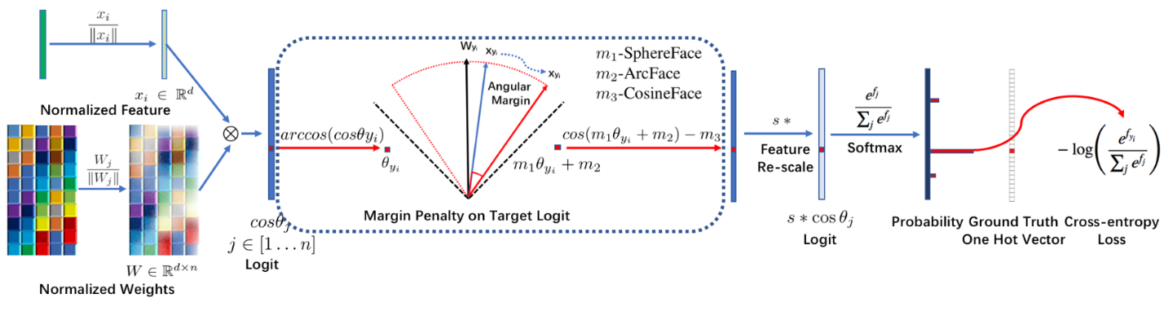
Figure 3. Illustration of the ArcFace additive angular margin loss [18]

The additive angular margin: ArcFace [18] addresses this by inserting an additive penalty $m$directly into the angle of the target class, as formalized in Equation (9):

$L_{3}=-\log{\frac{e^{s\cos\left(θ_{y_{i}}+m\right)}}{e^{s\cos\left(θ_{y_{i}}+m\right)}+\sum_{j≠y_{i}}{e^{s{\cos{θ}}_{j}}}}}$ (9)

This loss can only be reduced if $\cos\left(θ_{y_{i}}+m\right)$still exceeds every competing class score, forcing each sample to within angle $θ_{j}-m$of its own class centre. The boundary shifts outward by $m$, creating a margin region around each class boundary that no training sample occupies at convergence. Distinct identities therefore occupy angularly separated, non-adjacent regions of the hypersphere. The scale $s$controls how sharply the softmax concentrates probability on the highest-similarity class; without it the logits lie in $\left[-1,1\right]$and gradients are too small to drive learning. [42][43]
ArcFace [18] reports $s=64$and $m=0.5$rad as effective defaults across thousands of identities.
Motivation for choosing ArcFace: ArcFace's iResNet50 backbone is used as a frozen feature extractor in this thesis; its weights are never updated during cross-modal training (Chapter 6). What is inherited from pretraining is the geometric organization of the 512D output space: because the encoder was trained with $L_{3}$, its embeddings for different identities are angularly separated by at least $m$, and cosine similarity between two ArcFace embeddings is a calculated measure of identity proximity. VGG16 and ResNet trained with standard softmax provide no such guarantee. FaceNet's triplet loss does organise the space by distance, but its 128D embeddings and object-classification backbone limit identity discriminability. Among the angular margin family, ArcFace's additive angular margin corresponds to a constant arc length on the hypersphere regardless of $θ$, making the enforced separation geometrically uniform across all class pairs. The component comparison in Chapter 7 confirms that replacing VGG16 with ArcFace produced a 408% improvement in cross-lingual Urdu cosine similarity, validating this choice empirically.

Methods for obtaining voice embeddings
A voice embedding is a fixed-length vector extracted from a speech utterance that encodes speaker-discriminative properties, such as vocal tract resonance, pitch characteristics, and articulatory patterns, in a form that is comparable across recordings of the same speaker under different conditions. The general pipeline consists of feature extraction from the raw waveform (typically mel-filterbank features or raw samples), followed by a temporal encoder that processes the variable-length sequence, and a pooling mechanism that collapses the time dimension into a single fixed-length vector. Classical approaches such as i-vectors [44], dominated speaker recognition for over a decade, representing speaker variability through a low-dimensional total variability subspace estimated via factor analysis. Then, x-vectors [45] replaced the generative factor analysis framework with a discriminatively trained TDNN classifier, producing fixed-length embeddings by mean pooling over frame-level representations. Both approaches remain competitive in low-resource scenarios but lack the multi-scale temporal modelling and channel attention mechanisms needed for robust speaker discrimination across languages and recording conditions.
Self-supervised approaches: Wav2vec 2.0 [46] learns speech representations from raw waveforms without labels, using a contrastive objective over quantized latent representations. Its transformer-based architecture captures long-range acoustic context and generalizes well across languages, but the model is computationally expensive and was designed primarily for speech recognition rather than speaker verification. HuBERT [47] extends this with a masked prediction objective over discrete acoustic units, achieving strong phoneme disentanglement.
Both wav2vec 2.0 and HuBERT produce rich representations but require fine-tuning to perform competitively on speaker verification tasks, and their large parameter counts make them impractical as frozen feature extractors in a pipeline that also trains fusion and classification components. [48]
ECAPA-TDNN architecture and mechanisms: In ECAPA-TDNN, Desplanques et al. [20] process a sequence of mel-filterbank features x1,…,xT ∈ R in using one-dimensional dilated convolutions along the time axis.

A dilated 1D convolution with kernel size $K$and dilation $d$produces, for each output channel, as given in Equation (10):

$y\left[t\right]=\sum_{k=0}^{K-1}{\sum_{c=1}^{C_{in}}{w_{c,k}}}x_{c}\left[t+d⋅k\right]$ (10)

where $w_{c,k}$are learned weights. Dilation $d$controls the temporal spacing between the $K$taps: with $d=1$the convolution sees $K$ consecutive frames, while $d=3$spreads the same $K$taps across a span $3\left(K-1\right)+1$frames wide, without increasing the number of parameters [20][49]. Stacking several such layers with progressively increasing dilation ($d=1,2,4,…$) causes the receptive field, the span of input frames that influence a given output to grow exponentially with depth, while the parameter count grows only linearly. This mirrors the dilation principle used in WaveNet-style architectures [49], and is what allows ECAPA-TDNN to integrate information from both short-range acoustic detail (a few milliseconds, relevant to pitch periodicity and formant structure) and longer-range context (hundreds of milliseconds, relevant to phoneme transitions and prosody) within a manageable number of layers.
Squeeze-and-Excitation channel attention: At each layer, the TDNN produces a tensor $x∈R^{C×T}$, with $C$channels across $T$time steps. Not every channel is equally informative for a given utterance: some may respond to background noise or channel-specific recording artefacts rather than speaker identity [50][20]. Squeeze-and-Excitation (SE) [50] addresses this with a lightweight, input-dependent channel reweighting, applied in two steps.
Squeeze: global average pooling collapses the time dimension, producing a per-channel summary statistic, Equation (11)

$z_{c}=\frac{1}{T}\sum_{t=1}^{T}{x_{c,t}}, z={\left(z_{1},…,z_{C}\right)}^{T}$ (11)

Excitation: a small bottleneck network maps this $C$-dimensional summary to a set of per-channel gates $s∈(0,1)^{C}$, via Equation (12):

$s=σ\left(W_{2}δ\left(W_{1}z+b_{1}\right)+b_{2}\right)$ (12)

where $δ(⋅)$is a ReLU non-linearity, $σ(⋅)$is the sigmoid function, $W_{1}∈R^{(C/r)×C}$and $W_{2}∈R^{C×(C/r)}$project down to a bottleneck dimension $\frac{C}{r}$and back up ($r$ is the reduction ratio, a small integer such as 8). Finally, each channel of the original feature map is rescaled by its corresponding gate, Equation (13):

${\overset{˜}{x}}_{c,t}=s_{c}⋅x_{c,t}$ (13)

The effect is that the network learns, on every utterance, which of the $C$frequency/feature channels currently carry the strongest speaker distinctive signal, and amplifies those while suppressing the rest, an equivalent of the dynamic re-weighting that Transformer attention performs across modalities rather than channels.
ECAPA-TDNN enroots the SE mechanism within Res2Net-style blocks [51]. Rather than processing all $C$channels with a single convolution, the channels are split into $g$groups $x_{1},…,x_{g}$, each of width $C/g$, and then processed via Equation (14):

$y_{i}=\left\{\begin{matrix}x_{i} & i=1 \\ K_{i}\left(x_{i}+y_{i-1}\right) & i=2,…,g\end{matrix}\right.$ (14)

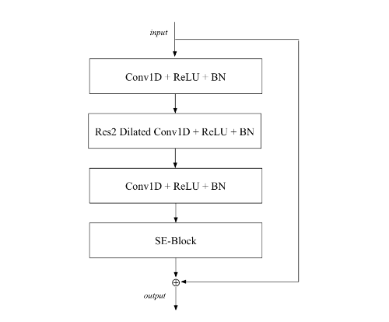
where $K_{i}$is a small convolution applied to group $i$. Each group $y_{i}$therefore aggregates information from an increasingly large field; group 1 sees only its own local context, while group $g$has been convolved $g-1$times and has effectively integrated information across $g$different temporal scales. The groups are concatenated, $y=[y_{1},…,y_{g}]$, and passed through the SE block described above. This multi scale Res2Net grouping followed by SE channel attention is referred to as an SE-Res2Block and forms the repeating unit of the ECAPA-TDNN backbone, as shown in Fig. 4
Figure 4. The SE-Res2Block of the ECAPA-TDNN architecture [20]
Multi-scale Feature Aggregation (MFA): ECAPA-TDNN stacks several SE-Res2Blocks, each operating at progressively larger effective receptive fields due to increasing dilation (per the TDNN discussion above). Rather than using only the output of the final block, the outputs of all SE-Res2Blocks are concatenated channel-wise and passed through a final $1×1$convolution, Equation (15):

$h={Conv}_{1×1}\left(\left[y^{\left(1\right)},y^{\left(2\right)},…,y^{\left(L\right)}\right]\right)$ (15)

where $y^{\left(l\right)}$is the output of the $l$-th block. This gives the final frame representation $h∈R^{C^{'}×T}$access to features computed at every scale simultaneously short-range spectral detail from early blocks and long-range prosodic context from later blocks rather than forcing all this information through a single bottleneck at the end of the network. Attentive Statistics Pooling (ASP). The frame-level representation $h=(h_{1},…,h_{T})$must be reduced to a single fixed-length utterance embedding, regardless of $T$. Simple averaging would treat every frame as equally informative, including frames dominated by silence or noise. Attentive Statistics Pooling [52] instead learns a per-frame attention weight, defined in Equation (16):

$e_{t}=v^{T}\tanh\left(Wh_{t}+b\right), α_{t}=\frac{\exp\left(e_{t}\right)}{\sum_{τ=1}^{T}{\exp\left(e_{τ}\right)}}$ (16)

and computes both an attention-weighted mean $\tilde{μ}$and an attention-weighted standard deviation $\tilde{σ}$across time, as given in Equation (17):
$\overset{˜}{μ}=\sum_{t=1}^{T}{α_{t}}h_{t}, \overset{˜}{σ}=\sqrt{\sum_{t=1}^{T}{α_{t}}h_{t}^{⊙2}-{\overset{˜}{μ}}^{⊙2}}$ (17)
(where $⊙2$denotes elementwise squaring). Concatenating $\left[\tilde{μ} , \tilde{σ}\right]$and passing the result through a final fully connected layer produces the 192-dimensional speaker embedding. Pooling both the mean and the spread of the attended frame-level features rather than the mean alone preserves information about the variability of the speaker's acoustic details across the utterance [52] (e.g. pitch range, articulatory variability), which is ignored by mean-only pooling.
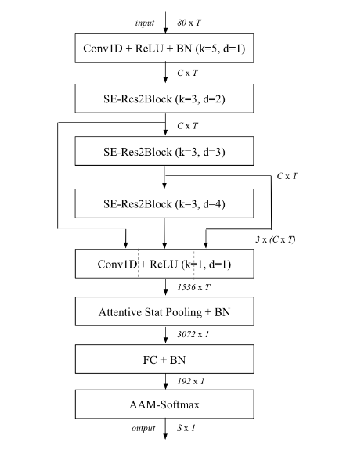

Figure 5. Overall ECAPA-TDNN architecture for speaker embedding extraction [20].

Motivation for choosing ECAPA-TDNN: ECAPA-TDNN was pretrained on VoxCeleb1+2 [21,22] using AAM-SoftMax, as illustrated in Figure 5, the same additive angular margin loss described earlier in this chapter, applied to speaker identity rather than face identity. Its 192D output space therefore has the same angularly organized structure as ArcFace's 512D space: cosine similarity between two ECAPA-TDNN embeddings is a calculated measure of speaker proximity. This property is inherited by the voice-branch Modality Translator, which projects the frozen 192D embedding into the shared 512D hypersphere $S^{511}$. Compared to wav2vec 2.0 and HuBERT, ECAPA-TDNN is substantially more lightweight, does not require fine-tuning, and provides a pretrained SpeechBrain checkpoint that integrates directly into the training pipeline. Compared to x-vectors, it provides richer multi-scale temporal modelling and input-dependent channel attention that improve speaker discriminability across the multilingual conditions of MAVCeleb. These properties, combined with its strong performance on the VoxCeleb speaker verification benchmark, motivated its selection as the voice encoder for this thesis.

Transformer attention mechanism
The face and voice branch descriptions earlier in this chapter described how the face and voice branches independently produce embeddings $z_{F},z_{V}∈R^{512}$on the shared hypersphere. This section addresses the final step of the pipeline: combining $z_{F}$and $z_{V}$into a single fused embedding. The mechanism used Transformer Cross Attention, built on the scaled dot-product attention of Vaswani et al. [25] is examined here at the level of its underlying $Q/K/V$mathematics, with the specific two-token configuration used in this thesis. Scaled dot-product attention. Given an input sequence $X∈R^{n×d_{model}}$ with $n$tokens, each a $d_{model}$ dimensional vector, attention first produces three linear projections of $X$, Equation (18):

$Q=XW_{Q}, K=XW_{K}, V=XW_{V}$ (18)

Where $W_{Q},W_{K},W_{V}$ are learned weight matrices. The naming follows a retrieval analogy: $Q$("query") represents what a token is searching for, $K$("key") represents what a token advertises as available, and $V$("value") is the content retrieved once a match is found. The attention output is then given by Equation (19):
$\text{Attention}\left(Q,K,V\right)=\text{softmax}\left(\frac{QK^{T}}{\sqrt{d_{k}}}\right)V$ (19)

Here $QK^{T}∈R^{n×n}$is a matrix of pairwise dot products, the entry ($i$, $j$) measures how well token $i$'s query aligns with token $j$'s key. The softmax is applied row-wise, converting each row of $QK^{T}$into a probability distribution $α_{i}∈R^{n}$over the $n$tokens (the attention weights), and the output for token $i$is the attention weighted combination $\sum_{j=1}^{n}{α_{ij}}V_{j}$of all tokens' value vectors.
The two-token cross-modal sequence: In the architecture of this thesis, $X$is constructed by stacking the two modality embeddings as a sequence of length $n=2$, Equation (20):

$X=\left[\begin{matrix}z_{F} \\ z_{V}\end{matrix}\right]∈R^{2×512}$ (20)

Self-attention is then applied, $Q$, $K$, and $V$are all derived from the same $X$, rather than computing $Q$from $z_{F }$only and $K,V$from $z_{V }$only. With $n=2$, the attention matrix $QK^{T}/\sqrt{d_{k}}$is a $2×2$matrix, and after the row-wise softmax it contains four attention weights, Equations (21):

$α_{FF},α_{FV},α_{VF},α_{VV}, α_{FF}+α_{FV}=1, α_{VF}+α_{VV}=1$ (21)

The output token for the face position is $α_{FF}V_{F}+α_{FV}V_{V}$; a mixture of the face token's own value and the voice token's value, where the mixing proportions $α_{FF},α_{FV}$ computed from the dot products $Q_{F}⋅K_{F}$and $Q_{F}⋅K_{V }$for a specific pair. Symmetrically, the voice position's output mixes $V_{F}$and $V_{V}$according to $α_{VF},α_{VV}$. This is the sense in which the fusion is bidirectional and dynamic: for a given face-voice pair, the network computes from the content of $z_{F}$and $z_{V}$ how much each modality's information should flow into the other's representation, rather than applying a fixed combination rule (e.g. a static $0.5/0.5$average) to every pair regardless of content.
Multi-head attention: Rather than computing a single attention operation with $d_{k}=d_{model}=512$, the embedding dimension is split across $h$parallel heads, each operating in a $d_{k}=d_{model}/h$-dimensional subspace. With $h=8$heads (as used in this thesis), $d_{k}=512/8=64$.

Each head $i$has its own projection matrices $W_{Q}^{\left(i\right)},W_{K}^{\left(i\right)},W_{V}^{\left(i\right)}∈R^{512×64}$and computes its own attention output independently, Equation (22):

${\text{head}}_{i}=\text{Attention}\left(XW_{Q}^{\left(i\right)},XW_{K}^{\left(i\right)},XW_{V}^{\left(i\right)}\right)∈R^{2×64}$ (22)

The $h$head outputs are concatenated along the feature dimension and projected back to $d_{model}=512$by a final output matrix $W_{O}∈R^{512×512}$, Equation (23):

$\text{MultiHead}\left(X\right)=\left[{\text{head}}_{1},…,{\text{head}}_{8}\right]W_{O}$ (23)

Each head learns an independent compatibility pattern between $z_{F}$and $z_{V}$, allowing the network to capture different physiological couplings across the two modalities simultaneously, rather than forcing all cross-modal correspondence through a single shared pattern. Residual connection and Layer Normalization. The multi-head attention output is combined with the original input via a residual connection, followed by Layer Normalization, Equation (24):

$Z=\text{LayerNorm}\left(X+\text{Dropout}\left(\text{MultiHead}\left(X\right)\right)\right)$ (24)

The residual connection ensures that the attention mechanism improves the original embeddings rather than replacing them even if the attention sub-layer were to produce an unhelpful output early in training, the original $z_{F},z_{V}$information still passes through unchanged via the $X$term, and gradients can flow directly back through this path [37][25]. LayerNorm then re-normalizes the activations of each token (across its 512 features) to have zero mean and unit variance before scaling/shifting by learned parameters [53]; a standard stabilization step that keeps the distribution of values entering subsequent layers consistent regardless of how large the attention sub-layer's output happens to be. Dropout is applied to the attention output during training as a regularizer, consistent with the dropout used in Modality Translators.
Final pooling into the fused embedding. $Z∈R^{2×512}$still contains two separate (attention-refined) tokens, $Z_{F}$and $Z_{V}$. These are combined by simple averaging, Equation (25):

$z_{fused}=\frac{1}{2}\left(Z_{F}+Z_{V}\right)$ (25)

followed by L2 normalization placing the fused representation back on $S^{511}$ the same hypersphere described earlier in this chapter, and the space in which the loss functions and the evaluation metrics operate. Averaging is a deliberate dimensionality choice: it keeps the fused embedding at 512D matching the dimensionality of the unimodal embeddings, and treats the two attention-refined tokens symmetrically, with neither modality's refined representation given structural priority over the other in the final combination.

Loss functions for cross-modal identity learning
The loss functions used during cross-modal training serve a different purpose than the pretraining objectives of ArcFace and ECAPA-TDNN described in earlier sections. Those objectives organized each modality's embedding space independently. The objectives in this section operate on the fused embeddings and directly shape the shared latent space for cross-modal retrieval: pulling same-identity face-voice pairs together and pushing different-identity pairs apart.

InfoNCE and temperature scaling
InfoNCE [15] formulates cross-modal matching as a noise contrastive estimation problem. For a batch of $N$face-voice pairs ${\left\{(f_{i},v_{i})\right\}}_{i=1}^{N}$, each face embedding $f_{i}$must identify its matching voice $v_{i }$among all $N$voice embeddings in the batch. The loss for a single face anchor is, Equation (26):

$L_{\text{NCE}}^{\left(i\right)}=-\log{\frac{\exp\left(f_{i}⋅v_{i}/τ\right)}{\sum_{j=1}^{N}{\exp\left(f_{i}⋅v_{j}/τ\right)}}}$ (26)

where $τ$is the temperature parameter. Applied symmetrically, the full bidirectional InfoNCE loss averages this over both directions, Equation (27):

$L_{\text{InfoNCE}}=\frac{1}{2N}\sum_{i=1}^{N}{\left[L_{\text{NCE}}^{\left(i\right)}\left(f→v\right)+L_{\text{NCE}}^{\left(i\right)}\left(v→f\right)\right]}$ (27)

The temperature $τ$controls the sharpness of the distribution over negatives [55]. Setting $τ=0.1$, as used in this thesis, concentrates the softmax on the hardest negatives, producing large gradients from near-miss pairs and pushing the network toward finer-grained separation. Raising $τ$instead smooths the distribution, treating negatives more uniformly and yielding a weaker training signal.

Supervised Contrastive Loss
InfoNCE [15] treats each sample as having exactly one positive per batch: the paired face-voice sample. Khosla et al. [16] generalize this with Supervised Contrastive Loss (SupCon), supporting multiple positives per anchor, defined by the identity label rather than the pairing index. For an anchor embedding $z_{i}$, the set of positives $P(i)$contains all other embeddings in the batch sharing the same identity label, including cross-language pairs of the same speaker, as formalized in Equation (28):

$L_{\text{SupCon}}=\sum_{i=1}^{N}{\frac{-1}{\left|P\left(i\right)\right|}}\sum_{p∈P\left(i\right)}{\log{\frac{\exp\left(z_{i}⋅z_{p}/τ\right)}{\sum_{a∈A\left(i\right)}{\exp\left(z_{i}⋅z_{a}/τ\right)}}}}$ (28)

where $A(i)$is the set of all other samples in the batch. By pulling together all same identity embeddings regardless of modality or language, SupCon directly encourages the shared space to be organized by biolthogical identity rather than by language or recording condition, making it well suited to the multilingual training setup of this thesis.

Orthogonal Projection Loss
Saeed et al. [6] use Orthogonal Projection Loss (OPL) as an alternative geometric constraint in their FOP baseline. Rather than working through a softmax over negatives, OPL directly penalizes the dot product between embeddings of different identities and rewards alignment between embeddings of the same identity, as formalized in Equation (29):

$L_{\text{OPL}}=\sum_{i,j}{1}\left[y_{i}=y_{j}\right]\left(1-z_{i}⋅z_{j}\right)+\sum_{i,j}{1}\left[y_{i}≠y_{j}\right]\left|z_{i}⋅z_{j}\right|$ (29)

The first term penalizes same-identity pairs whose dot product falls below 1. The second term penalizes different-identity pairs whose dot product deviates from 0. The target geometry is one where same-identity embeddings are collinear and different-identity embeddings are orthogonal, regardless of batch composition or the number of identities present.

The effect of identity count on loss function performance
The key practical difference between OPL and SupCon lies in their dependence on batch diversity. SupCon's gradient signal comes entirely from positive pairs within the batch. For a batch of size 64 drawn from only 64 identities, the expected number of same-identity pairs per anchor is very small, often zero. In this regime, $∣P(i)∣≈0$for most samples, the positive term in the SupCon loss contributes to negligible gradient, and only the push apart signal from negatives operates. The loss behaves approximately like InfoNCE with random negatives, which is weaker than OPL's direct orthogonality constraint that applies regardless of batch composition. At 198 identities with 500 cross-language pairs per identity, batches of size 64 reliably contain multiple samples per identity across different languages and modalities. $∣P(i)∣$is now consistently non-zero, and SupCon's pull-together signal operates on cross-language same-identity pairs, directly enforcing language-agnostic identity clustering.
OPL's rigid orthogonality target, by contrast, forces all different-identity pairs to exactly zero dot product regardless of how similar or dissimilar the identities actually are, which can over-constrain the geometry and prevent the embedding space from learning the continuous similarity structure needed for generalization to unseen identities. The theoretical prediction is that OPL should dominate in sparse-identity regimes and SupCon in dense multilingual ones. This prediction is tested directly in the component comparison study in Chapter 7.

Evaluation metrics
The system developed in this thesis is evaluated under two complementary protocols: verification, which asks whether a given face-voice pair belongs to the same identity, and identification, which asks which identity from a known set a given probe most closely matches. Each protocol requires a different metric.

Equal Error Rate
Verification systems assign a scalar similarity score $s(f,v)=cos⁡θ(g_{F}(x),g_{V}(y))$to each face-voice pair. Given a set of genuine pairs (same identity) and impostor pairs (different identity), the scores of the two groups form overlapping distributions. Two types of error arise from any attempt to separate them:
False Acceptance Rate (FAR): the fraction of impostor pairs whose score exceeds $δ$, i.e. different-identity pairs are incorrectly accepted as genuine. False Rejection Rate (FRR): the fraction of genuine pairs whose score falls below $δ$, i.e. same-identity pairs are incorrectly rejected.
As $δ$increases, FAR decreases (fewer impostors are accepted) but FRR increases (more genuine pairs are rejected), and vice versa. The Equal Error Rate (EER) is the value of $δ$at which FAR and FRR are equal, as defined in Equation (30):

$\text{EER}=\text{FAR}\left(δ^{*}\right)=\text{FRR}\left(δ^{*}\right), δ^{*}=\arg{\min_{δ}\left|\text{FAR}\left(δ\right)-\text{FRR}\left(δ\right)\right|}$ (30)

EER is computed numerically by sweeping all unique similarity scores as candidate thresholds, computing FAR and FRR at each, and identifying the crossing point [56]. A lower EER indicates better verification performance; a system with no discriminative ability achieves 50% EER (random chance), while a perfect system achieves 0%. [57]
EER summarizes the separability of the genuine and impostor score distributions in a single number, without requiring commitment to a fixed operating point, making it a standard comparison metric across biometric systems. The MAVCeleb FOP baseline achieves 37.9% EER on Urdu cross-lingual evaluation, which serves as the primary reference point for the results in Chapter 7.

Rank-1 Retrieval Accuracy
Rank-1 retrieval evaluates identification rather than verification. Given $N$face embeddings and $N$voice embeddings (one per identity), a cosine similarity matrix $S∈R^{N×N}$is computed, where entry $S_{ij}=cos⁡θ(g_{F}(x_{i}),g_{V}(y_{j}))$. For each face embedding $i$, the voice embedding with the highest similarity score is selected, Equation (31):

$\overset{ˆ}{j}\left(i\right)=\arg{\max_{j}{S_{ij}}}$ (31)

Rank-1 accuracy is the fraction of faces for which the top 1 retrieved voice belongs to the correct identity, Equation (32):
$\text{Rank-1}=\frac{1}{N}\sum_{i=1}^{N}{1}\left[\overset{ˆ}{j}\left(i\right)=i\right]$ (32)

Random chance for this task is $1/N$, making Rank-1 a meaningful metric only when it exceeds this baseline. EER measures how well the system separates genuine from impostor pairs in verification, while Rank-1 measures how reliably it retrieves the correct identity in an open retrieval task.

Implementation

System overview and pipeline architecture
The system is organized into two operationally distinct phases: Stage I (feature extraction) and Stage II (training and evaluation). This separation is a deliberate architectural choice.
The frozen pretrained encoders, ArcFace iResNet50 and ECAPA-TDNN, are computationally expensive to run and their weights are never updated during cross-modal training. Extracting embeddings once and storing them as tensors on disk decouples the encoding cost from the training loop entirely, reducing each training epoch to lightweight matrix operations on pre-computed 512D and 192D vectors rather than full forward passes through two large pretrained networks. This decoupling made 45 training epochs computationally tractable without repeated encoding overhead.
The full pipeline is illustrated in Figure 6. Data flows left to right through six stages: raw data sources, feature extraction, embedding storage, trainable modality translators, transformer cross-attention fusion, and output heads. The compound loss function feeds gradients back into the trainable components only, leaving the frozen encoders unaffected.
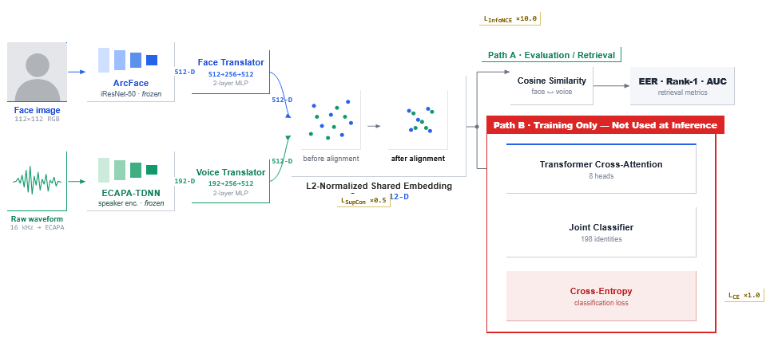
Figure 6. Pipeline for the image and voice processing

Stage I – Feature Extraction: Raw face images and speech recordings from MAVCeleb v1, v2, and v3, and from the RO-FaceVoice corpus introduced in this thesis, are processed by the two pre-trained encoders. ArcFace iResNet50 produces a 512-dimensional L2-normalized face embedding per image. ECAPA-TDNN produces a 192-dimensional L2-normalized voice embedding per 3-second audio clip. Each face-voice pair is saved as a single file containing both embeddings, the identity label, and the source language for each modality. The full extraction produced 98,828 embedding pairs across 198 identities, stored on Google Drive for access during training.
Stage II – Training and Evaluation: At training time, the stored embeddings are indexed and served in random batches of 64 face-voice-label triples. Each batch passes through two independent translator networks: a face translator that projects the 512D ArcFace embedding into the shared 512D space, and a voice translator that projects the 192D ECAPA-TDNN embedding into the same space. Both outputs are L2-normalized before being combined by a Transformer-based cross-attention fusion module, which produces a single 512D embedding via bidirectional 8-head self-attention. During training, the fused embedding is passed to a classification head (512→1024→198) for cross-entropy supervision.

The compound loss, detailed later in this chapter, combines cross-entropy, InfoNCE, and Supervised Contrastive Loss with fixed weights and drives gradient updates through all four trainable components: the face translator, the voice translator, the fusion module, and the classifier. At evaluation time, the classifier is not used, and matching is performed through cosine similarity directly over the translator output embeddings, prior to Transformer fusion. The fusion module and classifier remain part of the trained pipeline and influence the translator weights through backpropagation during training but are not invoked at evaluation; this is discussed further in the Limitations section of Chapter 7.
All four trainable components are jointly registered in a single optimizer, so a single backward pass and optimizer step updates all of them simultaneously in each training iteration. The exact implementation of each of these components, including their internal layer structure, is described per-module in Section 5.4.

Dataset creation and organization

MAVCeleb dataset structure
The MAVCeleb dataset [5] is organized as a directory tree where each identity folder contains separate language subfolders, each holding face images and voice recordings from that identity speaking that language. The face and voice data are stored under parallel faces/ and voices/ roots. Each utterance corresponds to one matched face-voice pair, so the utterance counts reported in Table 1 (18,385 for v1, 20,715 for v2, and 3,812 for v3) equal both the number of face images and the number of voice clips available in each split, respectively.
The three splits are treated as independent datasets with globally unique identity labels assigned across all three: v1 identities receive labels 0–63, v2 identities 64–147, and v3 identities 148–205, yielding 198 unique identities in total after discarding identities with missing face or voice data in any language folder. MAVCeleb v1 contributes only 64 of its 70 total identities to this label space, since the FAME challenge protocol keeps identity ground truth hidden for its remaining 6 identities, which are reserved as the official test set; the label ranges assigned to v2 and v3 correspond to their full identity counts, indicating no equivalent held-out restriction applied.
For training, only the English-language recordings of each identity are used as the primary training signal for MAVCeleb v1, while v2 and v3 contribute their full English plus Hindi and German recordings respectively. The Urdu recordings of MAVCeleb v1 are held out entirely and used exclusively for cross-lingual evaluation.

Cross-Language sampling strategy
A central objective of the training setup is to force the model to learn identity representations that are invariant to language. A model trained only on matched-language face-voice pairs, English face with English voice of the same person risks learning to match faces and voices based on shared English phonetic patterns rather than underlying biological identity. This is the phonetic entanglement problem described earlier.
To counter this, the extraction pipeline samples face language and voice language independently for each training pair. For each identity, on each of 500 sampling iterations, a face language folder and a voice language folder are chosen uniformly at random from the available languages for that identity, independently of each other. This generates cross-language pairs: an English face frame paired with an Urdu voice clip of the same identity, or a Hindi face frame paired with a German voice clip. Same language pairs also occur naturally at a rate proportional to the number of available languages, but they are not enforced.
The rationale is that the only consistent signal available to the network across cross-language pairs is the identity's underlying biology, the vocal tract geometry that produced both the face geometry and the voice resonance characteristics rather than language-specific acoustic patterns.
This forces the shared latent space to organize around biological identity rather than linguistic similarity.
With 500 sampled pairs per identity and 198 identities, the theoretical maximum is 99,000 embedding pairs. The actual extracted count is 98,828, with 172 samples lost to ArcFace face detection failures on blurry, heavily occluded, or extreme-angle frames that did not pass the detector's confidence threshold.

Corpus of Romanian faces and voices
RO-FaceVoice is a novel Romanian-language face-voice evaluation corpus introduced in this thesis. Romanian is absent from all MAVCeleb language splits and from VoxCeleb, which is the pretraining corpus of ECAPA-TDNN. The corpus therefore constitutes a genuinely unseen-unheard evaluation: both the identities and the language are completely absent from all training data.
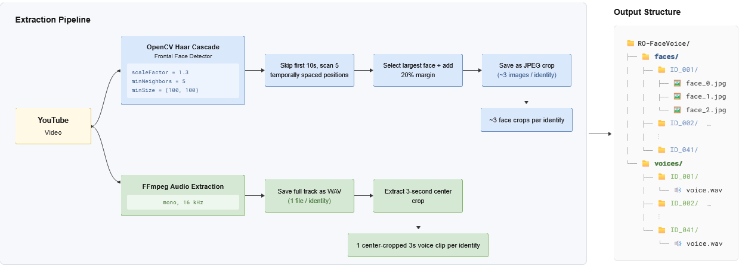
The corpus covers 41 Romanian public figures spanning journalists, stand-up comedians, television presenters, vloggers, and content creators, chosen to provide gender balance and acoustic diversity. For each identity, one YouTube video was selected using yt-dlp and downloaded in MP4 format at up to 720p resolution. The full corpus construction pipeline is illustrated in Figure 7.
Figure 7. Corpus construction pipeline for the RO-FaceVoice dataset.

Face extraction used OpenCV's Haar cascade frontal face detector with parameters scaleFactor = 1.3, minNeighbors = 5, and minSize = (100, 100). The minNeighbors=5 threshold is raised above the default value of 3 to reject spurious detections on clothing textures, background patterns, and partial face regions that commonly trigger the detector at lower confidence.
The minSize = (100, 100) constraint excludes face regions smaller than 100×100 pixels, which at 720p resolution corresponds to faces that are too distant or motion-blurred to yield reliable ArcFace embeddings. The video was scanned at five temporally spaced positions, with the first 10 seconds skipped entirely. During manual review of the source videos, the opening seconds were frequently found to contain channel branding, title cards, or animated intros rather than the speaker, motivating a 10-second skip window in the extraction pipeline.
The remaining frames were divided into five equal intervals, with one target position per interval, ensuring that the extracted faces sample different temporal moments of the video rather than clustering around a single scene.
At each target position, the detector scanned forward frame by frame until a frontal face was confirmed. The largest detected region was selected, and a 20% margin was added around the bounding box before saving the crop as a JPEG.
The margin is necessary because the Haar cascade bounding box is tight around the face region, and ArcFace's recognition backbone requires surrounding context like the forehead, jaw outline, and ear regions, to produce stable identity embeddings. Truncating these areas at the crop boundary degrades embedding quality. This procedure produced approximately 3 face images per identity.
Audio extraction used FFmpeg to strip the audio track from the downloaded video, convert it to mono, and resample to 16kHz. The full audio track was saved as a single WAV file per identity.
During embedding extraction, a 3-second segment centered on the midpoint of the audio file was used as the voice input to ECAPA-TDNN.
The midpoint of the recording consistently falls within the main spoken content, maximizing the probability of capturing identity-relevant acoustic signal. The corpus was built and extracted locally rather than on Colab, since YouTube downloads and face detection are CPU-bound operations that do not benefit from GPU acceleration. The resulting face and voice embeddings were transferred to Google Drive and used exclusively for the zero-shot Romanian evaluation.

Face and voice feature extraction
Prior to any training, all raw face images and audio files from were processed once through the frozen encoders on Google Colab Pro (NVIDIA Tesla T4), producing fixed-length embedding vectors stored as .pt files on Google Drive. The RO-FaceVoice corpus embeddings were extracted separately on a local CPU machine and used exclusively for evaluation. Because ArcFace and ECAPA-TDNN are frozen and produce identical outputs for the same input on every forward pass, running them inside the training loop would be redundant and computationally wasteful. Processing all inputs once and storing the resulting vectors reduces each training iteration to lightweight operations on pre-computed tensors, without repeating the encoding step.

Face embedding extraction
Face embeddings are extracted using InsightFace's buffalo_l model pack, which bundles a face detection model (det_10g.onnx) and the ArcFace iResNet50 recognition backbone (w600k_r50.onnx). The detector is initialized with det_size = (128, 128), chosen to match the tightly-cropped, close-up face framing typical of MAVCeleb frames, where faces occupy 70–80% of the image rather than appearing as small regions within a larger scene.The extraction interface requires raw BGR numpy arrays rather than normalized tensors.
InsightFace runs detection and alignment internally: it locates the face bounding box, identifies five facial landmarks (eye centers, nose tip, mouth corners), and applies an affine transformation to place the face at a canonical orientation within the 112×112 input grid of the recognition backbone. The backbone then outputs a 512-dimensional embedding that is intrinsically L2-normalized. An explicit F.normalize call is applied after extraction as a safeguard. Samples where app.get() returns an empty list for blurry frames, heavily occluded faces, or extreme angles beyond the detector's confidence threshold are skipped silently. This accounts for 172 of the 99,000 theoretical samples not being saved.

Voice embedding extraction
Voice embeddings are extracted using SpeechBrain's pretrained ECAPA-TDNN checkpoint (spkrec-ecapa-voxceleb), loaded with run_opts = {"device": "cuda"} during Colab extraction to ensure the encoder and waveform tensors reside on the same device, a device mismatch between the two was the first critical bug encountered during the Colab phase.
Each audio file is loaded with torchaudio, converted to mono if stereo, and resampled to 16kHz if necessary.

The waveform is then padded with zeros if shorter than 3 seconds, or center-cropped to exactly 3 seconds (48,000 samples) if longer, as shown in Listing 1:

target_len = 16000 * 3
if waveform.shape[1] < target_len:
waveform = F.pad(waveform, (0, target_len - waveform.shape[1]))
else:
start = (waveform.shape[1] - target_len) // 2
waveform = waveform[:, start: start + target_len]
Listing 1. Audio preprocessing and center-crop

Center cropping is preferred over cropping from the start because the opening seconds of a recording often contain silence, music, or background noise before the speaker begins.
The 3-second fixed length is a standard input duration for ECAPA-TDNN and matches the SpeechBrain model's expected input distribution. The encoder outputs a 192-dimensional L2-normalized speaker embedding. [58]

Embedding storage format
Each extracted face-voice pair is saved as a single .pt file using torch.save. The file contains a Python dictionary with five fields: face_emb (a 1×512 float32 tensor), voice_emb (a 1×192 float32 tensor), label (an int64 scalar identifying the identity), face_lang (a string recording which language folder the face image was drawn from), and voice_lang (a string recording which language folder the voice clip was drawn from).
The EmbeddingDataset class indexes all .pt files in a given directory at initialization and returns (face_emb, voice_emb, label) triples in __getitem__. A deterministic 80/20 split is applied at load time using torch.utils.data.random_split with a fixed seed of 42, ensuring the same train and validation sets are used across all experiments regardless of file system ordering.

Model architecture
This section describes the four trainable components of the system: the two Modality Translators, the TransformerCrossAttention fusion module, and the JointClassifier. All four are defined in models.py and jointly registered in a single Adam optimizer during training.

Modality Translators
The two pre-trained encoders produce embeddings in different dimensional spaces: ArcFace outputs 512-dimensional face embeddings and ECAPA-TDNN outputs 192-dimensional voice embeddings.
Before fusion, both must be projected into the same 512-dimensional shared space described earlier. This projection is handled by two independent ModalityTranslator instances, one per modality, with the same internal structure but different input dimensions.
The translator is a feed-forward projector with batch normalization, non-linear activations, and dropout regularization.

The full definition from models.py is given in Listing 2:

class ModalityTranslator(nn.Module):
def __init__(self, input_dim: int = 128, output_dim: int = 512, dropout: float = 0.3):
super(ModalityTranslator, self).__init__()
self.projector = nn.Sequential(
nn.Linear(input_dim, 256),
nn.BatchNorm1d(256),
nn.ReLU(),
nn.Dropout(dropout),
nn.Linear(256, output_dim),
nn.BatchNorm1d(output_dim),
nn.LeakyReLU(0.2),
)

def forward(self, x):
out = self.projector(x)
return F.normalize(out, p=2, dim=1)
Listing 2. Modality Translator

The first linear layer compresses the input to an intermediate 256-dimensional bottleneck, encouraging the network to retain identity-relevant structure while discarding modality-specific noise, before expanding back to 512 dimensions. BatchNorm1d is applied after each linear layer to stabilize the activation distribution across the batch and accelerate convergence. ReLU introduces non-linearity after the first projection; LeakyReLU(0.2) is used after the second to avoid dead neurons in the higher-dimensional output space. Dropout(0.3) is applied between the two linear layers as a regularizer, consistent with the dropout applied inside the TransformerCrossAttention module.
The final F.normalize call L2-normalizes the output, placing it on the unit hypersphere $S^{511}$as required by the cosine similarity comparisons in the loss functions and evaluation metrics.
The face translator is instantiated with input_dim=512 (ArcFace output dimension) and the voice translator with input_dim=192 (ECAPA-TDNN output dimension). Both use output_dim=512 and dropout=0.3.

Transformer Cross Attention
The TransformerCrossAttention module fuses the two 512-dimensional translated embeddings into a single fused representation. It implements the bidirectional self attention mechanism described earlier, using PyTorch's built-in nn.MultiheadAttention.
The forward method stacks the face and voice embeddings into a sequence of length 2 along the token dimension: seq has shape (batch_size, 2, 512). Self-attention is applied with query=seq, key=seq, value=seq, meaning both tokens attend to each other bidirectionally as described in this chapter. The batch_first=True flag ensures the batch dimension is the first axis, consistent with the rest of the pipeline. With num_heads=8 and embed_dim=512, each head operates in a 64-dimensional subspace. The attention output is passed through Dropout, added to the original sequence via the residual connection, and normalized by LayerNorm.
The two resulting tokens are averaged along the sequence dimension and L2-normalized, producing a single 512-dimensional fused embedding on $S^{511}$.

The full definition from models.py is given in Listing 3:

class TransformerCrossAttention(nn.Module):
def __init__(self, embed_dim: int = 512, num_heads: int = 8, dropout: float = 0.3):
super(TransformerCrossAttention, self).__init__()
self.multihead_attn = nn.MultiheadAttention(
embed_dim=embed_dim, num_heads=num_heads,
dropout=dropout, batch_first=True
)
self.layer_norm = nn.LayerNorm(embed_dim)
self.dropout = nn.Dropout(dropout)

def forward(self, face_emb, voice_emb):
seq = torch.stack([face_emb, voice_emb], dim=1)
attn_output, attn_weights = self.multihead_attn(
query=seq, key=seq, value=seq
)
seq_out = self.layer_norm(seq + self.dropout(attn_output))
fused_emb = torch.mean(seq_out, dim=1)
return F.normalize(fused_emb, p=2, dim=1)
Listing 3 Transformer Cross Attention

Joint Classifier
The JointClassifier maps the fused 512-dimensional embedding to a probability distribution over the 198 training identities. It is used only during training to provide the cross-entropy supervision signal; at evaluation time it is discarded, and matching is performed purely through cosine similarity over the translator output embeddings, prior to Transformer fusion. The JointClassifier architecture is shown in Listing 4:

class JointClassifier(nn.Module):
def __init__(self, num_classes, embedding_dim: int = 512):
super(JointClassifier, self).__init__()
self.classifier = nn.Sequential(
nn.Linear(embedding_dim, 1024),
nn.ReLU(),
nn.Linear(1024, num_classes)
)

def forward(self, x):
return self.classifier(x)
Listing 4 Joint Classifier

The hidden layer expands the 512-dimensional fused embedding to 1024 dimensions before projecting to the 198-class output, giving the classifier sufficient capacity to distinguish all training identities without reducing the embedding to the output space in a single step. No softmax is applied in the forward pass since PyTorch's CrossEntropyLoss accepts raw logits and applies log-softmax internally.

Review of the implementation stages
To illustrate how the four components operate as a unified system, consider a single face-voice pair drawn from the EmbeddingDataset during a training iteration. The __getitem__ method returns three tensors: face_emb of shape (1, 512), voice_emb of shape (1, 192), and a scalar identity label. After batching, the DataLoader assembles these into tensors of shape (64, 512), (64, 192), and (64,) respectively, where 64 is the batch size.
The face embeddings are passed first to the face ModalityTranslator. The first linear layer projects the (64, 512) input to (64, 256), BatchNorm1d normalizes the activations across the batch, and ReLU introduces non-linearity. Dropout(0.3) is then applied, randomly zeroing 30% of the 256 neurons during training. The second linear layer expands back to (64, 512), followed by a second BatchNorm1d and LeakyReLU(0.2). The final F.normalize call places every row on the unit hypersphere, producing a (64, 512) tensor of L2-normalized face projections. The voice embeddings undergo the same sequence through the voice ModalityTranslator, with the first linear layer accepting (64, 192) and projecting to (64, 256), before the same bottleneck-expand-normalize sequence produces a (64, 512) tensor of L2-normalized voice projections.
Both (64, 512) tensors are then passed to TransformerCrossAttention. The forward method stacks them along the token dimension using torch.stack([face_emb, voice_emb], dim=1), producing a sequence tensor of shape (64, 2, 512, a batch of 64 two-token sequences, where token 0 is the face and token 1 is the voice. This sequence is passed as query, key, and value simultaneously to nn.MultiheadAttention, allowing each token to attend to the other. The attention output, also (64, 2, 512), is passed through Dropout, added to the original sequence via the residual connection, and normalized by LayerNorm. The two tokens are then averaged along the sequence dimension via torch.mean(seq_out, dim=1), collapsing (64, 2, 512) to (64, 512). A final F.normalize places the fused embeddings on the unit hypersphere.
During training, the (64, 512) fused tensor follows two paths simultaneously. It is passed to the JointClassifier, which projects it through (64, 512) → (64, 1024) → (64, 198), producing raw logits over 198 identities for the cross-entropy loss. In parallel, the same fused tensor and the pre-fusion translated embeddings are used to compute the InfoNCE and SupCon terms respectively. All three loss values are combined with their fixed weights and a single loss.backward() call propagates gradients back through the classifier, the fusion module, and both translators simultaneously. At evaluation time the classifier branch is absent entirely, the (64, 512) fused embeddings are used directly for cosine similarity computation.

Training configuration

Compound Loss Function
The training objective combines three complementary loss terms, each targeting a different aspect of the shared embedding space, defined in Equation (33):

$L=L_{\text{CE}}+10.0⋅L_{\text{InfoNCE}}+0.5⋅L_{\text{SupCon}}$ (33)

Cross-entropy loss $L_{\text{CE}}$operates on the JointClassifier logits against the identity labels. It provides the primary supervised classification signal and ensures the fused embeddings carry discriminative identity information throughout training.
Without it, the contrastive losses alone would have no closed-form guarantee that the 198 training identities are globally distinguishable rather than just locally separated within each batch.
InfoNCE $L_{\text{InfoNCE}}$is applied bidirectionally between the translated face and voice embeddings before fusion, operating as a cross-modal alignment loss. For each face embedding in a batch of 64, it must identify its matching voice among 63 negatives, and symmetrically for each voice. The weight of 10.0 reflects the central importance of cross-modal alignment to the thesis objective: the system must learn to match faces to voices, and this loss directly optimizes for that retrieval task. The temperature $τ=0.1$concentrates the softmax on hard negatives, producing strong gradients from near-miss pairs.

The implementation from utils.py is given in Listing 5:

def cross_modal_alignment_loss(face_embeddings, voice_embeddings,
labels, temperature=0.1):
sim_matrix = torch.matmul(face_embeddings,
voice_embeddings.T) / temperature
labels = labels.view(-1, 1)
mask_pos = torch.eq(labels, labels.T).float()

log_prob_face_to_voice = F.log_softmax(sim_matrix, dim=1)
log_prob_voice_to_face = F.log_softmax(sim_matrix.T, dim=1)

loss_f2v = -(mask_pos * log_prob_face_to_voice).sum(dim=1) / \
(mask_pos.sum(dim=1) + 1e-6)
loss_v2f = -(mask_pos * log_prob_voice_to_face).sum(dim=1) / \
(mask_pos.sum(dim=1) + 1e-6)

return (loss_f2v.mean() + loss_v2f.mean()) / 2.0
Listing 5. InfoNCE bidirectional cross-modal alignment loss

Supervised Contrastive Loss $L_{\text{SupCon} }$operates on the fused embeddings after fusion, pulling all same-identity pairs together across languages and modalities. The weight of 0.5 prevents it from overpowering the cross-entropy signal while still enforcing the language-agnostic identity clustering, SupCon requires sufficient batch diversity to form meaningful positive pairs; at 198 identities with batch size 64, batches reliably contain multiple same-identity samples across different language combinations.

Optimizer and learning rate
All four trainable components: face_translator, voice_translator, TransformerCrossAttention, and JointClassifier, are jointly registered in a single Adam optimizer. The optimizer registration is shown in Listing 6:

params_to_train = (
list(model.parameters()) +
list(face_translator.parameters()) +
list(voice_translator.parameters()) +
list(transformer_fusion.parameters())
)
optimizer = optim.Adam(params_to_train, lr=0.001, weight_decay=1e-4)
Listing 6. Optimizer registration of all trainable components

Adam is chosen for its adaptive per-parameter learning rates, which handle the heterogeneous gradient scales produced by the compound loss [59], the InfoNCE term weighed at 10.0 produces substantially larger raw gradients than the SupCon term weighted at 0.5, and Adam's moment estimates normalize these differences more robustly than SGD with a fixed learning rate. Weight decay of ${10}^{-4}$provides L2 regularization across all trainable parameters. [60]

A ReduceLROnPlateau scheduler monitors validation loss and halves the learning rate whenever it fails to improve for 5 consecutive epochs, shown in Listing 7:

scheduler = optim.lr_scheduler.ReduceLROnPlateau(
optimizer, mode='min', factor=0.5, patience=5
)
Listing 7. Learning Rate reducing on plateau

This allows the optimizer to take large steps early in training when the loss landscape is steep and automatically reduce step size when the model approaches a local minimum and validation loss begins to plateau.

Regularization and Early Stopping
Three regularization mechanisms operate simultaneously during training. Dropout(0.3) is applied inside both Modality Translators (between the two linear layers) and inside the TransformerCrossAttention module (applied to the attention output before the residual addition). BatchNorm1d in the Modality Translators normalizes activations across the batch after each linear layer, reducing internal covariate shift and stabilizing training [61]. Weight decay in the Adam optimizer penalizes large parameter magnitudes globally. Early stopping monitors validation loss with a patience of 15 epochs, implemented as in Listing 7:

class EarlyStopping:
def __init__(self, patience=5, min_delta=0):
self.patience = patience
self.min_delta = min_delta
self.counter = 0
self.best_loss = None
self.early_stop = False

def __call__(self, val_loss):
if self.best_loss is None:
self.best_loss = val_loss
elif val_loss > self.best_loss - self.min_delta:
self.counter += 1
if self.counter >= self.patience:
self.early_stop = True
else:
self.best_loss = val_loss
self.counter = 0
Listing 8. Early Stopping Implementation

The patience of 15 is intentionally generous to accommodate the noisy loss behavior of SupCon in early epochs, where sparse positive pairs produce high variance in the contrastive signal before batch diversity stabilizes around epoch 18–20.

Hardware, training runtime, and checkpointing
Training ran on Google Colab Pro with an NVIDIA Tesla T4 GPU (15GB VRAM), with data stored on Google Drive. The training ran for a maximum of 80 epochs with batch size 64. Colab Pro's background execution preserved compute state on Google's servers between sessions, and Drive checkpointing prevented loss of progress.

The best model checkpoint is saved whenever validation loss improves, as shown in Listing 9:

if avg_val_loss < best_val_loss:
best_val_loss = avg_val_loss
best_checkpoint = {
'classifier': model.state_dict(),
'face_translator': face_translator.state_dict(),
'voice_translator': voice_translator.state_dict(),
'transformer_fusion': transformer_fusion.state_dict(),
'epoch': epoch + 1,
'val_loss': avg_val_loss,
} torch.save(best_checkpoint, "model.pth")
Listing 9. Best checkpoint saving logic

The checkpoint saves all four trainable component state dictionaries along with the epoch number and validation loss. The frozen ArcFace and ECAPA-TDNN encoder weights are not saved, since they are always loaded from their original pretrained checkpoints. The final best checkpoint was saved at epoch 45 with validation loss 2.31, producing a file of 8.52 MB.
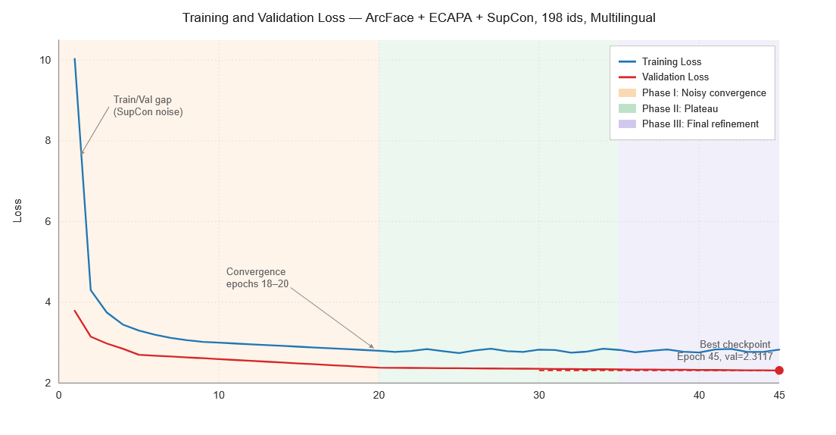
During training, validation loss was consistently lower than training loss in early epochs, particularly around epoch 1 where training loss was 10.03 and validation loss was 3.79. This is not overfitting but a known behavior of SupCon: random batches of 64 samples from 198 classes often contain very few positive pairs, making the contrastive signal noisy and inflating training loss. During validation, the model runs in eval() mode with stable BatchNorm statistics and no dropout, producing consistently lower loss values. Both losses converged toward each other by epochs 18–20, confirming healthy training dynamics. The full training and validation loss curves across all 45 epochs are illustrated in Figure 8, showing three distinct phases: an initial noisy convergence phase driven by sparse SupCon positive pairs (epochs 1–20), a plateau regime where ReduceLROnPlateau fires and halves the learning rate (epochs 20–35), and a final refinement phase ending at the best checkpoint at epoch 45 with validation loss 2.31.
Figure 8. Training and validation loss curves for the ArcFace + ECAPA-TDNN + SupCon configuration

The fast initial drop in both curves might suggest that the model converges too quickly for 45 epochs of training to be necessary, or that this reflects overfitting rather than genuine learning. To verify this was not the case, checkpoints saved at epochs 20, 40, and 45 were each evaluated on the Urdu cross-lingual protocol, on the same 63 identities. Table 3 summarizes the result: EER improves from epoch 20 to epoch 40 (8.86% to 7.99%), consistent with continued learning, before rising slightly to 8.60% at epoch 45; Rank-1 retrieval follows the same pattern, since both metrics are derived from the same underlying similarity matrix and are expected to move together rather than independently.
This small, non-monotonic reversal between epochs 40 and 45 does not indicate degradation. Urdu is held out entirely from training and never directly optimized against; any improvement observed on this set is a side effect of the model learning more language-invariant identity features overall, rather than the direct target of the loss function, and side effects of this kind do not necessarily improve smoothly and monotonically the way the training loss itself does. In addition, with only 63 evaluated identities, a small number of borderline pairs shifting their relative ranking is sufficient to move EER by roughly one percentage point, the same sample-size sensitivity noted for the Romanian evaluation. Taken together, these results confirm that the plateau visible after epoch 20 in Figure 8 reflects genuine convergence rather than overfitting: had the model been overfitting to the training distribution, generalization to the unseen Urdu recordings would be expected to degrade consistently in later epochs, which is not observed. Training could plausibly have been stopped closer to epoch 20 without a substantial loss in final performance; the epoch-45 checkpoint was nonetheless retained as the reported result throughout this thesis for consistency.

Table 3. Cross-lingual generalization at different training checkpoints
Checkpoint | EER | Avg. true-match similarity | Rank-1 retrieval
Epoch 20 | 8.86% | 0.5071 | 76.19%
Epoch 40 | 7.99% | 0.5158 | 82.54%
Epoch 45(final) | 8.60% | 0.4984 | 79.37%

Evaluation protocols

Closed-Set validation
During training, a 20% validation split is used to monitor generalization and drive the learning rate scheduler and early stopping. The split is produced by torch.utils.data.random_split with a fixed seed of 42, ensuring the exact same 19,766 samples are held out across all training runs and all comparison configurations. Validation loss is computed identically to training loss, the same compound objective of cross-entropy, InfoNCE, and SupCon, but with all components in eval() mode, BatchNorm statistics frozen, and no dropout applied. Closed-set validation accuracy on the 198 training identities reached 99.05% at the best checkpoint, confirming that the fused embeddings carry sufficient identity-discriminative information for classification. This metric is reported for completeness but is not the primary evaluation target of the thesis, since it measures performance on identities the model was trained on.

Urdu cross-lingual evaluation
The primary benchmark evaluation tests cross-lingual generalization on known identities. MAVCeleb v1 contains 64 training identities whose Urdu recordings were held out entirely from the extraction and training pipeline. For each identity, one Urdu face frame and one Urdu voice clip are selected, both from recording sessions separate from the English training data.
At evaluation time, each embedding is passed through the respective trained translator. A 64×64 cosine similarity matrix is computed via torch.matmul(f_512, v_512.T), where diagonal entries are genuine pairs and off-diagonal entries are impostor pairs. EER is computed by sweeping all unique similarity scores as candidate thresholds, as implemented in compute_eer() in test_urdu.py, shown in Listing 10.

def compute_eer(genuine_scores, impostor_scores):
all_scores = genuine_scores + impostor_scores
all_labels = [1] * len(genuine_scores) + [0] * len(impostor_scores)
thresholds = sorted(set(all_scores))
best_eer = 1.0
for t in thresholds:
pred = [1 if s >= t else 0 for s in all_scores]
fp = sum(1 for p, l in zip(pred, all_labels) if p == 1 and l == 0)
fn = sum(1 for p, l in zip(pred, all_labels) if p == 0 and l == 1)
fpr = fp / max(1, len(impostor_scores))
fnr = fn / max(1, len(genuine_scores))
eer = (fpr + fnr) / 2
if eer < best_eer:
best_eer = eer
return best_eer
Listing 10 EER Computation

Zero-Shot evaluation on MavCeleb and Romanian
For the Romanian evaluation, the RO-FaceVoice corpus of 50 identities is used; due to label compression during loading, 41 identities were retained for the evaluation matrix. Multiple face embeddings per identity (approximately 3) are averaged and L2-normalized into a single centroid vector per identity. A 41×41 cosine similarity matrix is then computed on these centroids and Rank-1 retrieval accuracy is reported via torch.argmax over each row, as implemented in test_in_the_wild.py. Table 4 summarizes the three evaluation protocols and their key properties

Table 4. Evaluation protocols used in this thesis.
Protocol | Identities | Language | Sessions | Script
Closed-set validation | 198 (seen) | EN | Seen | train.py
Urdu cross-lingual | 64 (seen) | UR | Unseen | test_urdu.py
Romanian zero-shot | 41 (unseen) | RO | Unseen | test_in_the_wild.py

Embedding space visualization
To qualitatively inspect the geometry of the shared latent space, the fused face and voice embeddings from the held-out Urdu evaluation set are projected into two dimensions using t-SNE and UMAP, implemented in tsne_urdu.py and umap_urdu.py respectively.
Both scripts follow the same pipeline: load the trained face_translator and voice_translator weights from model_arcface.pth, project each of the 64 Urdu test embeddings through the corresponding translator, L2-normalize the outputs, and reduce them to a 2D layout for plotting.
The face translator is instantiated with input_dim=512, matching the 512-dimensional output of the ArcFace encoder; the voice translator with input_dim=192, matching ECAPA-TDNN. Both project into the shared 512-dimensional space before normalization, consistent with the architecture we described until now.
Before dimensionality reduction, the face and voice vectors are concatenated into a single tensor, mean-centered, and re-normalized to unit length. Centering removes a systematic offset between the two modalities that would otherwise dominate the projection and visually separate all faces from all voices regardless of identity, independent of the model's actual cross-modal alignment.
For t-SNE, a cosine metric is used with perplexity 25 and early exaggeration 24.0, consistent with the parameters used for the closed-set visualizations earlier in development; PCA initialization and the 'auto' learning rate setting are used to stabilize convergence over 2500 iterations. For UMAP, n_neighbors=15 and min_dist=0.8 are used with a cosine metric, the same configuration applied throughout this thesis's visualization scripts. Running both algorithms on the same data allows the resulting structure to be cross validated: agreement between two methods with different underlying optimization objectives provides stronger evidence for the layout reflecting genuine embedding geometry rather than an artifact specific to one algorithm.

Experimental results
This chapter evaluates the design decisions made in Chapters 3 and 4. Instead of presenting the final system's performance on its own, the results are built up in three stages. First, a systematic comparison of individual architectural components (face encoder, voice encoder, loss function, and identity-pool scale) isolates how much each decision contributes to overall performance, and which choices matter most. Second, the resulting configuration is evaluated on the core objective of the thesis: generalizing to a language unseen during training, using identities the system was trained on but never heard speaking that particular language. Third, the same configuration is evaluated under a stricter, fully open-set protocol, using the RO-FaceVoice corpus introduced in this thesis, where both the identities and the language are completely absent from training.
Across all three stages, the goal is not simply to report accuracy figures, but to explain the behavior behind them: why certain components produce larger gains than others, why performance under a known-identity protocol differs so much from performance under a fully unseen one, and where the system's limitations come from. Section 6.5 closes the chapter with an explicit discussion of these limitations, since several of the reported figures depend on evaluation conditions that are not directly comparable to prior published baselines.

Comparison of architectural components
The contribution of each architectural and training-objective decision was isolated through a systematic five-configuration comparison study, in which a single component was modified between successive rows while all other factors were held constant. Each configuration was evaluated on two held-out sets under the protocols described in the Implementation chapter: the 64-identity Urdu cross-lingual set (cosine similarity and Equal Error Rate) and the 41-identity Romanian zero-shot set (cosine similarity and Rank-1 retrieval accuracy). Table 5 summarizes the results across all five configurations.

Table 5. Component comparison configurations and results.
Configuration | Identities | Urdu Cosine Sim. | Urdu EER | RO Cosine  Sim. | RO Rank-1
ResNet18 + OPL, EN | 64 | — | — | 0.1377 | 0%
VGG16 + ECAPA + OPL, EN | 64 | 0.0382 | ~50% | 0.2532 | 0%
VGG16 + ECAPA + SupCon, EN | 64 | 0.0204 | 47.06% | 0.2252 | 0%
VGG16 + ECAPA + SupCon, ML | 198 | 0.0972 | 43.60% | 0.2265 | 2.44%
ArcFace + ECAPA + SupCon, ML | 198 | 0.4941 | 9.10% | 0.3323 | 4.88%
EN = English only. ML = multilingual (v1+v2+v3). MAVCeleb FOP baseline Urdu EER: 37.90%. FAME 2024 winner Urdu EER: 19.91%. Sim. = mean cosine similarity between genuine face-voice pairs

A Rank-1 accuracy of 0% for the first three configurations indicates that none of the 41 Romanian queries retrieved the correct identity as their top match, not that the Romanian evaluation was omitted for these configurations; a similarity score was computed and reported for every configuration in Table 5, and these scores are non-zero even where Rank-1 retrieval failed entirely.
This is consistent with the state of the embedding space at these stages. ResNet18 and VGG16 are not trained with an angular-margin objective, so cosine similarity between their embeddings is not a calibrated measure of identity proximity(describer in the Theoretical Fundamentals chapter); retrieval on an unseen language like Romanian is therefore close to random. Against a random-chance baseline of 2.44% (1 in 41), a result of exactly 0% is unremarkable at this gallery size. These same configurations are also trained only on the 64 English-language identities of MAVCeleb v1, with no cross-language pairing yet introduced. Once the multilingual pool and ArcFace are introduced in the last two configurations, Rank-1 accuracy rises above chance.
As reference points, the MAVCeleb FOP baseline reports an Urdu EER of 37.90% [6], and the FAME 2024 challenge winner reports 19.91% [8]. The final configuration in Table 5 achieves an EER of 9.10%, though this figure is not directly comparable to either baseline: both evaluate under an unseen-identity, unseen-language setting, whereas the present result is obtained under the known-identity, unseen-language, unseen-recordings protocol described in the Implementation chapter. This distinction discussed further in the Limitations section below, and the Urdu result itself is examined in detail earlier in this chapter.

Comparison of ResNet18 and ECAPA-TDNN
The scope of this experiment is to determine whether a domain-specific speaker-verification encoder outperforms a vision backbone repurposed for audio.

Table 6. Effect of replacing ResNet18 with ECAPA-TDNN as voice encoder
Configuration | Voice Encoder | RO Cosine Sim.
Before | ResNet18 | 0.1377
After | ECAPA-TDNN | 0.2532

The first transition replaces an ImageNet-pretrained ResNet18, repurposed as a voice encoder by operating on mel-spectrogram images, with ECAPA-TDNN, a model trained directly on speaker-verification data. As shown in Table 6, this change produced a 65% improvement in Romanian cosine similarity, from 0.1377 to 0.2532. The magnitude of this gain reflects a domain mismatch inherent to the ResNet18 configuration: a network trained to classify 1,000 visual object categories has no inductive bias toward the acoustic and prosodic features that distinguish speakers, and treating a spectrogram as a natural image discards the temporal structure that voice-specific architectures are designed to exploit.
ECAPA-TDNN, by contrast, was trained on over one million speaker-verification utterances and extracts channel-attentive, multi-scale temporal features directly relevant to speaker identity [20]. This first transition establishes that domain-specific pretraining is a prerequisite for a usable voice embedding, independent of any subsequent choice of face encoder or loss function. No Urdu measurement is available for the ResNet18 configuration, as this baseline was evaluated only on the Romanian set at this stage of the comparison.

Comparison of Orthogonal Projection Loss and Supervised Contrastive Loss
The scope of this experiment is to evaluate whether Supervised Contrastive Loss outperforms Orthogonal Projection Loss at a fixed, small identity count. This second transition replaces Orthogonal Projection Loss (OPL) with Supervised Contrastive Loss (SupCon) [16] while holding the encoder pair (VGG16, ECAPA-TDNN) and the identity pool (64, English-only) fixed. Rather than the improvement generally expected of SupCon over OPL, this transition produced a decline in cosine similarity, from 0.0382 to 0.0204, while EER remained essentially at chance level (from approximately 50% to 47.06%), a negligible shift with no practical significance.

Table 7. Comparison of OPL and SupCon
Configuration | Loss Function | Urdu Cosine Sim. | Urdu EER | RO Cosine  Sim. | RO Rank-1
Before | OPL | 0.0382 | ~50.00% | 0.2532 | 0%
After | SupCon | 0.0204 | 47.06% | 0.2252 | 0%

A Rank-1 accuracy of 0% for both configurations in Table 7 means that none of the 41 Romanian queries retrieved the correct identity as their top match, not that the Romanian evaluation was skipped; a similarity score was computed for both, and both are non-zero despite retrieval failing entirely. This is expected at this stage: VGG16's softmax objective does not constrain the embedding space beyond class separability, so cosine similarity does not track identity proximity for unseen identities, and both configurations are trained only on English-only identities, with no cross-language pairing yet to signal that a face and voice in a different language can share an identity. With no meaningful ranking signal, retrieval on the 41-candidate gallery is effectively random, and zero correct matches is a normal outcome of that near-random process. This outcome is attributable to the structural property of the contrastive objective rather than a weakness of SupCon itself. With 64 identities sampled into batches, many batches contain at most one example of a given identity, leaving the positive pair set for that identity nearly empty within the batch. Under these conditions, the pull-together term of the SupCon loss is rarely activated, and training is dominated by the push-apart term alone, which does not by itself enforce identity-consistent clustering.
OPL, which enforces a fixed orthogonality target between all identity pairs regardless of batch composition, is insensitive to this sparsity and therefore performs more reliably when the identity pool is small. This result motivates the subsequent transition to a larger, multilingual identity pool, under which SupCon is expected to recover its theoretical advantage

Effect of identity pool scale and multilingualism
The scope of this experiment is to estimate the effect of identity-pool size and linguistic diversity on SupCon's performance.
The third transition holds the loss function fixed at SupCon and increases the identity pool from 64 English-only identities to 198 identities drawn from the multilingual MAVCeleb v1, v2, and v3 sets.

Table 8. Effect of expanding the identity pool
Configuration | Identities | Urdu Cosine Sim. | Urdu EER | RO Cosine  Sim. | RO Rank-1
Before | 64 (EN Only) | 0.0204 | 47.06% | 0.2252 | 0%
After | 198(multilingual) | 0.0972 | 43.60% | 0.2265 | 2.44%

As shown in Table 8, this produced an increase in Urdu cosine similarity, from 0.0204 to 0.0972, a 376% increase, while Romanian similarity remained comparatively flat (0.2252 to 0.2265).
The 0% Rank-1 accuracy in the 'Before' row reflects the same near-random retrieval behavior discussed in Section 6.1.2; the 2.44% achieved in the 'After' row is the first result in the comparison sequence to exceed random chance.
This pattern is consistent with the 198 identities sampled across three languages, batches are substantially more likely to contain multiple same-identity, cross-language pairs, supplying SupCon's pull-together term with the same-identity signal it lacked at 64 identities. The disproportionate gain on the Urdu metric relative to the Romanian metric at this stage is expected, since English, Hindi, German, and Urdu are represented within the training distribution through MAVCeleb, whereas Romanian remains entirely unseen at this point in the comparison sequence; the modest Romanian improvement is best interpreted as a general effect of increased identity diversity rather than a language-specific one.

Comparison of VGG16 and ArcFace as face encoders
The purpose of this final experiment is to determine the effect of replacing a generic classification-trained face encoder with an angular-margin trained one.
The final transition replaces VGG16 with ArcFace (iResNet50) as the face encoder, while holding the voice encoder, loss function, and multilingual identity pool constant. As shown in Table 9, this produced the largest single gain observed in the comparison: Urdu cosine similarity increased from 0.0972 to 0.4941, a 408% improvement, Urdu EER dropped from 43.60% to 9.10%, and Urdu Rank-1 retrieval rose from 0% to 79.69%, discussed in the Cross-lingual evaluation section earlier in this chapter. Romanian Rank-1 accuracy improved from 2.44% to 4.88%, and Romanian similarity rose from 0.2265 to 0.3323.

Table 9. Effect of replacing VGG16 with ArcFace as face encoder
Configuration | Face Encoder | Urdu Cosine Sim. | Urdu EER | RO Cosine  Sim. | RO Rank-1 | Urdu  Rank-1
Before | VGG16 | 0.0972 | 43.60% | 0.2265 | 2.44% | 0.00%
After | ArcFace | 0.4941 | 9.10% | 0.3323 | 4.88% | 79.69%

This transition isolates the face encoder as the dominant bottleneck in the earlier configurations. VGG16, trained under a standard softmax classification objective, enforces linear separability between classes but does not constrain the geometry of the embedding space beyond that, so cosine similarity between two VGG16 embeddings is not a reliable measure of identity proximity. ArcFace's additive angular margin loss enforces a minimum angular separation between different identities on the embedding hypersphere [18], so cosine similarity between two ArcFace embeddings corresponds directly to identity proximity by construction. Because the cross-modal fusion stage of the system relies on cosine similarity as its primary comparison operation, this property transfers directly into the quality of the final face-voice alignment, accounting for the magnitude of the gain observed here relative to the more modest gains produced by the voice-encoder and scale transitions.

Synthesis
Across the four transitions, the component comparison indicates a clear ordering of component importance for this task. The face encoder produced the single largest improvement (+408% Urdu similarity), followed by the voice encoder domain-match transition (+65% Romanian similarity) and the multilingual scale-up (+376% Urdu similarity from the SupCon low point, though this recovery is best read as correcting a deficit introduced in the loss-function comparison discussed above, rather than as an independent gain).
The loss-function transition in isolation, at low identity count, was actively detrimental, demonstrating that SupCon's benefit is conditional on sufficient identity diversity within each training batch rather than an unconditional property of the objective. Taking them together, these results support the design decision, to prioritize encoders with an explicit angular or margin-based geometric structure over encoders trained purely under classification objectives, since the reliability of cosine similarity as a comparison metric depends directly on this structural property.

Cross-lingual evaluation

Evaluation protocol
The Urdu evaluation set consists of 64 identities drawn from MAVCeleb v1, all of which are present in the training distribution through their English-language recordings. For this evaluation, each identity is represented by a face image and a voice recording that differ from training in three respects simultaneously: the recording session is different, the specific photograph is different, and the spoken language is Urdu rather than any language seen during training. This is referred to throughout the chapter as the known-identity, unseen-language, unseen-recordings protocol. Varying all three factors together is deliberate: it rules out the possibility that the system succeeds by memorizing session-specific or pixel-level artifacts from training and isolates cross-lingual voice generalization as the property under test, since the identity itself, but not the language or recording instance, was seen during training.
This protocol should be distinguished from the unseen-unheard protocol used by the MAVCeleb FOP baseline [6] and the FAME challenge baselines [7], in which both the identity and the language are absent from training. The two protocols are not directly interchangeable, and this distinction is discussed further as a limitation in this chapter.
The Urdu evaluation is implemented in test_urdu.py, which constructs a 64×64 pairwise cosine similarity matrix between face and voice embeddings, treating the 64 diagonal entries as genuine pairs and the 4,032 off-diagonal entries as impostor pairs.

Verification performance
Verification performance is summarized by the Equal Error Rate (EER) and the Area Under the ROC Curve (AUC), two complementary metrics that describe different aspects of the same score distribution.
The system achieves an EER of 9.10%, corresponding to a verification accuracy of 90.90% at the balanced-threshold operating point, and an AUC of 0.9538, meaning that a randomly selected genuine pair is ranked above a randomly selected impostor pair 95.38% of the time. Figure 9 shows the ROC curve from which the AUC is computed. In practical terms, this means that if the system were deployed at this operating threshold, roughly 1 in 11 verification attempts on unseen-language recordings would be misclassified.
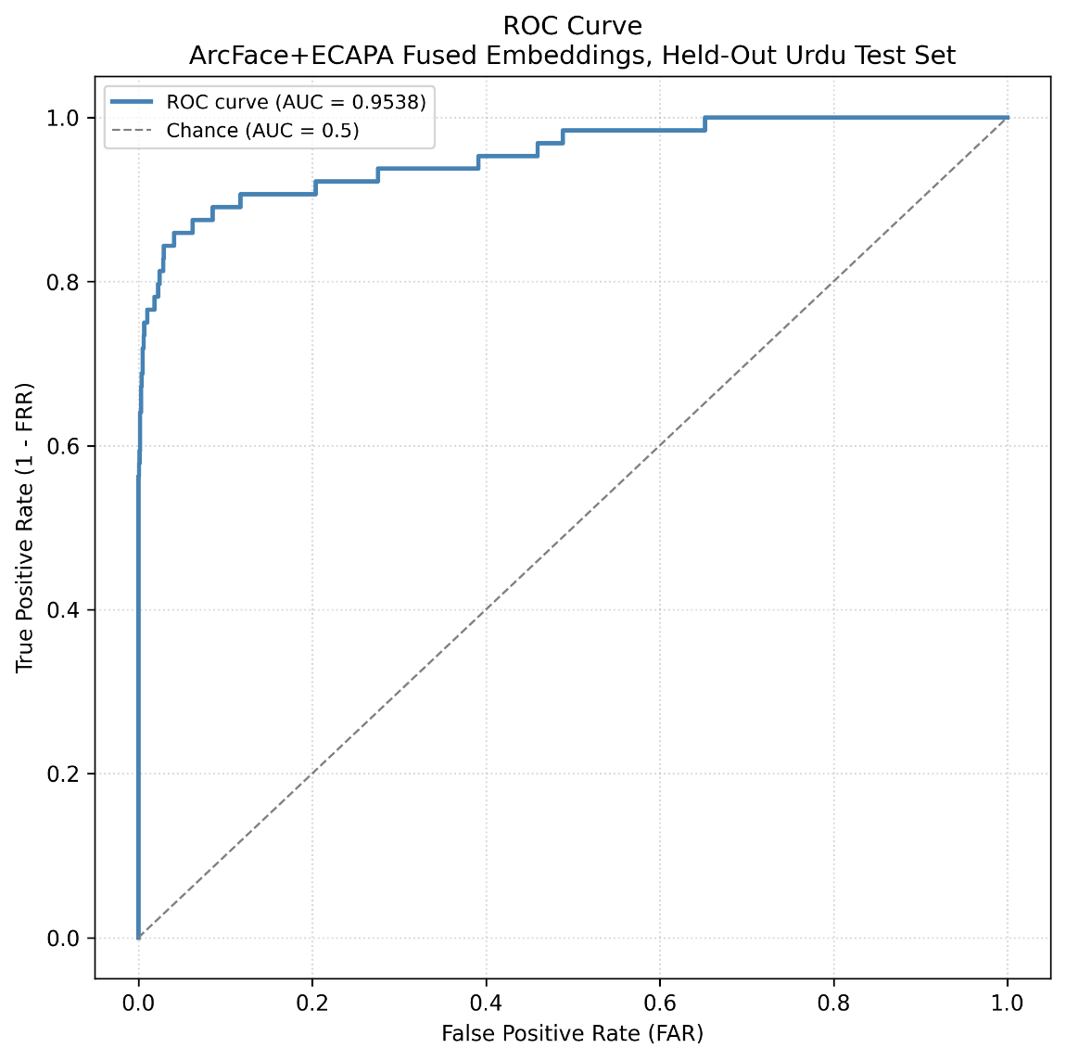
Figure 9. ROC curve for the Urdu cross-lingual verification task

EER and AUC are not in tension despite the apparent gap between 9.10% and 95.38%: EER reports the single error rate obtained at one specific threshold, the point at which the false acceptance rate equals the false rejection rate, whereas AUC summarizes ranking quality averaged across every possible threshold. Both metrics are reported together in the FOP baseline [6] against which the present result is compared and are included here for the same reason.

Figure 10 presents the corresponding Detection Error Tradeoff (DET) curve, plotting the false acceptance rate against the false rejection rate on a normal-deviate scale, following the convention used in the speaker-verification literature [20].
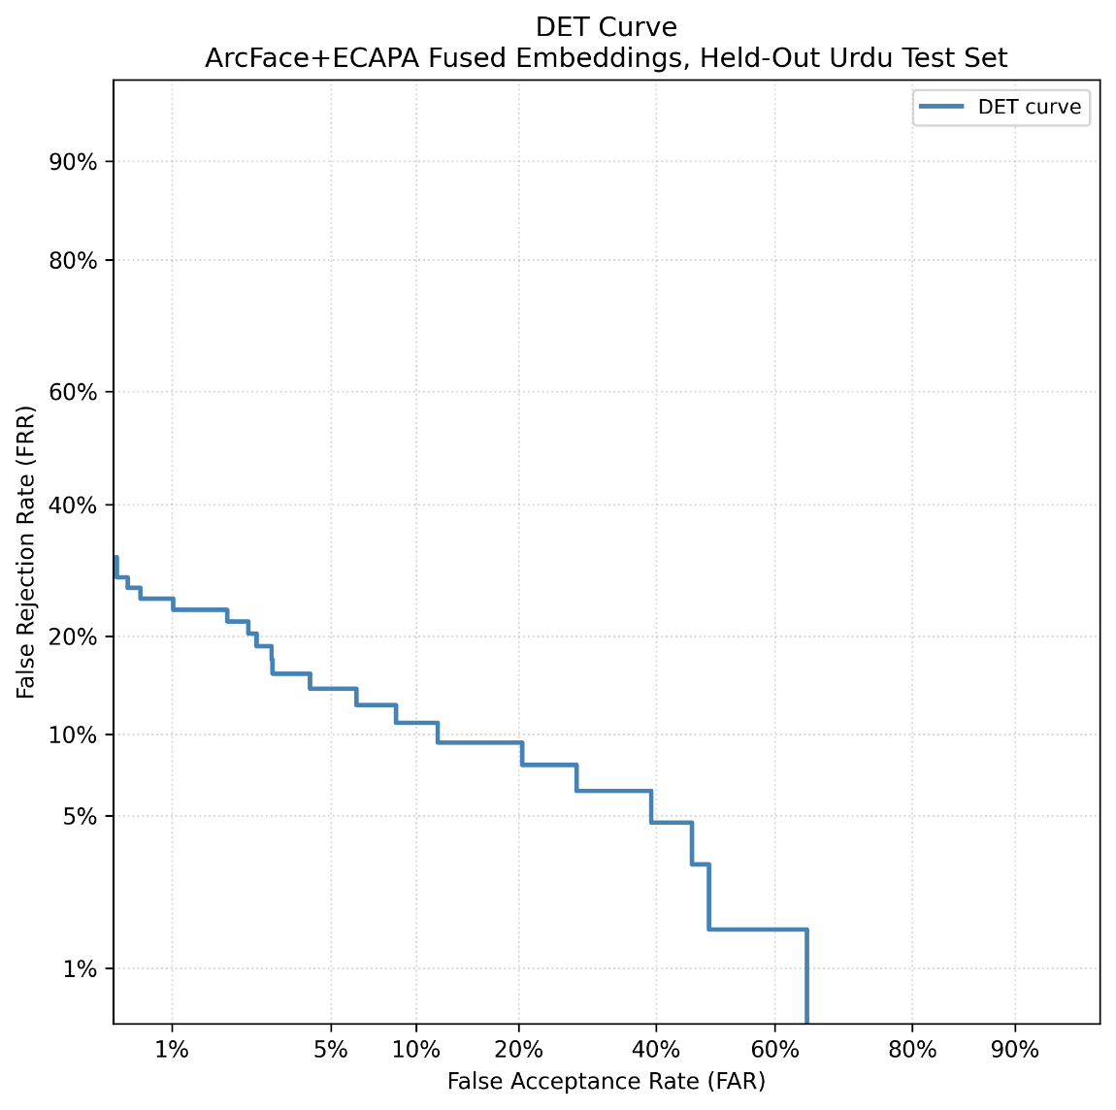
Figure 10. Detection Error Tradeoff curve

The staircase shape visible in the curve is an expected consequence of the small sample size, 64 genuine pairs, and is not an artifact of the plotting procedure. [62][63]
An EER value independently estimated directly from this DET curve, using a different threshold-search method than the one used to compute the primary 9.10% figure, differs from it by approximately 1.8 percentage points.
This discrepancy was confirmed to result from a difference in threshold interpolation between the two computation methods rather than a data inconsistency and is expected at this sample size; the 9.10% figure obtained through the primary evaluation script is reported consistently throughout this thesis, and no competing EER value is marked on the DET curve.

Score distribution analysis
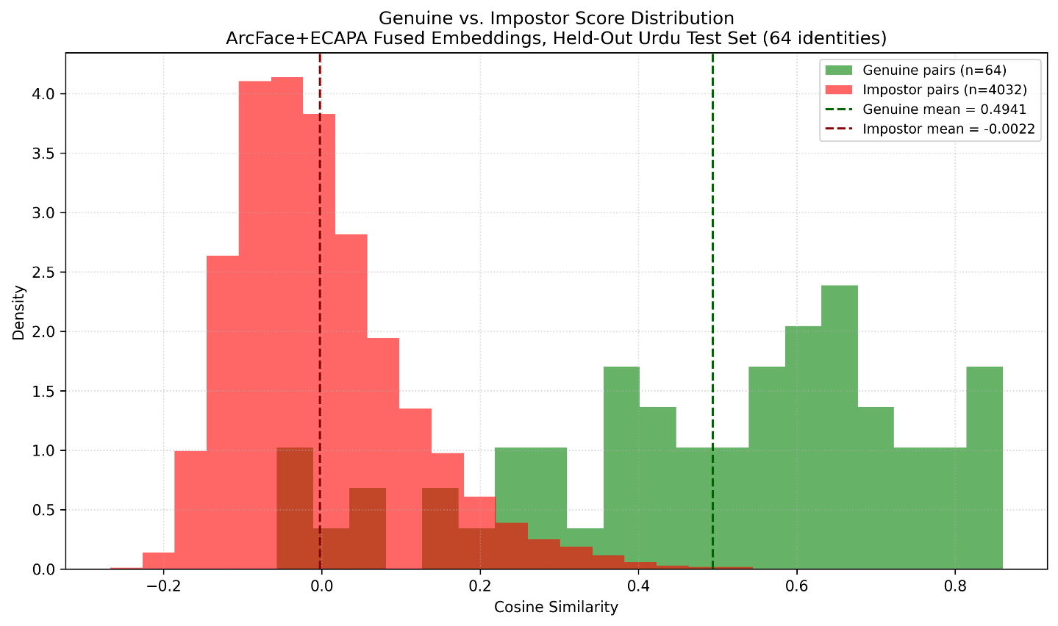
Figure 11 shows the distribution of cosine similarity scores separately for the 64 genuine pairs
Figure 11. Distribution of cosine similarity scores for genuine and impostor pairs

The genuine pairs have a mean cosine similarity of 0.4941, while the impostor pairs have a mean of approximately 0.0022, effectively zero. This matches what the capacity argument made previously in this chapter predicts: two independently drawn unit vectors on a high-dimensional hypersphere have an expected dot product that approaches zero as dimensionality increases [31]. The resulting separation between the two distributions, 0.4963, quantifies the discriminative margin achieved by the system on the Urdu test set. Figure 11 also shows a region of visible overlap between the two distributions, roughly between 0.0 and 0.3, corresponding to the pairs responsible for the residual 9.10% error rate.

Retrieval performance
In addition to verification, the system is evaluated on a retrieval task in which each face embedding is used to query all 64 candidate voice embeddings and rank them by cosine similarity. Rank-1 retrieval accuracy, the proportion of queries for which the correct voice is ranked first among all 64 candidates, reaches 79.69%. This result is obtained from the same 64×64 similarity matrix used for the verification analysis presented earlier in this chapter and represents a considerably more demanding task than pairwise verification, since it requires the correct match to outrank 63 competing impostor candidates simultaneously rather than clearing a single decision threshold.
In practical terms, this means that for roughly 4 out of every 5 face queries, the system correctly identifies the matching voice as the single best candidate among 64 possibilities, rather than merely ranking it among the top few.

Embedding space visualization
To provide qualitative insight into the structure of the cross-modal embedding space, Figure 12 shows a two-dimensional t-SNE projection of the 128 translated embeddings from the Urdu test set (64 face and 64 voice embeddings), with 10 identities highlighted for clarity.
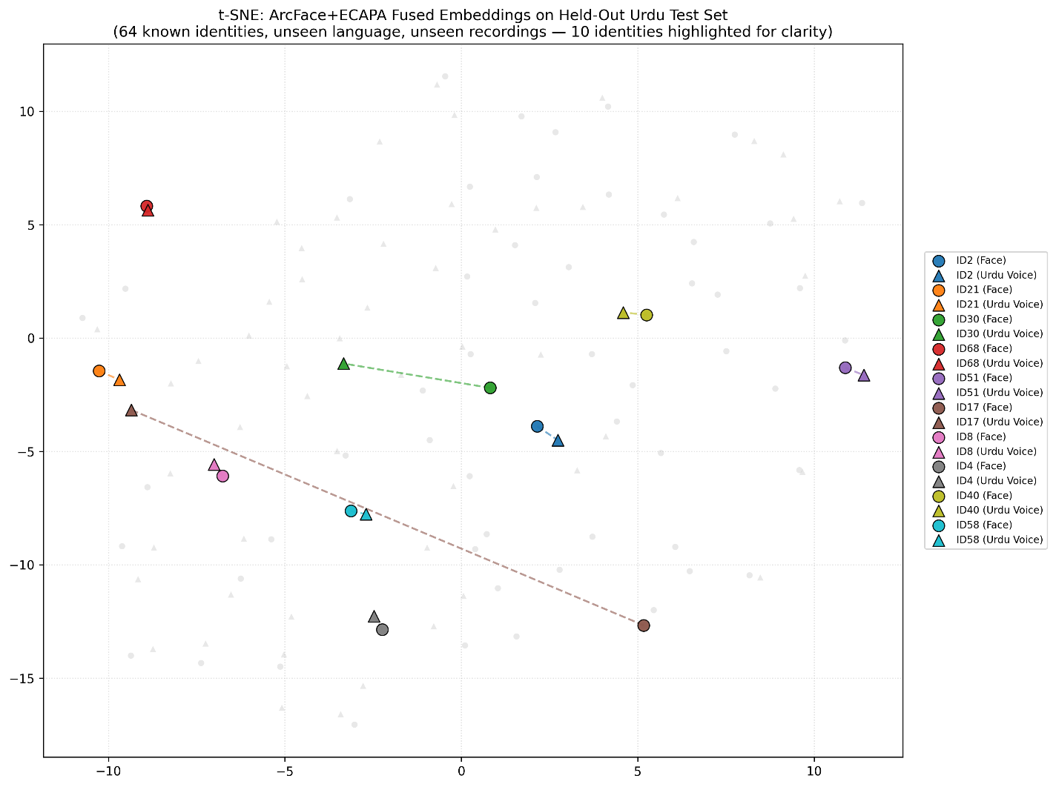
Figure 12. t-SNE projection

All 64 identities are plotted in the background, and a fixed, reproducible subset of 10 identities is highlighted with dashed lines connecting each identity's face point to its corresponding voice point. The alignment quality visible in this highlighted subset is heterogeneous rather than uniform: some identities show short connector lines, indicating tight face-voice alignment in the embedding space, while others show longer connector lines, indicating looser alignment. This variability is reported as an observed characteristic of the learned embedding space rather than a result smoothed for presentation, and is consistent with the residual error captured quantitatively by the 9.10% EER.
The same 10 identities and the same random seed used in Figure 12 are highlighted in Figure 13 as well, allowing direct comparison between the two dimensionality-reduction techniques on identical underlying pairs. The pattern of heterogeneous alignment observed in the t-SNE projection is preserved under UMAP: identities with short connector lines in Figure 12 generally retain short connector lines here, and likewise for identities with looser alignment, indicating that this variability reflects a genuine property of the embedding space rather than an artifact of either projection method.

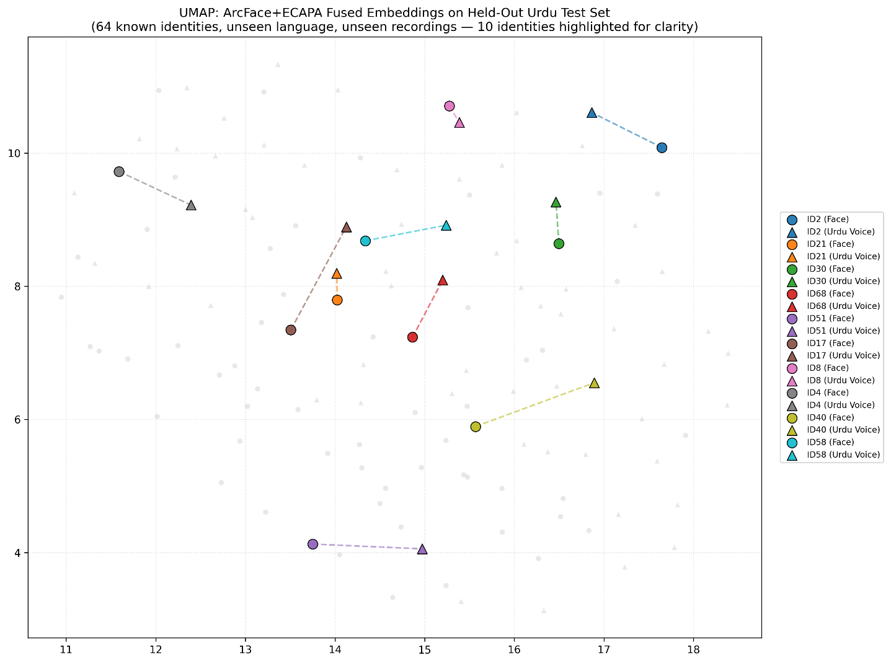
Figure 13 shows the same 128 translated face-voice embeddings from the held-out Urdu test set, with the same 10 identities highlighted as in Figure 12.
Figure 13. UMAP projection

Romanian zero-shot evaluation

Evaluation protocol
The Romanian evaluation set, introduced in the Implementation chapter as the RO-FaceVoice corpus, consists of 50 collected identities that are entirely absent from the training distribution, both as individuals and as speakers of a language present in MAVCeleb v1, v2, or v3, due to label compression during loading, 41 identities were retained for the evaluation matrix. Unlike the Urdu evaluation, in which the identities themselves were seen during training, the Romanian evaluation constitutes a genuine unseen-identity, unseen-language protocol, matching the open-set generalization setting typically targeted by zero-shot cross-modal biometric systems. This evaluation is implemented in test_in_the_wild.py.
Each Romanian identity is represented by three face images and one voice clip. Because multiple face images are available per identity but the retrieval protocol compares a single query against a gallery of candidates, the three face embeddings for each identity are averaged into a single centroid embedding prior to computing cosine similarity and Rank-1 retrieval accuracy.
This centroid-averaging step should be understood as an upper-bound estimate of performance rather than a measure of single-sample retrieval accuracy, since averaging across three images suppresses per-image noise that a single-shot query would be fully exposed to; this caveat is treated as a limitation and is revisited in this chapter’s Limitations section.

Results
The system achieves a Romanian Rank-1 retrieval accuracy of 4.88%, exceeding the random-chance baseline of 2.44% for a 41-identity gallery, and a mean cosine similarity of 0.3323 between genuine face-voice centroid pairs. Both figures represent the strongest Romanian result obtained across the comparison sequence in Table 5, reached only once the ArcFace face encoder is introduced in the final configuration.
These results should be interpreted with caution given the small evaluation set. With only 41 identities, a single additional correct retrieval shifts the reported Rank-1 accuracy by 2.4 percentage points, so the 4.88% figure indicates that cross-modal alignment transfers beyond the training languages, without serving as a precise estimate of open-set generalization performance.

Comparison with Urdu result
The gap between the Urdu Rank-1 accuracy of 79.69% and the Romanian Rank-1 accuracy of 4.88% is substantial, but the two figures are not directly comparable, since they are obtained under different protocols, as established earlier in this chapter: the Urdu evaluation tests generalization to a new language for known identities, while the Romanian evaluation tests generalization to both new identities and a new language simultaneously

Table 10. Urdu and Romanian evaluation results compared
Metric | Urdu | Romanian | Random chance
Rank-1 retrieval | 79.69% | 4.88% | 1.56%(Urdu)/2.44%(RO)
Mean cosine sim. | 0.49 | 0.33 | —

The relevant comparison for the Romanian result is therefore its own random-chance baseline of 2.44%, against which a 4.88% Rank-1 accuracy represents a modest but meaningful improvement, rather than the Urdu figure. A more detailed discussion of why Romanian, despite being linguistically closer to English than Urdu, does not yield proportionally stronger results is presented in the following sections.

The linguistic proximity paradox
Standard biometric theory would predict stronger transfer to Romanian than to Urdu: Romanian is a Romance language sharing lexical and phonetic structure with English, while Urdu is Indo-Aryan and phonetically more distant [64]. The frozen ECAPA-TDNN voice encoder, pretrained exclusively on English-dominant VoxCeleb data, would therefore be expected to generalize more readily to Romanian speech.
The results, once the identity-overlap confound talked about earlier is set aside, do not support this expectation. Urdu cosine similarity reaches 0.4941 on known identities, while Romanian reaches only 0.3323 on entirely unknown identities, a harder task along the identity dimension. Romanian's linguistic proximity to English does not translate into a correspondingly larger advantage.

Proposed explanation
Because ECAPA-TDNN's parameters are frozen during cross-modal training, it cannot adapt to phonetic structures absent from its VoxCeleb pretraining distribution [21][22], regardless of the language's family-level closeness to English.
Reuter and Jessen [17] report that speaker verification scores for frozen embeddings correlate with language similarity as measured by a language classification system, particularly for languages absent from the training data. Romanian's central vowels /ə/ and /ɨ/, absent from English and from all MAVCeleb training languages, may pose a transfer challenge comparable to Urdu's despite Romanian's closer family relationship to English [65].

Implications
Since this constraint lies in the frozen voice encoder itself, further identity scaling or multilingual translator training is unlikely to close the Romanian gap on its own; meaningful improvement would require fine-tuning or replacing the voice encoder with one exposed to a phonetically broader pretraining set. This is treated as a limitation in the section that follows.

Limitations

Protocol differences from baseline comparisons
The Urdu EER of 9.10% is obtained under a known-identity, unseen-language, unseen-recordings protocol, in which the 64 evaluated identities were present in the training distribution. This differs from the unseen-unheard protocol used by the MAVCeleb FOP baseline [6] and the FAME challenge baseline [7], in which both identity and language are absent from training. The comparison against these baselines is therefore directional rather than strict: it indicates that the system performs favorably relative to published reference points, but the two protocols measure related, not identical, capabilities, and the 9.10% figure should not be read as a direct, like-for-like replacement for an unseen-unheard EER.

Romanian evaluation scale and centroid averaging
The Romanian Rank-1 accuracy of 4.88% is computed on 41 identities, a sample size at which a single additional correct retrieval shifts the reported accuracy by 2 percentage points, as noted earlier in this chapter. In addition, the reported similarity and Rank-1 figures rely on centroid averaging across three face images per identity, which suppresses per-image noise and represents an upper bound on single-sample retrieval performance rather than a direct measure of it. Both factors mean the Romanian result should be treated as a preliminary, directionally positive signal of cross-lingual transfer, not a precise estimate of open-set generalization accuracy.

Identity count relative to zero-shot generalization
The training set comprises 198 identities, substantially smaller than large-scale verification corpora such as VoxCeleb (7,000+ speakers [21]) or VGGFace2 (9,131 identities [19]), both of which underline the pretrained encoders used in this pipeline. This scale gap may constrain the model's capacity for zero-shot generalization to entirely unseen identities, which is consistent with the modest absolute Romanian Rank-1 accuracy despite the encoder improvements demonstrated in the comparison, and suggests that identity scaling, rather than further architectural changes alone, is likely necessary for stronger zero-shot performance.

Transformer fusion module not exercised at inference
Cross-modal retrieval and verification in this chapter use the translator output embeddings directly, since InfoNCE explicitly optimizes this space for cross-modal alignment. The Transformer fusion module and classifier are trained jointly with the pipeline and shape the translator weights via backpropagation but are not invoked during evaluation. A separate internal check found fusion-based verification performs at chance level, consistent with the classifier having seen only genuine pairs during training. This is not reported as a thesis finding but is noted for transparency about this chapter's scope.
Diagnosing the exact cause of this collapse, whether from attention-head dominance by one modality, vanishing gradients through the residual connection, or insufficient positive-pair diversity during joint training was outside the scope of this thesis but represents a natural next step: investigating why the fusion module fails to generalize could clarify whether cross-attention offers any advantage over the simpler translator-based comparison used here.

Conclusions
This thesis sets out to build a system that can match a face to a voice even when the language being spoken was never seen during training. The results, organized below by the three core problems this work has addressed, show that this is achievable to varying degrees depending on how far the system is pushed from its training distribution.
The first problem was architectural: which combination of encoders, fusion mechanism, and loss function produces a shared embedding space where cosine similarity means something.
The component comparison in Chapter 7 answers this clearly. The face encoder mattered most, with the switch from VGG16 to ArcFace producing the largest single improvement observed across all the comparisons, and the training set's identity and language diversity mattered almost as much, since Supervised Contrastive Loss only outperformed the Orthogonal Projection Loss baseline once enough identities were available per batch. The underlying reason ties both findings together: cosine similarity is only a meaningful comparison metric when the encoder's own training objective imposes an explicit angular or margin-based structure on its embedding space, and this structure is what the fusion module and loss function ultimately inherit and build on. This problem can be considered solved for the architecture tested here, though it would be worth confirming whether the same ranking of components holds for more recent speaker or face encoders not evaluated in this thesis.
The second problem was generalization to a language absent from training, for identities the system had already learned. Here the results are encouraging: the final configuration reached a 9.10% Equal Error Rate on the Urdu evaluation, a large improvement over the 37.90% FOP baseline, though under a known-identity protocol that is not directly comparable to fully unseen-unheard baselines. What limits further progress here is not the architecture but the frozen voice encoder itself: because ECAPA-TDNN's parameters never update during training, it cannot adapt to phonetic structures it was never pretrained on, regardless of how much multilingual identity data is added on top of it.
The third and least solved problem was generalization to both an unseen identity and an unseen language at once, tested on the Romanian evaluation. A Rank-1 accuracy of 4.88% is only a modest improvement over the 2.44% random-chance baseline, and the small size of the RO-FaceVoice corpus, 41 identities and 147 utterances, means this result should be read as a preliminary signal rather than a reliable estimate.
Beyond these three problems, this thesis makes two lasting contributions. The RO-FaceVoice corpus itself extends face-voice matching research to a language not previously covered in this literature. The component comparison in Chapter 7 offers concrete evidence for how much each architectural decision contributes to a cross-modal biometric system, work that generalizes beyond this specific face-voice task to any system that relies on cosine similarity between independently trained encoders.
Several directions follow directly from the limitations identified above. Extending RO-FaceVoice toward the scale of the other MAVCeleb splits would both narrow the statistical uncertainty in the reported Romanian accuracy and make it practical to fine-tune the voice encoder directly on Romanian speech, addressing the frozen-encoder ceiling rather than working around it. More broadly, fine-tuning or replacing ECAPA-TDNN with an encoder pretrained on a phonetically wider set of languages would test whether the Urdu result generalizes beyond the language pairs seen during training, rather than remaining specific to them. Confirming whether the same ranking of architectural components holds for more recent speaker or face encoders would also strengthen the generality of the component comparison's conclusions. Finally, understanding why the Transformer fusion module fails to improve on the translator-based comparison at inference, whether from modality dominance, insufficient positive-pair diversity, or the residual connection bypassing attention entirely, remains an open question worth investigating in its own right

References
[1] M. Kamachi, H. Hill, K. Lander, and E. Vatikiotis-Bateson, "Putting the Face to the Voice: Matching Identity Across Modality," Current Biology, vol. 13, no. 19, 2003.
[2] S. B. Davis and P. Mermelstein, "Comparison of Parametric Representations for Monosyllabic Word Recognition in Continuously Spoken Sentences," IEEE Trans. Acoust., Speech, Signal Process., vol. 28, no. 4, 1980.
[3] A. Misra and J. H. L. Hansen, "Spoken Language Mismatch in Speaker Verification: An Investigation with Kazakh-Russian Bilingual Speech," in Proc. IEEE Spoken Language Technology Workshop (SLT), 2014.
[4] K. Nam et al., "Cross-Lingual Speaker Verification: Evaluation on X-vector Method," in Proc. Interspeech, 2023.
[5] S. Nawaz, M. S. Saeed, et al., "Cross-modal Speaker Verification and Recognition: A Multilingual Perspective," in Proc. IEEE/CVF Conf. Computer Vision and Pattern Recognition Workshops (CVPRW), 2021.
[6] M. S. Saeed, M. H. Khan, S. Nawaz, M. H. Yousaf, and A. Del Bue, "Fusion and Orthogonal Projection for Improved Face-Voice Association," in Proc. IEEE Int. Conf. Acoustics, Speech and Signal Processing (ICASSP), 2022.
[7] M. S. Saeed, S. Nawaz, M. S. Tahir, R. K. Das, M. Z. Zaheer, M. Moscati, M. Schedl, M. H. Khan, K. Nandakumar, and M. H. Yousaf, "Face-voice Association in Multilingual Environments (FAME) Challenge 2024 Evaluation Plan," arXiv:2404.09342, 2024.
[8] R. Tao, K. A. Lee, R. K. Das, V. Hautamäki, and H. Li, "Multi-Stage Face-Voice Association Learning with Keynote Speaker Diarization," arXiv:2407.17902, 2024.
[9] "Face-voice Association in Multilingual Environments (FAME) 2026 Challenge Evaluation Plan," arXiv:2508.04592, 2025.
[10] A. Hannan, F. Malik, H. Jabbar, S. S. Sadiq, and M. Noman, "RFOP: Rethinking Fusion and Orthogonal Projection for Face-Voice Association," arXiv:2512.02860, 2025.
[11] Z. Fang, "XM-ALIGN: Unified Cross-Modal Embedding Alignment for Face-Voice Association," arXiv:2512.06757, 2025.
[12] C. Simic, K. Riedhammer, and T. Bocklet, "Shared Multi-modal Embedding Space for Face-Voice Association," arXiv:2512.04814, 2025.
[13] G. Geigle, J. Pfeiffer, N. Reimers, I. Vulić, and I. Gurevych, "Retrieve Fast, Rerank Smart: Cooperative and Joint Approaches for Improved Cross-Modal Retrieval," Trans. Assoc. Comput. Linguistics (TACL), vol. 10, 2022.
[14] Y.-C. Wu, C.-Y. Chen, et al., "Cross-Modal Perceptionist: Can Face Geometry be Gleaned from Voices?," in Proc. IEEE/CVF Conf. Computer Vision and Pattern Recognition (CVPR), 2022.
[15] A. van den Oord, Y. Li, and O. Vinyals, "Representation Learning with Contrastive Predictive Coding," arXiv:1807.03748, 2018.
[16] P. Khosla, P. Teterwak, C. Wang, A. Sarna, Y. Tian, P. Isola, A. Maschinot, C. Liu, and D. Krishnan, "Supervised Contrastive Learning," in Proc. Advances in Neural Information Processing Systems (NeurIPS), vol. 33, 2020.
[17] P. M. Reuter and M. Jessen, "On the Influence of Language Similarity in Non-Target Speaker Verification Trials," in Proc. Interspeech, 2025.
[18] J. Deng, J. Guo, N. Xue, and S. Zafeiriou, "ArcFace: Additive Angular Margin Loss for Deep Face Recognition," in Proc. IEEE/CVF Conf. Computer Vision and Pattern Recognition (CVPR), 2019.
[19] Q. Cao, L. Shen, W. Xie, O. M. Parkhi, and A. Zisserman, "VGGFace2: A Dataset for Recognising Faces Across Pose and Age," in Proc. IEEE Int. Conf. Automatic Face & Gesture Recognition (FG), 2018.
[20] B. Desplanques, J. Thienpondt, and K. Demuynck, "ECAPA-TDNN: Emphasized Channel Attention, Propagation and Aggregation in TDNN Based Speaker Verification," in Proc. Interspeech, 2020.
[21] A. Nagrani, J. S. Chung, and A. Zisserman, "VoxCeleb: A Large-Scale Speaker Identification Dataset," in Proc. Interspeech, 2017.
[22] J. S. Chung, A. Nagrani, and A. Zisserman, "VoxCeleb2: Deep Speaker Recognition," in Proc. Interspeech, 2018.
[23] J. Arevalo, T. Solorio, M. Montes-y-Gómez, and F. A. González, "Gated Multimodal Units for Information Fusion," in Proc. ICLR Workshop, 2017.
[24] H. Zhao et al., "Adaptive Camera-LiDAR Fusion for Robust Perception," arXiv:2403.01452, 2024.
[25] A. Vaswani, N. Shazeer, N. Parmar, J. Uszkoreit, L. Jones, A. N. Gomez, Ł. Kaiser, and I. Polosukhin, "Attention Is All You Need," in Proc. Advances in Neural Information Processing Systems (NeurIPS), vol. 30, 2017.
[26] Y.-H. H. Tsai, S. Bai, P. P. Liang, J. Z. Kolter, L.-P. Morency, and R. Salakhutdinov, "Multimodal Transformer for Unaligned Multimodal Language Sequences," in Proc. 57th Annu. Meeting Assoc. Comput. Linguistics (ACL), 2019.
[27] J. Lu, D. Batra, D. Parikh, and S. Lee, "ViLBERT: Pretraining Task-Agnostic Visiolinguistic Representations for Vision-and-Language Tasks," in Proc. Advances in Neural Information Processing Systems (NeurIPS), vol. 32, 2019.
[28] C. Busso, Z. Deng, S. Yildirim, M. Bulut, C. M. Lee, A. Kazemzadeh, S. Lee, U. Neumann, and S. Narayanan, "Analysis of Emotion Recognition Using Facial Expressions, Speech and Multimodal Information," in Proc. Int. Conf. Multimodal Interfaces (ICMI), 2004.
[29] K. R. Scherer, "Vocal Communication of Emotion: A Review of Research Paradigms," Speech Communication, vol. 40, no. 1–2, 2003.
[30] S. Albanie, A. Nagrani, A. Vedaldi, and A. Zisserman, "Emotion Recognition in Speech using Cross-Modal Transfer in the Wild," in Proc. ACM Int. Conf. Multimedia, 2018.
[31] R. Vershynin, High-Dimensional Probability: An Introduction with Applications in Data Science. Cambridge, U.K.: Cambridge Univ. Press, 2018.
[32] L. van der Maaten and G. Hinton, "Visualizing Data using t-SNE," J. Mach. Learn. Res., vol. 9, 2008.
[33] L. McInnes, J. Healy, and J. Melville, "UMAP: Uniform Manifold Approximation and Projection for Dimension Reduction," J. Open Source Softw., vol. 3, no. 29, 2018.
[34] D. Kobak and G. C. Linderman, "Initialization Is Critical for Preserving Global Data Structure in Both t-SNE and UMAP," Nature Biotechnology, vol. 39, 2021.
[35] T. Chari and L. Pachter, "The Specious Art of Single-Cell Genomics," PLoS Comput. Biol., vol. 19, no. 8, 2023.
[36] O. M. Parkhi, A. Vedaldi, and A. Zisserman, "Deep Face Recognition," in Proc. British Machine Vision Conf. (BMVC), 2015.
[37] K. He, X. Zhang, S. Ren, and J. Sun, "Deep Residual Learning for Image Recognition," in Proc. IEEE Conf. Computer Vision and Pattern Recognition (CVPR), 2016.
[38] R. Ranjan, C. D. Castillo, and R. Chellappa, "L2-Constrained Softmax Loss for Discriminative Face Verification," arXiv:1703.09507, 2017.
[39] F. Schroff, D. Kalenichenko, and J. Philbin, "FaceNet: A Unified Embedding for Face Recognition and Clustering," in Proc. IEEE Conf. Computer Vision and Pattern Recognition (CVPR), 2015.
[40] W. Liu, Y. Wen, Z. Yu, M. Li, B. Raj, and L. Song, "SphereFace: Deep Hypersphere Embedding for Face Recognition," in Proc. IEEE Conf. Computer Vision and Pattern Recognition (CVPR), 2017.
[41] H. Wang, Y. Wang, Z. Zhou, X. Ji, D. Gong, J. Zhou, Z. Li, and W. Liu, "CosFace: Large Margin Cosine Loss for Deep Face Recognition," in Proc. IEEE Conf. Computer Vision and Pattern Recognition (CVPR), 2018.
[42] F. Wang, X. Xiang, J. Cheng, and A. L. Yuille, "NormFace: L2 Hypersphere Embedding for Face Verification," in Proc. ACM Int. Conf. Multimedia, 2017.
[43] X. Zhang, R. Zhao, Y. Qiao, X. Wang, and H. Li, "AdaCos: Adaptively Scaling Cosine Logits for Effectively Learning Deep Face Representations," in Proc. IEEE Conf. Computer Vision and Pattern Recognition (CVPR), 2019.
[44] N. Dehak, P. J. Kenny, R. Dehak, P. Dumouchel, and P. Ouellet, "Front-End Factor Analysis for Speaker Verification," IEEE Trans. Audio, Speech, Language Process., vol. 19, no. 4, 2011.
[45] D. Snyder, D. Garcia-Romero, G. Sell, D. Povey, and S. Khudanpur, "X-Vectors: Robust DNN Embeddings for Speaker Recognition," in Proc. IEEE Int. Conf. Acoustics, Speech and Signal Processing (ICASSP), 2018.
[46] A. Baevski, Y. Zhou, A. Mohamed, and M. Auli, "wav2vec 2.0: A Framework for Self-Supervised Learning of Speech Representations," in Proc. Advances in Neural Information Processing Systems (NeurIPS), vol. 33, 2020.
[47] W.-N. Hsu, B. Bolte, Y.-H. H. Tsai, K. Lakhotia, R. Salakhutdinov, and A. Mohamed, "HuBERT: Self-Supervised Speech Representation Learning by Masked Prediction of Hidden Units," IEEE/ACM Trans. Audio, Speech, Language Process., vol. 29, 2021.
[48] C. Wang, A. Boumadane, and A. Heba, "A Fine-Tuned Wav2vec 2.0/HuBERT Benchmark for Speech Emotion Recognition, Speaker Verification and Spoken Language Understanding," arXiv:2111.02735, 2021.
[49] A. van den Oord, S. Dieleman, H. Zen, K. Simonyan, O. Vinyals, A. Graves, N. Kalchbrenner, A. Senior, and K. Kavukcuoglu, "WaveNet: A Generative Model for Raw Audio," in Proc. ISCA Speech Synthesis Workshop (SSW), 2016.
[50] J. Hu, L. Shen, and G. Sun, "Squeeze-and-Excitation Networks," in Proc. IEEE Conf. Computer Vision and Pattern Recognition (CVPR), 2018.
[51] S. Gao, M.-M. Cheng, K. Zhao, X.-Y. Zhang, M.-H. Yang, and P. Torr, "Res2Net: A New Multi-Scale Backbone Architecture," IEEE Trans. Pattern Anal. Mach. Intell., vol. 43, no. 2, 2021.
[52] K. Okabe, T. Koshinaka, and K. Shinoda, "Attentive Statistics Pooling for Deep Speaker Embedding," in Proc. Interspeech, 2018.
[53] J. L. Ba, J. R. Kiros, and G. E. Hinton, "Layer Normalization," arXiv:1607.06450, 2016.
[54] N. Srivastava, G. Hinton, A. Krizhevsky, I. Sutskever, and R. Salakhutdinov, "Dropout: A Simple Way to Prevent Neural Networks from Overfitting," J. Mach. Learn. Res., vol. 15, no. 1, 2014.
[55] F. Wang and H. Liu, "Understanding the Behaviour of Contrastive Loss," in Proc. IEEE/CVF Conf. Computer Vision and Pattern Recognition (CVPR), 2021.
[56] T. Fawcett, "An Introduction to ROC Analysis," Pattern Recognition Letters, vol. 27, no. 8, 2006.
[57] A. K. Jain, K. Nandakumar, and A. Ross, "50 Years of Biometric Research: Accomplishments, Challenges, and Opportunities," Pattern Recognition Letters, vol. 79, 2016.
[58] N. Dawalatabad, M. Ravanelli, F. Grondin, J. Thienpondt, B. Desplanques, and H. Na, "ECAPA-TDNN Embeddings for Speaker Diarization," in Proc. Interspeech, 2021.
[59] D. P. Kingma and J. Ba, "Adam: A Method for Stochastic Optimization," in Proc. Int. Conf. Learning Representations (ICLR), 2015.
[60] A. Krogh and J. A. Hertz, "A Simple Weight Decay Can Improve Generalization," in Proc. Advances in Neural Information Processing Systems (NeurIPS), vol. 4, 1992.
[61] S. Ioffe and C. Szegedy, "Batch Normalization: Accelerating Deep Network Training by Reducing Internal Covariate Shift," in Proc. Int. Conf. Machine Learning (ICML), 2015.
[62] M. S. Pepe, The Statistical Evaluation of Medical Tests for Classification and Prediction. Oxford, U.K.: Oxford Univ. Press, 2003.
[63] F. Hsieh and B. W. Turnbull, "Nonparametric and Semiparametric Estimation of the Receiver Operating Characteristic Curve," Annals of Statistics, vol. 24, no. 1, 1996.
[64] M. P. Lewis, G. F. Simons, and C. D. Fennig, Eds., Ethnologue: Languages of the World, 18th ed. Dallas, TX: SIL International, 2015.
[65] M. E. L. Renwick, "Vowels of Romanian: Historical, Phonological and Phonetic Studies," Ph.D. dissertation, Cornell Univ., Ithaca, NY, 2012.

Appendix

Loss functions and training utilities (utils.py)
import torch
import torch.nn.functional as F # we will need this for the log_softmax

class EarlyStopping:
def __init__(self, patience=5, min_delta=0):
# setup the patience monitor so we don't overcook the model
self.patience = patience
self.min_delta = min_delta
self.counter = 0 # strike counter
self.best_loss = None # tracks the high score
self.early_stop = False # the kill switch

def __call__(self, val_loss):
if self.best_loss is None:
self.best_loss = val_loss # set the baseline score on the first try
elif val_loss > self.best_loss - self.min_delta:
self.counter += 1 # add a strike if the math didn't improve
print(f'EarlyStopping counter: {self.counter} out of {self.patience}')
if self.counter >= self.patience:
self.early_stop = True # pull the plug if it's been too long without progress
else:
self.best_loss = val_loss # record the new high score
self.counter = 0 # reset the strikes

def orthogonal_projection_loss(embeddings, labels):
# make sure different people are pushed far apart into their own math corners
simMatrix = torch.matmul(embeddings, embeddings.T) # measure the distance between everyone
labels = labels.view(-1, 1)
maskPos = torch.eq(labels, labels.T).float() # find the vectors that belong to the same person
maskNeg = 1 - maskPos # find the vectors that belong to completely different people
posLoss = torch.sum(maskPos * (1 - simMatrix)) / (maskPos.sum() + 1e-6) # penalty if the same person's vectors aren't right on top of each other
negLoss = torch.sum(maskNeg * torch.abs(simMatrix)) / (maskNeg.sum() + 1e-6) # penalty if different people are intruding on each other's space
return posLoss + negLoss

def cross_modal_alignment_loss(face_embeddings, voice_embeddings, labels, temperature = 0.1):
# this function will align our face and voice embeddings before fusion. pulls embeddings which are from same identity together and pushes diff ones apart

# cosine similarity
sim_matrix = torch.matmul(face_embeddings, voice_embeddings.T) / temperature # measure the math distance between every face and every voice

# mask of positive pairs based on labels
labels = labels.view(-1,1)
mask_pos = torch.eq(labels,labels.T).float() # create a cheat sheet of the true face-voice pairs

# logsoftmax for getting the probabilitoes
log_prob_face_to_voice = F.log_softmax(sim_matrix, dim = 1) # turn the distances into percentages for face looking at voice
log_prob_voice_to_face = F.log_softmax(sim_matrix.T, dim =1) # turn the distances into percentages for voice looking at face

# compute mean loss overpositive pairs
loss_f2v = -(mask_pos * log_prob_face_to_voice).sum(dim=1)/(mask_pos.sum(dim=1)+ 1e-6) # penalty if the face couldn't find its matching voice
loss_v2f = -(mask_pos * log_prob_voice_to_face).sum(dim=1)/(mask_pos.sum(dim=1)+ 1e-6) # penalty if the voice couldn't find its matching face

return (loss_f2v.mean() + loss_v2f.mean()) / 2.0 # average the two penalties together

def supervised_contrastive_loss(embeddings, labels, temperature=0.1):
import torch.nn.functional as F
embeddings = F.normalize(embeddings, p=2, dim=1)
sim = embeddings @ embeddings.T / temperature
sim = sim - sim.max(dim=1, keepdim=True).values.detach()
labels = labels.view(-1, 1)
pos_mask = labels.eq(labels.T).float()
eye = torch.eye(pos_mask.size(0), device=pos_mask.device)
pos_mask = pos_mask - eye
exp_sim = torch.exp(sim) * (1.0 - eye)
log_prob = sim - torch.log(exp_sim.sum(dim=1, keepdim=True) + 1e-12)
pos_count = pos_mask.sum(dim=1).clamp_min(1.0)
loss = -(pos_mask * log_prob).sum(dim=1) / pos_count
return loss.mean()

def paeff_fusion(face_emb, voice_emb):
# the magic fusion machine

stacked_embs = torch.stack([face_emb, voice_emb], dim=-1) # put the face and voice side by side

# calculate attention weights (softmax forces the 2 weights to equal 100%)
# finds which modality has the stronger/more confident feature
attention_weights = F.softmax(stacked_embs, dim=-1)

fused_emb = torch.sum(stacked_embs * attention_weights, dim=-1) # smash them together using the confidence weights

return fused_emb

Training loop and model initialization (train.py)
import torch
import torch.optim as optim
import torch.nn as nn
from torch.utils.data import DataLoader
from dataset import EmbeddingDataset # no longer duplicated here
from models import JointClassifier, ModalityTranslator, TransformerCrossAttention
from utils import supervised_contrastive_loss, EarlyStopping, cross_modal_alignment_loss

EMBEDDING_DIR = r"C:\Users\Axiuc\Downloads\mavceleb_embeddings"
BATCH_SIZE = 32
EPOCHS = 80
DEVICE = torch.device("cuda" if torch.cuda.is_available() else "cpu")

if __name__ == "__main__":

full_dataset = EmbeddingDataset(EMBEDDING_DIR)

train_size = int(0.8 * len(full_dataset))
test_size = len(full_dataset) - train_size

generator = torch.Generator().manual_seed(42) # fixed seed so the split is reproducible across runs
train_dataset, val_dataset = torch.utils.data.random_split(
full_dataset, [train_size, test_size], generator=generator
)

train_loader = DataLoader(train_dataset, batch_size=BATCH_SIZE, shuffle=True)
val_loader = DataLoader(val_dataset, batch_size=BATCH_SIZE, shuffle=False)

model = JointClassifier(num_classes=198, embedding_dim=512).to(DEVICE)
face_translator = ModalityTranslator(input_dim=512, output_dim=512).to(DEVICE)
voice_translator = ModalityTranslator(input_dim=192, output_dim=512).to(DEVICE)
transformer_fusion = TransformerCrossAttention(embed_dim=512).to(DEVICE)

# single optimizer over all four modules, so the translators and fusion layer
# get shaped jointly by the combined loss below, not trained independently
params_to_train = (
list(model.parameters()) +
list(face_translator.parameters()) +
list(voice_translator.parameters()) +
list(transformer_fusion.parameters())
)
optimizer = optim.Adam(params_to_train, lr=0.001, weight_decay=1e-4)
scheduler = optim.lr_scheduler.ReduceLROnPlateau(optimizer, mode='min', factor=0.5, patience=5)
criterion = nn.CrossEntropyLoss()
early_stopper = EarlyStopping(patience=15)

best_val_loss = float('inf')
best_checkpoint = None # will be populated on first improvement

for epoch in range(EPOCHS):

# ── Training pass ──────────────────────────────────────────────────────
model.train()
face_translator.train()
voice_translator.train()
transformer_fusion.train()
total_train_loss = 0

for face_emb, voice_emb, labels in train_loader:
face_emb, voice_emb, labels = face_emb.to(DEVICE), voice_emb.to(DEVICE), labels.to(DEVICE)

face_emb = face_translator(face_emb)
voice_emb = voice_translator(voice_emb)

# computed on the translator outputs (pre-fusion), since InfoNCE
# needs separate face/voice spaces to align, not a single fused one
align_loss = cross_modal_alignment_loss(face_emb, voice_emb, labels)

fused_emb = transformer_fusion(face_emb, voice_emb)
fused_emb = torch.nn.functional.normalize(fused_emb, p=2, dim=1) # re-normalize post-fusion for cosine-based losses/eval

optimizer.zero_grad()
logits = model(fused_emb)
class_loss = criterion(logits, labels.view(-1))
supcon_loss = supervised_contrastive_loss(fused_emb, labels)

# compound loss weights found empirically: alignment dominates early
# to force the two modalities into a shared space, classification and
# SupCon then shape the fused space for identity separation
loss = class_loss + (0.5 * supcon_loss) + (10.0 * align_loss)
loss.backward()
optimizer.step()
total_train_loss += loss.item()

avg_train_loss = total_train_loss / len(train_loader)

# ── Validation pass ────────────────────────────────────────────────────
model.eval()
face_translator.eval()
voice_translator.eval()
transformer_fusion.eval()
total_val_loss = 0

with torch.no_grad():
for face_emb, voice_emb, labels in val_loader:
face_emb, voice_emb, labels = face_emb.to(DEVICE), voice_emb.to(DEVICE), labels.to(DEVICE)

face_emb = face_translator(face_emb)
voice_emb = voice_translator(voice_emb)

align_loss = cross_modal_alignment_loss(face_emb, voice_emb, labels)

fused_emb = transformer_fusion(face_emb, voice_emb)
fused_emb = torch.nn.functional.normalize(fused_emb, p=2, dim=1)

logits = model(fused_emb)
class_loss = criterion(logits, labels.view(-1))
supcon_loss = supervised_contrastive_loss(fused_emb, labels)

loss = class_loss + (0.5 * supcon_loss) + (10.0 * align_loss)
total_val_loss += loss.item()

avg_val_loss = total_val_loss / len(val_loader)
print(f"Epoch {epoch+1:3d} | Train Loss: {avg_train_loss:.4f} | Val Loss: {avg_val_loss:.4f}")

# scheduler and early stopping both watch validation loss, not training loss
scheduler.step(avg_val_loss)
early_stopper(avg_val_loss)

# save whenever validation improves — captures the best model, not just the last one
if avg_val_loss < best_val_loss:
best_val_loss = avg_val_loss
best_checkpoint = {
'classifier': model.state_dict(),
'face_translator': face_translator.state_dict(),
'voice_translator': voice_translator.state_dict(),
'transformer_fusion': transformer_fusion.state_dict(),
'epoch': epoch + 1,
'val_loss': avg_val_loss,
}
torch.save(best_checkpoint, "model_cu_transformer.pth")
print(f" -> Best model saved (val_loss={avg_val_loss:.4f})")

if early_stopper.early_stop:
print("Early stopping triggered.")
break

# periodic milestone checkpoint — saves the current best dict, not the current epoch's weights
if (epoch + 1) % 20 == 0 and best_checkpoint is not None:
torch.save(best_checkpoint, f"checkpoint_epoch_{epoch+1}.pth")

print(f"\nTraining complete. Best validation loss: {best_val_loss:.4f}")

Model architecture definitions (models.py)
import torch
import torch.nn as nn
import torch.nn.functional as F

EMBEDDING_DIM = 128 # base size for our initial frozen vectors

class FaceEncoder(nn.Module):
# ArcFace iResNet50 pretrained on VGGFace2 via InsightFace buffalo_l
# Purpose-built for face identity recognition — extracts 512D embeddings
# that capture identity-discriminative facial geometry (jaw width, orbital
# spacing, nasal structure) which biologically correlates with vocal tract.
# Reference: Deng et al., ArcFace, CVPR 2019.
def __init__(self):
super(FaceEncoder, self).__init__()
from insightface.app import FaceAnalysis
self.app = FaceAnalysis(name='buffalo_l')
self.app.prepare(ctx_id=-1, det_size=(128, 128))
for p in self.parameters():
p.requires_grad = False

def forward(self, img_bgr: torch.Tensor) -> torch.Tensor:
# img_bgr: (B, H, W, 3) numpy uint8 or (B, 3, H, W) tensor
# Returns: (B, 512) L2-normalized embeddings
if isinstance(img_bgr, torch.Tensor):
# Convert from (B, 3, H, W) float tensor to (B, H, W, 3) uint8 numpy
img_bgr = (img_bgr.permute(0, 2, 3, 1).cpu().numpy() * 255).astype(np.uint8)

embeddings = []
for img in img_bgr:
faces = self.app.get(img)
if len(faces) > 0:
emb = torch.tensor(faces[0].embedding, dtype=torch.float32)
else:
emb = torch.zeros(512, dtype=torch.float32)
embeddings.append(emb)

emb_tensor = torch.stack(embeddings)
emb_tensor = F.normalize(emb_tensor, p=2, dim=1)
return emb_tensor

class VoiceEncoder(nn.Module):
# ECAPA-TDNN pretrained on VoxCeleb1+2 — purpose-built for speaker
# verification using 1D dilated convolutions that understand speech
# natively. Replaces ImageNet ResNet18 which had no acoustic knowledge.
# Reference: Desplanques et al., Interspeech 2020.
def __init__(self, savedir: str = "pretrained_ecapa"):
super(VoiceEncoder, self).__init__()
from speechbrain.inference.speaker import EncoderClassifier
self.encoder = EncoderClassifier.from_hparams(
source="speechbrain/spkrec-ecapa-voxceleb",
savedir=savedir,
run_opts={"device": "cpu"}
)
# Freeze all parameters — we use this as a fixed feature extractor
for p in self.encoder.parameters():
p.requires_grad_(False)

@torch.no_grad()
def forward(self, waveform):
# waveform: (B, T) raw audio at 16kHz, mono
# output: (B, 192) L2-normalized speaker embedding
emb = self.encoder.encode_batch(waveform) # (B, 1, 192)
emb = emb.squeeze(1) # (B, 192)
return F.normalize(emb, p=2, dim=1)

class JointClassifier(nn.Module):
# the bouncer that guesses the final name
def __init__(self, num_classes, embedding_dim: int = 512): # expanded 512d door to match our upgraded translators
super(JointClassifier, self).__init__()
# added a hidden layer to make the bouncer think deeper before guessing
self.classifier = nn.Sequential(
nn.Linear(embedding_dim, 1024), # inflate into a bigger thinking space
nn.ReLU(), # activation function so it can learn complex patterns
nn.Linear(1024, num_classes) # narrow it down to the exact number of buttons (identities)
)

def forward(self, x):
return self.classifier(x) # make the final guess

class ModalityTranslator(nn.Module):
def __init__(self, input_dim: int = 128, output_dim: int = 512, dropout: float = 0.3):
super(ModalityTranslator, self).__init__()

# removed the old Tanh/Sigmoid attention here.
# a deep, stable projector to get the 128d vectors up to 512d.
self.projector = nn.Sequential(
nn.Linear(input_dim, 256),
nn.BatchNorm1d(256),
nn.ReLU(),
nn.Dropout(dropout),
nn.Linear(256, output_dim),
nn.BatchNorm1d(output_dim),
nn.LeakyReLU(0.2),
)
def forward(self, x):
out = self.projector(x)
return F.normalize(out, p=2, dim=1)

class TransformerCrossAttention(nn.Module):
# mplement the Q, K, V math from "The Illustrated Transformer"
def __init__(self, embed_dim: int = 512, num_heads: int = 8, dropout: float = 0.3):
super(TransformerCrossAttention, self).__init__()

# PyTorch's built-in Multihead Attention
self.multihead_attn = nn.MultiheadAttention(embed_dim=embed_dim, num_heads=num_heads, dropout=dropout, batch_first=True)
self.layer_norm = nn.LayerNorm(embed_dim)
self.dropout = nn.Dropout(dropout)

def forward(self, face_emb, voice_emb):
# modalities into a sequence of length 2: [Face, Voice]
# Shape becomes: (Batch_Size, 2_tokens, 512_dimensions)
seq = torch.stack([face_emb, voice_emb], dim=1)

# Face and Voice act as Queries, Keys, and Values for each other
attn_output, attn_weights = self.multihead_attn(query=seq, key=seq, value=seq)

# add & normalize
seq_out = self.layer_norm(seq + self.dropout(attn_output)
# average the two attention-boosted vectors together to get the final fused vector
fused_emb = torch.mean(seq_out, dim=1)
return F.normalize(fused_emb, p=2, dim=1)

Dataset loading and preprocessing (dataset.py)
import os
import glob
import torch
import torchaudio
import torch.nn.functional as F
from torch.utils.data import Dataset
from torchvision import transforms
from PIL import Image
import random

class MavCelebDataset(Dataset):
def __init__(self, rootDir):
self.rootDir = rootDir

self.faceRoot = os.path.join(rootDir, "faces")
self.voiceRoot = os.path.join(rootDir, "voices")

if not os.path.exists(self.faceRoot) or not os.path.exists(self.voiceRoot):
raise RuntimeError(f"Error: Could not find 'faces' or 'voices' inside {rootDir}")

self.identities = sorted([d for d in os.listdir(self.faceRoot) if d.startswith('id')])

self.dataMap = {}
print(f"Scanning {len(self.identities)} identity folders...")

for identity in self.identities:
facePaths = glob.glob(os.path.join(self.faceRoot, identity, "**", "*.jpg"), recursive=True)
voicePaths = glob.glob(os.path.join(self.voiceRoot, identity, "**", "*.wav"), recursive=True)

if len(facePaths) > 0 and len(voicePaths) > 0:
self.dataMap[identity] = {"audios": voicePaths, "faces": facePaths}

self.validIds = list(self.dataMap.keys())
self.classToIdx = {identity: i for i, identity in enumerate(self.validIds)}

print(f"Found {len(self.validIds)} valid identities with both audio and video")

# setup spectrogram tool — log-scale (dB) is standard: raw mel power has huge dynamic range
self.mel_transform = torchaudio.transforms.MelSpectrogram(sample_rate=16000, n_mels=64)
self.amplitude_to_db = torchaudio.transforms.AmplitudeToDB(top_db=80)

# setup face transform tool
self.face_transform = transforms.Compose([
transforms.Resize((224,224)),
transforms.RandomHorizontalFlip(p=0.5),
transforms.RandomRotation(15), # NEW: Randomly tilt the head up to 15 degrees
transforms.ColorJitter(brightness=0.2, contrast=0.2), # NEW: Randomly change lighting and shadows
transforms.ToTensor(),
transforms.Normalize(mean=[0.485, 0.456, 0.406], std=[0.229, 0.224, 0.225])
])

def __len__(self):
return len(self.validIds)*500 # artificially extending dataset

def __getitem__(self, idx):
anchorId = self.validIds[idx % len(self.validIds)]
label = self.classToIdx[anchorId] # get their number tag

# picks the file
facePath = random.choice(self.dataMap[anchorId]["faces"])
voicePath = random.choice(self.dataMap[anchorId]["audios"])

faceImg = Image.open(facePath).convert("RGB") # opens and converts
faceTensor = self.face_transform(faceImg) # transforms face into ready-to-use numbers

waveform, sr = torchaudio.load(voicePath) # load audio

if waveform.shape[0] > 1: # If it has 2 channels (Stereo)
waveform = torch.mean(waveform, dim=0, keepdim=True)

if sr != 16000: # resample if needed
resampler = torchaudio.transforms.Resample(sr, 16000) # standardizes the audio quality
waveform = resampler(waveform)

targetLen = 16000 * 3 # aim for exactly 3 seconds of audio

if waveform.shape[1] < targetLen: # padding if too short
waveform = F.pad(waveform, (0, targetLen - waveform.shape[1])) # add silence to the end if it's too short
else:
#grab a random 3-second window instead of the first 3 seconds
max_start = waveform.shape[1] - targetLen
start_idx = random.randint(0, max_start)
waveform = waveform[:, start_idx: start_idx + targetLen] # cropping if too long # cut it off at 3 seconds if it's too long

specTensor = self.mel_transform(waveform) # create mel spectrogram (linear power scale)
specTensor = self.amplitude_to_db(specTensor) # convert to dB (log scale) — tighter dynamic range, better gradients
specTensor = specTensor.unsqueeze(0) # add channel dim: [1, 1, n_mels, time]

return faceTensor, waveform.squeeze(0), specTensor, torch.tensor(label, dtype=torch.long)

class EmbeddingDataset(Dataset):
def __init__(self, directory):
self.files = glob.glob(os.path.join(directory, "*.pt"))

def __len__(self):
return len(self.files)

def __getitem__(self, idx):
data = torch.load(self.files[idx], weights_only=False)
return data['face_emb'].squeeze(0), data['voice_emb'].squeeze(0), data['label']

RO-FaceVoice Corpus Construction (build youtube_corpus.py)
import os
import cv2
import subprocess
import yt_dlp

CORPUS_DIR = r"build_youtube_corpus"
FACE_DIR = os.path.join(CORPUS_DIR, "faces", "English")
VOICE_DIR = os.path.join(CORPUS_DIR, "voices", "English")

YOUTUBE_TARGETS = {
# Men
"CristianPresura": "https://www.youtube.com/watch?v=ZPu-EbA5f2I",
"GheorgheBuhnici": "https://www.youtube.com/watch?v=z-VQi0iGpDk",
"SpiritulVremii": "https://www.youtube.com/watch?v=yG-q7_fmxec",
"Zaiafet": "https://www.youtube.com/watch?v=n09AI9bui2I",
"DorianPopa": "https://www.youtube.com/watch?v=92UzrkZGmWw",

# Women
"IrinaManea": "https://www.youtube.com/watch?v=wxk1ahooRWg",
"Mimi": "https://www.youtube.com/watch?v=_emLikcsV-U",
"Marilu": "https://www.youtube.com/watch?v=F63RARBLQOI",
"LorenaVisan": "https://www.youtube.com/watch?v=d3WwTdikN-4&t=17s",
"RuxSiOpulenta": "https://www.youtube.com/watch?v=3LB1RdxQg0A",
# Men — Stand-up (new)
"RaduBucalae": "https://www.youtube.com/watch?v=67r0QEMIb1g",
"CatalinBordea": "https://www.youtube.com/watch?v=zH-8uhhnWc0",
"Teo": "https://www.youtube.com/watch?v=nC6MXCMJ5PQ",
"CosminNatanticu":"https://www.youtube.com/watch?v=sEMwLLthMqs",
"Micutzu": "https://www.youtube.com/watch?v=2CrUHESag7U",
"DanBadea": "https://www.youtube.com/watch?v=49tqnbMOUR4",
"ClaudiuPopa": "https://www.youtube.com/watch?v=bXZLrV3WLp0",
"Vio": "https://www.youtube.com/watch?v=A3PFZE1YXyc",
"MihaiBobonete": "https://www.youtube.com/watch?v=nQBMnoupeNQ",
"NelucCortea": "https://www.youtube.com/watch?v=IKvYZoCAYB4",
"AlexMocanu": "https://www.youtube.com/watch?v=MRY4CopDU_A",
"AndreiCiobanu": "https://www.youtube.com/watch?v=bzqoWcr1EFI",
# Men — Vloggers / Entertainers (new)
"Selly": "https://www.youtube.com/watch?v=boCyTnKCnqM",
"MirceaBravo": "https://www.youtube.com/watch?v=0jpDgZ1umfw",
"AlexVelea": "https://www.youtube.com/watch?v=SwHbnZp3b3c",
"Speak": "https://www.youtube.com/watch?v=uaR9aYTGrPY",
"BogdanTeches": "https://www.youtube.com/watch?v=5QFsr9xxJFQ",
"MihaiGainusa": "https://www.youtube.com/watch?v=d8w9rl-2FPc",
"RazvanGogan": "https://www.youtube.com/watch?v=hC4oHSjx020",
"VladGherman": "https://www.youtube.com/watch?v=HMUs9S3jm_Y",
"CristianFlorea": "https://www.youtube.com/watch?v=PUzAjSdOfug",
"DaniOtil": "https://www.youtube.com/watch?v=UQyii9ObPdI",
"VladMunteanu": "https://www.youtube.com/watch?v=5Xn9kn8NGEI",
"MihaiMorar": "https://www.youtube.com/watch?v=dRGAX7yBsXc",
"PavelBartos": "https://www.youtube.com/watch?v=OQVY8i3zSbk",
# Women — Stand-up (new)
"MariaPopovici": "https://www.youtube.com/watch?v=1d_-qcrowxU",
"IoanaState": "https://www.youtube.com/watch?v=vTryt3DgePQ",
# Women — Vloggers / Influencers (new)
"AndraGogan": "https://www.youtube.com/watch?v=9SxBOR2d8DU",
"AndreeaBalaban": "https://www.youtube.com/watch?v=fnG6mGu-qYk",
"IoanaGrama": "https://www.youtube.com/watch?v=djvxFsRbNVY",
"IrinaDeaconescu":"https://www.youtube.com/watch?v=6gMgVHGfZt4",
"SanzianaNegru": "https://www.youtube.com/watch?v=3XKR-BqNGy0",
"CarmenGrebenisan":"https://www.youtube.com/watch?v=nWXmcBMb5sg",
"IrinaColumbeanu":"https://www.youtube.com/watch?v=mqSDm2eNsQ0",
"JamilaCuisine": "https://www.youtube.com/watch?v=E0hkLMCHpDg",
"CristinaAlmasan":"https://www.youtube.com/watch?v=8wv2wFzV76U",
"CezaraCristescu":"https://www.youtube.com/watch?v=zcfhm-8Q_KI",
"BiancaAdam": "https://www.youtube.com/watch?v=79KyCOOpWRQ",
"AnaMorodan": "https://www.youtube.com/watch?v=FyPWQloYEuU",
"AlinaCeusan": "https://www.youtube.com/watch?v=GtuTeXLUoC8",
}

def get_identity_id_map():
"""Maps each real name to an anonymized ID001, ID002, ... identifier,
in the fixed dict-insertion order of YOUTUBE_TARGETS, so the mapping
is stable and reproducible across runs."""
return {
name: f"ID{str(i + 1).zfill(3)}"
for i, name in enumerate(YOUTUBE_TARGETS.keys())
}
os.makedirs(FACE_DIR, exist_ok=True)
os.makedirs(VOICE_DIR, exist_ok=True)
os.makedirs("temp", exist_ok=True)

def extract_multiple_faces(video_path, identity, video_id, save_dir, num_faces=10):
"""Scans the video and extracts N distinct faces spaced temporally.
Saves into save_dir/identity/video_id/face_N.jpg, mirroring MAVCeleb's
id/video_id/frames nesting convention."""
print(f" -> Scanning for {num_faces} distinct facial frames...")
cap = cv2.VideoCapture(video_path)
face_cascade = cv2.CascadeClassifier(cv2.data.haarcascades + 'haarcascade_frontalface_default.xml')

fps = cap.get(cv2.CAP_PROP_FPS)
total_frames = cap.get(cv2.CAP_PROP_FRAME_COUNT)

#skip the first 10 seconds
start_frame = int(10 * fps)
if total_frames <= start_frame:
start_frame = 0 # fallback just in case the video is super short

# step size to jump through the video in num_faces equal chunks
remaining_frames = total_frames - start_frame
step = int(remaining_frames / num_faces)

identity_session_dir = os.path.join(save_dir, identity, video_id)
os.makedirs(identity_session_dir, exist_ok=True)
faces_saved = 0

for i in range(num_faces):
target_frame = start_frame + (i * step)
cap.set(cv2.CAP_PROP_POS_FRAMES, target_frame)

face_found = False
attempts = 0
# Scan forward from the target jump point until we find a clear face (max 150 frames)
while cap.isOpened() and not face_found and attempts < 150:
ret, frame = cap.read()
if not ret: break
attempts += 1

gray = cv2.cvtColor(frame, cv2.COLOR_BGR2GRAY)
faces = face_cascade.detectMultiScale(gray, scaleFactor=1.3, minNeighbors=5, minSize=(100, 100))

if len(faces) > 0:
# Grab the largest face
faces = sorted(faces, key=lambda x: x[2]*x[3], reverse=True)
x, y, w, h = faces[0]

# 20% margin for the VGG jawline
margin = int(w * 0.2)
x1 = max(0, x - margin)
y1 = max(0, y - margin)
x2 = min(frame.shape[1], x + w + margin)
y2 = min(frame.shape[0], y + h + margin)

face_crop = frame[y1:y2, x1:x2]

# Save as face_0.jpg, face_1.jpg, etc. within identity/video_id/
save_path = os.path.join(identity_session_dir, f"face_{faces_saved}.jpg")
cv2.imwrite(save_path, face_crop)
faces_saved += 1
face_found = True
print(f" Face {faces_saved}/{num_faces} saved.")

cap.release()
if faces_saved < num_faces:
print(f" -> WARNING: Only found {faces_saved}/{num_faces} clean faces in this video.")

def get_audio_duration(path):
"""Returns duration in seconds via ffprobe."""
result = subprocess.run(
['ffprobe', '-v', 'error', '-show_entries', 'format=duration',
'-of', 'default=noprint_wrappers=1:nokey=1', path],
capture_output=True, text=True
)
return float(result.stdout.strip())

def process_audio(video_path, save_path):
"""Extracts the full audio track, mono, 16kHz."""
print(f" -> Extracting and downsampling acoustic waveform...")
command = [
'ffmpeg', '-y',
'-i', video_path,
'-vn', '-ac', '1', '-ar', '16000', save_path
]
subprocess.run(command, stdout=subprocess.DEVNULL, stderr=subprocess.DEVNULL)

def extract_center_crop(full_wav_path, crop_save_path, crop_seconds=3.0):
"""
Extracts a fixed-length segment centered on the midpoint of the full
track. Center cropping is preferred over cropping from the start
because YouTube videos frequently open with music, applause, or crowd
noise before the speaker begins, making the midpoint a more reliable
source of clean speech than the start of the recording.
"""
print(f" -> Extracting {crop_seconds}s center crop...")
duration = get_audio_duration(full_wav_path)

if duration <= crop_seconds:
# track is shorter than the crop window, just use the whole thing
start = 0.0
actual_crop = duration
else:
center = duration / 2.0
start = max(0.0, center - crop_seconds / 2.0)
actual_crop = crop_seconds

command = [
'ffmpeg', '-y',
'-i', full_wav_path,
'-ss', str(start), '-t', str(actual_crop),
'-ac', '1', '-ar', '16000',
crop_save_path
]
subprocess.run(command, stdout=subprocess.DEVNULL, stderr=subprocess.DEVNULL)

def main():
setup_directories()
id_map = get_identity_id_map()

# Save the name-to-ID mapping once, kept separately and not committed
# to any public repo folder, purely for internal bookkeeping.
mapping_path = os.path.join(CORPUS_DIR, "identity_mapping.txt")
with open(mapping_path, "w", encoding="utf-8") as f:
for name, anon_id in id_map.items():
f.write(f"{anon_id}\t{name}\n")

ydl_opts = {
'format': 'best[ext=mp4][height<=720]/best',
'outtmpl': 'temp/%(id)s.%(ext)s',
'quiet': True
}

with yt_dlp.YoutubeDL(ydl_opts) as ydl:
for name, url in YOUTUBE_TARGETS.items():
anon_id = id_map[name]
print(f"\nProcessing Identity: [{anon_id}]")

try:
print(f" -> Downloading media stream...")
info = ydl.extract_info(url, download=True)
video_path = f"temp/{info['id']}.mp4"
video_id = info['id']

identity_voice_dir = os.path.join(VOICE_DIR, anon_id, video_id)
os.makedirs(identity_voice_dir, exist_ok=True)

voice_save_path = os.path.join(identity_voice_dir, "voice_full.wav")
voice_crop_path = os.path.join(identity_voice_dir, "voice_3s.wav")

# Simple check if audio already exists to avoid re-downloading
if os.path.exists(voice_save_path):
print(" -> Audio data already exists. Skipping.")
continue

extract_multiple_faces(video_path, anon_id, video_id, FACE_DIR)
process_audio(video_path, voice_save_path)
extract_center_crop(voice_save_path, voice_crop_path, crop_seconds=3.0)

os.remove(video_path)

except Exception as e:
print(f" -> FAILED to process {anon_id} ({name}): {e}")

print("\nCorpus generation complete.")

if __name__ == "__main__":
main()

Multilingual embedding extraction pipeline (extract_all_features.py)
import torch
import torchaudio
import os
import glob
import random
import torch.nn.functional as F
import cv2
from models import FaceEncoder, VoiceEncoder

try:
torchaudio.set_audio_backend("soundfile")
except:
pass

DEVICE = torch.device("cuda" if torch.cuda.is_available() else "cpu")

# All three datasets with their available languages
DATASETS = [
{
"path": r"C:\Users\Axiuc\OneDrive - Technical University of Cluj-Napoca\Desktop\Licenta\mavceleb_v1_train",
"languages": ["English"]
},
{
"path": r"C:\Users\Axiuc\OneDrive - Technical University of Cluj-Napoca\Desktop\Licenta\v2",
"languages": ["English", "Hindi"]
},
{
"path": r"C:\Users\Axiuc\OneDrive - Technical University of Cluj-Napoca\Desktop\Licenta\mav_celeb_v3_train",
"languages": ["English", "German"]
},
]

OUTPUT_DIR = r"C:\Users\Axiuc\Downloads\mavceleb_all_embeddings"
MULTIPLIER = 500 # pairs per identity per language combination

def get_files(root, identity, language, ext):
pattern = os.path.join(root, identity, language, "**", f"*.{ext}")
return glob.glob(pattern, recursive=True)

def extract():
os.makedirs(OUTPUT_DIR, exist_ok=True)

face_net = FaceEncoder().eval()
voice_net = VoiceEncoder().eval()

# Build global identity map across all datasets
# key: (dataset_idx, identity_folder) → label
identity_map = {}
label_counter = 0

for ds_idx, ds in enumerate(DATASETS):
face_root = os.path.join(ds["path"], "faces")
if not os.path.exists(face_root):
print(f"Skipping {ds['path']} — faces folder not found")
continue
identities = sorted([d for d in os.listdir(face_root) if d.startswith("id")])
for identity in identities:
key = (ds_idx, identity)
if key not in identity_map:
identity_map[key] = label_counter
label_counter += 1

print(f"Total unique identities: {label_counter}")

sample_idx = 0

with torch.no_grad():
for (ds_idx, identity), label in identity_map.items():
ds = DATASETS[ds_idx]
face_root = os.path.join(ds["path"], "faces")
voice_root = os.path.join(ds["path"], "voices")
languages = ds["languages"]

# collect all face and voice files per language
face_files = {}
voice_files = {}
for lang in languages:
ff = get_files(face_root, identity, lang, "jpg")
vf = get_files(voice_root, identity, lang, "wav")
if ff: face_files[lang] = ff
if vf: voice_files[lang] = vf

if not face_files or not voice_files:
print(f"Skipping {identity} in {ds['path']} — missing data")
continue

face_langs = list(face_files.keys())
voice_langs = list(voice_files.keys())

for _ in range(MULTIPLIER):
# randomly pick face language and voice language
# sometimes same language, sometimes cross-language
f_lang = random.choice(face_langs)
v_lang = random.choice(voice_langs)

face_path = random.choice(face_files[f_lang])
voice_path = random.choice(voice_files[v_lang])

# face embedding
# face embedding — ArcFace needs BGR numpy image
try:
img_bgr = cv2.imread(face_path)
if img_bgr is None:
continue
faces = face_net.app.get(img_bgr)
if len(faces) == 0:
continue
face_emb = torch.tensor(faces[0].embedding, dtype=torch.float32).unsqueeze(0)
face_emb = F.normalize(face_emb, p=2, dim=1)
except Exception as e:
continue

# voice embedding
try:
waveform, sr = torchaudio.load(voice_path)
if waveform.shape[0] > 1:
waveform = waveform.mean(dim=0, keepdim=True)
if sr != 16000:
waveform = torchaudio.transforms.Resample(sr, 16000)(waveform)
target_len = 16000 * 3
if waveform.shape[1] < target_len:
waveform = F.pad(waveform, (0, target_len - waveform.shape[1]))
else:
start = (waveform.shape[1] - target_len) // 2
waveform = waveform[:, start: start + target_len]
waveform_input = waveform.squeeze(0).unsqueeze(0).to(DEVICE)
voice_emb = voice_net(waveform_input)
except Exception as e:
continue

save_path = os.path.join(OUTPUT_DIR, f"sample_{sample_idx:06d}.pt")
torch.save({
'face_emb': face_emb.cpu(),
'voice_emb': voice_emb.cpu(),
'label': torch.tensor(label, dtype=torch.long),
'face_lang': f_lang,
'voice_lang': v_lang,
}, save_path)
sample_idx += 1

if label % 20 == 0:
print(f" Processed {label}/{label_counter} identities, {sample_idx} samples so far...")

print(f"\nDone. {sample_idx} total samples saved to {OUTPUT_DIR}")

if __name__ == "__main__":
random.seed(42)
extract()

