EEC 277
Digital Signal Processing

Final Project Report

AUTHORS
Andrew Sameh Adel Mikhail (G3 S1) – ID: 9489
Mazen Elkaslan (G2 S1) – ID: 9445
Galal Mohamed Taman (G3 S1) – ID: 9453

Throughout this report, the two recommended samples have been used. This includes Record 100 and Record 106 from PhysioNet database.
Part 1:
[1] Problem Definitions and Specifications
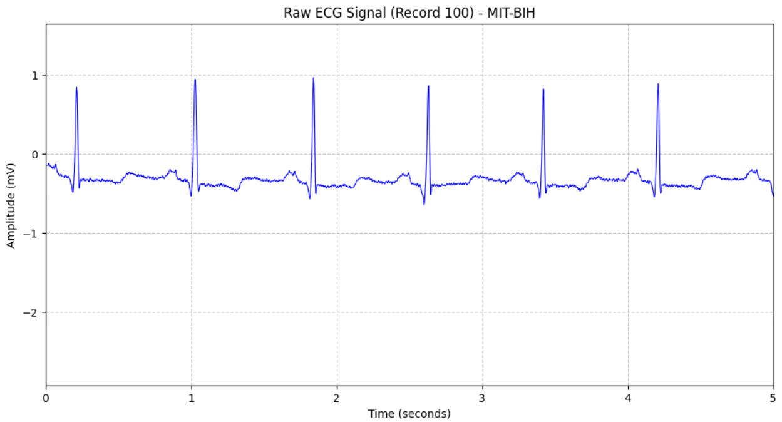  Fig 1.1: Record 100 ECG Signal with normal sinus rhythm | This signal shows a stable periodic rhythm. You can identify a small bump (P-wave) before the larger spike (QRS Complex) and the smaller bump after it (T-wave) as well.
The flat segments in between each spike are misaligned from the 0mV axis, this is called the Baseline Wonder.
It is a relatively clean signal, but one that has slight noise visible in the trace signal.

This signal shows a similar rhythm, but it also features PVCs (Premature Ventricular Contractions). These are the wider taller peaks after the larger spikes in each period. | 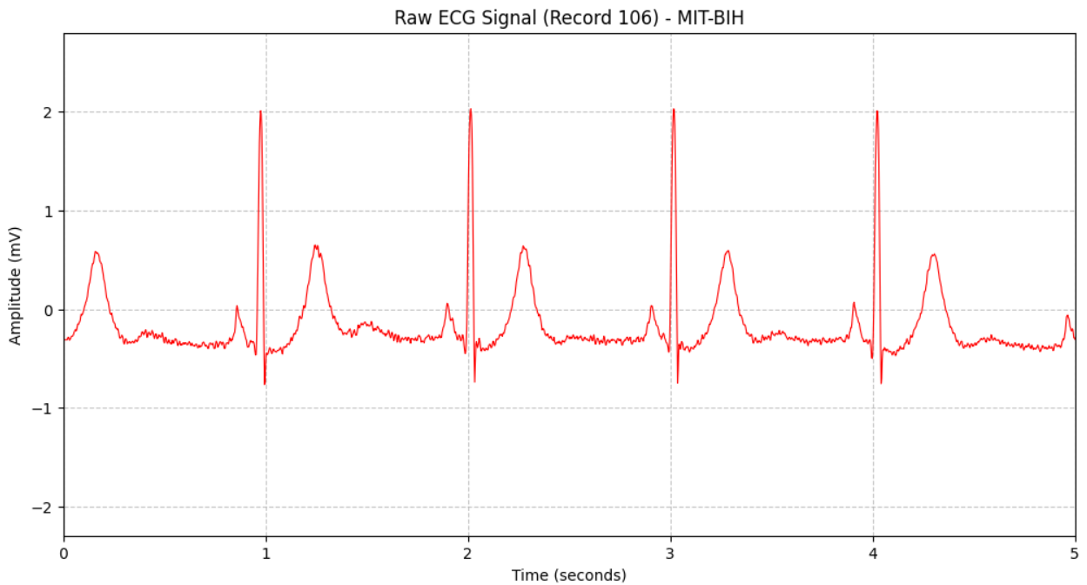
 | Fig 1.2: Record 106 ECG Signal with abnormal ventricular ectopic beats
If looked closely, there is more visible thickness within the flat segments that suggests a higher level of power-line interference. That is indicated by the subtle oscillations as you zoom in in the flat segments.

Considering these characteristics, the filtering objectives that need to be completed are (1) adjusting the baseline wonder back to the 0mV axis, (2) removing the power-line interference within the abnormal signal and (3) filtering any noise within T- and P- waves and the flat segments.
This will be achieved using 3 filters cascaded in series after one another:
- High-Pass Filter: To remove baseline wander. It allows everything above 0.5Hz to pass.
- Notch Filter: Tuned at 50Hz to remove the power-line interference while leaving surrounding frequencies untouched.
- Low-Pass Filter: To remove the muscle noise and smoothen the signal.

Filter Specifications
When implementing filters, one must consider its properties to attune the filter’s effect to get the desired results. Here are 4 properties for the filters used set in the recommended constraints along with a reason why it was set as such:
 | Condition | Justification
Passband Ripple | Very low ripple | If passband ripple is high, it can distort height of the R-peaks or the depth of the S-waves. Can lead to misdiagnosis.
Stopband Attenuation | $$40dB< A_{s} <60dB$$ | Reduce 50Hz power-line noise to 1% of its original amplitude, to make flat segments sharper.
Transition Bandwidth | Narrow | Remove exactly the 50Hz without deleting the 48Hz or 52Hz components of QRS complex.
Cutoff Frequencies | HPF = 0.5Hz,  LPF = 100Hz,  Notch = 50Hz | Remove respiration artifacts.  Preserve sharp peaks of QRS complex.  Standard.

Definitions:
- Passband Ripple ($R_{p}$): The maximum allowable fluctuation in the frequencies we want to keep.
- Stopband Attenuation ($A_{s}$): How much the unwanted noise is weakened.
- Transition Bandwidth ($∆f$): The speed at which the filter switches from passing to stopping.

Realistic Implementation Constraints
There are a few constraints that need to be considered when these filters are implemented in realistic situations. Here are 4 constraints as suggested in the requirements:
Constraint
Maximum Filter Order | More memory and processing power is needed, the higher the order of the filter is. We generally use lower orders.
Computational Complexity | Every multiplication in the filter consumes battery life.
Latency | The time it takes for a heartbeat to go through the filter and appear on a screen.
Phase Distortion | Most IIR filters shift different frequencies by different amounts of time, therefore we could use Linear Phase FIR filter to ensure the waves stay where they belong in time.

[2] Filter Design and Analysis
For the 3 filter types mentioned above, each filter will be assigned a specific digital filter to carry out its role. Details about each digital filter are listed below:
- High-Pass Filter:
- Uses IIR Butterworth, because it has a maximally flat passband.

Sampling frequency $(F_{s}$) | 360Hz
Cutoff frequency $(F_{c}$) | 0.5Hz
Filter order | 4

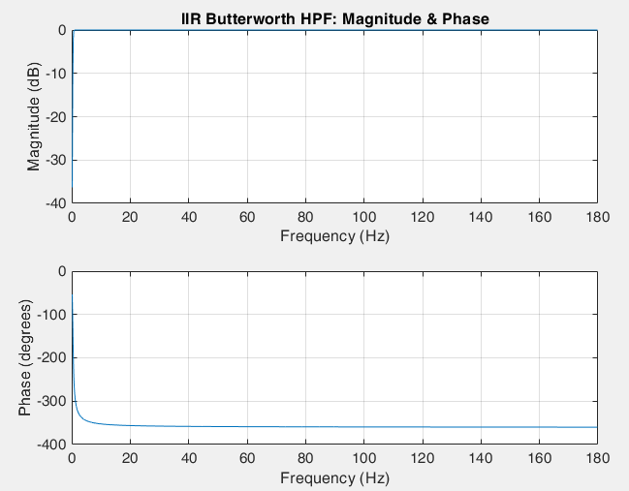
Fig 2.1: Magnitude and Phase Response for Butterworth
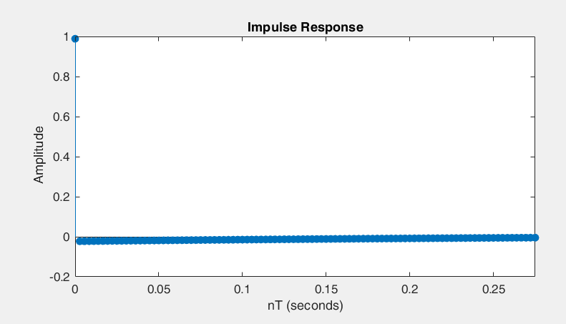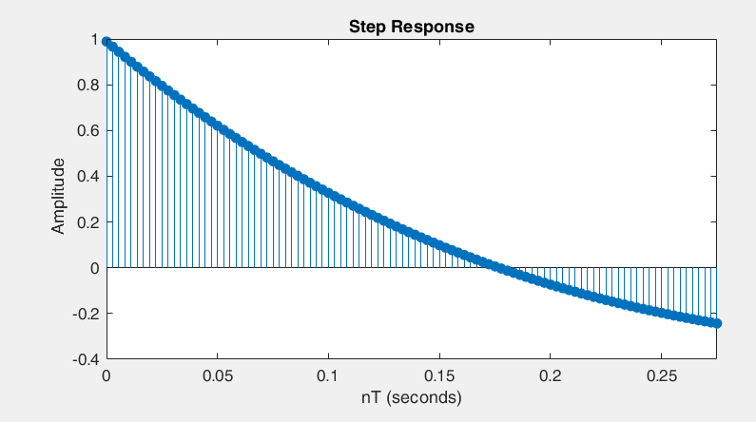
Fig 2.2: Impulse Response for Butterworth Fig 2.3: Step Response for Butterworth
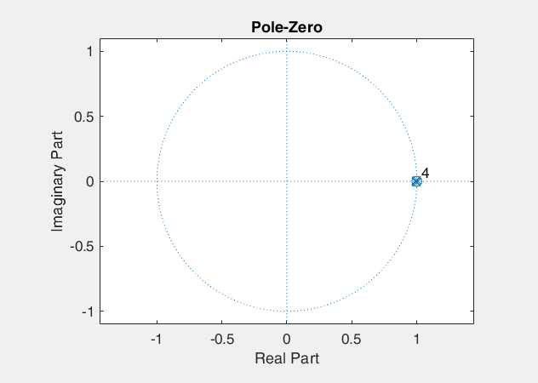
Fig 2.4: Pole-zero diagram for Butterworth
MATLAB Code:
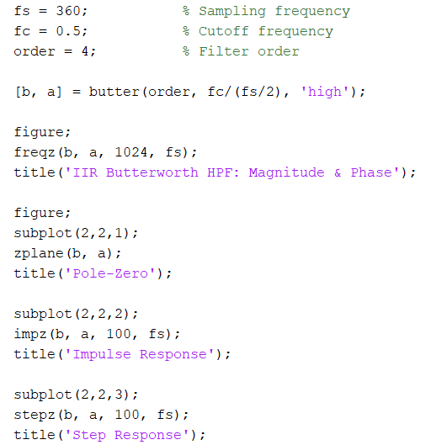

- Notch Filter:
- Uses Chebyshev Type II, because it allows for a flat passband while placing the unneeded noise in the 50Hz band that is filtered out.

Sampling frequency $(F_{s}$) | 360Hz
Notch frequency $(F_{n}$) | 50Hz
Bandwidth | 2

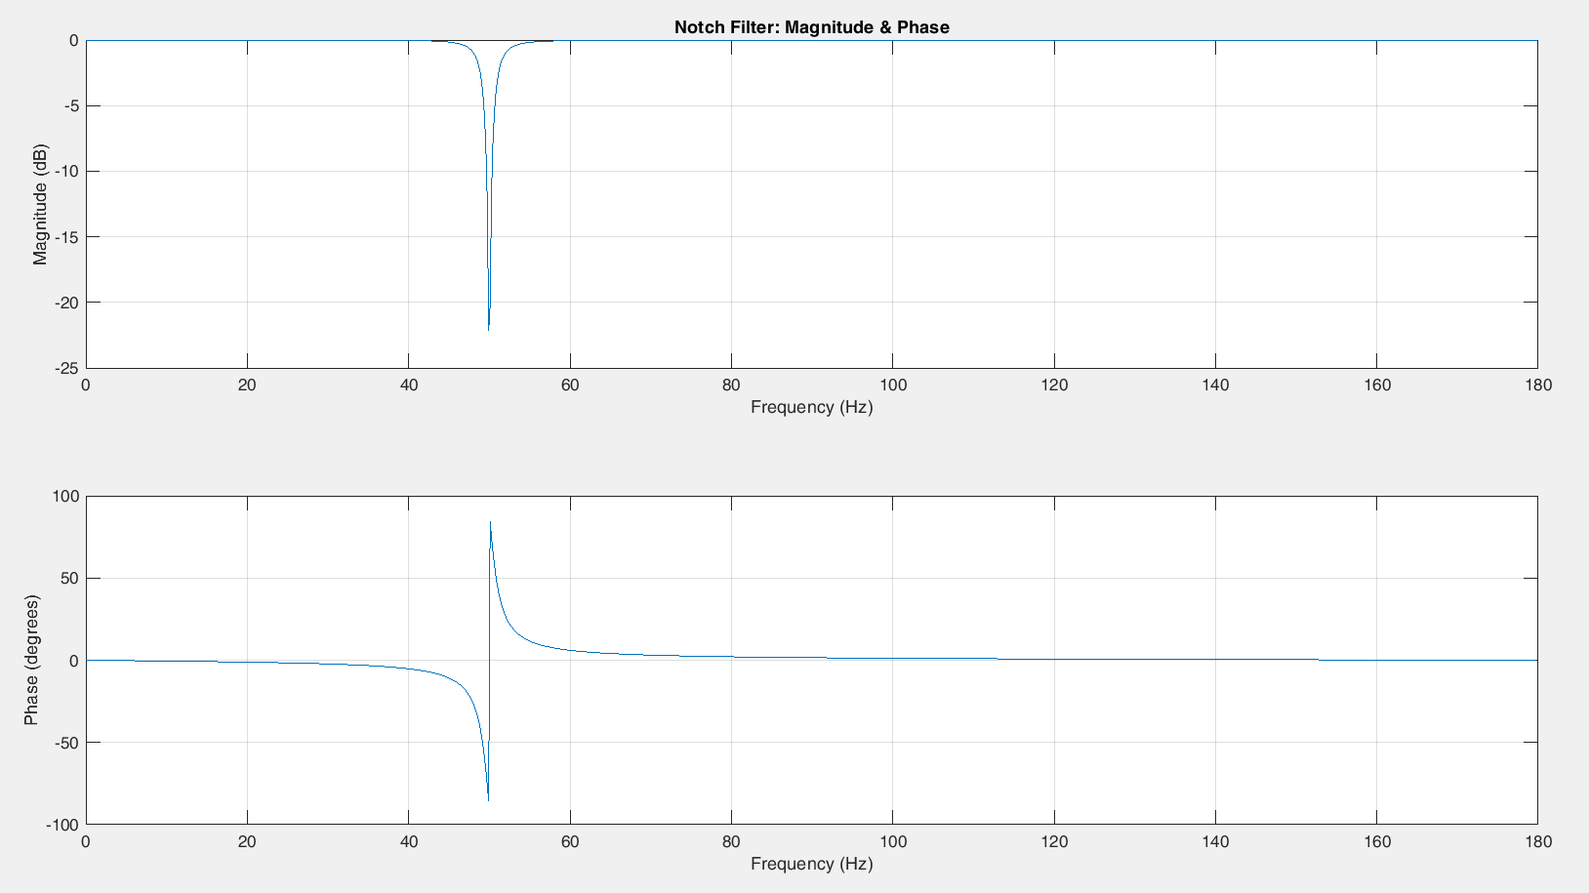
Fig 2.5: Magnitude and Phase Response for Chebyshev Type II
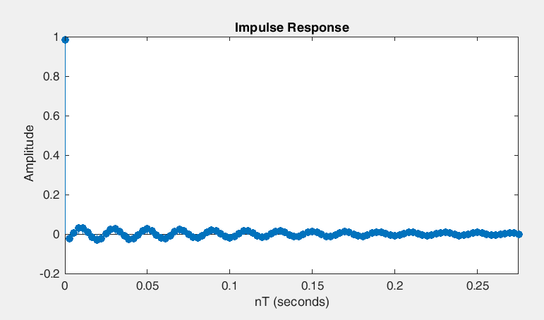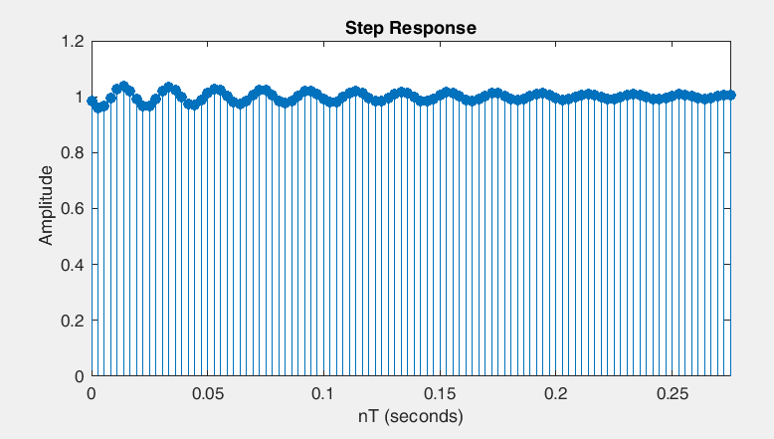
Fig 2.6: Impulse Response for Chebyshev Type II Fig 2.7: Step Response for Chebyshev Type II
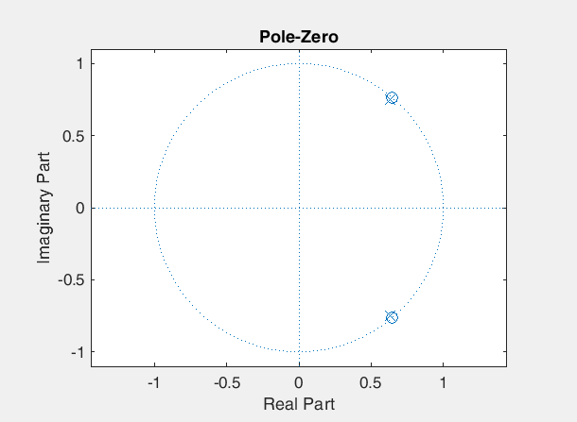
Fig 2.8: Pole-zero diagram for Chebyshev Type II
MATLAB Code:
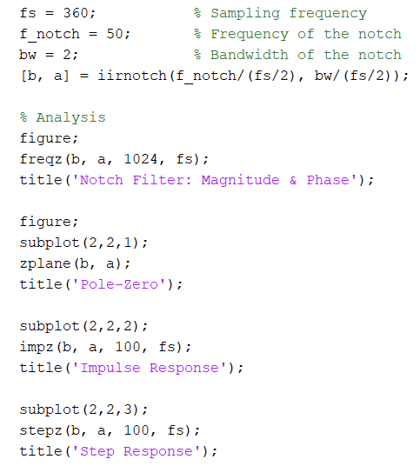\

- Low Pass Filter:
- Uses FIR Window-based filter, because it provides linear phase which ensures that all waves are delayed equally to prevent smearing the QRS complex.

Sampling frequency $(F_{s}$) | 360Hz
Cutoff frequency $(F_{c}$) | 100Hz
Stopband Attenuation | 50dB

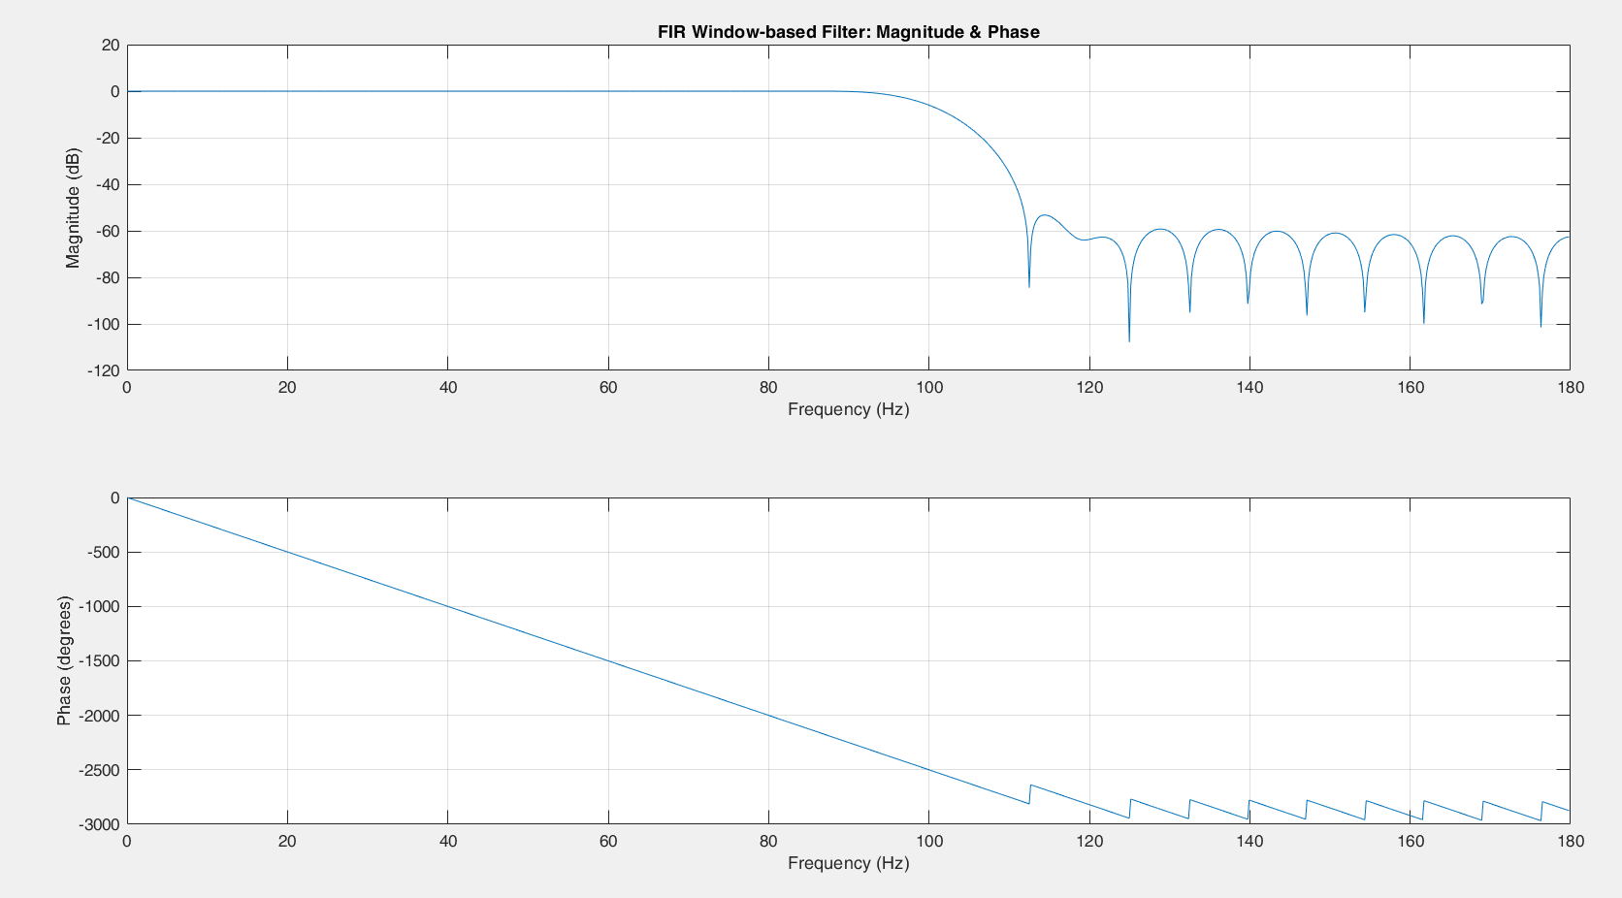
Fig 2.9: Magnitude and Phase Response for FIR Window-based
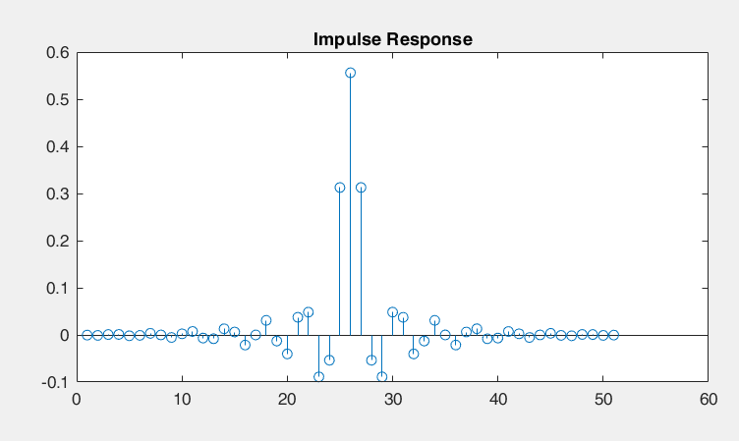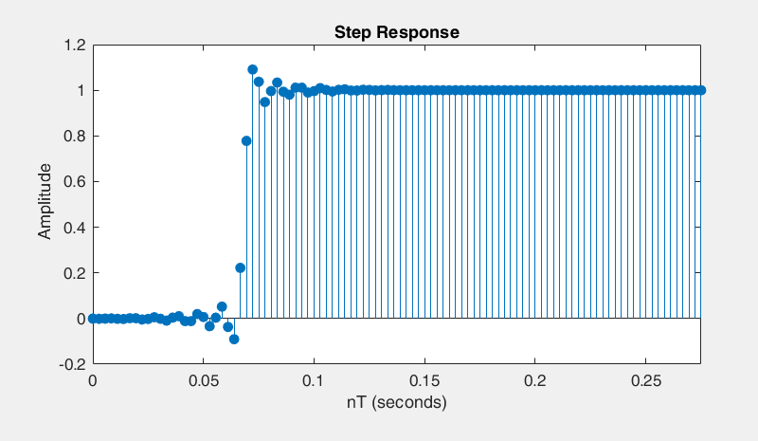
Fig 2.10: Impulse Response for FIR Window-based Fig 2.11: Step Response for FIR Window-based
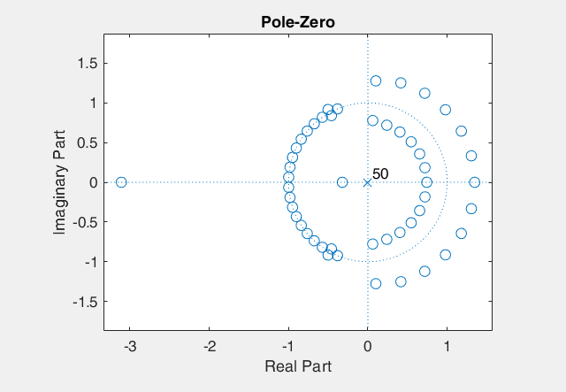
Fig 2.12: Pole-zero diagram for FIR Window-based

MATLAB Code:
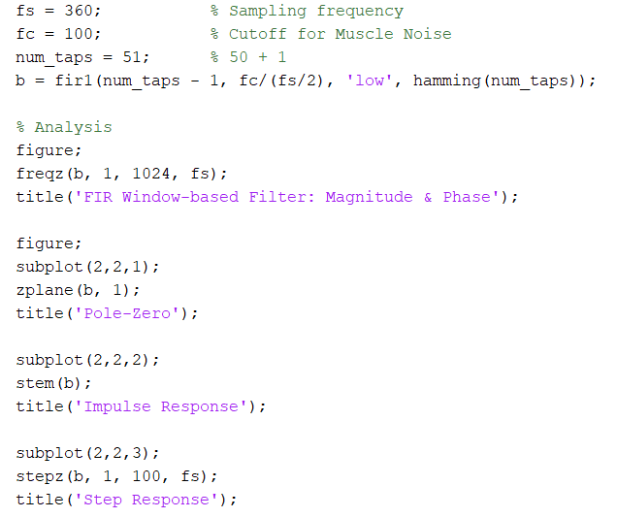

[3] Implementation and Validation

