Intro to Google Colab, Python, and Gemini

This module is designed to introduce students to use Google Colab, Gemini, and Python programming language to read, interpret, and analyze provided data for a sample of ideal gas.

AI Use Disclaimer: Microsoft Copilot was used to improve clarity and organization of the activity’s written instructions.

Learning Objectives
By the end of this recitation, you will be able to:
- Scientific Skills
  - Data Interpretation: Analyze how volume changes with temperature from a data table.
  - Graphical Representation: Construct a volume vs. temperature graph and interpret the meaning of the slope and intercepts.
  - Mathematical Modeling: Derive the mathematical relationship from the graph and data. Describe the relationship between volume and temperature and connect it to the Ideal Gas Law, PV = nRT.
- Cyberinfrastructure Skills
  - Data Handling: Import and load a CSV file into a Pandas DataFrame.
  - Access and open a notebook in Google Colab
  - Identify and use the key components of the Google Colab interface (code cells, text cells, run button).
  - Read and understand a Python script with comments.
  - Run a Python script and interpret its output.
  - Data Cleaning/Transformation: Create a new column by converting Celsius to Kelvin.
  - Data Visualization: Generate a scatter plot and a linear regression line using Python libraries (e.g., Pandas, Matplotlib, NumPy/SciPy).
  - Computational Analysis: Perform a linear fit to find the slope and intercept.
  - AI Literacy: Formulate effective and specific prompts to get the most out of an AI assistant.

A Little on Python: Python is a widely used, open source programming language and was designed to be readable with a simple and consistent syntax. Python is free and readily available to both PC and MAC users! You don't need to know any python or any programming to go through this exercise. Just keep the following in mind as you complete the exercise:
- Hashtags (#) at the beginning of a line signify comments and get color-coded as green but do not impact the execution of the code.
- The notebook only executes the current code block. This can have several unintended consequences. If you change a value and then go back and run an earlier code block, it will use the new value, not the first defined value, which may give you incorrect analysis. Similarly, if you open your notebook later, and try to run a code block in the middle, it may tell you that your variables are undefined, even though you can clearly see them defined in earlier code blocks. But if you didn’t re-run those code blocks, then Python doesn’t know they exist.

Getting Started:

Step 1: Download Relevant Files and Access Google Colab
- Download the files "Student.ipynb" and "Gas-data.csv" from your recitation Canvas course site. Once downloaded, these files will most likely be stored in the Download folder of your local computer.
- Open your web browser and go to https://colab.research.google.com/.
- Log in with your Google account. This is the same account you use for Gmail, Google Drive, etc. If you don't have one, you'll need to create a free account.

Step 2: Open a Notebook
Once you're on the Colab homepage, click "File" > "Open notebook": This will open a window with several tabs:
Use the "Upload" option to open the "Student.ipynb" file.

Step 3: Tour the Interface
You should now see a Colab notebook. Here are the key parts you'll be using:
- Code Cells: These are the gray boxes where you'll write and run your code. You can add a new one by clicking on "+ Code" at the top of the notebook.
- Text Cells: These are for adding notes, explanations, and instructions. You can add a new one by clicking on "+ Text" at the top of the notebook.
- Run Button: To run a code cell, click the "play" button (a triangle) on the left side of the cell, or press Shift + Enter on your keyboard.

Step 4: Upload the Experimental Data to Colab Worksheet
Once uploaded, the file should appear on the left sidebar below the folder titled "sample_data".
The “Gas-data.csv” file contains a series of volume measurement at different temperatures for a 0.25 mole sample of ideal gas, recorded at a constant temperature.

Step 5: Read the data:
Once the code finishes processing, you will see the temperature and volume data from the file printed right below the code cell. Inspect the data table and answer the next three questions:
- Do the values in the output table agree with those in the input file?
Yes
- How does volume change as temperature increases?
V increase as T increases
- Is the relationship linear?
Yes

Step 6: Initial plot of data
Once the code finishes processing, you should see a plot with volume on the y-axis and temperature (in ℃) on the x-axis. Right click the images and paste them below:
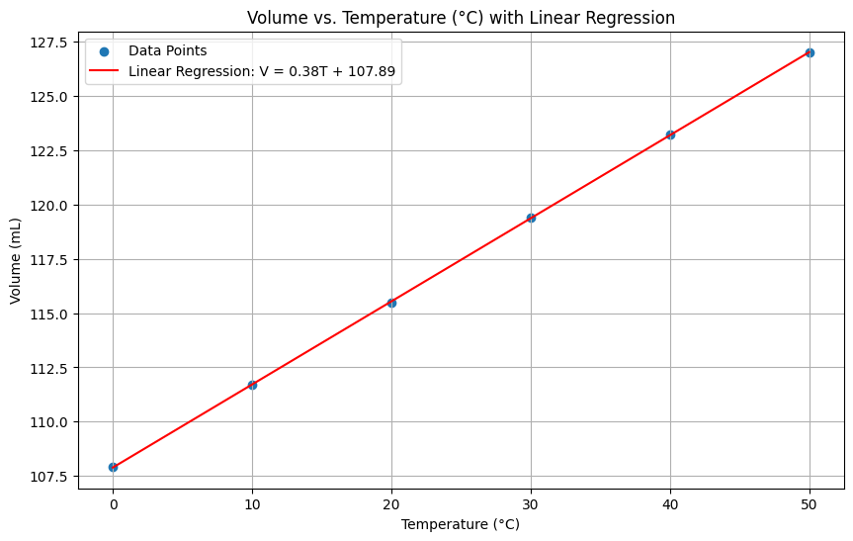

Answer the next three questions:

- For an ideal gas at constant pressure, the temperature–volume relationship is linear. What are the expressions for the slope and y-intercept of this line?

A linear line with a slope of $k=nR/P$ and a y-intercept = 0

- Does the plotted data match the prediction from the Ideal Gas Law? Report the slope and y-intercept of the linear fit shown in your graph.

No, the graph shown above has slope = 0.38 mL/℃ and y-intercept =107.89 mL.

- If not, what factors could account for the discrepancy between your data and the Ideal Gas Law prediction?

The temperature here is in Celsius, instead of Kelvin.

Step 7: Data Transformation
Once the code finishes processing, you should see a plot with volume on the y-axis and temperature (in 𝐾) on the x-axis. Right click the images and paste them below:
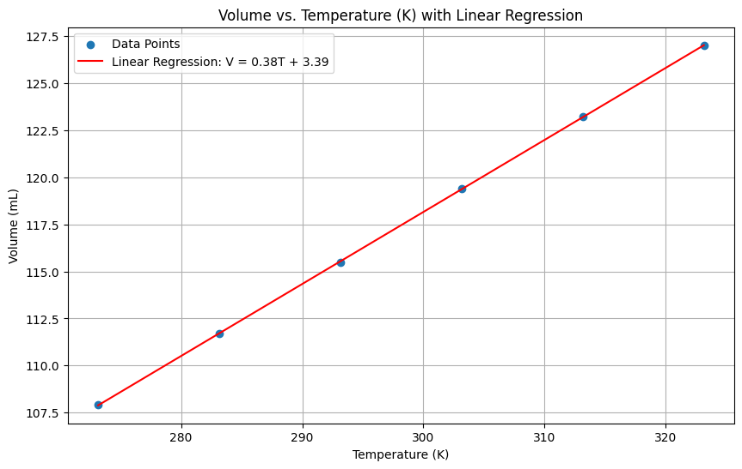

Answer the new four questions:

- Does the plotted data match the prediction from the Ideal Gas Law? Report the slope and y-intercept of the linear fit shown in your graph.

This is closer. The graph shown above has slope = 0.38 mL/K and y-intercept =3.39 mL

- If not, what factors could account for the discrepancy between your data and the Ideal Gas Law prediction?

The non-zero y-intercept is mostly due to experimental error. The data was simulated with common experimental errors built in.

- What are the similarities and differences between the two plots?

Both plots have the same slope of 0.38 mL/K but different y-intercepts

- What does the slope physically represent in the context of the Ideal Gas Law.

The slope has an expression of $nR/P$. For the given amount of ideal gas, we can use the slope to obtain information about the pressure.
E.g. Given that $\frac{nR}{P}=0.38\frac{mL}{K}=0.00038\frac{L}{K}$, and n=0.25 moles, $R=0.08206\frac{L∙atm}{mol∙K}$,
we can calculate:
$$P= \frac{\left(0.25\right)(0.08206)}{0.00038}=54 atm$$

