Week 2 Recitation: Modeling Kinetics of Drug Degradation

This module is designed for students to use Google Colab, Gemini, and Python programming language to read, interpret, and analyze kinetics data for drug degradation in aqueous solutions.

AI Use Disclaimer: This module is created with the assistance of Google Gemini.

Learning Objectives
By the end of this recitation, you will be able to:
- Scientific Skills
  - Data Interpretation: Interpret and compare rate constants across temperatures and pHs in a table.
  - Graphical Representation: Visualize the differences between 𝑘 as a function of 𝑇 and ln𝑘 as a function of 1/𝑇 for a reaction under different pHs using Python modeling.
  - Mathematical Modeling: Analyze how the slopes and y-intercept of the graph relate to reaction activation energies 𝐸𝑎 and frequency factor 𝐴.
- Cyberinfrastructure Skills
  - Data Handling: Import and load a CSV file into a Pandas DataFrame.
  - Python Programming:
    - Access and open a notebook in Google Colab
    - Identify and use the key components of the Google Colab interface (code cells, text cells, run button).
    - Read and understand a Python script with comments.
    - Run a Python script and interpret its output.
  - Data Cleaning/Transformation: Create new columns using mathematical models.
  - Data Visualization: Generate a scatter plot and a linear regression line using Python libraries (e.g., Pandas, Matplotlib, NumPy/SciPy).
  - Computational Analysis: Perform a linear fit to find the slope and intercept.
  - AI Literacy: Formulate effective and specific prompts to get the most out of an AI assistant.

Getting Started

Download Files and Open Google Colab

Your assigned molecule for this activity is: ______________________
- Download the Colab notebook file (.ipynb) and the corresponding .csv file for your assigned molecule from your recitation Canvas course. Once downloaded, these files will typically appear in your computer’s Download folder.
- Open your web browser and go to https://colab.research.google.com/.
- Sign in with your Google account. If you don't have one, create a free account to continue.

Open the Notebook in Colab:

On the Colab homepage, select File -> Open notebook.

Choose the Upload table and upload the downloaded .ipynb file.

Upload the Experimental Data to Colab Worksheet.
- In the left sidebar, click the folder icon to open the file browser.
- Use the Upload button to add your .csv data file. Once uploaded, it will appear under the file list (below the subfolder sample_data).
Read and Verify the Experimental Data
- Run the Gemini provided code to load the data.
- After the cell finishes executing, review the printed concentration and time values. Confirm that the displayed data matches the contents of your .csv file
Gemini Prompt Tips:
For any step in the activities, if Gemini provides a list of tasks and asks you to choose between auto-complete or step-by-step, select “Cancel.” Then copy and paste your prompt again, adding “Output only the full code block” at the end.

Step 1: Interpret and Visualize Imported Data
Q1.1. Examine the data table provided (either from the Gemini output or the original CSV file). Based on the trends you observe:
- At a fixed pH, how does the rate constant vary with temperature?
The rate constant (k) increases as the temperature (T) increases.
- At a fixed temperature, how does the rate constant vary with pH?
The rate constant (k) depends strongly on pH. At lower temperature (25 $℃$), k tends to decrease as pH increases. However, at higher temperature (100 $℃$), the trend becomes inconsistent, with k sometime increasing and sometime decreasing as pH increases.

Q1.2. Prompt Gemini to plot the imported data. Once the codes finish processing, right click the images and paste them below:
- Rate constant as a function of T for each pH:
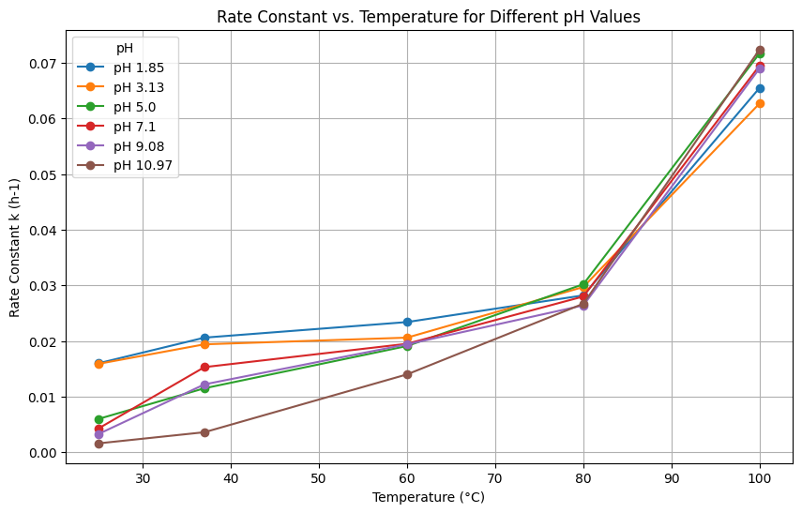
- Rate constant as a function of pH for each T:

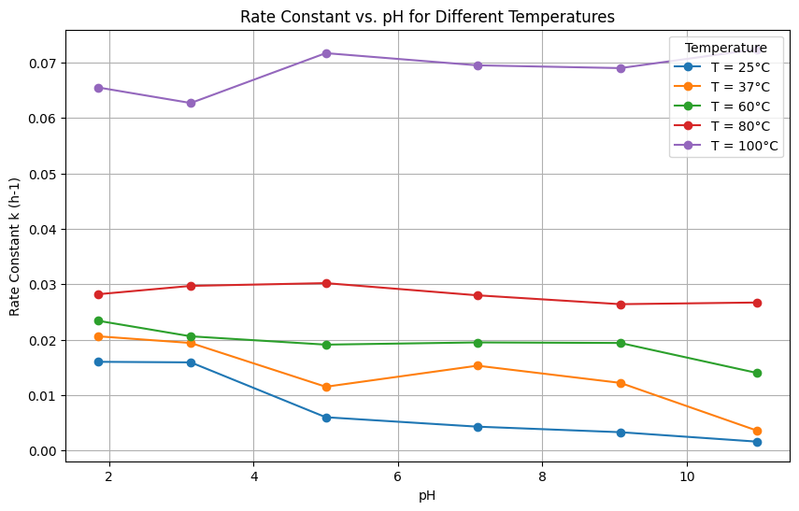

Q1.3. Examine the two plots carefully. What patterns or trends do you observe in each plot? Do these visual trends align with the observations you made from the data table?

Step 2: Transform Data and Visualize Transformed Data
Q2.1. Prompt Gemini to calculate $\ln{k}$, convert temperature from $℃$ to $K$, and calculate $1/T$. Once the codes finish processing, right click the generated image and paste it below:
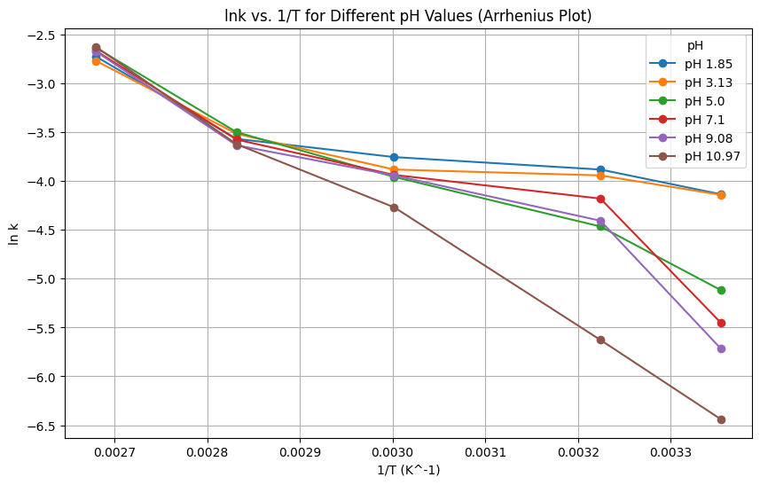
Q2.1. Examine the plot carefully: How does ln𝑘 change with 1/𝑇 at a fixed pH? Does the relationship appear linear?

Q2.2. Prompt Gemini to run the linear regression analysis. After the codes finish, a plot will appear showing the regression line and the slope, y-intercept, and R² value for each pH. Right click the image and paste it below.

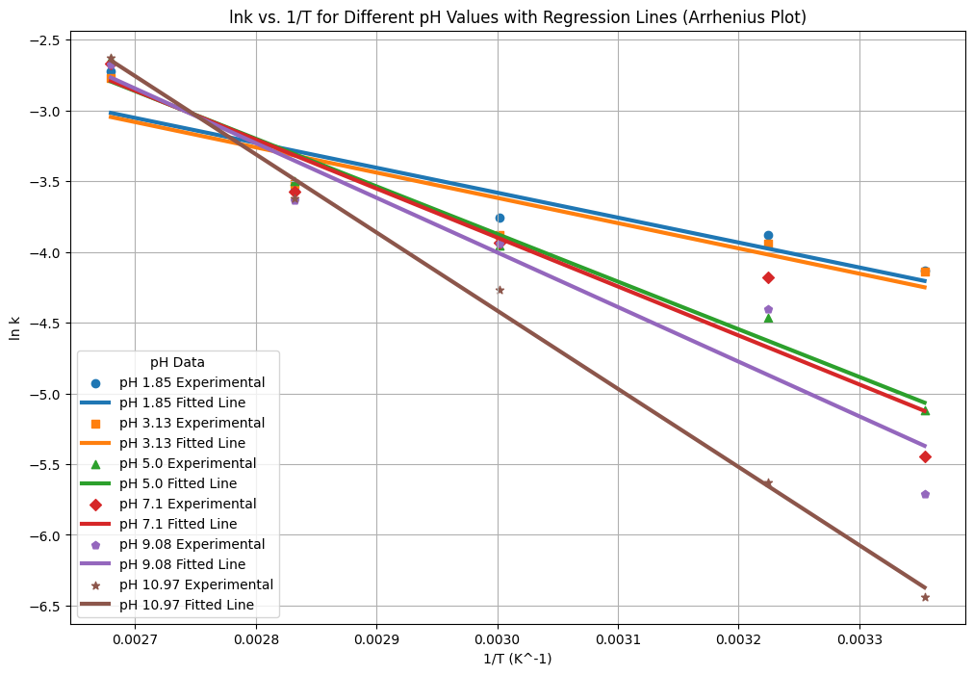

Q2.3. Record the linear regression results for pH = 5:

slope = ____________, y-intercept = ___________.

Then use these values to calculate the activation energy (in kJ/mol) and the frequency factor.

Step 3: Parameter Estimation:
Q3.1. Prompt Gemini to estimate parameters from the linear regression for pH = 5. Once the codes finish running, record the resulting values of $E_{a}$ and $A$ below.

Q3.2. Compare your calculated $E_{a}$ and $A$ with the values generated by Gemini. How closely do they agree, and what factors could explain any differences?

Q3.3. Compare your $E_{a}$ values with those reported in the journal article. Be sure to note the units used in the article and ask Gemini to convert $E_{a}$ into matching units when needed. Discuss how closely your results align with the published values and consider possible sources of any discrepancies.

Step 4: Reflection:
Q4.1. Which part of the activity—AI-assisted prompts, data interpretation, or applying the chemistry concepts—was easiest and which was most difficult?

Q4.2. Describe a mistake you encountered and how you corrected it. What clues or feedback helped you recognize the error and make the adjustment?

Final Notes about Grading:
In addition to completing the guiding questions, your TA will check that you followed the activity instructions. Submit shareable links to your Colab Notebook as part of your participation. To share your Colab notebook:
- Rename your copy: Change the filename to include YOUR name (the student's name), not your instructor's name.
- Share your notebook: Set the sharing permissions so that anyone with the link can view.
- Copy and paste your share link into the Exit Form.

