Week 10 Recitation: Modelling Titration Curves of Common Acids

This module is designed to for students to use Google Colab, Gemini, and Python programming language to read, interpret, and analyze titration data of common household acids with a strong base.

AI Use Disclaimer: This module is created with the assistance of Google Gemini.

Learning Objectives
- Scientific Skills
  - Data Interpretation: Identify key features of titration curves (buffer region, half-equivalence point, equivalence point) for weak acids.
  - Graphical Representation: Visualize the differences in titration curves of polyprotic and monoprotic acids. Compare experimental titration curve for an unknown acid to reference curves from known acids.
  - Mathematical Modeling: Use curve shape and equivalence point behavior of the titration curve to determine 𝑝𝐾𝑎 and the identity of an unknown acid.
- Cyberinfrastructure Skills
  - Data Handling: Import and load a CSV file into a Pandas DataFrame.
  - Python Programming:
    - Access and open a notebook in Google Colab
    - Identify and use the key components of the Google Colab interface (code cells, text cells, run button).
    - Read and understand a Python script with comments.
    - Run a Python script and interpret its output.
  - Data Cleaning/Transformation: Create the first derivative curves using mathematical models.
  - Data Visualization: Generate scatter plots using Python libraries (e.g., Pandas, Matplotlib, NumPy/SciPy).
  - Computational Analysis: Calculate the first derivatives of pH to find the pHs and corresponding volumes at the equivalence points.
  - AI Literacy: Formulate effective and specific prompts to get the most out of an AI assistant.
Guideline for using AI tools in this activity:
Use AI tools only for tasks such as importing data, organizing or transforming it, and creating plots. For all other questions in the worksheet, rely on your own chemical understanding. Do not ask AI tools to solve the conceptual or guiding questions for you.

Getting Started

Download Files and Open Google Colab
- Download the Colab notebook file (.ipynb), the data files (.csv) for the titration of four known acids with a strong base from your recitation Canvas course. Once downloaded, these files will typically appear in your computer’s Download folder.
- Open your web browser and go to https://colab.research.google.com/.
- Sign in with your Google account. If you don't have one, create a free account to continue.

Open the Notebook in Colab:

On the Colab homepage, select File -> Open notebook.

Choose the Upload table and upload the downloaded .ipynb file.

Upload the Experimental Data to Colab Worksheet.
- In the left sidebar, click the folder icon to open the file browser.
- Use the Upload button to add the four .csv data files to the sample_data subfolder.

Part 1: Titration Curves for the Known Acids
The names and skeletal structures of the four acids are shown below, along with their corresponding acid dissociation constants (pK_{a} values) at 25 °C.

Q1.1: Examine the structures and pK_{a} values of the four acids to determine whether each one is monoprotic, diprotic, or triprotic. Use this information to predict the number of equivalence points each acid should exhibit during titration.

- Acetic acid: monoprotic, 1 equivalence point
- Aspirin (ASA): monoprotic, 1 equivalence point
- Carbonic acid: diprotic, since pK_{a1} is much smaller than pK_{a2} (i.e. K_{a1}/K_{a2} >> 10³), the two deprotonation steps are well separated we would expect 2 equivalence point
- Citric acid: triprotic acid. Since the three pK_{a} values are relatively close to each other, the corresponding equivalence points may overlap, and we may not observe three distinct equivalence points on the titration curve.

Each data file contains measurements of pH and the corresponding volume of NaOH(aq) added during a titration. All four acids have an initial concentration of 0.10 M and a volume of 20 mL. Each acid is titrated using 0.10 M NaOH(aq).

Q1.2: Prompt Gemini to import the titration data and plot the titration curves for the four known acids. Be sure to review the printed volume and pH values. Confirm that the displayed data matches the contents of your .csv file. Once the code finishes running, right click the images and paste them below:

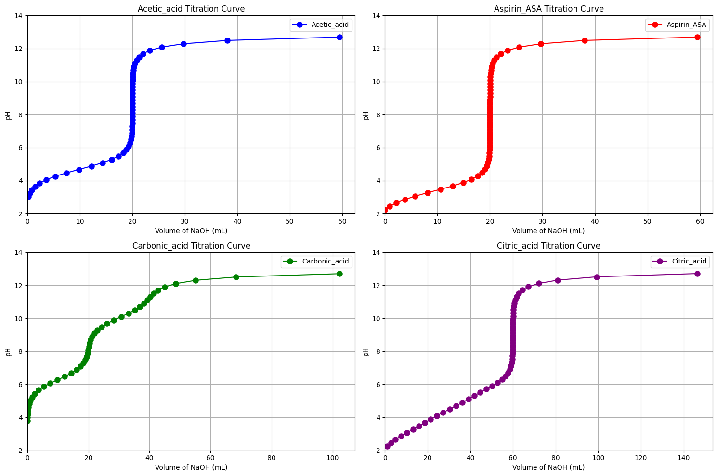

Q1.3: Identify the equivalence points in each titration curve and record the approximate pH and volume of added NaOH at each one.

Acetic acid: 1 equivalence point, V_{NaOH} = 20 mL, pH ~ 8
Aspirin (ASA): 1 equivalence point, V_{NaOH} = 20 mL, pH ~ 8
Carbonic acid: 2 equivalence point, V_{NaOH,1} = 20 mL, pH ~ 8; V_{NaOH,2} = 40 mL, pH ~ 11
Citric acid: 1 equivalence point, V_{NaOH} = 60 mL

Q1.4: Compare your results from Q1.3 with your predictions in Q1.1. If they differ, discuss possible reasons such as acid strength or overlapping equivalence points (e.g., two steps merging into one broad rise or a second step appearing only as a slight shoulder).

The results for the monoprotic acids (acetic acid and aspirin) align well with the predicted number of equivalence points. For carbonic acid, the second equivalence point appears very gradual, lacking a distinct vertical jump. In the case of citric acid, the three expected equivalence points merge into one broad rise, with only the third equivalence point (around V_{NaOH} = 60 mL) showing a pronounced vertical increase.

Part 2: Titration Curves for the Unknown Monoprotic Acid

Your assigned unknown monoprotic acid for this activity is: __Unknown Acid 2___. The unknown acid has an initial concentration of 0.05 M and a volume of 30 mL, and it is titrated using 0.05 M NaOH(aq).

Q2.1: Download the .csv data file for your assigned unknown acid from your recitation Canvas site. Then use the Upload button to add the file to the sample_data subfolder. Prompt Gemini to import the file and display all volume and pH data. After checking that the printed values match your .csv file, manually estimate the pH at the half-equivalence point by examining the data yourself. Do not ask Gemini to calculate or identify this value for you.

The half-equivalence point for this titration occurs at V_{NaOH} = 15 mL, which corresponds to a pH of 3.45 (V_{NaOH} = 15.1 mL) in the tabulated data.

Q2.2: Prompt Gemini to plot the titration curve for your unknown acid. Once the code finishes running, right click the image and paste it below:

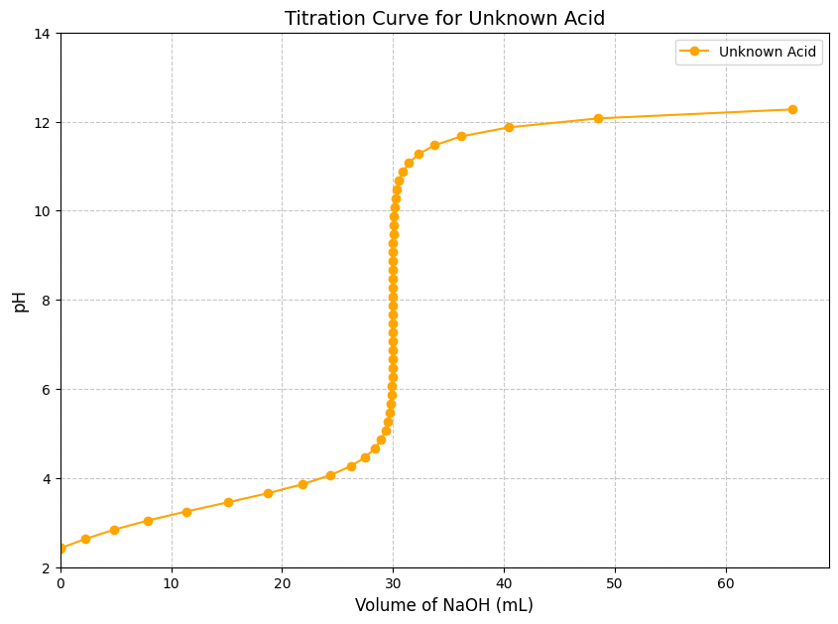

Q2.3: Use the titration curve of the unknown acid to estimate the pH at the half-equivalence point. Then compare this estimated value with your prediction from Q2.1 based on the tabulated data. Do the two values agree? If not, discuss possible reasons for the discrepancy.

The half-equivalence point for this titration occurs at V_{NaOH} = 15 mL, where the pH is about 3.5. This value is consistent with the estimate obtained from the tabulated data.

Q2.5: Since pH equals pK_{a} at the half-equivalence point, use your estimated pH and the provided pK_{a} values to identify which known acid matches the unknown.

The unknown acid has a pK_{a} of approximately 3.5, which matches the pK_{a} of Aspirin (ASA). Therefore, the unknown acid is most likely Aspirin (ASA).

Part 3: Titration Curve Comparison: Unknown Acid and Reference
Q3.1: Prompt Gemini to plot the titration curves for your unknown acid and its corresponding reference acid on the same graph. Once the code finishes running, right-click the generated plot and paste it in the space below.

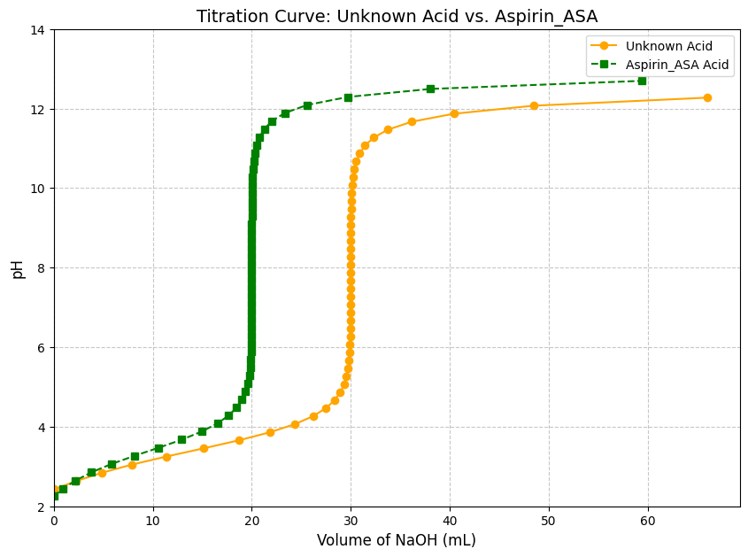

Q3.2: Carefully examine the plotted curves and describe the key similarities and differences between them, focusing on the initial pH values, the half-equivalence point, the buffer region, and the equivalence point.

The two curves begin at similar pH values, but the unknown acid shows a slightly higher initial pH than the reference acid. This is expected, since the unknown acid has a lower initial concentration (0.05 M) compared to the reference acid (0.10 M).

The two curves show nearly the same pH at the half-equivalence point, as expected for different concentrations of the same weak acid.

Both curves show similar shapes in the buffer region, but the unknown acid requires a larger volume of NaOH to reach the equivalence point. This is expected because the unknown sample has a larger initial volume (30 mL) than the reference acid (20 mL). Since each acid is titrated with NaOH of the same concentration, the sample with the greater initial volume naturally requires more titrant to reach equivalence.

Both curves show pH values above 7 at the equivalence point, but the unknown acid reaches a slightly lower pH than the reference acid. This is expected because the unknown acid has a lower initial concentration (0.05 M vs. 0.10 M), leading to a lower concentration of conjugate base at equivalence. A smaller amount of conjugate base produces less OH⁻, resulting in a higher pOH and therefore a lower pH at the equivalence point.

Q3.3: Predict whether the acid or its conjugate base will be present in greater concentration when the titration mixture has a pH of 2.50. Then calculate the ratio $\left[A^{-}]/[HA\right]$ at this pH, and state whether your calculated ratio matches your prediction.

When the titration mixture has a pH of 2.50 (< 3.48, the pK_{a} of Aspirin_ASA), the solution is in the buffer region, with the acid form predominates. Therefore, $\left[ASA]>[ASA^{-}\right]$.

$$pH=pK_{a}+\log\left(\frac{\left[base\right]}{\left[acid\right]}\right)⇒2.50=3.48+\log\left(\frac{\left[ASA^{-}\right]}{\left[ASA\right]}\right)$$

$$⇒\frac{\left[ASA^{-}\right]}{\left[ASA\right]}={10}^{-0.98}=0.10 or \frac{\left[ASA\right]}{\left[ASA^{-}\right]}=10$$

The calculated ratio agrees with the prediction.

Part 4: Reflection:
Q4.1. Which part of the activity—AI-assisted prompts, data interpretation, or applying the chemistry concepts—was easiest and which was most difficult?

Q4.2. Describe a mistake you encountered and how you corrected it. What clues or feedback helped you recognize the error and make the adjustment?

Final Notes about Grading:
In addition to completing the guiding questions, your TA will check that you followed the activity instructions. Submit shareable links to your Colab Notebook as part of your participation. To share your Colab notebook:
- Rename your copy: Change the filename to include YOUR name (the student's name), not your instructor's name.
- Share your notebook: Set the sharing permissions so that anyone with the link can view.
- Copy and paste your share link into the Exit Form.

