Week 13 Recitation: Modeling the Impact of Concentration on Voltaic Cell Potentials

This module is designed for students to perform data modeling for a voltaic cell under different conditions. Students will use Google Colab, Gemini, and Python programming language to read, interpret, and analyze provided data.
AI Use Disclaimer: This module is created with the assistance of Google Gemini.

Learning Objectives
By the end of this recitation, you will be able to:
- Scientific Skills
  - Data Interpretation: Interpret data to determine how changes in concentrations influence cell potential.
  - Graphical Representation: Graph and interpret how cell potential ($E_{cell}$) varies with concentrations, reaction quotients ($Q$), or logarithms of reaction quotients ($\log{Q}$) to identify trends.
  - Mathematical Modeling: Use the $E_{cell}$ vs. $\log{Q}$ graph to determine the number of electrons transferred ($n$), the standard cell potential ($E_{cell}^{o}$), and the equilibrium constant ($K$), then evaluate whether these values match theoretical predictions.
- Cyberinfrastructure Skills
  - Data Handling: Import and load a CSV file into a Pandas DataFrame.
  - Python Programming:
    - Access and open a notebook in Google Colab
    - Identify and use the key components of the Google Colab interface (code cells, text cells, run button).
    - Read and understand a Python script with comments.
    - Run a Python script and interpret its output.
  - Data Cleaning/Transformation: Calculate $Q$ and $\log{Q}$ using mathematical models.
  - Data Visualization: Generate scatter plots using Python libraries (e.g., Pandas, Matplotlib, NumPy/SciPy).
  - Computational Analysis: Perform a linear fit to find the slope and intercept.
  - AI Literacy: Formulate effective and specific prompts to get the most out of an AI assistant.

Guideline for using AI tools in this activity:
Use AI tools only for tasks such as importing data, organizing or transforming it, and creating plots. For all other questions in the worksheet, rely on your own chemical understanding. Do not ask AI tools to solve the conceptual or guiding questions for you.

Getting Started

Download Files and Open Google Colab

Your assigned cell for this activity is: _Cr_Co_Voltaic_Cell__
- Download the Colab notebook file (.ipynb) and the data file (.csv) for your assigned voltaic cell from your recitation Canvas course. Once downloaded, these files will typically appear in your computer’s Download folder.
- Open your web browser and go to https://colab.research.google.com/.
- Sign in with your Google account. If you don't have one, create a free account to continue.

Open the Notebook in Colab:

On the Colab homepage, select File -> Open notebook.

Choose the Upload table and upload the downloaded .ipynb file.

Upload the Experimental Data to Colab Worksheet.
- In the left sidebar, click the folder icon to open the file browser.
- Use the Upload button to add the .csv data file. Once uploaded, it will appear under the file list (below the sample_data subfolder).

Part 1: Read and Verify Experimental Data
Q1.1. Prompt Gemini to import the file and display all the data. Review the output carefully, then describe the patterns, trends, or relationships you observe in the variables and the resulting cell voltage.

The output contains six columns of data corresponding to two separate experiments.

- Experiment A (first three columns):
The concentration of Cr³⁺ is held constant, while Co²⁺ increases from 0.001 M to 10.0 M. As the Co²⁺ concentration increases, the cell voltage shows minor fluctuations but overall increases, rising from approximately 0.3937 V to 0.5154 V. This indicates a positive relationship between Co²⁺ concentration and cell voltage.

- Experiment B (second three columns):
The concentration of Co²⁺ is held constant, while Cr³⁺ increases from 0.001 M to 10.0 M. In this case, the cell voltage again fluctuates slightly but overall decreases, dropping from about 0.4906 V to 0.4183 V. This reveals a negative relationship between Cr³⁺ concentration and cell voltage.

Overall trend: Increasing the concentration of Co²⁺ increases the cell voltage, while increasing the concentration of Cr³⁺ decreases the cell voltage.

Q1.2. The voltaic cells studied in this recitation are constructed from two metal/metal-cation half-cells. Using the cations listed in your input file and the standard reduction potential table provided on the CHEM 112 data sheet, answer the following conceptual warm-up questions for your assigned voltaic cell.

- Which half reaction occurs at the anode?
Cr (s) Cr³⁺ (aq) + 3 e⁻ $E_{ox}^{ο}=0.74 V$
- Which half reaction occurs at the cathode?
Co²⁺ (aq) + 2 e⁻ $→$ Co (s) $E_{red}^{ο}=-0.277 V$
- What is the overall balanced reaction?
2 Cr (s) + 3 Co²⁺ (aq) 2 Cr³⁺ (aq) + 3 Co (s)
- How many moles of electrons ($n$) are transferred in the balanced overall reaction?
n= 6
- Determine the standard cell potential, $E_{cell}^{o}$, for this cell.
$$E_{cell}^{ο}=E_{red}^{ο}+E_{ox}^{ο}=0.463 V$$
- Write the correct expression for the reaction quotient ($Q$) for this cell.
$$Q=\frac{{\left[{Cr}^{3+}\right]}^{2}}{{[{Co}^{2+}]}^{3}}$$

Q1.3. The Nernst equation, $E=E°-\frac{0.0592}{n}\ln{Q}$ describes the relationship between cell potential and non-standard conditions. Predict:
- At a fixed anode ion concentration, how does increasing the cathode ion concentration affect the cell potential?

Anode ion: Cr³⁺(aq), Cathode ion: Co²⁺(aq).
Increasing [Co²⁺] while keeping [Cr³⁺] the same, $Q$ decreases, $E_{cell}$ increases.

- At a fixed cathode ion concentration, how does increasing the anode ion concentration affect the cell potential?

Anode ion: Cr³⁺(aq), Cathode ion: Co²⁺(aq).
Increasing [Cr³⁺] while keeping [Co²⁺] the same, $Q$ increases, $E_{cell}$ decreases.

- Do these predictions align with the overall trend you observed based on the dataset. Explain any discrepancies.
Yes, these predictions agree with the overall trend observed from the datasets.

Part 2: Interpret and Visualize the Experimental Data
Q2.1. Prompt Gemini plot $E_{cell}$ as a function of solution concentrations for Experiments A and B. Display the results as side-by-side subplots, using different colors and marker styles to clearly distinguish the experiments. Once the codes finish processing, right click the images and paste them below:

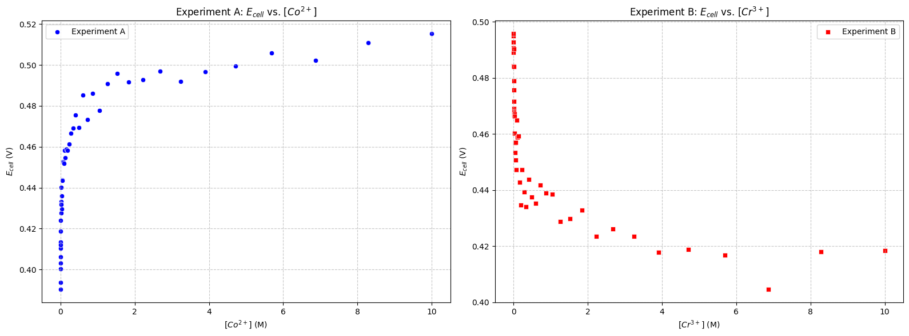

Q2.2. Carefully examine the subplots you generated and describe how the voltage, $E_{cell}$, changes as the solution concentrations vary. Are the observed relationships linear or non-linear?
For experiment A, $E_{cell}$ increases as [Co²⁺] increases. For experiment B, $E_{cell}$ decreases as [Cr³⁺] increases. Both subplots curve rather than forming straight lines, showing that cell potential does not change linearly with concentration. This makes sense because the Nernst equation shows that $E_{cell}$ depends on the logarithm of reaction quotient, not directly on concentration itself.

Part 3: Transform Data and Visualize Transformed Data
Q.3.1. Prompt Gemini to calculate $Q$ and $\log{Q}$ for each concentration set in each experiment and display the first five rows of results.
- Examine the reaction quotient expression in the code. Is it implemented correctly?
Yes, the reaction quotient expression is implemented correctly. Only aqueous species appear in $Q$, and the exponents for the aqueous species agree with the stoichiometric coefficients in the balanced reaction.

df['Q_Exp_A'] = (df['Cr3+_Conc_Exp_A']**2) / (df['Co2+_Conc_Exp_A']**3)
df['logQ_Exp_A'] = np.log10(df['Q_Exp_A'])

- Examine the $Q$ and $\log{Q}$ values in the output. Do they appear accurate?
Yes, the values of $Q$and $\log{Q}$agree with the results from manual calculations, confirming the correctness of the computational approach.

- Under what condition does $Q=1$? How does the cell potential compare to the standard cell potential in this case? Explain why this relationship occurs.
The reaction quotient $Q=1$ when [Cr³⁺]² = [Co²⁺]³. This occurs when [Cr³⁺] =0.1 M, [Co²⁺] = 0.2154 M in Experiment A, and when [Cr³⁺] =0.03162 M, [Co²⁺] = 0.10 M in Experiment B.

It also occurs under standard conditions, where aqueous ion concentrations are 1.0 M, so [Cr³⁺] = [Co²⁺] = 1.0 M.

When $Q=1,\ln{Q}=0, E=E°$. So, the cell potential equals the standard cell potential.

Q.3.2. Prompt Gemini to plot $E_{cell}$ as a function of $Q$ and $\log{Q}$ for each experiment. Present the results in a 2x2 grid of subplots, using distinct colors and marker styles to clearly differentiate between the experiments and the plotted variables. Once the codes finish processing, right click the images and paste them below:

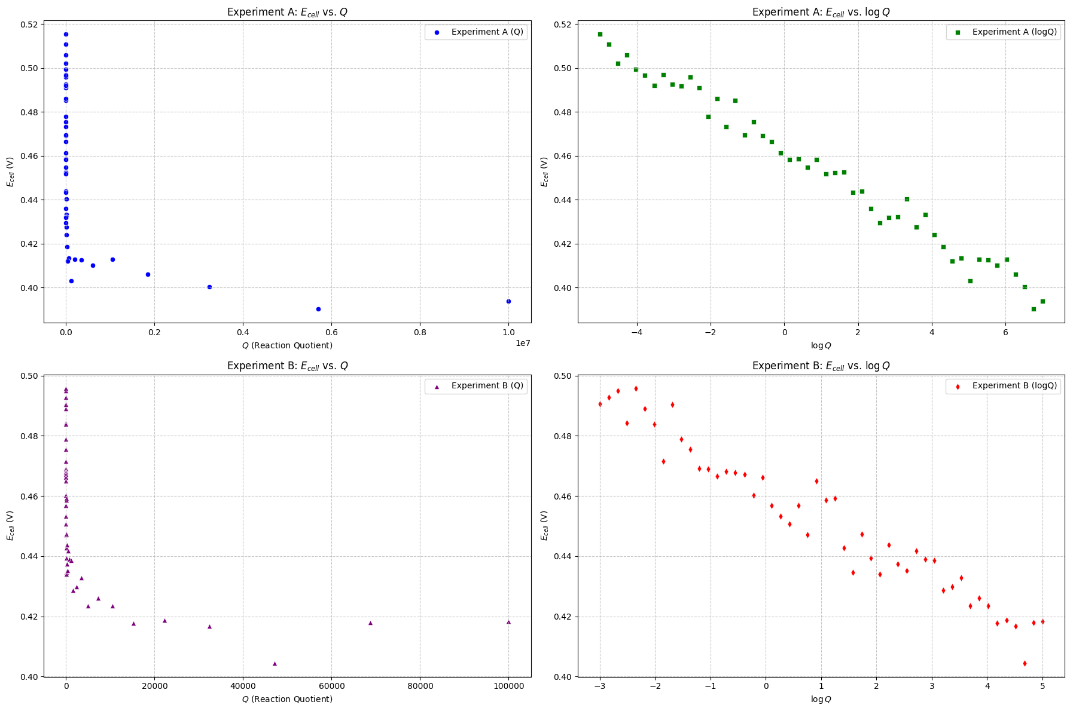

- How does the shape of the $E_{cell}$ vs $Q$ plot differ from the $E_{cell}$ vs $\log{Q}$ plot?
The plot of $E_{\text{cell}}$ versus $Q$ is non-linear: as $Q$ increases, $E_{\text{cell}}$ drops quickly at first and then levels off. In contrast, the plot of $E_{\text{cell}}$ versus $\log{Q}$is approximately linear. This matches the Nernst equation and makes it easier to interpret the data, since the slope and intercept have clear physical meaning.

- Explain why the relationship between $E_{cell}$ and $\log{Q}$ is expected to be linear based on the Nernst equation. What does the slope and intercept of this line represent physically?
The Nernst equation,
$$E=E^{∘}-\frac{0.0592}{n} ln⁡Q,$$
can be rewritten in the linear form $y=mx+b$. In this form, $y=E$ and $x=ln⁡Q$, so the slope is $m=-\frac{0.0592}{n}$and the y-intercept is $b=E^{∘}$.
This means that the y-intercept of a plot of $E$versus $\ln{Q}$gives the standard cell potential, $E^{∘}$, while the slope is related to the number of electrons transferred. Specifically, the number of electrons can be determined from the slope using
$$n=\frac{0.0592 V}{∣\text{slope}∣}.$$
- Compare the two experiments: Does varying the anode concentration produce similar trends as varying the cathode concentration? Explain any differences.
Both experiments produced similar trends in how cell potential changes with the reaction quotient and the logarithm of the reaction quotient, since both are governed by the Nernst equation.

Q.3.3. Prompt Gemini to perform a linear regression analysis for each $E_{\text{cell}}$versus $\log{Q}$subplot. Overlay the best-fit line on the corresponding plot and display the associated fit parameters (slope and intercept). Present only the updated plots showing both the data and the regression results. Once the codes finish processing, right click the images and paste them below:

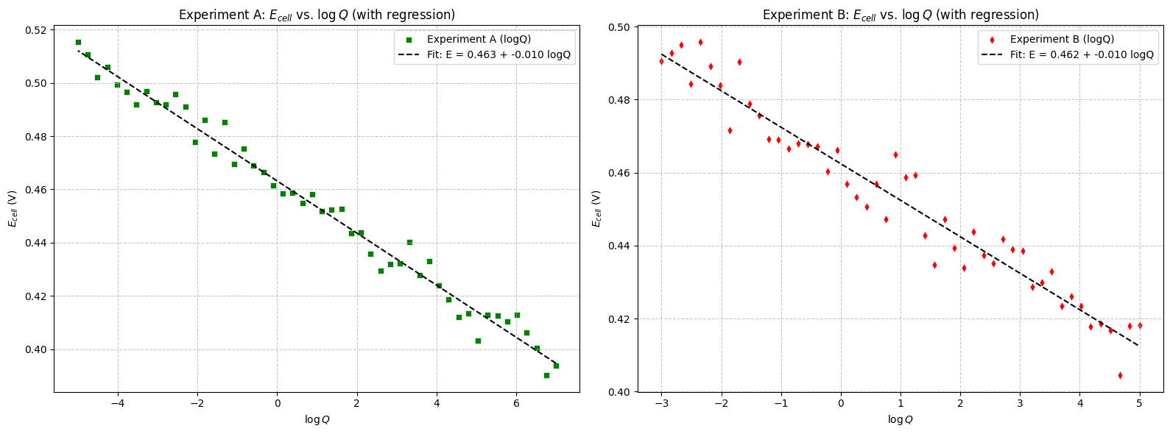

Record the results of the linear regressions in the table below:
 | Slope | Y-intercept | R-squared
Experiment A | -0.0098 V | 0.4632 V | 0.9827
Experiment B | -0.0100 V | 0.4624 V | 0.9470

- Compare the two experiments: Do they produce similar slopes and y-intercepts in the $E_{cell}$ vs $\log{Q}$ plot? Explain any differences.
Yes, both experiments yield similar slopes and y-intercepts. However, Experiment A shows a higher $R^{2}$value, indicating an overall better linear fit.

Q.3.4. Use your plotted data to estimate the standard cell potential, the number of moles of electrons transferred, the equilibrium constant, and the maximum amount of work performed by this voltaic cell. Clearly show all steps and equations used. Do not ask Gemini to calculate or identify these values for you.

- Use the average slope of the $E_{cell}$ vs $\log{Q}$ plot to calculate the number of moles of electrons ($n$) transferred in the overall redox reaction. Do they agree with the $n$ predicted from Q.1.2.?

$$average slope=\frac{\left(-0.0098V\right)+\left(-0.0100V\right)}{2}=-0.0099 V$$

$$n=\frac{0.0592V}{∣\text{slope}∣}=\frac{0.0592V}{∣\text{-0.0099}\text{V}∣}=5.98$$

6 moles of electrons are transferred in the overall redox reaction. This agrees with the prediction from Q.1.2.

- Use the average y-intercept of the $E_{cell}$ vs $\log{Q}$ plot to determine the standard cell potential. Do they agree with the $E^{∘}$ predicted from Q.1.2.?

$$average intercept=\frac{\left(0.4632+0.4624\right)V}{2}=0.4628 V$$

The value of $E^{∘}$obtained from the plotted data is 0.4628 V, which is in close agreement with the value of 0.463 V predicted from Q.1.2.

- Determine the equilibrium constant ($K$) for your assigned voltaic cell.

$$E°=\frac{0.0592}{n}\log{K} ⇒0.4628=\frac{0.0592}{6}\log{K} ⇒\log{K}=46.9⇒K=8.04 ×{10}^{46}$$

- Determine the maximum amount of work done by your assigned voltaic cell.

$$∆G°=-nFE°=-\left(6\right)96485 \left(C∙{mol}^{-1}\right)\left(0.4628V\right)=-267.9 kJ/mol$$
The maximum amount of work done by the cell is 267.9 kJ/mol.

Part 4: Reflection:
Q5.1. Which part of the activity—AI-assisted prompts, data interpretation, or applying the chemistry concepts—was easiest and which was most difficult?

Q5.2. Describe a mistake you encountered and how you corrected it. What clues or feedback helped you recognize the error and make the adjustment?

Final Notes about Grading:
In addition to completing the guiding questions, your TA will check that you followed the activity instructions. Submit shareable links to your Colab Notebook as part of your participation. To share your Colab notebook:
- Rename your copy: Change the filename to include YOUR name (the student's name), not your instructor's name.
- Share your notebook: Set the sharing permissions so that anyone with the link can view.
- Copy and paste your share link into the Exit Form.

