Week 1 Recitation: Modeling Reaction Kinetics

This module is designed for students to use Google Colab, Gemini, and Python programming language to read, interpret, and analyze kinetics data for organic reactions.

Written by Dr. Linlin Jensen

AI Use Disclaimer: This module is created with the assistance of Google Gemini.

Learning Objectives
By the end of this recitation, you will be able to:
- Scientific Skills
  - Data Interpretation: Show theoretical reactant concentrations in a table and in a graph. Predict the half-life of first or second order reactions from concentration/time data.
  - Graphical Representation: Visualize the differences between 1st and 2nd order kinetic rate laws using Python modeling.
  - Mathematical Modeling: Discriminate between theoretically generated models to determine which one best matches the experimental data. Determine the reaction orders by comparing the experimental and theoretical graphs.
- Cyberinfrastructure Skills
  - Data Handling: Import and load a CSV file into a Pandas DataFrame.
  - Python Programming:
    - Access and open a notebook in Google Colab
    - Identify and use the key components of the Google Colab interface (code cells, text cells, run button).
    - Read and understand a Python script with comments.
    - Run a Python script and interpret its output.
  - Data Cleaning/Transformation: Create new columns using mathematical models.
  - Data Visualization: Generate a scatter plot and a linear regression line using Python libraries (e.g., Pandas, Matplotlib, NumPy/SciPy).
  - Computational Analysis: Perform a linear fit to find the slope and intercept.
  - AI Literacy: Formulate effective and specific prompts to get the most out of an AI assistant.

Getting Started

Download Files and Open Google Colab

Your assigned molecule for this activity is: ___Acetaldehyde_____
- Download the Colab notebook file (.ipynb) and the corresponding .csv file for your assigned molecule from your recitation Canvas course. Once downloaded, these files will typically appear in your computer’s Download folder.
- Open your web browser and go to https://colab.research.google.com/.
- Sign in with your Google account. If you don't have one, create a free account to continue.

Open the Notebook in Colab:

On the Colab homepage, select File -> Open notebook.

Choose the Upload table and upload the downloaded .ipynb file.

Upload the Experimental Data to Colab Worksheet.
- In the left sidebar, click the folder icon to open the file browser.
- Use the Upload button to add your .csv data file. Once uploaded, it will appear under the file list (below the subfolder sample_data).
Read and Verify the Experimental Data
- Run the Gemini provided code to load the data.
- After the cell finishes executing, review the printed concentration and time values. Confirm that the displayed data matches the contents of your .csv file

Step 1: Predicting half-life from experimental data
The half-life ($t_{1/2}$) of a reaction is the amount of time required for the reactant concentration to decrease to half of its initial value.
Q1.1. Using your experimental data, estimate the reaction’s half-life ($t_{\frac{1}{2}}$).
t = 0: [A]₀ = 0.00303 M; ½ [A]₀ = 0.001515 M.
$t_{1/2}$ should be between 120 min ([A] = 0.002301 M) and 360 min ([A] = 0.001364 M).
Q1.2. Prompt Gemini to determine the reaction’s half-life. What is the half-life Gemini predict for this reaction?
321.32 min
Q1.3. Do your estimated value and Gemini’s value agree? If not, which estimate is more reliable? Explain your reasoning based on the data.
Gemini prediction falls within the expected range for $t_{1/2}$.

Step 2: Calculating and Plotting Concentrations for 1st & 2nd Order Kinetics

Determine the 1st and 2nd order rate constants
The rate constants ($k_{1}$, $k_{2}$) relate to the half-life through the following equations:
$t_{1/2}=\frac{\ln{2}}{k_{1}}$ 1st order half-life equation
$t_{1/2}=\frac{1}{k_{2} {\left[A\right]}_{0}}$ 2nd order half-life equation

Where ${[A]}_{0}$ stands for the initial concentration of the reactant.

Q2.1. Prompt Gemini to determine the rate constants based on 1st and 2nd order kinetics. Record the rate constants below:
1st order rate constant ($k_{1}$): 2.157264 x 10^{–3} min^{–1}
2nd order rate constant ($k_{2}$): 1.027106 M^{–1} min^{–1}

Calculate theoretical concentrations for 1st and 2nd order kinetics
The reactant concentrations relate to the time through the following equations:
$\left[A\right]= {\left[A\right]}_{0}e^{-k_{1}t}$ (1st-order Integrated Rate Law)
$\left[A\right]= {\left(\frac{1}{{\left[A\right]}_{0}}+k_{2}t\right)}^{-1}$ (2nd-order Integrated Rate Law)

Q2.2. Carefully review Gemini’s output. Which theoretical reaction order more closely matches the experimental data?

2nd order

Plot reactant concentrations vs. time
Q2.3. After the codes finish processing, the plot will appear below the cell. Right-click the image and paste it in the space below:
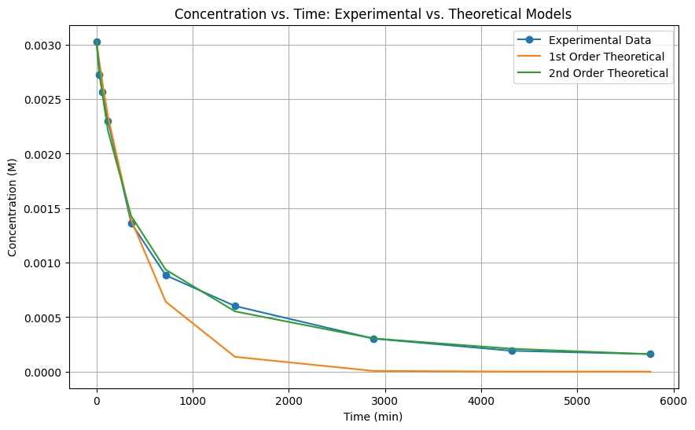

Q2.4. Based on the plot, which reaction order (1st or 2nd) better matches the experimental data?
2nd order

Step 3: Using Linear Form of Rate Laws to Find Reaction Order
The linear forms of the integrated rate laws for 1st and 2nd order reactions are:
$\ln\left[A\right]=-kt+\ln{{\left[A\right]}_{0}}$ (1st-order Integrated Rate Law)
$\frac{1}{\left[A\right]}=kt+\frac{1}{{\left[A\right]}_{0}}$ (2nd-order Integrated Rate Law)

Calculate ln[A] and 1/[A]
Q3.1. Carefully review Gemini’s output. what patterns do you notice in the ln[A] and 1/[A] values?

As t increases, ln[A] decreases, while 1/[A] increases.

Create a three-panel plot with linear regression fit
Q3.2. After the codes finish processing, you will see a plot with three subplots printed right below the code cell. Right-click on the image and paste it in the space below:

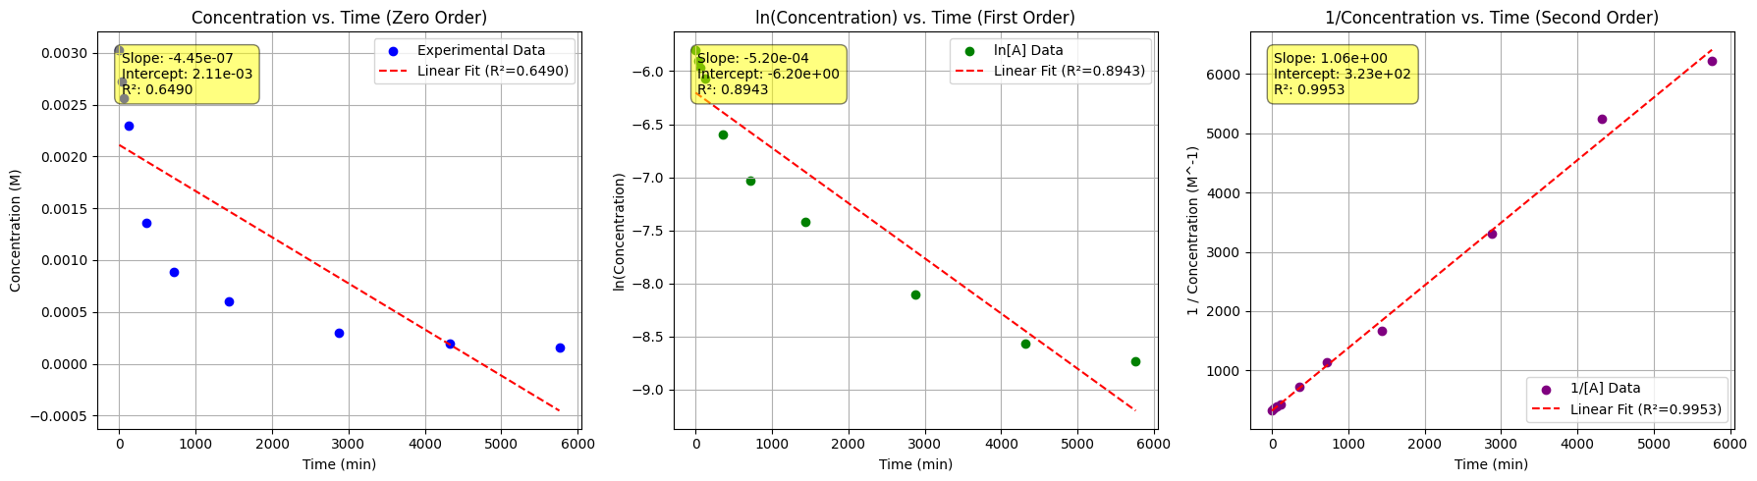

Q3.3. Record the results of the linear regressions for the three subplots in the table below:

 | 0 Order  Linear Regression | 1st Order  Linear Regression | 2nd Order  Linear Regression
Slope: | - 4.45 x 10^{–7} M | - 5.20 x 10^{–4} min^{–1} | 1.06 M^{–1} min^{–1}
y-intercept: | 2.11 x 10^{–3} M | -6.20 M | 3.23 x 10² M^{–1}
$R^{2}$: | 0.6490 | 0.893 | 0.9953

Q3.4. Consider the subplot with the best linear fit (highest $R^{2}$ value):
- Determine the reaction order: 2nd order
- Determine the reaction’s rate constant: k = slope = 1.06 M^{–1} min^{–1}

Calculate half-life from the determined reaction order
Q3.5. Record the Gemini results below:
- Theoretical reaction order: 2nd order
- Theoretical rate constant: 1.055989 M^{–1} min^{–1}
- Theoretical half-life: 312.53 minutes

Q3.6. What are the advantages and disadvantages of using the linear forms of the 1st and 2nd order rate laws?
Advantages: The linear forms make it easy to identify reaction order and determine $k$ from the slope of a straight-line plot.

Disadvantages: Need to manually test multiple plots. Transforming data into $ln⁡[A]$or $1/[A]$can amplify experimental error and make the results less accurate

Step 4: Reflection:
Q4.1. Which part of the activity—AI-assisted prompts, data interpretation, or applying the chemistry concepts—was easiest and which was most difficult?

Q4.2. Describe a mistake you encountered and how you corrected it. What clues or feedback helped you recognize the error and make the adjustment?

Final Notes about Grading:
In addition to completing the guiding questions, your TA will check that you followed the activity instructions. Submit shareable links to your Colab Notebook as part of your participation. To share your Colab notebook:
- Rename your copy: Change the filename to include YOUR name (the student's name), not your instructor's name.
- Share your notebook: Set the sharing permissions so that anyone with the link can view.
- Copy and paste your share link into the Exit Form.

