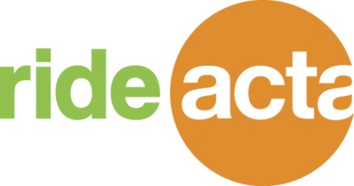

**ATTENTION: RIDEACTA SHUTTLE RIDERS**

**Beginning Sunday November 22, 2015**

* + RideACTA Sunday shuttle hours will be expanded. Service will operate from **6:00am – 6:00pm**

**Beginning Saturday November 28, 2015**

* + RideACTA Saturday shuttle hours will be expanded. Service will operate from 6:00am – 11:00pm

**Beginning Sunday November 22, 2015**

* New FEDEX Clinton schedule. Ask your employer or shuttle driver for the new flyer.

**There will be NO RideACTA shuttle service**

* Thanksgiving Day / November 26, 2015
* Christmas Day /December 25, 2015

**Please remember …**

**Pay your $.025 as you board the shuttle. Riders not paying a fare will be denied a ride.**

* There is no need to call for a ride when you arrive at the IKEA Stop. If the shuttle is not there it will arrive back shortly.
* **DO CALL Dispatch IN ADVANCE** to schedule your pick–up/ return trip. Last minute calls cannot be fit into the pick-up schedule. Dispatch number is 412-442-4773.
* Be patient, courteous and respectful to dispatchers, drivers

and fellow passengers. Holiday traffic and weather can cause delays.

A new RideACTA Holiday flyer will be distributed in mid-December. This will outline RideACTA shuttle operation through January 3, 2016.