SỞ GIÁO DỤC VÀ ĐÀO TẠO HÀ NỘI  TRƯỜNG THPT ĐOÀN THỊ ĐIỂM  --------------------  (Đề thi có 4 trang) | MOCK TEST 1  NĂM HỌC 2025 - 2026  Môn: Tiếng Anh; Lớp: 10  Thời gian làm bài: 60 phút  (không kể thời gian phát đề)

Họ và tên: ............................................................................ | Số báo danh: ....... | Mã đề: 204
A. MULTIPLE-CHOICE QUESTIONS
For questions 1 to 29, fill in your answers on the multiple-choice answer sheet below.
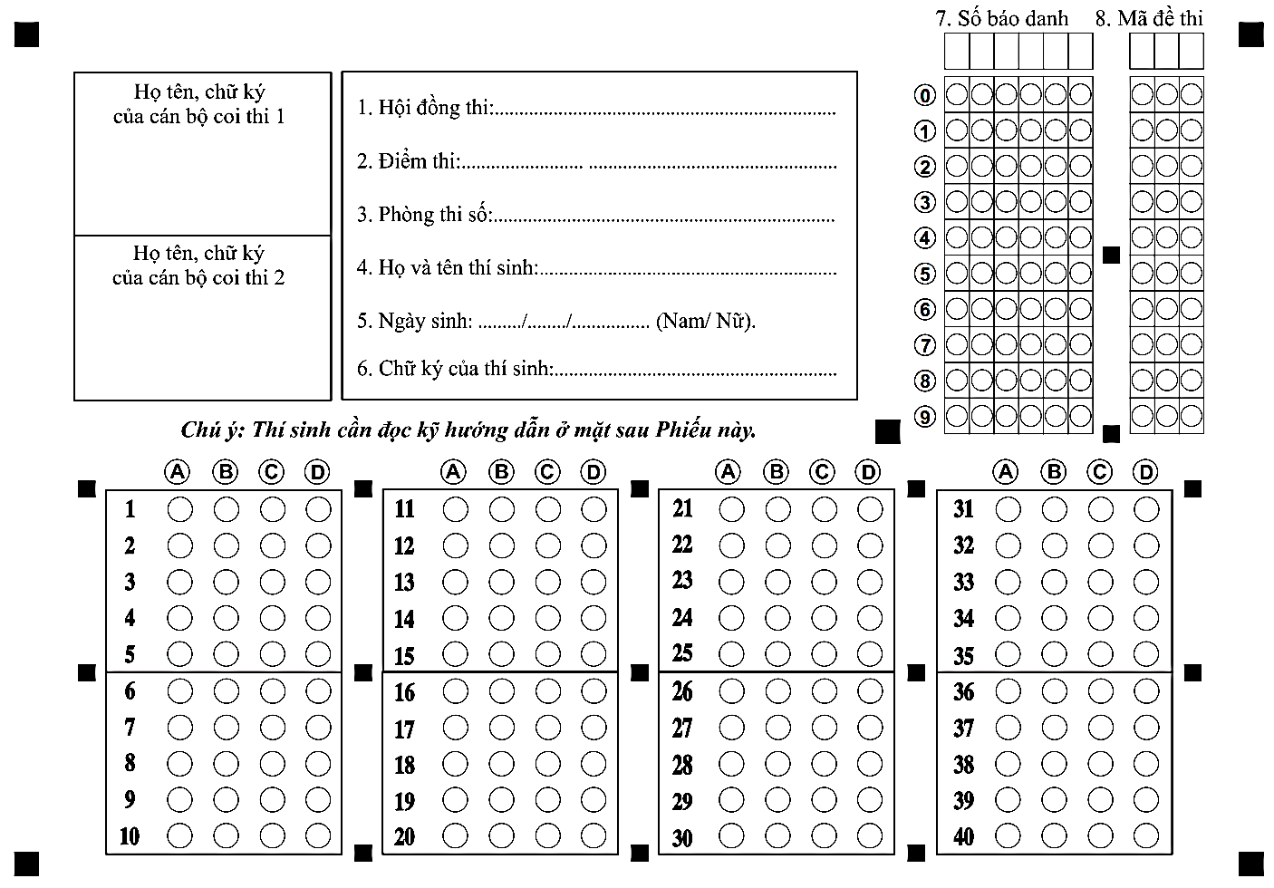
B. WRITTEN RESPONSE QUESTIONS
For question 30 – 40, write your written responses in the answer sheet below.
Question | Answer | Question | Answer
 |  | 34.
31. |  | 35.
32. |  | 36.
33. |  | 37.

38. | ………………………………………………………………………………………………...  ………………………………………………………………………………………………...
39. | ………………………………………………………………………………………………...  ………………………………………………………………………………………………...
40. | ………………………………………………………………………………………………...  ………………………………………………………………………………………………...

A. MULTIPLE-CHOICE QUESTIONS
You will hear a conversation between a boy, Frank, and a girl, Linda, in a music shop. Decide if each sentence is True or False.
Question 1. Linda wants to change a cassette because she dislikes it.
A. True B. False
Question 2. Linda already knows what she wants to get.
A. True B. False
Question 3. Frank recommends a famous band.
A. True B. False
Question 4. Linda is happy with her cassette player.
A. True B. False
Question 5. Linda thinks the price of the cassette is reasonable.
A. True B. False
Question 6. Linda has already seen the Irish band
A. True B. False
You will hear a woman called Sarah talking to a group of people about her painting. For each question, choose the correct answer A, B or C.
Question 7. How often does Sarah paint now?
A. three days a week B. five days a week C. every evening
Question 8. When she was at primary school, Sarah
A. painted pictures of people. B. learnt to use chalk. C. drew scenes in pencil.
Question 9. What pleased Sarah most about her painting holidays?
A. meeting other artists B. seeing beautiful scenery C. receiving individual teaching
Question 10. After watching Sarah's video, the audience will
A. fill in a questionnaire about the talk. B. look round an art exhibition. C. have a break and a drink.

Mark the letter A, B, C, or D on your answer sheet to indicate the correct answer to each of the
following questions.
Question 11. Stop using plastic bag is one way to reduce carbon ___________ .
A. mark B. shoesmark C. footprint D. footstep
Question 12. It’s my responsibility to ___________ my sister when my parents are away.
A. look into B. look after C. take after D. run after
Mark the letter A, B, C, or D on your answer sheet to indicate the word whose underlined part differs from that of the other three in pronunciation in each of the following questions.
Question 13. A. pesticide B. electric C. benefit D. vegetable
Mark the letter A, B, C, or D on your answer sheet to indicate the word that differs from the other
three in the position of stress in each of the following questions.
Question 14. A. maintain B. nurture C. sustain D. collect
Choose the correct word to complete the text.
FAMILY CLUB
Join our Family Club and spend more time together with the people you love. Every Friday evening, families (####) _____ at the library to share stories, read books, and do fun activities such as drawing, puzzles, and short plays. Children can learn new skills, and parents can talk to each other about daily life, school, or work.
Last month, the club (####) _____ a big picnic in the park for more than 50 families. Family Club is a great way to build stronger family bonds and create happy memories. Everyone is welcome to join us this week!
Question 15. A. meets B. meet C. met D. meeting
Question 16. A. holds B. held C. will hold D. is holding
Choose the correct answer to complete the text.
Many large cities around the world have struggled to keep up with the increase in traffic jam in recent times. Densely populated areas, growing car ownership, as well as narrow roads brought for much lower volumes of traffic all contribute (####) _____ this. In 1975, Singapore (####) _____ to introduce a congestion charge a fee paid by drivers entering the most traffic-heavy zones of the city. London introduced a congestion charge in 2003. (####) _____ opinions were first against the idea, but people soon became more (####) _____ of the scheme. Despite this, its first decade brought mixed success, and the number of cars in the city fell by only 10%. However, the scheme proved massively profitable, which allowed the city council to invest in other measures aimed at improving (####) _____ conditions in London. These included cycle lanes, pedestrianized areas and better road surfaces.
Question 17. A. in B. from C. at D. to
Question 18. A. has decided B. decides C. was deciding D. decided
Question 19. A. Many B. Much C. Lot of D. Little
Question 20. A. supporter B. unsupported C. supportive D. support
Question 21. A. rural B. water C. traffic D. division
Rearrange the sentences to make a meaningful paragraph/letter/dialogue in each of the following questions.
Question 22. a. Noah: I’ll check. If not, I can run to the store quickly.
b. Noah: Good idea. Let’s make something simple for dinner tonight.
c. Emma: Let’s split the task to prepare for the party. I’ll do the cooking if you don’t mind setting the table.
d. Emma: Sure, pasta sounds perfect. Do we have enough sauce?
A. b-c-a-d B. c-b-d-a C. d-a-c-b D. a-b-d-c
Question 23. Hi Sophie,
a. That time I was organizing the bookshelves while my brother was vacuuming the living room.
b. Anyway, I hope school isn’t keeping you too busy these days.
c. How are you? I’m writing to tell you about my family clean-up day last week.
d. Do you and your family also share the housework?
e. After that, I realize it’s faster to do chores as a team.
See you soon,
Ella
A. a-e-c-d-b B. c-a-e-d-b C. c-a-b-d-e D. a-b-d-c-e
Question 24. a. For example, we can recycle by separating paper, glass, and plastic.
b. Recycling is one of the simplest ways we can help protect the environment.
c. Another method is composting food waste instead of throwing it away.
d. Schools and communities should teach people how to recycle correctly.
e. By doing so, we reduce pollution and conserve resources.
A. b-c-a-d-e B. e-a-d-c-b C. b-a-c-d-e D. a-b-c-d-e
Read the following passage and mark the letter A, B, C, or D to indicate the correct answer to each of the questions.
The everyday things that families do together can help build strong relationships with teenagers. Regular family meals are a great chance for everyone to chat about their day, or about interesting things that are going on or coming up. If parents encourage everyone to have a say, no one will feel they’re being put on the spot to talk. Also, many families find that meals are more enjoyable when the TV isn’t turned on!
We should all take turns choosing outdoor activities for our families. A relaxing holiday or weekend away together as a family can also build togetherness. Spending time with children gives parents the chance to stay connected and enjoy each other’s company. Sometimes, it’s just a matter of watching the children play sports or listen to their favorite music or drive them somewhere. It can also be a chance to share thoughts and feelings. Parents should celebrate children’s achievements, share their disappointments, and show interest in their hobbies.
Family traditions, routines and rituals can help parents and their children set aside regular dates and special times. For example, we might have a movie night together, a favourite meal or cooking session on a particular night, a family games afternoon or an evening walk together. Agreed household responsibilities give kids of all ages the sense that they’re making an important contribution to family life. These could be things like chores, shopping or helping older or younger members of the family.
Question 25. What is the main idea of the passage?
A. The ways families can strengthen family bonds B. The best holidays for parents and children
C. The problems teenagers face in family life D. The importance of family rules and disciplines
Question 26. According to the passage, decide if the following statement is TRUE or FALSE:
“Parents can connect with their children by watching them playing sports.”
A. True B. False
Question 27. What can help build strong relationships with teenagers during family meals?
A. Planning special topics to discuss each day B. Encouraging everyone to share
C. Having structured discussions about school D. Making sure meals last at least 30 minutes
Question 28. According to the passage, decide if the following statement is TRUE or FALSE:
“Family traditions and rountines are the only ways for family to spend time together.”
A. True B. False
Question 29. Which of the following is CLOSEST in meaning to the word “routines” in paragraph 3?
A. habits B. holidays C. difficulties D. surprises

Circle one mistake in each sentence and write your corrections.
Question 30. Parents are responsible to the household chores, so they try to split the work equally and set a good example to their children.
Question 31. Look! Many volunteers clean the beach near the village at the moment, and some of them are collecting plastic bottles to recycle.
Rewrite the following sentences so that they have a similar meaning to the first ones. You must use BETWEEN THREE AND FIVE WORDS.
Question 32. Look! The baby is very tired and keeps closing his eyes. I think he will fall asleep soon. (GOING)
→ The baby ……………………………………………… asleep soon.
Question 33. I last saw my grandparents two months ago. (SEEN)
→ I ……………………………………………… for two months.
Fill in each blank with the correct form of the verbs provided.
Question 34. We _____________ five books about the environment since September. (READ)
Question 35. By the time the teacher asked us yesterday, we _____________ about the Earth Hour campaign. (NOT HEAR)
Give the correct form of words in capitals.
Question 36. There are usually many types of animals that ___________ after a forest fire. (APPEAR)
Question 37. She has taken on many ___________ ever since her mother passed away. (RESPONSIBLE)
Rearrange the words to make meaningful sentences.
Question 38. children / help / chores / independence. / develop / Household / can/
Question 39. on Earth/ ecosystem/ are/ important/ balance/ the / Forests/ to/
Question 40. vegetables/ in/ our garden/ He/ grows/ to/ food. / healthy/ have/

