Regression and Classification on Tabular Data with PyTorch, ONNX and GitHub Pages
Student: Hoang Thien Thanh Le (Tea)
Course: ITS 52000 – Applied Machine Learning, Purdue University Northwest
Live demo: https://acteavity.github.io/ml-onnx-deploy/
Code: https://github.com/acteavity/ml-onnx-deploy

1. Overview
Two complete machine-learning pipelines were built on public tabular datasets: a regression model that predicts concrete compressive strength and a classification model that predicts diabetes. For each task five PyTorch architectures discussed in class were trained with the same loop and compared — a linear model, a one-hidden-layer MLP, a deeper network with dropout, the F1+F2 (linear + non-linear) model and a residual network. Each architecture was trained with five random seeds and the deployed model was selected on a held-out validation set, so the test set is used only for the final report. Following the class deployment example, all pre-processing statistics are stored inside the model, which is exported with torch.onnx.export (opset 15, input1 → output1) and executed in the browser with onnxruntime-web on GitHub Pages.

2. Part 1 — Regression: Concrete Compressive Strength

2.1 Data
The Concrete Compressive Strength dataset (Yeh, 1998; UCI repository) has 1030 laboratory samples with 8 numeric inputs — cement, blast-furnace slag, fly ash, water, superplasticizer, coarse and fine aggregate (kg/m³) and age (days) — and the target compressive strength in MPa. There are no missing values; 25 duplicated rows were removed so that identical samples cannot leak between the training and test sets. The data were split 70/15/15 into training (703), validation (151) and test (151) sets.
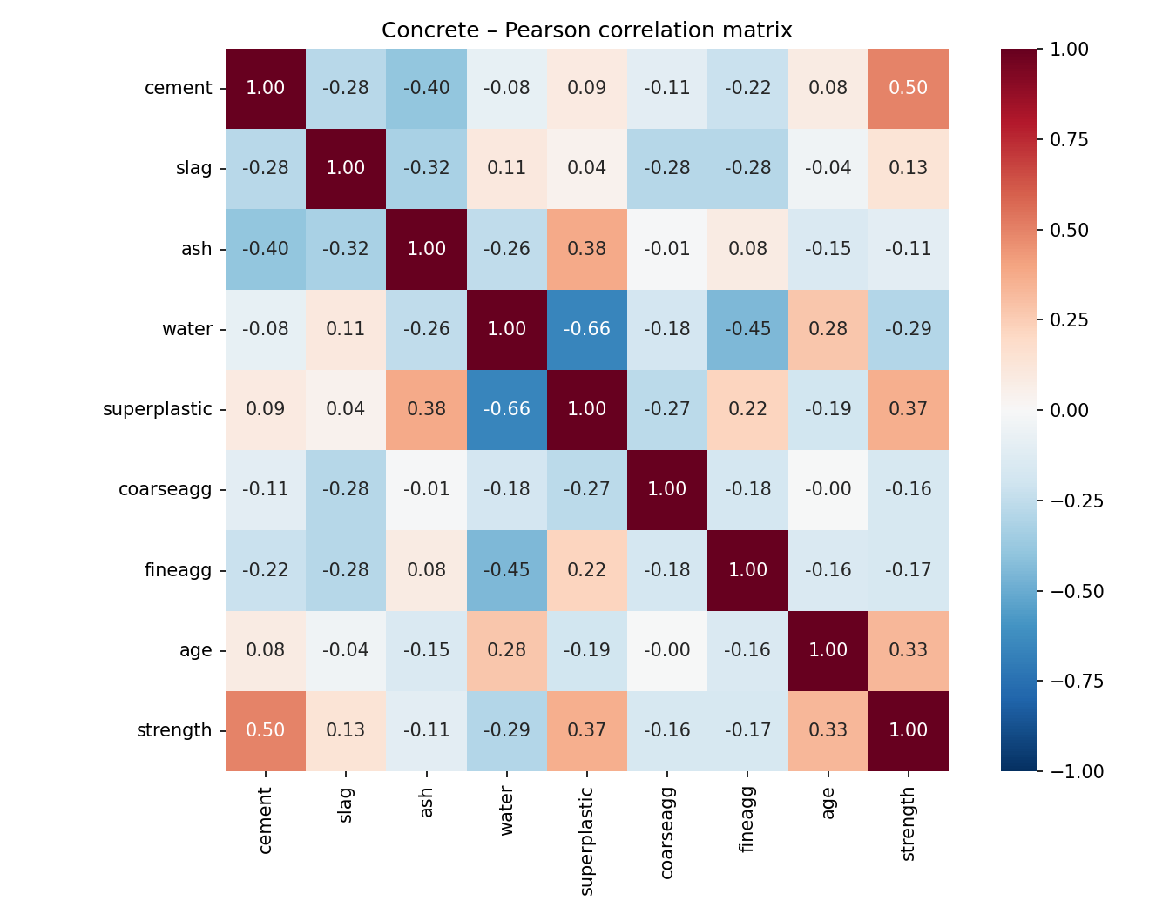
Correlation matrix
Cement (r = 0.50), superplasticizer (r = 0.37) and age (r = 0.33) correlate positively with strength, while water is negative (r = -0.29), reflecting the well-known water-to-cement ratio effect.

2.2 Processing
- Feature engineering: age is right-skewed (1–365 days) and strength gain saturates after about 28 days, so log(1 + age) is used (figure below).
- Standardization: inputs and target are z-scored with training-set means and standard deviations; the network predicts the scaled target and the output is de-scaled to MPa.
- Both steps are implemented inside forward(), so the ONNX file accepts raw values.
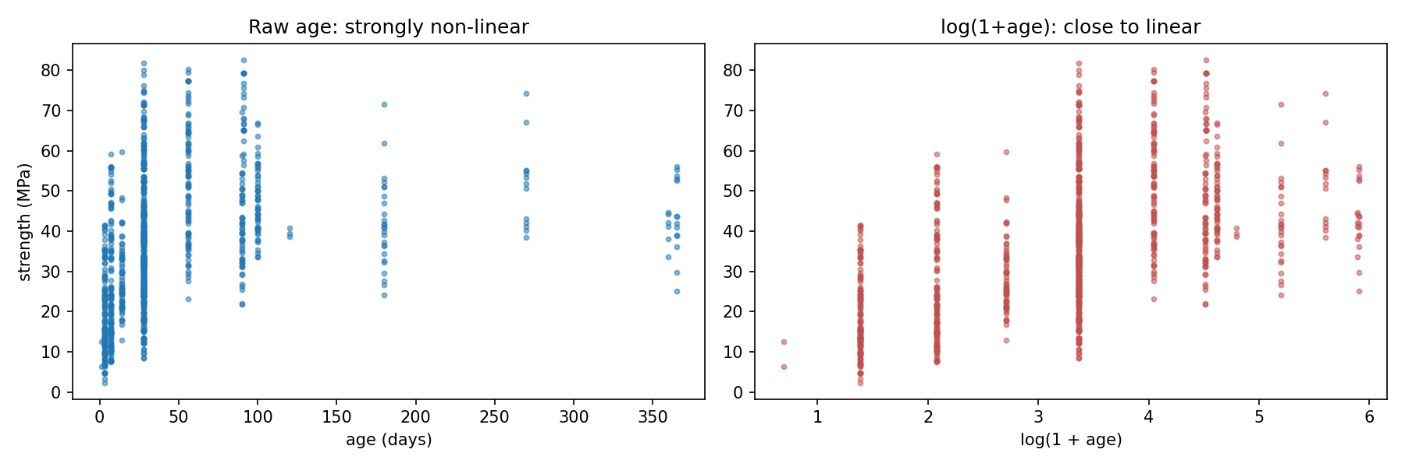
Age transform

2.3 Models and training
Loss MSE on the scaled target, Adam (lr 1e-3, weight decay 1e-5), batch 32, up to 2 000 epochs with early stopping on validation loss (patience 150) and restoration of the best weights.

2.4 Results
Model | Val R² | Test R² (mean ± std) | Test MAE (MPa) | Test RMSE (MPa) | Epochs
Linear | 0.812 | 0.764 ± 0.000 | 6.04 | 7.70 | 470
MLP | 0.910 | 0.900 ± 0.011 | 3.42 | 5.01 | 854
Deep NN | 0.905 | 0.911 ± 0.006 | 3.18 | 4.72 | 354
F1+F2 | 0.856 | 0.841 ± 0.009 | 4.97 | 6.32 | 1528
ResidualNet ★ | 0.917 | 0.916 ± 0.008 | 3.15 | 4.59 | 733
★ = deployed model (highest mean validation R²).
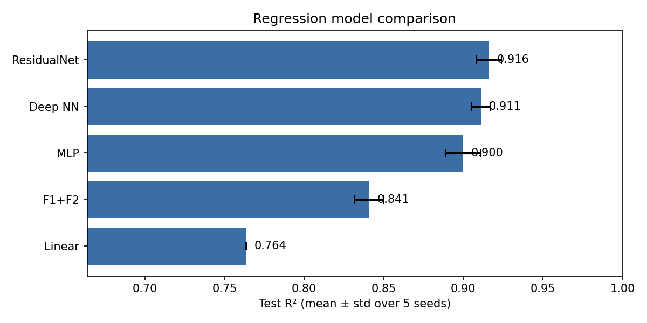
Model comparison
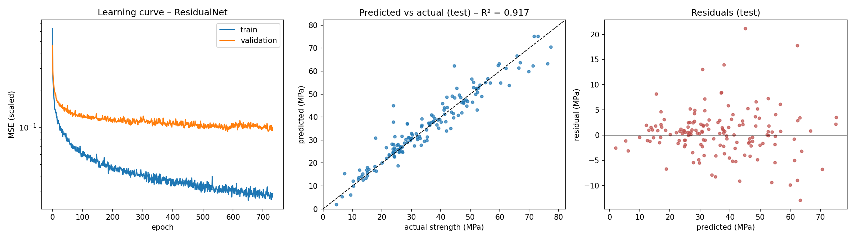
Diagnostics of the best model
The deployed ResidualNet reaches R² = 0.917 on the test set, with MAE = 3.11 MPa and RMSE = 4.56 MPa.

2.5 Analysis
- Non-linearity matters. The linear model explains 0.764 of the variance, while the best non-linear model (ResidualNet) reaches 0.916 — an improvement of 0.152 in R². Strength depends on interactions such as the water/cement ratio and on a saturating ageing curve, which a linear model cannot represent.
- Feature engineering is a cheap win. Replacing raw age with log(1+age) raised the linear model from R² = 0.506 to 0.764 and the MLP from 0.878 to 0.900. Domain knowledge narrows the gap between simple and complex models.
Model | raw age | log(1+age)
Linear | 0.506 | 0.764
MLP | 0.878 | 0.900
- Ranking of the networks. ResidualNet (0.916 ± 0.008), Deep NN (0.911 ± 0.006) and MLP (0.900 ± 0.011) are within about one standard deviation of each other, so their order should not be over-interpreted; all three clearly beat the Linear model. The Linear model has almost zero seed variance because its loss is convex and every seed converges to the same solution.
- F1+F2 underfits. The F1+F2 model (R² = 0.841) needed the most epochs (≈ 1 500) yet stayed well below the other networks: its non-linear branch has only 10 sigmoid units, which is not enough capacity for this problem. The linear part helps, but the small non-linear part limits the model.
- Generalization. The ResidualNet learning curve shows the training loss still decreasing while the validation loss levels off after about 300 epochs, a mild overfitting gap. Early stopping restored the best-validation weights, and the test R² (0.917) matches the validation R² (0.917), so the model generalizes well.
- Error pattern. In the predicted-vs-actual plot the points follow the diagonal across the whole 2–80 MPa range. Most residuals are within ±5 MPa with no visible trend against the prediction, so there is no systematic bias. A few large errors remain (up to +21 MPa, e.g. a ~24 MPa sample predicted at ~45 MPa); these are probably mixes with unusual recipes that are under-represented in the training data.
- Feature importance. Permutation importance ranks cement, age and slag as the most influential inputs. Shuffling cement drops R² by 1.41, which means R² becomes negative (worse than predicting the mean). This matches concrete engineering: strength is driven mainly by binder content (cement plus slag) and curing time. Slag has a weak linear correlation with strength (r = 0.13), yet it is the third most important input for the network, which shows that its effect is non-linear and depends on interactions with other inputs.
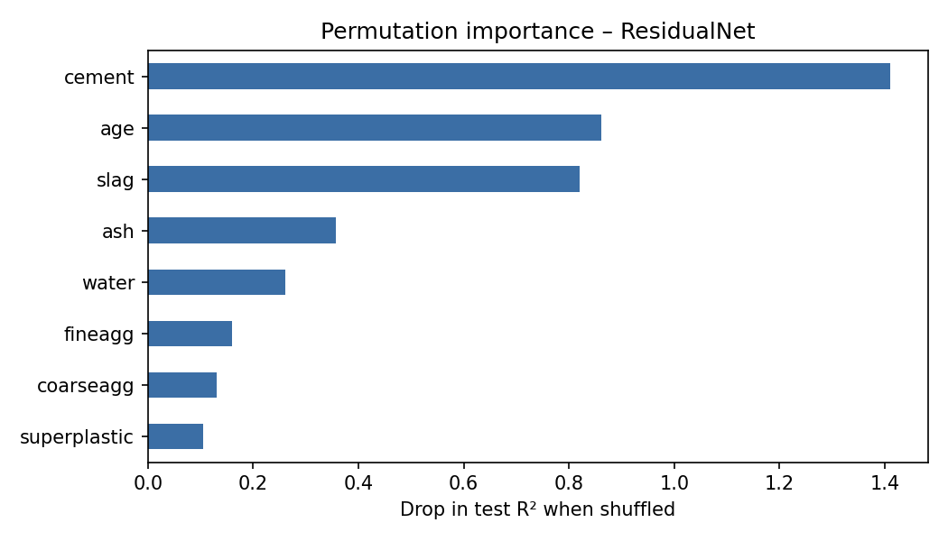
Permutation importance

3. Part 2 — Classification: Pima Indians Diabetes

3.1 Data
768 female patients of Pima heritage aged ≥ 21 years, 8 clinical inputs (pregnancies, 2-h plasma glucose, diastolic blood pressure, triceps skin-fold thickness, 2-h serum insulin, BMI, diabetes pedigree function, age) and a binary outcome (diabetes within five years). The classes are imbalanced: 500 negative vs 268 positive (34.9 % positive). A stratified 70/15/15 split gave 537 / 115 / 116 samples.
Hidden missing values. A value of 0 is physiologically impossible for glucose, blood pressure, skin thickness, insulin and BMI. Zeros appear 374 times for insulin and 227 times for skin thickness, so they were treated as missing.
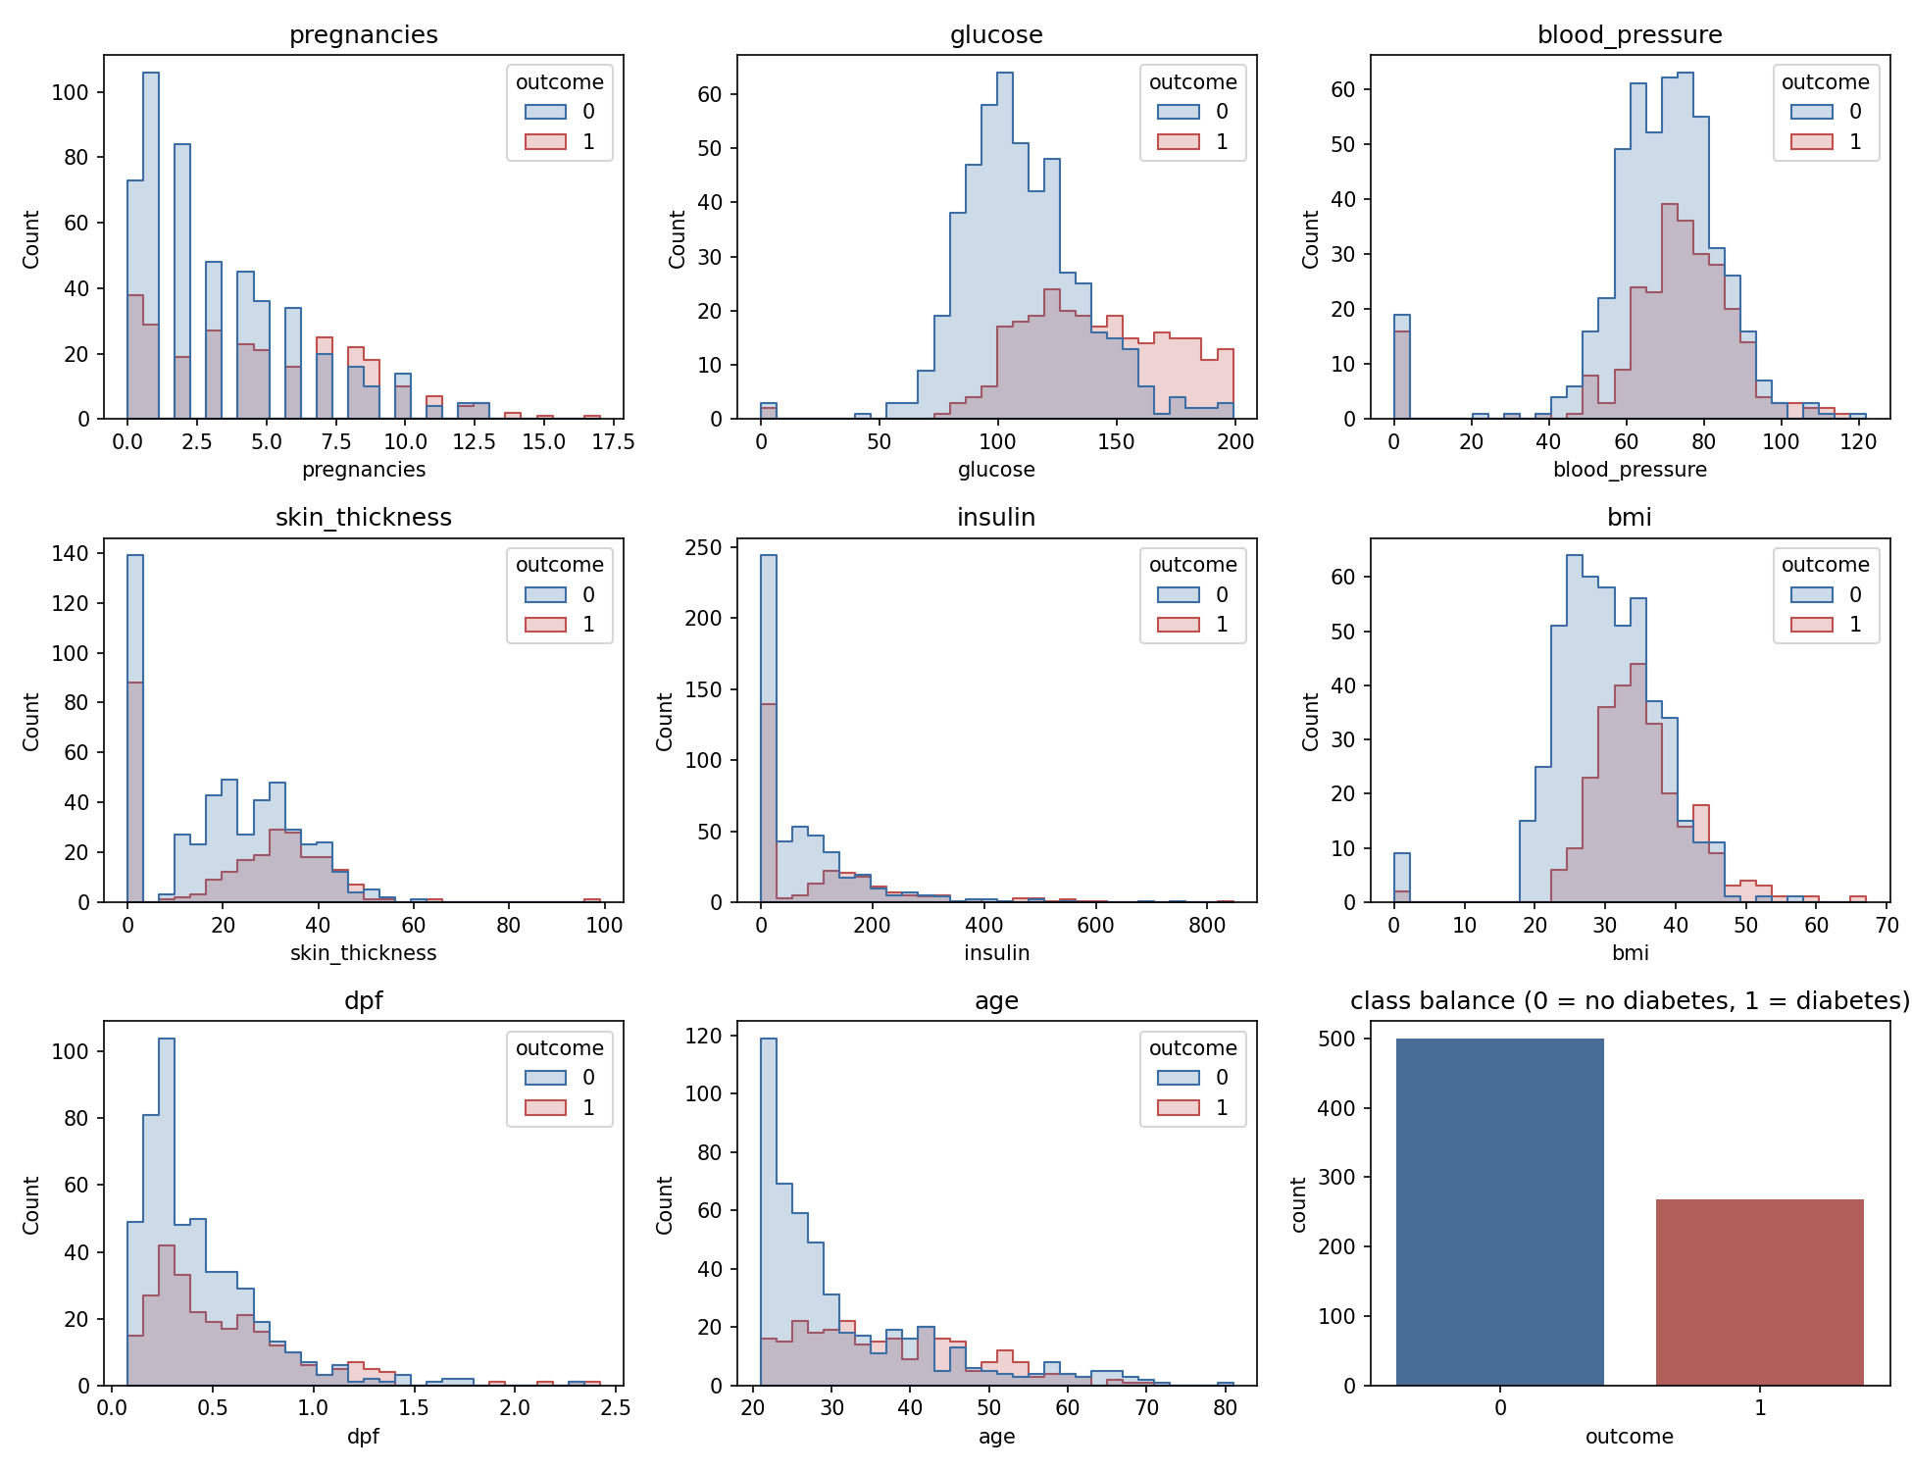
Distributions by class

3.2 Processing
- Zeros in those five columns are replaced by the median of the non-zero training values.
- Inputs are standardized with training-set statistics.
- The loss is class-weighted cross-entropy to counter the imbalance.
- Imputation and scaling are embedded in the model (torch.where + buffers), so the ONNX graph reproduces them in the browser; the exported model outputs softmax probabilities.
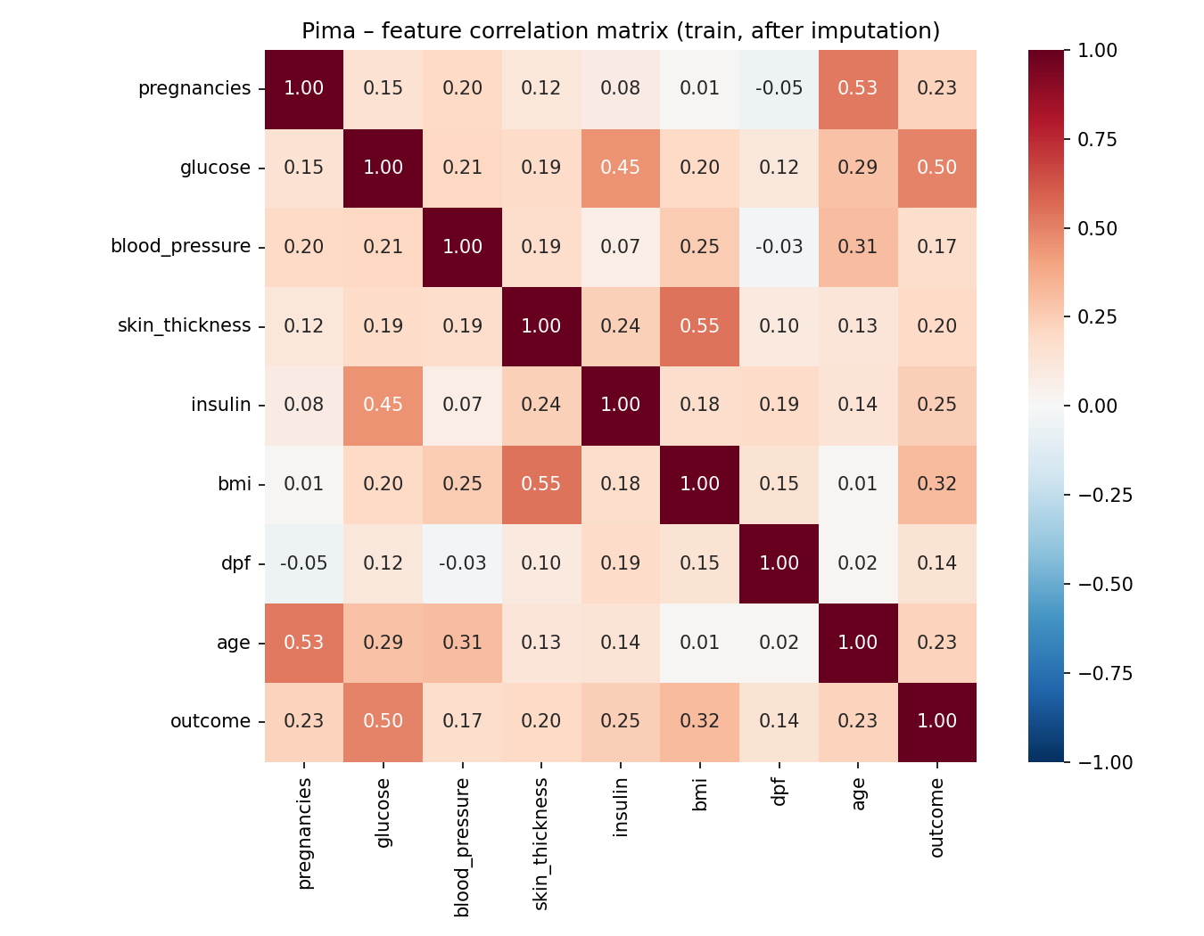
Correlation matrix
The correlation matrix shows that the outcome is most correlated with glucose (r = 0.50), BMI (r = 0.32) and insulin (r = 0.25). Among the inputs, BMI–skin thickness (r ≈ 0.55), age–pregnancies (r ≈ 0.53) and glucose–insulin (r ≈ 0.45) are the strongest pairs, but no pair is so highly correlated that a feature had to be dropped.

3.3 Models and training
Adam (lr 1e-3, weight decay 1e-4), batch 32, up to 1 000 epochs, early stopping on validation loss (patience 60), five seeds per architecture.

3.4 Results
Model | Val F1 | Test F1 (mean ± std) | Precision | Recall | Accuracy | MCC | ROC-AUC
Logistic Regression | 0.638 | 0.685 ± 0.020 | 0.698 | 0.673 | 0.781 | 0.518 | 0.859
MLP ★ | 0.653 | 0.700 ± 0.015 | 0.690 | 0.712 | 0.784 | 0.533 | 0.861
Deep NN | 0.649 | 0.692 ± 0.016 | 0.673 | 0.712 | 0.776 | 0.517 | 0.853
F1+F2 | 0.646 | 0.682 ± 0.012 | 0.696 | 0.668 | 0.779 | 0.514 | 0.856
ResidualNet | 0.647 | 0.698 ± 0.012 | 0.703 | 0.693 | 0.788 | 0.535 | 0.866
★ = deployed model (highest mean validation F1). F1, precision and recall refer to the diabetes class at threshold 0.5.
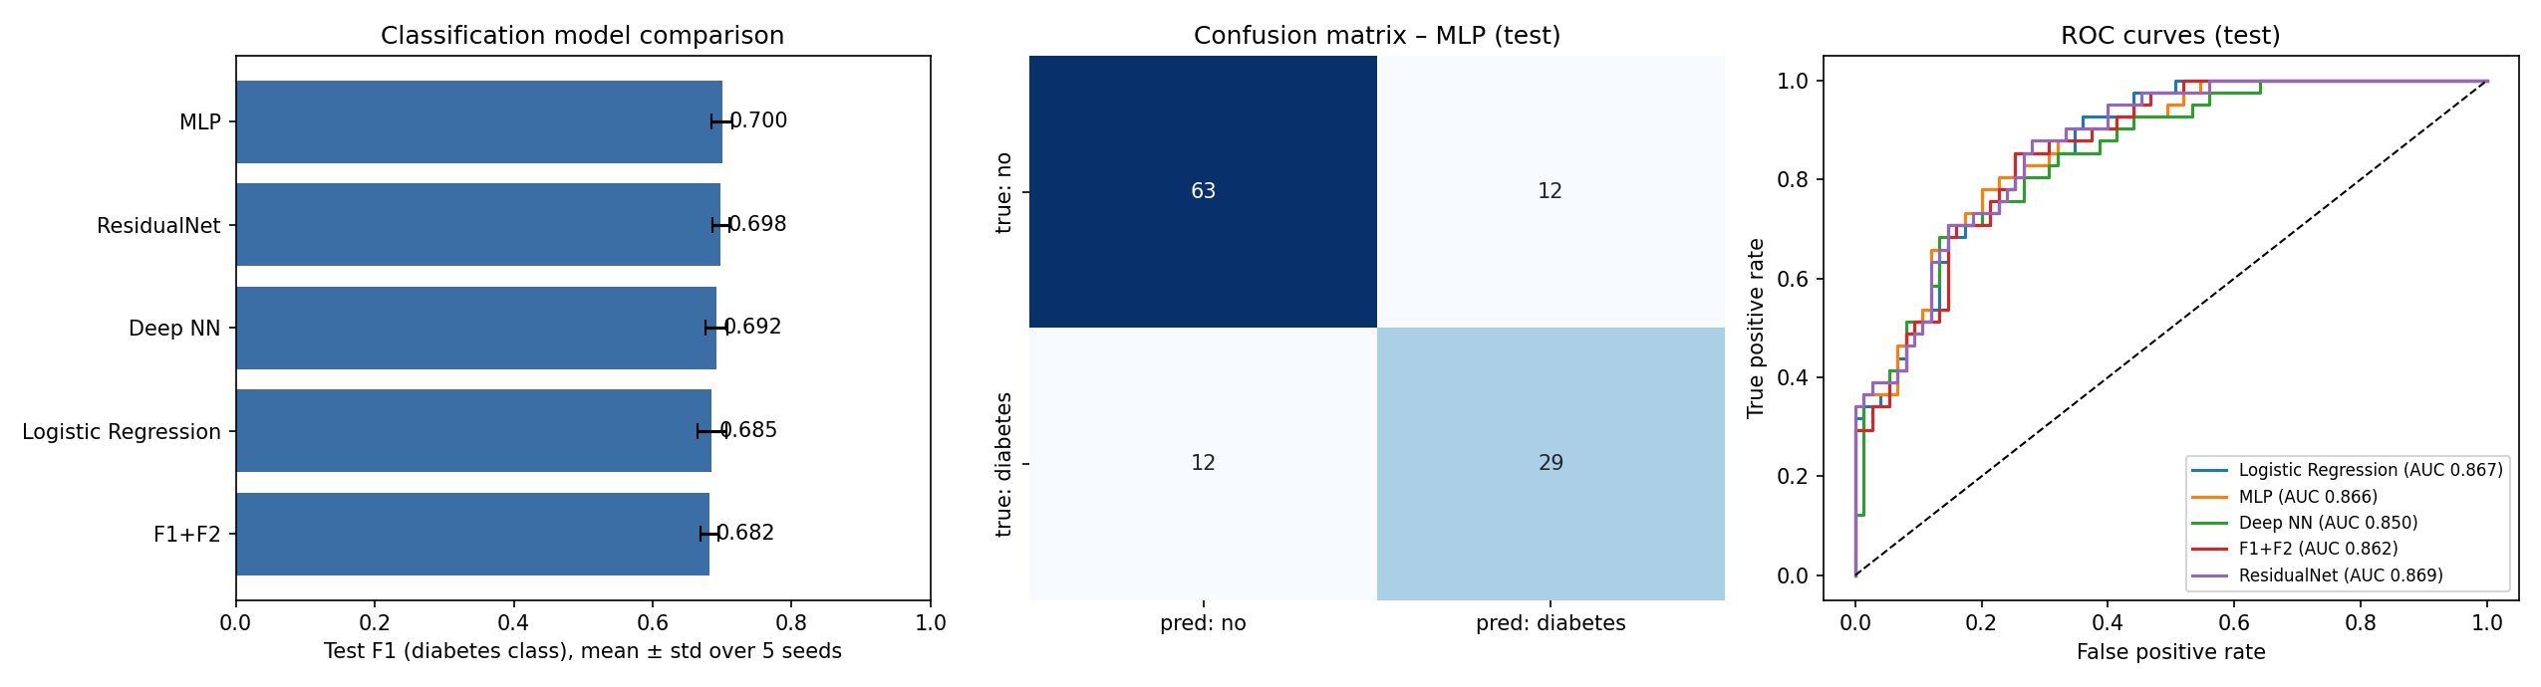
Results
The deployed MLP obtains on the test set: F1 = 0.707, precision = 0.707, recall = 0.707, accuracy = 0.793, MCC = 0.547 and ROC-AUC = 0.866. Confusion matrix: TN = 63, FP = 12, FN = 12, TP = 29.

3.5 Analysis
- Accuracy is not enough. Because 65 % of patients are negative, a model that always predicts “no diabetes” would already reach about 65 % accuracy with F1 = 0. F1, recall, MCC and AUC are therefore the main metrics.
- Model capacity. The best mean test F1 is 0.700 (MLP) versus 0.685 for logistic regression, a difference of 0.015. On a small, noisy dataset with mostly monotonic risk factors, extra depth brings limited benefit and adds variance across seeds; data quality (about half of the insulin values are imputed) limits performance more than the architecture does.
- All models rank patients almost equally well. Test ROC-AUC is between 0.850 and 0.869 for all five models (the ROC curves overlap), and logistic regression alone already reaches 0.867. So the networks do not separate diabetic from non-diabetic patients much better than a linear model; they mainly shift where the 0.5 decision threshold falls, which changes the precision/recall balance.
- Small test set. There are only 41 diabetic patients in the test set, so one patient changes recall by about 2.4 points. This explains why the validation F1 (≈ 0.64–0.65) and the test F1 (≈ 0.68–0.70) differ. Differences of 0.01–0.02 in F1 between models are within noise.
- Errors. The model misses 12 of 41 diabetic patients in the test set (false negatives) and raises 12 false alarms. For screening, missing a diabetic patient is usually more costly than a false alarm.
- Threshold. A threshold of 0.35 chosen on the validation set changes test precision/recall from 0.707/0.707 to 0.647/0.805 (F1 0.707 → 0.717). The web demo shows both decisions.
- Feature importance. Permutation importance ranks glucose far above the other inputs (AUC drop 0.171), followed by BMI (0.060) and age (0.009). This matches clinical knowledge that plasma glucose and adiposity are the main diabetes risk factors. Skin thickness, pedigree function and blood pressure have importance ≈ 0. Skin thickness is largely redundant with BMI (r ≈ 0.55 after imputation), and about 30 % of its values were imputed, so it adds little information once BMI is known.
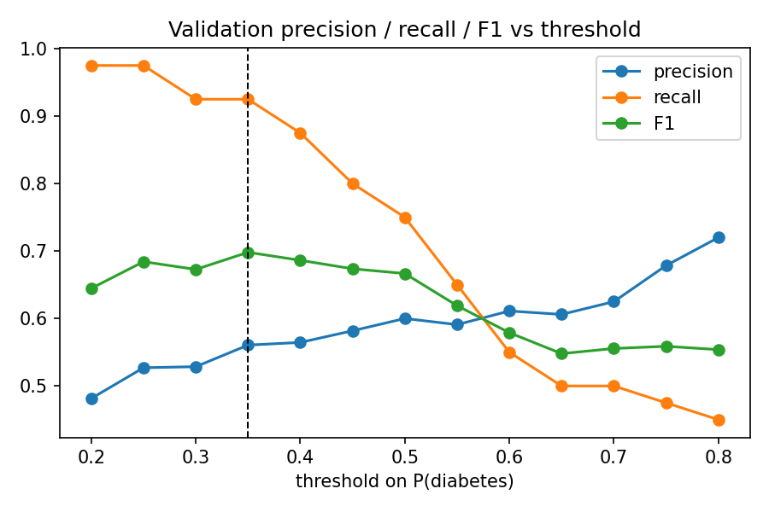
Threshold
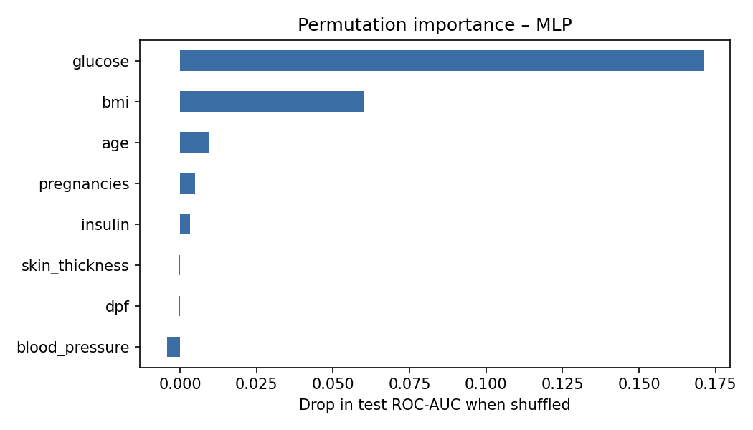
Permutation importance

4. Deployment with ONNX and GitHub Pages
- The selected model is wrapped so that it returns a single tensor (MPa for regression; softmax probabilities for classification) and exported with torch.onnx.export(..., input_names=["input1"], output_names=["output1"], opset_version=15, dynamic_axes=...), as in the class example.
- The ONNX file is checked with onnxruntime in Python: the maximum difference to the PyTorch output is printed in the notebooks.
- Static pages (index.html + index.js) load onnxruntime-web, build a float32 tensor of shape [1, 8] from the form and call session.run({ input1: tensor }). A metrics.json file shows the evaluation results next to the prediction.
- The docs/ folder is published with GitHub Pages: https://acteavity.github.io/ml-onnx-deploy/regression/ and https://acteavity.github.io/ml-onnx-deploy/classification/.

5. Conclusion
For concrete strength, non-linear networks clearly outperform linear regression, and a domain-informed transform of age gives a large improvement at no cost. For diabetes prediction, the gain from deeper networks is small; careful handling of hidden missing values, class imbalance and the decision threshold matter more than architecture. Embedding the pre-processing inside the PyTorch module makes the ONNX models self-contained, so both run fully in the browser without a server.

References
- Yeh, I-C. (1998). Modeling of strength of high-performance concrete using artificial neural networks. Cement and Concrete Research, 28(12), 1797–1808.
- Smith, J. W., Everhart, J. E., Dickson, W. C., Knowler, W. C., & Johannes, R. S. (1988). Using the ADAP learning algorithm to forecast the onset of diabetes mellitus. Proc. Symposium on Computer Applications in Medical Care, 261–265.
- Calix, R. A. ConstraintsMLprediction – ONNX deployment examples. https://github.com/rcalix1/ConstraintsMLprediction
- PyTorch ONNX export documentation; ONNX Runtime Web documentation.

