This is a synopsis of the talk given by Graham and Doug Johnson from RenEnergy at Greening Godalming’s home and small business energy workshop run in October 2010.



The Challenge
Despite the UK being colder than usual in 2010 the planet is warming up with 2010 being the second warmest year on record.

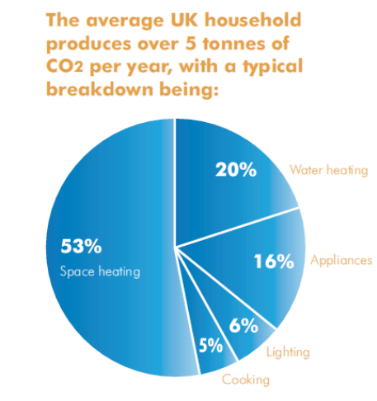
The Climate Change Act means that UK Government has committed to reduce carbon dioxide (CO₂) emissions by 80% by 2050 (from 1990 levels).

27% of UK CO₂ emissions come from housing:- domestic heating, lighting and appliances.

By 2016 all new housing will have to be zero carbon and social housing will have their carbon reduced by 25%

Figure 1: Breakdown of CO₂ emissions from an average house

So what can we do?
The number one thing we can do to conserve the energy – using the leaky bucket analogy – is simply to plug the holes (i.e. stop the heat from leaking out of our homes).
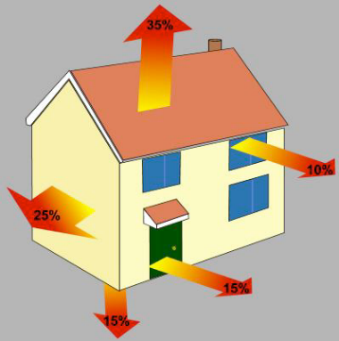
1. Insulation

Figure 2: The better insulated your home, the less energy you will need to keep it warm

1.1 Draught proofing
Plug all the holes: Make sure that all the chilly drafts are kept out. It can be as simple as a draft excluder at the bottom of your door to filling the holes left by pipework leading outside or even around cat flaps.

But beware!
- It is essential that rooms with fires (open or log) or boilers (unless balanced flue), Agas etc have adequate ventilation that must vent continuously through the wall to the outside.

- In rooms where a lot of moisture is produced good ventilation helps reduce condensation and damp

1.2 Insulation – Cavity Wall (Recommended Options: Beads or Chopped fibre)
A quarter of your homes heat could be lost through its walls. Homes with a cavity wall can dramatically reduce this figure by having cavity wall insulation installed.

Having cavity wall insulation added to a 3 bed semi- with gas central heating could save over ½ ton of CO₂ each year as well as around £110.

1.3 Insulation – Loft insulation (Options: Various fibres, chopped materials, or rigid foams)
The recommended depth of insulation in your loft is 27 cm deep – about 10.5 inches.
Annual savings for the 3 bed semi are around £145 – cutting just under ¾ ton of CO₂

1.4 Insulation – Windows (Options: Double glazing and secondary glazing)
Due to the cost and the financial savings involved it makes sense to insulate in the ways shown above before committing to double glazing. Annual savings range from £85 to £130 – saving between 2/5 and 3/5 of a ton of CO₂.

1.5 Insulation – Floor (options: Under-floor insulation and filling floor gaps)

Pitfalls when insulating your home
- Ventilation must be maintained in your roof and under suspended ground floors
- Failure to maintain ventilation will seriously damage your property

DO NOT
– Block up ‘air bricks’ – these ventilate cavities and under floor voids
– Prevent air circulation in the roof space by pushing insulation into the roof eves

2. Renewables investment solution
Having stopped the heat leaking out of our homes we now need to turn our attention to reducing the carbon footprint of the fuel we use to heat and power our homes. When we burn gas to cook or in our boiler to heat the radiators or water carbon dioxide is released. Although we can’t see it when we use electricity carbon dioxide is released as the power stations that supply our electricity are mainly fuelled by gas or coal and 20% by nuclear fuel.

So to reduce the amount of carbon dioxide we release when heating or powering our homes we can look at generating our own electricity, hot water and heat by installing some renewable energy technology. In addition to cutting the CO2 it can:
● Reduce your heating costs (typically by 20-50%)
● It can generate you a fixed but guaranteed income over the next 15 to 25 years
● Help to isolate you, to some degree, against fossil fuel energy price increases

Each solution is unique to the home as it can be made up of a combination of renewable technology depending upon your home’s location.

2.1 Photovoltaics – (generating electricity)
Siting:
– South roof is best! (but not essential it can be SE or SW facing)
– Fitted to an unshaded roof or in an unshaded area (shading reduced the system’s effectiveness)
– Realistically need a minimum area of 4 metres by 3.2 metres (to generate 1.5 kWp)

Other factors:
– Roof needs to be in good condition (tiles and structure)
– Consumer unit needs to be in good condition or may have to be replaced
– Payback – typically 8 -10 years (depends on % electricity used at source)

- Because of the generation tariff you are paid for ALL the electricity generated from approved renewable energy sources!
- Export tariff – you will be paid for any surplus electricity exported to the grid

BONUS
- Free use of the electricity you generate (if consumed at time of generation)
- Tariffs index linked to the Retail Price Index (RPI)
- Income is tax free
- Tariffs fixed for 2 years from 1st April 2010, will then reduce year on year
- Guaranteed for period of 25years

2.2 Wind Turbines – (generate electricity)
As they say it’s all to do with the location! location! location! The best site would be in a clear area and a taller turbine makes it more efficient, making it unlikely to be suitable for domestic applications in Godalming.

- Guaranteed for period of 20 years

2.3 Heat Pumps - (generate heat)
These can gather their heat from the ground, air or water. Using an electrical compressor these machines concentrate low grade heat to provide efficient heating or hot water up to 55ºC. If they are the correct size they can cover your entire heating and hot water demands

Considerations:
Ground or water source heat pumps will need a small room inside to house the plant – storage and control unit (no less than 2m x 1m x 2.4m height) because the tower units are the size of a American fridge. The collection area will typically be 400sqm (for a 10kW Heat Pump).

Air Source heat pumps need less space indoors - for the hydrobox (control unit) but will need a unit outside (about 1 metre square) with 1m free space in front it.

Emitters – Heat into the building
You will need to think about how the heat is sent around your home.
Low flow temperatures = higher system efficiency
- Typically emitter systems should be designed with a flow temperature of 45ºC
- and return temp of 35ºC
- Underfloor heating is the most efficient type of emitter. It is relatively simple and cheap but it is only as good as the control system.
- Radiators can either be LARGE standard radiators (finned and panel) or high quality low flow temperature fan assisted radiators

Be aware: Sizing of heat pumps
Ground source: ‘Does what is says on the tin’. A “16kW” ground source heat pump = 16kW at -5ºC outdoors
Air source: ‘Does NOT!’
- “16kW” air source heat pump = 16kW at 7ºC outdoors
- “16kW” air source heat pump = 11kW at -5ºC outdoors

2.4 Solar Thermal – (generate hot water)
There are 2 systems available the vacuum tubes (when not directly South facing) and flat panels.

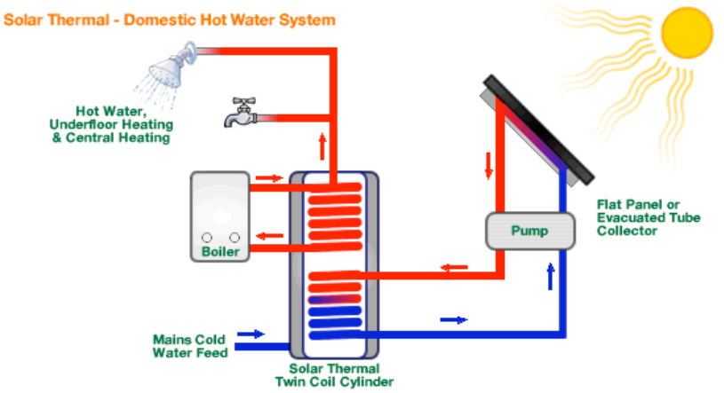

Vacuum tubes
Have a higher efficiency than flat panels and are easier to install

Flat panels
The ‘bullet proof’ option as they have a low/no maintenance with fewer components and seals and are cheaper. They also integrate with photovoltaic systems as they look the same

Savings are moderate - a solar water heating system can reduce your water heating bill by between £50 and £85 per year. It will also save up to 570kg of CO₂ emissions, depending on what fuel you will be replacing.

Maintenance costs are very low. You should take a look at your panels every year and have them checked more thoroughly by an accredited installer every 3-5 years, or as specified by your installer.

Could save up to £50 a year and ¼ ton of CO₂

3. Rain Water Harvesting (Save water)
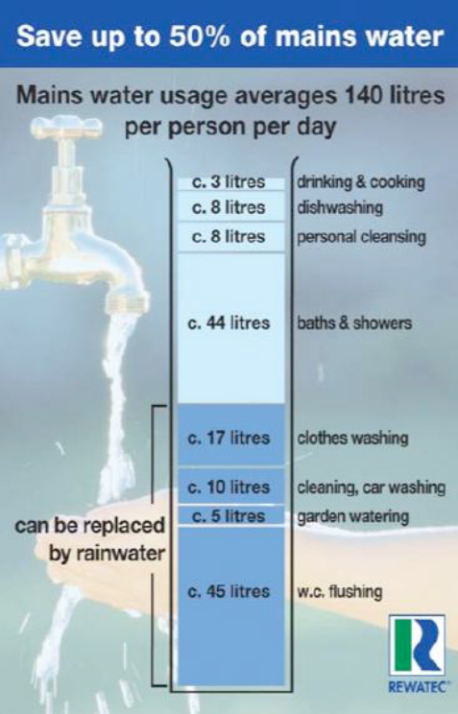
Although it doesn’t make the headlines until we have a hosepipe ban the amount of water we use in our homes can have a significant impact on the environment.

Rain water harvesting can save 50% of your normal water usage. The collected water can be used in: gardens, toilets, washing machines or vehicle washing.

The principles of rain water harvesting are simple: Catch it, Collect it, Use it!

Don’t confuse it with greywater recycling. This is collecting rain water rather than recycling water you have used in the house already.

The water is captured from your house roof/guttering and filtered before it is stored (either under or over ground).

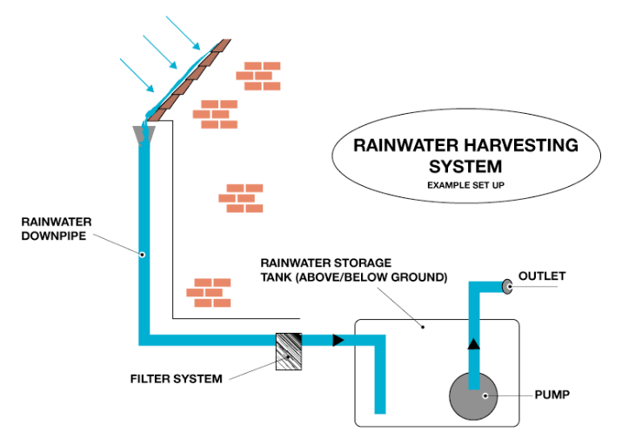

Costs vary from a simple DIY solution to a professionally installed one (£250 to £6000+)

