Rollins Tennis Archive – Java Full Stack Application

CMS 270 – Object Oriented Programming

Instructor:

Dr. Sirazum Munira Tisha

Team Members & Roles:

Madhav Khanal: Lead Programmer

Stella Fruijtier: Data Scientist, Data Visualization

Richard Stoiberer: Project Manager

December 2, 2025

Madhav Khanal, Stella Fruijtier, Richard Stoiberer
CMS 270
Dr. Sirazum Tisha
December 2, 2025

Rollins Tennis Archive – Java Full Stack Application

- Introduction:

Rollins Tennis Archive is a full-stack web application built with a Java REST API backend and a React frontend interface. The system stores and displays player information and match results from the past three Rollins College tennis seasons for a selected number of players and presenting the data through a clean and interactive dashboard. Users can easily browse player bios, review match details, and analyze performance trends across seasons.
The primary purpose of the application is to organize historical team data in one accessible location and make it easier for users to review past performances than on the current Rollins Tennis website. By supporting filtering, searching, and statistics generation, the system helps coaches, players, and fans quickly find relevant results and understand performance patterns. The project also aims to demonstrate how a real-world sports dataset can be managed using proper object-oriented design and a structured backend-frontend architecture, potentially being a guiding project for our team to select our Computer Science Capstone Project.
Our team selected this topic because of our close connection to the Rollins College tennis team, as some members of our team compete on the varsity tennis program, and our shared interest in sports and data. We recognized that tennis results were often scattered or difficult to revisit, and we wanted to create a tool that makes past performances easy to access and analyze. At the same time, tennis naturally provides a clear domain for applying OOP principles-such as modeling players, matches, seasons, and results-which made it an ideal fit for a Java OOP project.

- UML Diagram

Figure 1 shows the complete UML class diagram for the Rollins Tennis Archive backend. The diagram models all major components of the system, including classes, abstract classes, and enumerations. It highlights how the application uses object-oriented design to represent players, matches, seasons, and statistical logic in a structured way.
At the core of the diagram is the abstrac Match class, which defines the shared attributes and behaviors of all tennis matches. Match stores the match date, season, opponent, score/result, and provides methods such as getWinner(), getParticipants(), and getMatchType().
Two subclasses extend this abstract class:
- SinglesMatch - Contains one Rollins player and one opponent player.
- DoublesMatch - Contains a pair of Rollins players and a pair of opponents.
Both subclasses override shared behaviors while providing their own implementations of getParticipants() and getMatchType().
The Player class stores detailed player information (ID, name, nationality, class year, and UTR(Universal Tennis Rating)), and is associated with both match subclasses through composition. Each Match also contains a Result object that stores the score and whether Rollins won as a team, demonstrating a “has-a” relationship.
The Season enumeration provides the set of valid seasons (2022–2024) and is used throughout the model to categorize matches.
MatchRepository is responsible for storing all Match objects and organizes them via a Map<Season, List<Match>>, allowing fast access to matches by season. It offers methods such as:
- addMatch(Match match)
- getMatchesBySeason(Season season)
- getWinCount()
RosterManager maintains all Player objects using a List<Player> and a secondary lookup map. It provides methods to add new players, retrieve players by ID, and return the full roster.
StatsService sits above the repository layer and computes aggregated statistics such as:
- Win/loss records by player
- Season records
- Individual win percentage
This class demonstrates high cohesion and clean separation of concern by isolating all statistical logic away from the controller.
The TennisController connects the backend logic to the external world. It uses dependency references to RosterManager, MatchRepository, and StatsService to expose the main API endpoints. These endpoints return lists of players, match data, or computed statistics, which the React frontend uses to render the application interface.

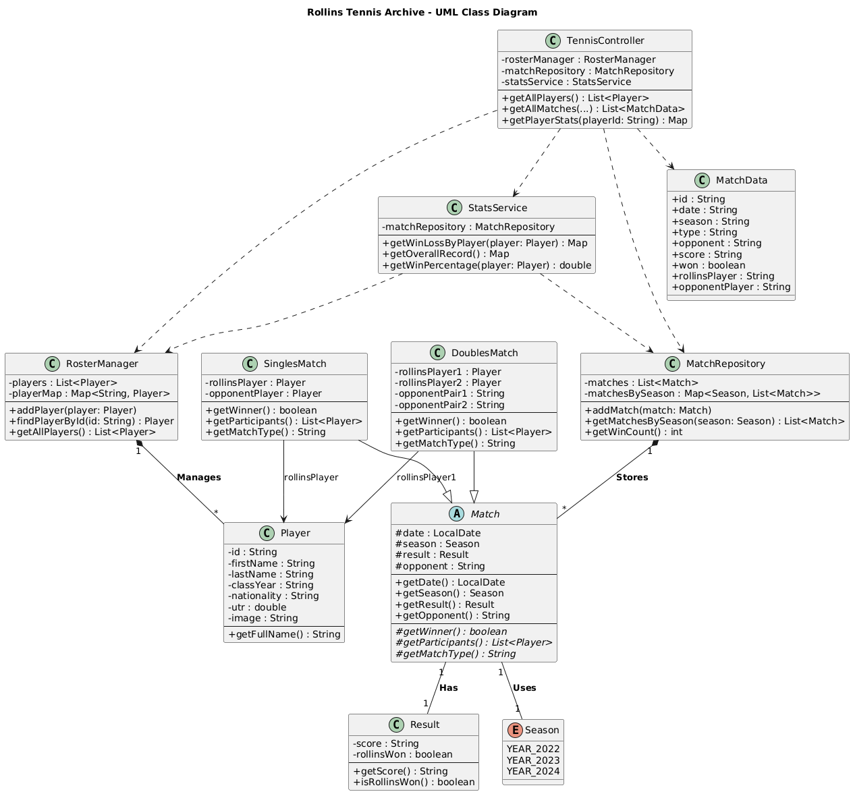Figure 1

- Implementation Description

