


SP-EU
Social Prescribing to promote and improve access to health and care services
for people in vulnerable situations in Europe
Horizon Europe – 101155873

D6.1.– ALTAI-Report

WP leader | Dr. Michael Sperber (Active Group GmbH)
Author(s) | Raoul Schlotterbeck (Active Group GmbH)  Markus Schlegel (Active Group GmbH)
Version | V1
Due date of delivery | 30.06.25
Actual date of delivery
Dissemination level | ?

This project has received funding from the European Union’s Horizon Europe research and innovation programme under grant agreement No 101155873.
Views and opinions expressed are however those of the author(s) only and do not necessarily reflect those of the European Union or European Health and Digital Executive Agency (HADEA). Neither the European Union nor the granting authorities can be held responsible for them.

Table of Contents

Table of Contents 2
Abbreviations 3
List of figures 4
List of tables 4
Executive Summary 5
1. Heading 6
1.1 Subheading Level 1 6
1.1.1 Subheading Level 2 6
1.2 Subheading Level 2 7
1.3 Subheading Level 1 7
1.3.1 Subheading Level 2 7
1.3.1.1.1 Subheading Level 3 7
1.3.1.1.2 Subheading Level 3 7
1.3.2 Subheading Level 2 7
2. Heading 8
2.1 Subheading Level 1 8
2.1.1 Subheading Level 2 8
2.1.2 Subheading Level 2 8
2.2 Subheading Level 1 8
2.2.1 Subheading Level 2 8
2.2.2 Subheading Level 2 8
3. Annex 9

Introduction
This report presents an assessment of a link worker resource management application with AI-assisted RDF formatting. The application aims to help link workers manage contacts and resources for social prescribing, particularly for three target groups: elderly individuals, first-generation immigrants, and members of the LGBTQ community across EU countries. The AI component assists users in formatting free-text entries into structured RDF data, powered by an Ollama server currently running the Phi-4 model.

Assessment

Human Agency and Oversight
The AI system is designed to assist users in converting free-text input into RDF data using a controlled vocabulary. Activation of the AI tool is entirely optional and triggered manually by the user via a clearly marked button. Once the AI generates a suggestion, users can choose to discard it or embed it into their RDF graph for further editing.

The AI does not guide or automate any decisions — its role is strictly to assist in formatting. Additionally, only RDF outputs that pass validation against a SHACL file are displayed, preventing malformed or structurally incorrect data from being shown. This restriction further limits the influence of AI-generated content on users.

There are no features that encourage overuse or dependence on the AI, and since output is clearly marked and user-controlled, there is no risk of manipulation or attachment behaviours developing.

Assessment: Low Risk
- It is clear which content is AI-generated
- AI-generated content is only usable in RDF format
- Users may accept or discard AI output freely
- No risk of addictive, manipulative, or persuasive AI behaviour

Recommendations:
- Consider providing a help tooltip or FAQ entry to explain how AI suggestions are validated and embedded

Technical Robustness and Safety
While the AI component was used during development and has shown robustness in some cases, it has not undergone systematic testing. Output quality is inconsistent: sometimes accurate, sometimes failing validation. Because only valid RDF data is accepted by the editor, invalid results are discarded before they can affect user workflows.

Using the AI is completely optional. When used, the generated data appears in a preview window, and users can decide whether to embed it in the RDF graph. If the AI response is invalid or triggers an error, users are notified and may continue working without it or retry.

RDF data is stored on servers controlled by the development team using the Apache Jena framework. Access requires authentication via Keycloak. While personal data can be entered, the app is primarily designed for managing publicly available resources.

[An OpenStreetMap interface (via Leaflet and Overpass) is included to assist with location-based search. While there are currently no AI components involved in ordering or selecting search suggestions, this may be explored in the future. If AI is introduced in that context, similar safeguards and validations would be recommended.]

The project will be supported by the development team for two to three years, with most updates front-loaded in the initial months. Ongoing support is minimal but planned.

Assessment: Low Risk
- AI has not been systematically tested
- No formal robustness or failover mechanisms in place, but all features are usable without the AI component.
- AI errors are handled gracefully
- Straightforward infrastructure and internal hosting mitigate many safety concerns

Recommendations:
- Conduct informal testing sessions to identify common failure cases in AI output
- Track the frequency and nature of validation failures

Privacy and Data Governance
Users are free to input any RDF-compatible data, which is a weak constraint. The system does not attempt to identify or prevent the entry of personal data, nor does it enforce any privacy policies in the data itself. The application is mainly intended for storing public resource data, but this is neither enforced nor enforceable.

The number of people with access to the shared RDF store is unclear, though likely in the tens or low hundreds. All authenticated users have equal access, as there are no role-based permission systems. This may pose risks around accidental data modification or deletion.

No mechanisms exist for data classification, consent management, or user-specific visibility settings. While the Ollama server and OpenStreetMap API usage are constrained, the system does not currently analyse input for misuse or sensitive content.

Assessment: Low Risk
- No explicit controls over personal data input or sharing
- No role-based access or audit trail for data changes
- Small and limited user base currently minimizes the impact

Recommendations:
- Consider role-based permissions
- Consider an edit history feature
- Clarify acceptable use and data input boundaries for users

Transparency
The graph editor simplifies RDF structures into a format resembling a rich table-like form. Users do not need RDF knowledge to interact with it. AI-generated content is clearly visible during the preview phase, but once embedded, it is not marked as AI-generated. Editing changes are reversible until committed.

Error messages for AI failures are minimal and may not always explain the problem clearly.

Assessment: Low Risk
- AI-generated content not labelled after embedding
- UI is mostly transparent, but complex structures may still be confusing to some users

Recommendations:
- Improve validation error messages or provide examples of acceptable input

Diversity, Non-discrimination and Fairness
Although the app supports work with underserved populations, those individuals are not the users themselves. As such, the UI and feature set were not explicitly designed with their direct accessibility in mind.

There is no specific review or mitigation process for potential bias in AI-generated content. Multilingual support is assumed based on the underlying model (Phi-4), but the effectiveness of different languages is yet untested. Users provide and maintain resource data independently, which introduces variability and potential underrepresentation of certain communities.

Assessment: Low Risk
- AI outputs may carry bias; no testing or correction process is in place, but users must explicitly commit AI-generated suggestions.
- Multilingual capability is unverified

Recommendations:
- Monitor AI behaviour across a few common EU languages for performance consistency
- Include prompts or suggestions to review AI output for fairness before accepting it

Societal and Environmental Well-being
The app is meant to positively impact link workers' ability to connect vulnerable individuals to appropriate resources. It provides a lightweight way to organize and share data, making link work more efficient.

Risks include the potential for incorrect or low-quality information to spread within the user base. There is no validation for correctness beyond the RDF format, and no version control or moderation features currently exist.

Environmentally, the system is considered low impact. The Ollama AI server is hosted locally and queried on demand. No large-scale infrastructure or frequent inference operations are involved.

Assessment: Low Risk
- Designed to benefit link workers and vulnerable groups indirectly
- Lightweight infrastructure, minimal energy footprint
- Some risk of low-quality data propagation

Recommendations:
- Add optional moderation or versioning features
- Document best practices for verifying resource information
- Maintain lightweight deployment even if the system scales

Accountability
The development team currently handles all technical responsibilities, including hosting, bug fixes, and maintenance. However, responsibilities across the broader project consortium are not clearly defined, which may lead to ambiguity if governance issues arise.

Users can report issues informally via Redmine or through personal contact with the team, but there is no direct feedback channel within the application. This may be sufficient for the research context but could become limiting if the app is extended.

There is no moderation or flagging system for problematic data, and no audit logs to trace AI usage or user activity.

Assessment: Medium Risk
- Clear internal responsibility, but unclear external roles
- No in-app issue reporting or user-facing contact
- No audit trails or moderation mechanisms

Recommendations:
- Define project-wide roles and responsibilities for data and system management
- Add a simple contact or feedback form within the app
- Consider lightweight user logging or change history tracking for accountability

Abbreviations
SP Social Prescribing
LGBTIQ Lesbian Gay Bisexual Trans Inter Queer
RCT Randomized Control Trial
XX XXX

List of figures
Figure 1: Description to be added via right-click on the figure via „Insert caption“. 6
Figure 2: Description to be added via right-click on the figure via „Insert Caption“. 8

List of tables
Table 1: Heading for first table to be added via right-click on the figure via „Insert caption“. 7
Table 2: Heading for second table to be added via right-click on the figure via „Insert caption“. 7

Executive Summary
This report presents an assessment of a link worker resource management application with AI-assisted RDF formatting. The application aims to help link workers manage contacts and resources for social prescribing, particularly for three target groups: elderly individuals, first-generation immigrants, and members of the LGBTQ community across EU countries. The AI component assists users in formatting free-text entries into structured RDF data, powered by an Ollama server currently running the Phi-4 model.

Heading
Standard text Calibri 11

Subheading Level 1
Standard text Calibri 11
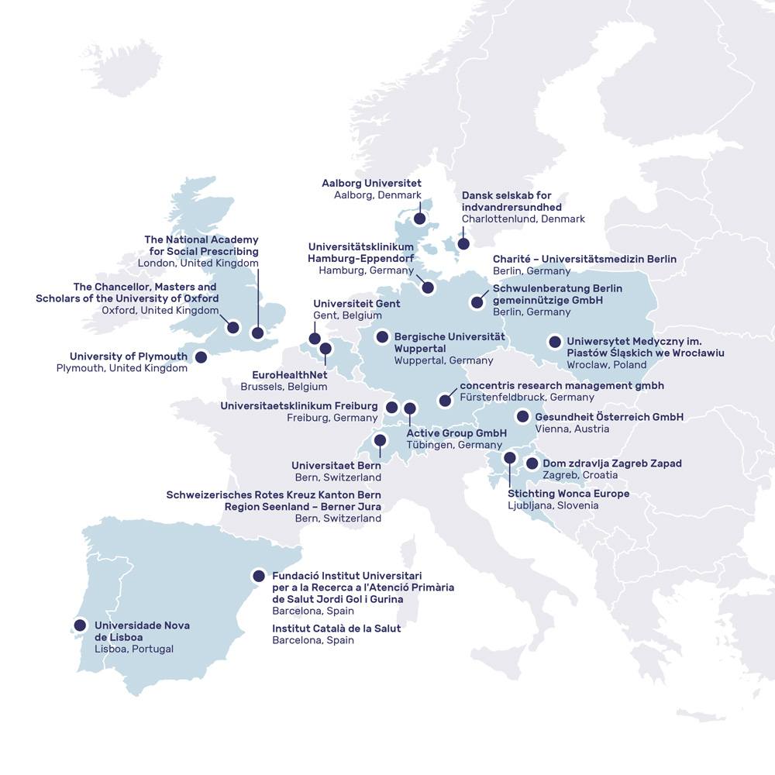
Figure 1: Description to be added via right-click on the figure via „Insert caption“.

Subheading Level 2
Standard text Calibri 11

Subheading Level 2
Standard text Calibri 11

Subheading Level 1
Standard text Calibri 11

Table 1: Heading for first table to be added via right-click on the figure via „Insert caption“.
Heading column 1 | Heading column 2 | Heading column 3 | Heading column 4
Text column 1 | Text column 2 | Text column 2 | Text column 2
Text column 1 | Text column 2 | Text column 2 | Text column 2
Text column 1 | Text column 2 | Text column 2 | Text column 2

Subheading Level 2
Standard text Calibri 11

Table 2: Heading for second table to be added via right-click on the figure via „Insert caption“.
Heading column 1 | Heading column 2 | Heading column 3 | Heading column 4
Text column 1 | Text column 2 | Text column 2 | Text column 2
Text column 1 | Text column 2 | Text column 2 | Text column 2
Text column 1 | Text column 2 | Text column 2 | Text column 2

Subheading Level 3
Standard text Calibri 11

Subheading Level 3
Standard text Calibri 11

Subheading Level 2
Standard text Calibri 11

Figure 2: Description to be added via right-click on the figure via „Insert Caption“.

Heading
Standard text Calibri 11

Subheading Level 1
Standard text Calibri 11

Subheading Level 2
Standard text Calibri 11

Subheading Level 2
Standard text Calibri 11

Subheading Level 1
Standard text Calibri 11

Subheading Level 2
Standard text

Subheading Level 2
Standard text

Annex
Please find the following documents annexed to this report in the following order:
- Ethics approval Germany
- Ethics Approval Italy
- Informed Consent Form in German
- Informed Consent Form in Italian

