SP-EU Workshop 19./20.02.2024
  - Status 14.02.2024

We are very happy to welcome you to Berlin for our workshop to prepare the full proposal for SP-EU.

Goals of this workshop
- To build a team which is able and willing to prepare the proposal and conduct the project successfully together
- To create a joint understanding of work packages and tasks involved
- To refine the work plan of the project
- To discuss crucial aspects for a successful implementation of the project

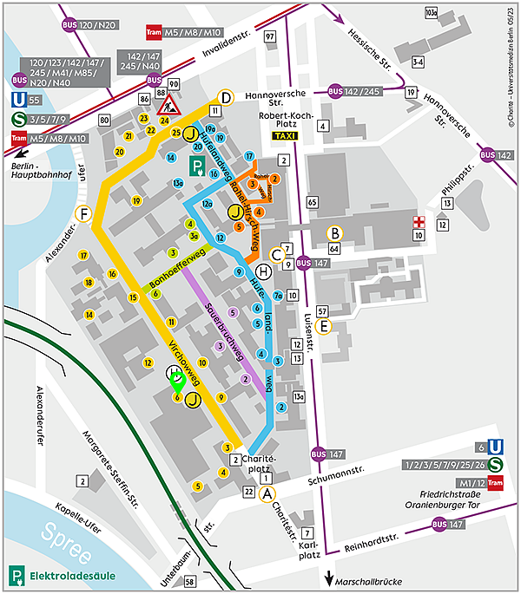
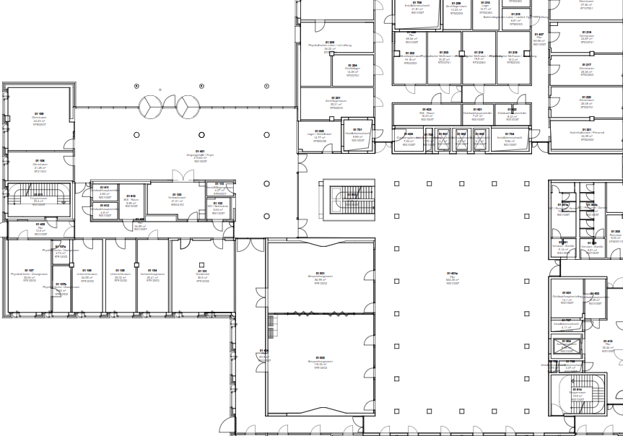
Plans

Day 1 February 19th
9:00-9:15 Goals of workshop and SP-EU
Aim: Set a foundation for the workshop
9:15-10:00 Introduction and get to know each other (hybrid: Click here to join the meeting)
Aim: Become familiar with each other and become a team
10:00-10:45 Lump Sums and Work Packages – Project management aspects of the proposal incl. Time for Questions (hybrid: Click here to join the meeting)
Aim: Set the technical foundation to understand work packages and funding
10:45-11:00 Coffee Break
11:00-12:00 KERs and necessary tasks (Group Work)
Aim: Look out for missing tasks and how to organize tasks best
12:00-12:45 Lunch
12:45 Group Photo
12:55-13:45 Group Work with three parallel groups
Co-Creation 1st phase;
Aim: Discuss the step-by-step procedure to conduct the co-creation process in 1st year
Digital tool development;
Aim: Discuss requirements for the tool
Ethics and Data security
Aim: Collect requirements in different countries and hubs involved
13:45-14:30 RCT Overall design (hybrid: Click here to join the meeting)
Aim: Create a shared understanding of the overall RCT design including preparation, study site initiation, baseline, follow up 6M FU 12M
14:30 Coffee break
15:00-16:00 Consultation with representatives of refugees and first-generation immigrants
Aim: Which topic should be addressed in adapting SP? What shall we take in mind in planning the RCT?
[Alternative: Discussion on language support for data acquisition and intervention delivery]
16:00-16:45 RCT Intervention delivery (hybrid: Click here to join the meeting)
Aim: Talk through the details of the intervention delivery
16:45-17:30 RCT Outcome Measurement (hybrid: Click here to join the meeting)
Aim: Discuss how to measure the primary outcome
18:00 Dinner at Hummus and Friends

Day 2 February 20th
9:00-9:15 Welcome and morning round
9:15-10:00 Communication, dissemination, exploitation, policy (hybrid: Click here to join the meeting )
Aim: What do we need? Stakeholders, channels, materials, measures
10:00-10:45 Additional partners and advisory boards: Advisory, Implementation, Patient Board and Data Monitoring Committee (hybrid: Click here to join the meeting)
Aim: Which forms and whom to include?
11:00-12:00 Consultation with representatives of LGBTI persons (hybrid: Click here to join the meeting)
Which topic should be addressed in adapting SP? What shall we take in mind in planning the RCT?
12:00-12:45 Lunch
12:45-13:45 Consultation with representatives of older persons
Which topic should be addressed in adapting SP? What shall we take in mind in planning the RCT?
13:45-14:15 Coffee break
14:15-15:00 Sum Up
15:00 End

Participants

In Berlin on site
- Stéphanie B (Bern) [arriving Monday noon]
- Moa (Bern) [arriving Monday noon]
- Hendrik (Berlin)
- Wolfram (Berlin)
- Philip (Berlin)
- Stephanie R (Berlin)
- Lilian (Berlin)
- Thomas K (Hamburg)
- Thomas Z (Hamburg)
- Claudia (Freiburg)
- Kerryn (Plymouth)
- Sine (Aalborg)
- Juliane (Wuppertal)
- Sibylle (Active Group)
- Jelena (Zagreb)
- Iva (Zagreb)
- Ana (Lisbon)
- Maria (Lisbon)
- Andrea (Concentris) [only on Monday]

Online
- Lina (Eurohealthnet)
- Alison (Eurohealthnet)
- Stephanie (Oxford)
- Sónia (Lisbon)
- Donata (Wroclaw)
- Merrick (Toronto)
- Nicola (Catalonia)
- Daniela (Vienna)
- Emmily (Ghent)

