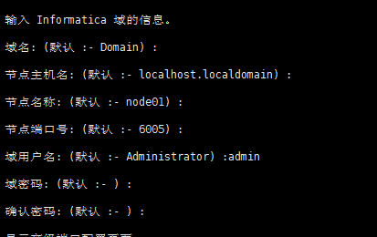

开启关闭服务
- cd $INFA_HOME(/home/oracle/infor_install/infa/tomcat/bin)
- ./infaservice startup
- ./infaservice shutdown

