Report

All my solutions are ubuntu focused, as i myself use Ubuntu 20.04.

Q2

Enter the input one by one. Please URL encode those inputs.

URL encoding means that come characters(like #) are not included in ASCII, so they are not transmitted, hence these need to be converted in transferable form.

Line 23:30 sets proxy for terminal use. These changes are not reflected in the Settings.

And

Line 42:53 sets proxy for Overall App use. These changes can be seen in the Settings.

Q3

Prerequisites:

Monit installed on ubuntu.

Main script to detect changes

Create the script (file: monit_docker_check.sh)

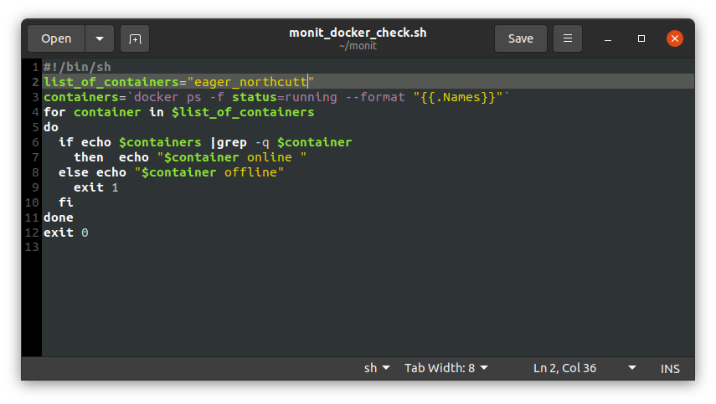Line 2: Here in list_of_containers define the containers that you want to monitor.

Line 3: This command searches for all the containers with status of running. The label “--format “{{.Names}}” displays the output in a better way.

Line 4: Iterate in the list for only those containers that we require

Line 5 – 10 :

Line 6 check if our container is in the returned list of “running containers” if

Line 7 Yes: then Print {container name} online

Line 8 No: Print {container name} offline

Monit is the monitoring method that i will use to detect changes in the output file.

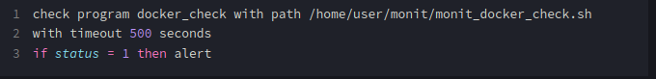 My Monit configuration is not able to send the mail.

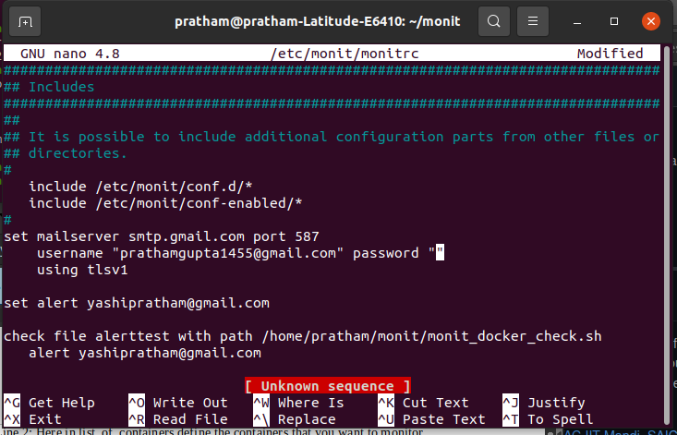The script to send mail placed in etc/monit/monitrc.