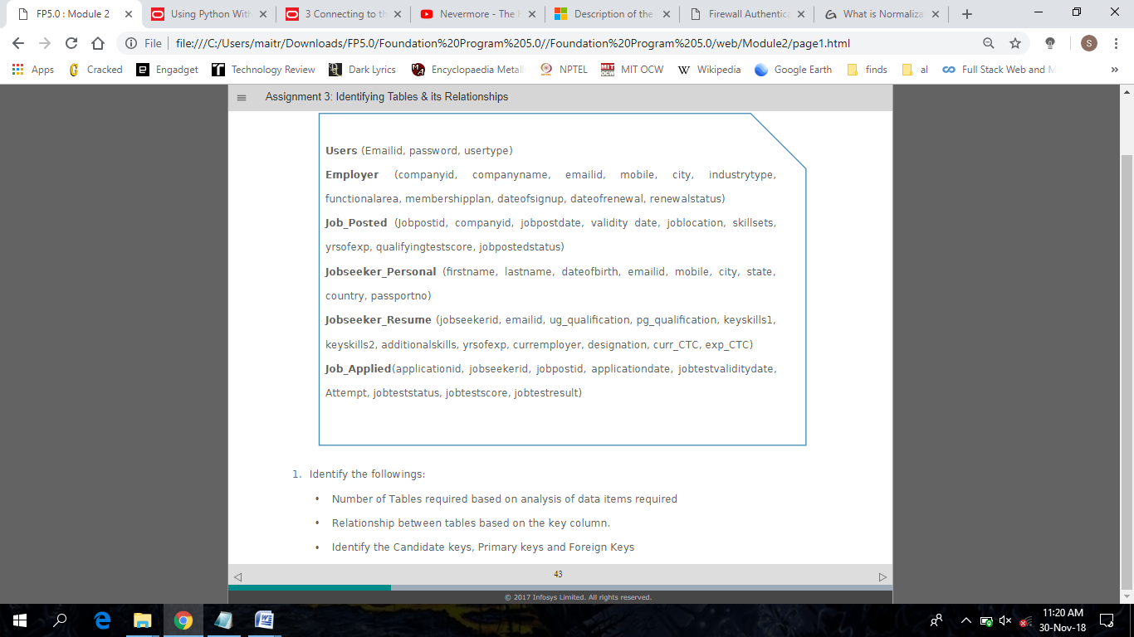

|  |  |
| --- | --- |
| **Table Name** | **Key column(s)** |
| Users | Email_ID (primary) |
| Employers | Company_ID (primary), Email_ID (foreign), |
| Job_Posted | JobPostID (primary), Company_ID (foreign) |
| JobSeeker_Personal | JobSeekerID (foreign), passportno (candidate) |
| JobSeeker_Resume | JobSeekerID (primary), Email_ID (foreign) |
| Job_Applied | ApplicationID (primary), JobSeekerID (foreign), JobPostID (foreign), |

Tables here are related by shared keys, where a primary or candidate key of one table is used as a foreign key for another table, as given above.