NEW FILE.
DATASET NAME DataSet3 WINDOW=FRONT.
GRAPH
/SCATTERPLOT(BIVAR)=X WITH Y
/MISSING=LISTWISE
/TITLE='SCATTER PLOT FOR PERFORMANCE AND INNOVATION'.

Graph

[DataSet3]

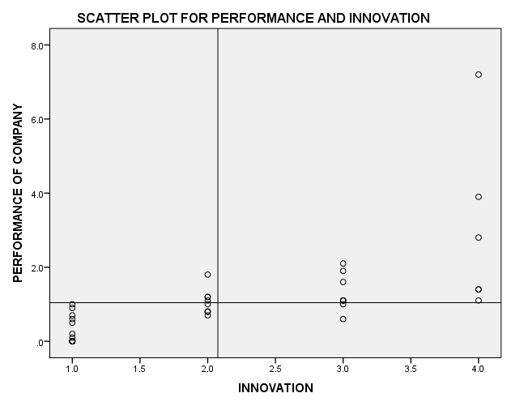

REGRESSION
/MISSING LISTWISE
/STATISTICS COEFF OUTS CI(95) R ANOVA
/CRITERIA=PIN(.05) POUT(.10)
/NOORIGIN
/DEPENDENT Y
/METHOD=ENTER X.

Regression

Variables Entered/Removedª
Model | Variables Entered | Variables Removed | Method
1 | INNOVATION^{b} | . | Enter
a. Dependent Variable: PERFORMANCE OF COMPANY
b. All requested variables entered.

Model Summary
Model | R | R Square | Adjusted R Square | Std. Error of the Estimate
1 | .688ª | .473 | .459 | .9553
a. Predictors: (Constant), INNOVATION

ANOVAª
Model |  | Sum of Squares | df | Mean Square | F | Sig.
1 | Regression | 31.140 | 1 | 31.140 | 34.123 | .000^{b}
1 | Residual | 34.678 | 38 | .913
1 | Total | 65.818 | 39
a. Dependent Variable: PERFORMANCE OF COMPANY
b. Predictors: (Constant), INNOVATION

Coefficientsª
Model |  | Unstandardized Coefficients |  | Standardized Coefficients | t | Sig. | 95.0% Confidence Interval for B
 |  | B | Std. Error | Beta | t | Sig. | Lower Bound | Upper Bound
1 | (Constant) | -.615 | .322 |  | -1.914 | .063 | -1.266 | .035
1 | INNOVATION | .799 | .137 | .688 | 5.842 | .000 | .522 | 1.076
a. Dependent Variable: PERFORMANCE OF COMPANY

